THEMIS
Science Coordinate Systems Definition
THM-SOC-110
July 29, 2010

Patrick Cruce, THEMIS Programmer/Analyst

Dr. John Bonnell, THEMIS EFI

Dr. Alain Roux, THEMIS SCM

Dr. Uli Auster, THEMIS FGM

Dr. Davin Larson, THEMIS SST

Dr. Krishan Khurana, THEMIS Science ACS

Michael Ludlam, THEMIS ISE

David King, THEMIS Software Manager

Vassilis Angelopoulos, THEMIS Principal Investigator

Document Revision Record

Rev. | Date | Description of Change | Approved By
1 | 2006-09-22 | Draft | -
2 | 2006-09-18 |  | Signatories
3 | 2010-07-29 | Added description of HDZ coordinates | David King

Distribution List
Name | Email
Jim Lewis, U.C. Berkeley | jwl@ssl.berkeley.edu
Dr. Tai Phan, U.C. Berkeley | phan@ssl.berkeley.edu
Dr. Forrest Mozer, UCB | fmozer@ssl.berkeley.edu
Dr. Robert Ergun, LASP | ree@fast.colorado.edu
Dr. James McFadden | mcfadden@ssl.berkeley.edu
Dr. Chris Cully, LASP | cully@colorado.edu
Dr. Manfred Bester | Manfred@ssl.berkeley.edu
Dr. Ellen Taylor, U.C. Berkeley | ertaylor@ssl.berkeley.edu
Dr. Krishan Khurana, UCLA | kkhurana@igpp.ucla.edu
Dr. Dave Sibeck, NASA GSFC | david.g.sibeck@nasa.gov

TBD List
Identifier | Description

Table of Contents

Introduction

Purpose and Scope.

The THEMIS coordinate systems are used in the transformation of sensor raw data into geophysical coordinates. Such transformations rely on ground measurements of Sun Sensor location relative to the magnetometers and also on ground or in orbit measurements of the Spin axis relative to the probe Geometry axis.

Applicable Documents.
- THM_SYS_012_PDMP THEMIS Project Data Management Plan
- THM_SOC_101_TIME THEMIS TIME Definition
- THM_SOC_108_GMAG_L1_VARNAMES THEMIS GMAG Variable Name Def’s
- THM_SOC_111_SUNSENSPROC THEMIS SUN SENSOR Science Processing
- THM_SOC_112_ATTPAIPROC THEMIS Science ATT & Inertia Determ.
- THM_SOC_113_FGM_CALPROC THEMIS FGM CAL File and Processing
- THM_SOC_114_SCM_CALPROC THEMIS SCM CAL File and Processing
- THM_SOC_115_EFI_CALPROC THEMIS EFI CAL File and Processing
- THM_SOC_116_ESA_CALPROC THEMIS ESA CAL File and Processing
- THM_SOC_117_SST_CALPROC THEMIS SST CAL File and Processing
- SAI-SPEC-1079A (Oct 26, 2005) THEMIS Coordinate systems
- SAI-RPT-0722a (September, 2006) Probe Alignment Report (MSSS data, p18)
- pturin e-mail on Faro alignment results (9/28/06) FGM, SCM mag alignments
- THM-MB-MEC-005-Magnetometer clocking r7.pdf MAG clocking angles

Probe-Centered Coordinate Systems

The probe-centered coordinate systems have their origin at the probe (rather than at Earth) and are named in accordance with the general rule ABC, where A ∈ {S, D} denotes spinning or despun coordinates; B∈{P, S, S} denotes the general direction of the X axis being along the ProbeX axis, the SunSensor X axis or the Sun, and finally C ∈ { G or L} denotes the Z axis direction being along the geometric Z axis or the probe L-vector.

SPG (Spinning Probe Geometric)

This system (Fig. 1) is defined by the mechanical designers of the probe in SAI-SPEC-1079A. Definition:
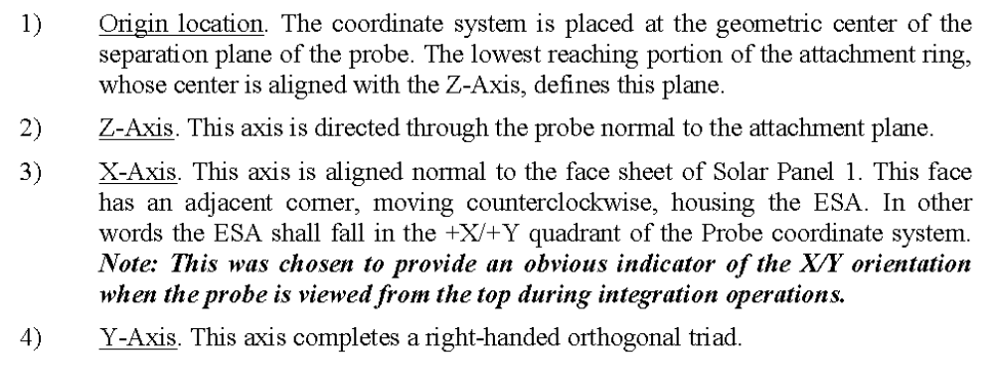
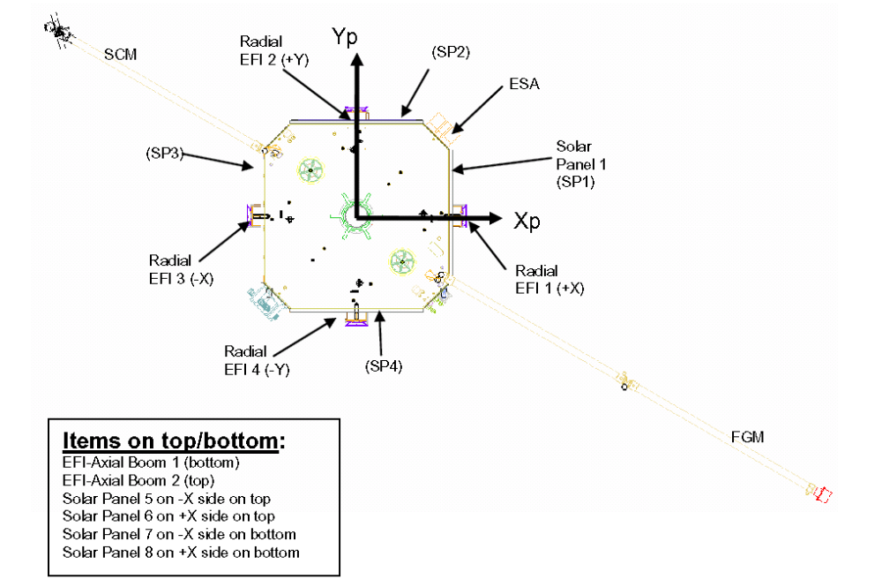
Figure 1 SPG system, probe view from top.

SSL (Spinning SunSensor – L-vectorZ)

This system points with Z along the Spin axis of the probe (the momentum vector is along the principal axis of inertia). The Izz was measured during spin balance tests at JPL to be within 0.25deg of the geometric axis assuming (by modeling) magnetometer booms have been deployed but EFI booms are stowed. As fuel is consumed this angle is expected to change but not by much. Nevertheless we shall track it as function of time, after accurate determination (to within 0.1deg) by modeling magnetometer data through perigee. This angle is recorded in the daily STATE file.

The X axis of the system points towards the Sun Sensor (Miniature Spinning Sun Sensor) look direction. Theoretical angle between the Sun Sensor look direction and the probe X axis is 135 deg (must rotate Xgeometric about Zgeometric axis to obtain Xsunsensor). A detailed figure of the sun sensor it shown in Figure 2, excerpt from SAI-spec 1079a. The Zaxis of the sun sensor is aligned within <1deg to the Zgeometric axis of the probe, based on alignment measurements at JPL. The theoretical transformation matrix that takes a vector in the SPG system into one in the SSL system is thus given (based on ICDs) by:
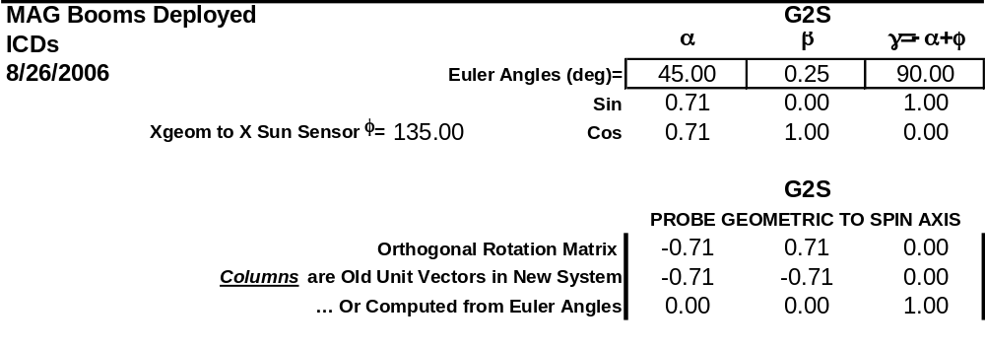

The actual rotation matrix based on measured alignments at JPL is given in the appendix.

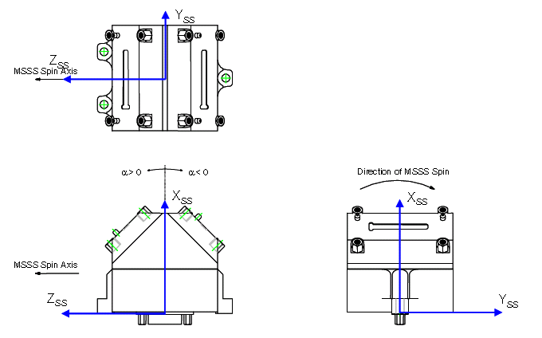
Figure 2 Detail of Sun Sensor coordinates
The orientation of the sun sensor relative to the magnetometers in seen in Figure 3 (THM-MB-MEC-005).
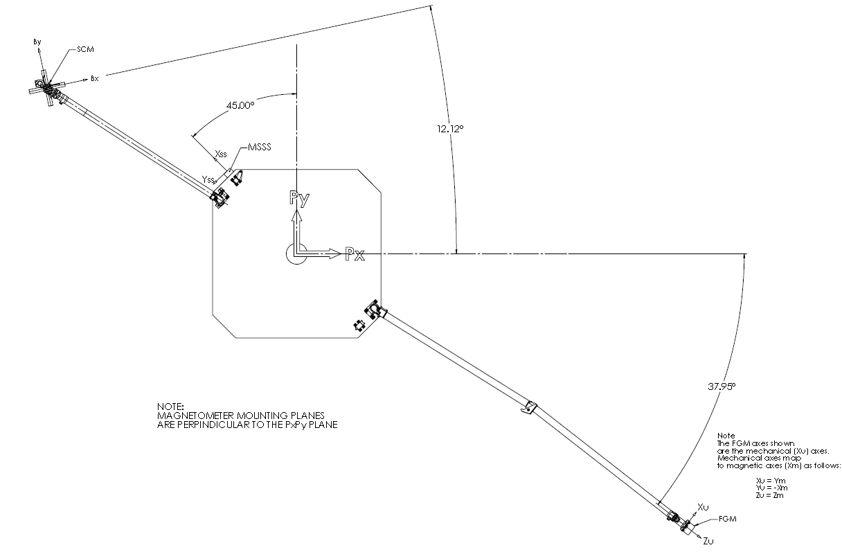
Figure 3 Detail of theoretical Sun Sensor and Mag sensor locations in the Spinning Probe Geometric system (SPG).

DSL (Despun Sun – L-vectorZ)

This is the system whose Z axis points towards the spin axis, the Y axis is normal to Z and the Spacecraft Sun direction viewed from the probe, and X completes the triad.

Operationally the despun system is obtainable by a rotation about the spin axis by an angle equal to Spin Phase in the direction opposite the spin direction. This rotation provides the DSL system at the time of the Spin Phase. This information is determined using the sun pulse signal by science operations, and written into the STATE file at 1min resolution for future use for coordinate transformation. Box car averaging is applied such that the noise level of the sun pulse is reduced, and the spin phase moves gradually from one point to the next, and interpolation between successive points to determine the spin phase is possible.

Since the plane defined by the Spin axis and the Spacecraft Sun direction ought to contain the intersection line of the nominal sun sensor field of view and the spin axis, the X-axis can be operationally defined as the intersection of the nominal sun sensor field of view at the time of the sun pulse, and the actual spin plane.

The theoretical and practical (measured) spin axis will be within <0.25deg of each other. The measured sun sensor view plane is within <1deg of the geometric axis. For spin axes near the ecliptic normal (as expected during the science operations phase) the sun pulse will occur when the sun sensor view direction is within a negligible angle (<0.1deg) from the DSL X axis.

In the arbitrary (or unfortunate) case when the spin axis ends up at a large angle to the geometric axis, the Sun Sensor plane at the time of the sun pulse may be a large angle to the theoretical DSL axis. In that case, there needs to be either an elevation-dependent correction to the sun pulse time or an elevation-dependent Spin Phase rotation.

Earth-Centered Coordinate Systems

GEI (Geocentric Equatorial Inertial)
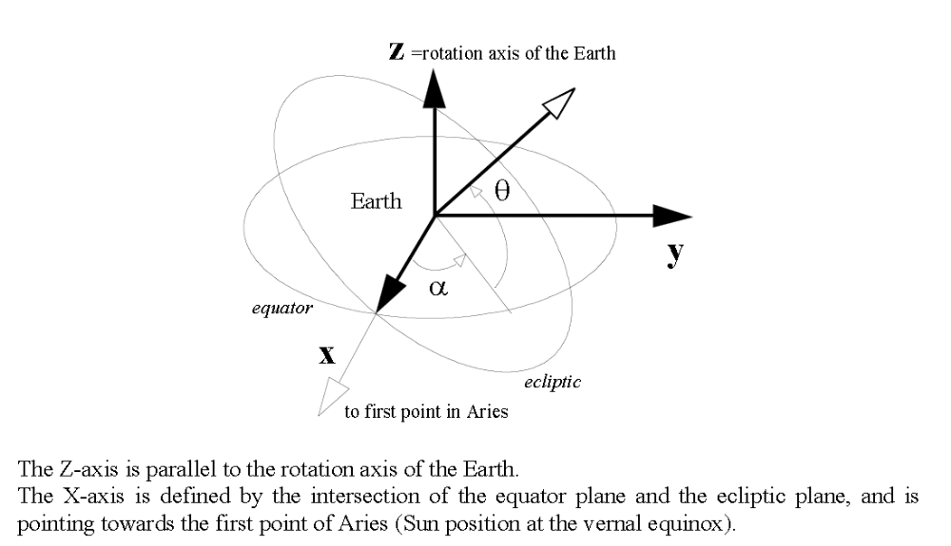
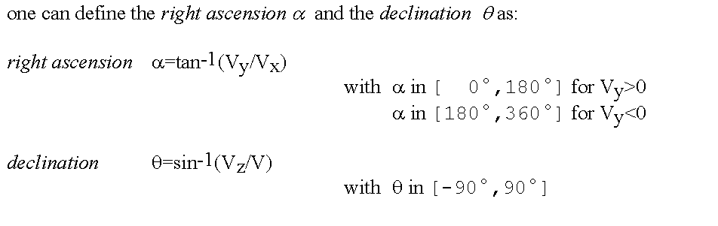

GEO (Geographic)

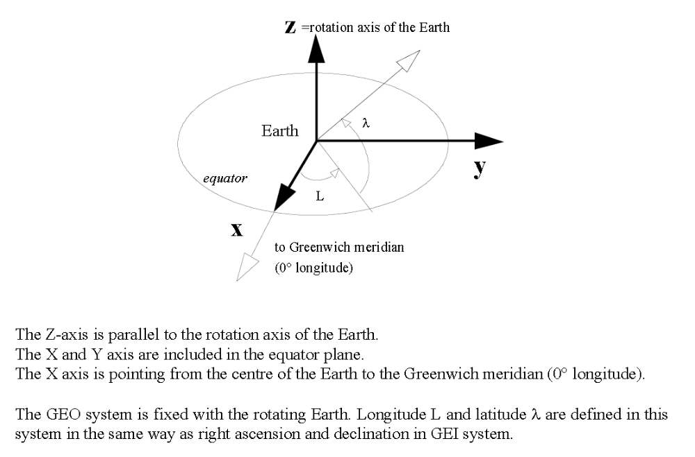

GSE (Geocentric Solar Ecliptic) 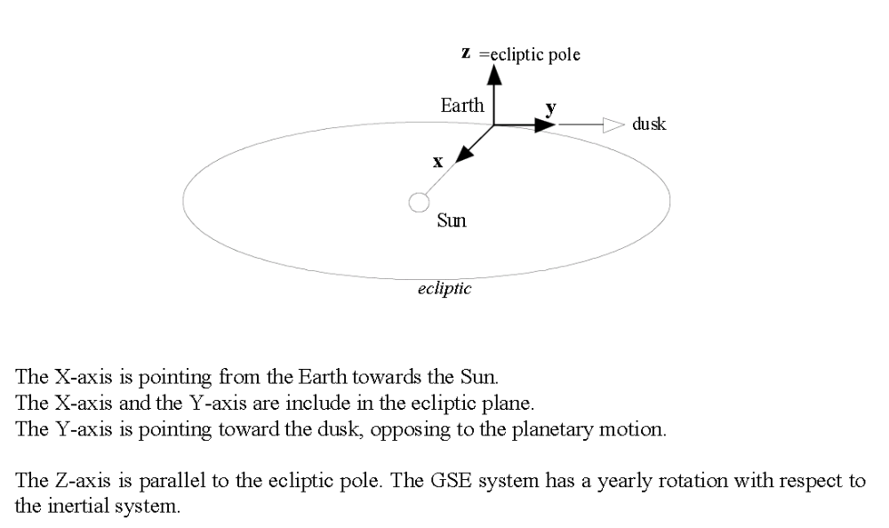

GSM (Geocentric Solar Magnetospheric).
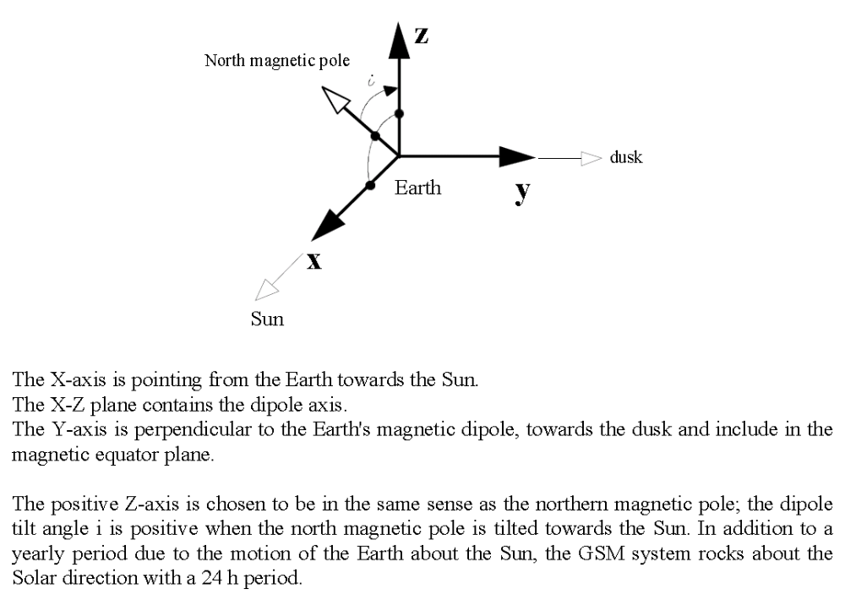

Solar Magnetic (SM)

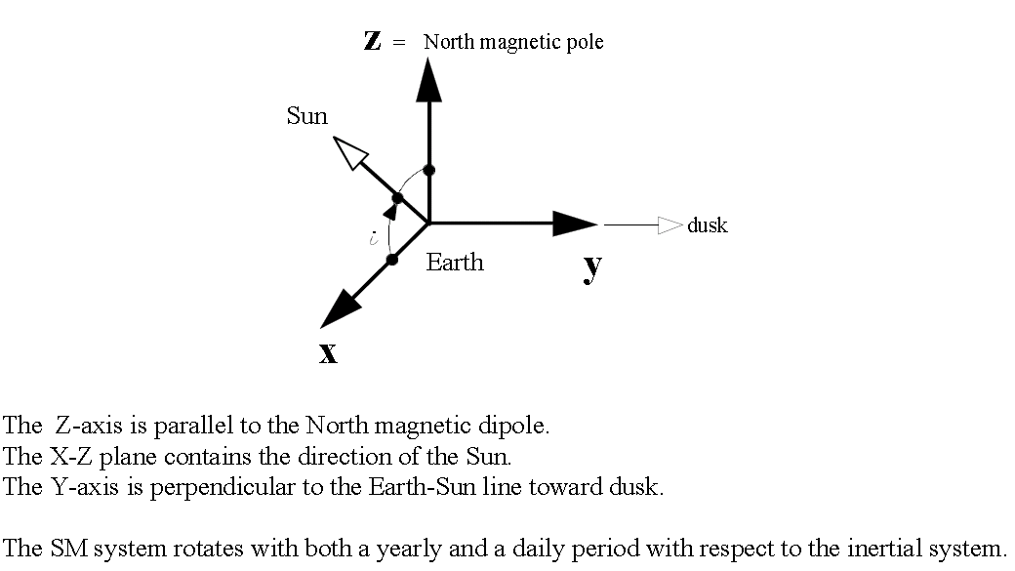

HDZ (GMAG)
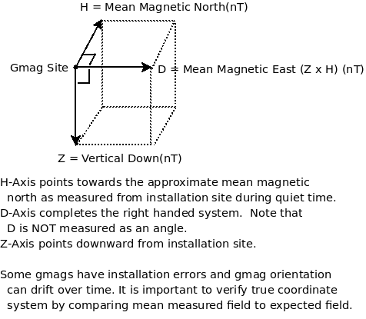

Appendix: Ground measured rotation from SPG to SSL (G2S)
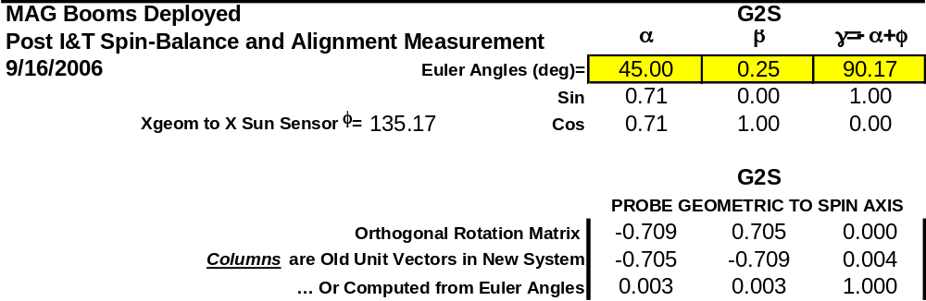
Probe A.

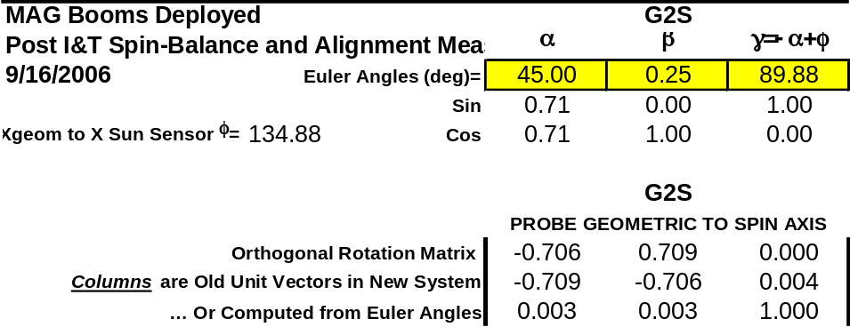
Probe B

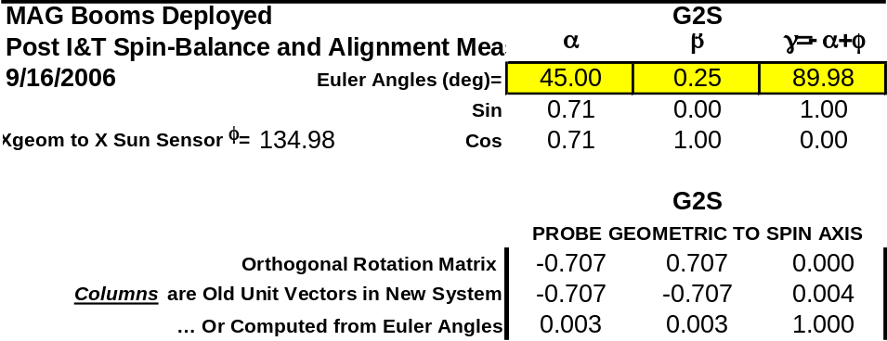
Probe C

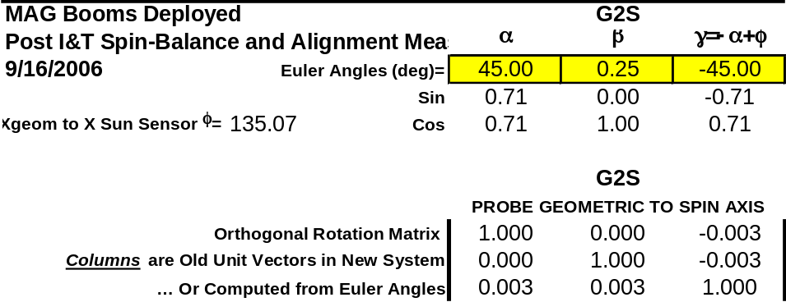
Probe D

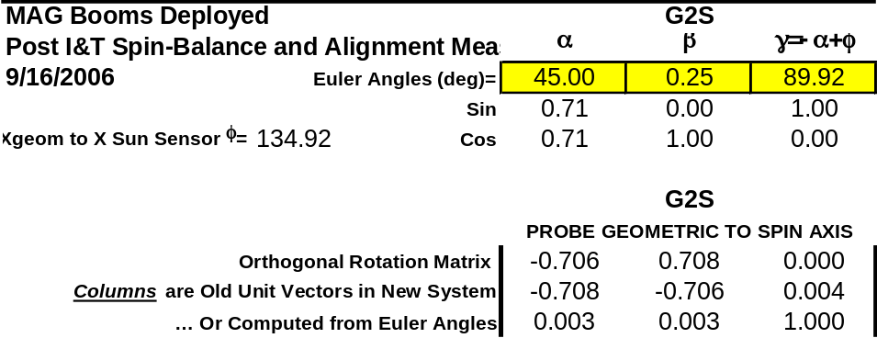
Probe E.

