THEMIS
Ground Magnetometer L2 Data files Variable Name Definition
THM-SOC-108
July 28, 2010

Patrick Cruce, THEMIS Programmer/Analyst

Dr. C. T. Russell, THEMIS Ground Magnetometers

Dr. Stephen Mende, THEMIS GBOs

David King, THEMIS Software Manager

Vassilis Angelopoulos, THEMIS Principal Investigator

Document Revision Record

Rev. | Date | Description of Change | Approved By
1 | 2006-09-11 | Draft | -
2 | 2006-09-22 | Signature Version | Signatories
3 | 2006-09-27 | Varnames lower case, NaNs for FILLVAL of R4, R8 | Signatories
4 | 2010-07-28 | Added description of gmag coordinate system. | D. King,

Distribution List
Name | Email
Jim Lewis, U.C. Berkeley | jwl@ssl.berkeley.edu
Dr. Ian Mann, U of Alberta | imann@space.ualberta.ca
Dr. Brian Jackel, U of Calgary | fmozer@ssl.berkeley.edu
Dr. Eric Donovan, U of Calgary | eric@phys.ucalgary.ca
Dr. David Sibeck, NASA GSFC | david.g.sibeck@nasa.gov

TBD List
Identifier | Description

Table of Contents

Document Revision Record 2
Distribution List 2
TBD List 2
1. Introduction 4
1.1 Purpose and Scope. 4
1.2 Applicable Documents. 4
2. General L2DAT File Variable Naming Conventions 4
2.1 Construct of VARNAMES: thg_mag_ssss 4
2.2 Calibration files used 5
2.3 Calibration files used 5
2.4 Coordinate System 7

Introduction

Purpose and Scope.
THEMIS Level 2 GMAG data, shall be CDF files containing each one day’s worth of data in calibrated physical quantities (nT) with no need for further calibration or offset. Plotting tools designed to integrated these data with the rest of the L1 or L2 data products on THEMIS shall be provided by the THEMIS team. SPDF, NSSDC and CDAWeb are expected to plot, use and distribute these files for scientific use, using nominal CDAWeb capabilities.

THEMIS ground magnetometer (GMAG) data are two types: Type 1, are those data that produced by UCLA-built ground magnetometers. Those are the GBO stations in Alaska and Canada that are an integral component of the THEMIS Ground Based Observatories, necessary for achieving mission objectives; and the EPO stations in the US that are part of the THEMIS Education and Public Outreach program. In addition, Type 2 data are those data that are produced by existing stations in Alaska or Canada, part of other efforts but contributed to THEMIS for use in its data analysis. The time resolution and sensitivity of all stations is equivalent: 0.5s, and 0.1nT respectively. The GBO data are downloaded from the ground based observatory stations via the University of Calgary data collection and dissemination site and are then relayed daily via internet connection to both UCLA and UCB. They are also included in local disks at the sites, which are then swapped-out by local custodians and mailed 1-3months after data collection. The EPO data are downloaded daily at UCLA and UCB via internet from the school sites. Type-2 are contributed data, received by internet connection from the University of Alberta or the University of Alaska.

All datasets are processed at UCB in order to adhere to the same format and file structure described herein. The same structure is intended for use by future Ancillary datasets, as they become available, such that analysis can proceed seamlessly for those stations as well.

The purpose of this document is to define the L2 GMAG variable names within the CDF.

Applicable Documents.
- THM_SYS_012_PDMP THEMIS Project Data Management Plan
- THM_SOC_101_TIME THEMIS TIME Definition
- THM_SOC_109_ASI_L1_VARNAMES THEMIS ASI Variable Name Definitions

General L2DAT File Variable Naming Conventions

Construct of VARNAMES: thg_mag_ssss

Following an overall principle of naming THEMIS variables using more general to less general descriptors, separated by the underscore character “_”, the GMAG variables shall be named: thg_mag_ssss, where “g” denotes ground based observatory, the “mag” denotes magnetic field and “ssss” is the 4-letter identification of the station (Figure 1).

This construct works well with data from all probe data, and when further specificity is required in order to ensure optimal file size, such as in the number of spectral quantities, additional descriptors _YY may be utilized.

Ancillary magnetometer data in CDF format for use by THEMIS shall adhere to the same format with the identifier “o” for “other”.

Calibration files used

The calibration files utilized for the production of the L1DAT data shall be documented in the L2 Data file by pointing to the web site http://www-ssc.igpp.ucla.edu/themis_data/calib_files/ where the files reside.

Figure 1 List of the required quantities for a single station L2 data CDF file.
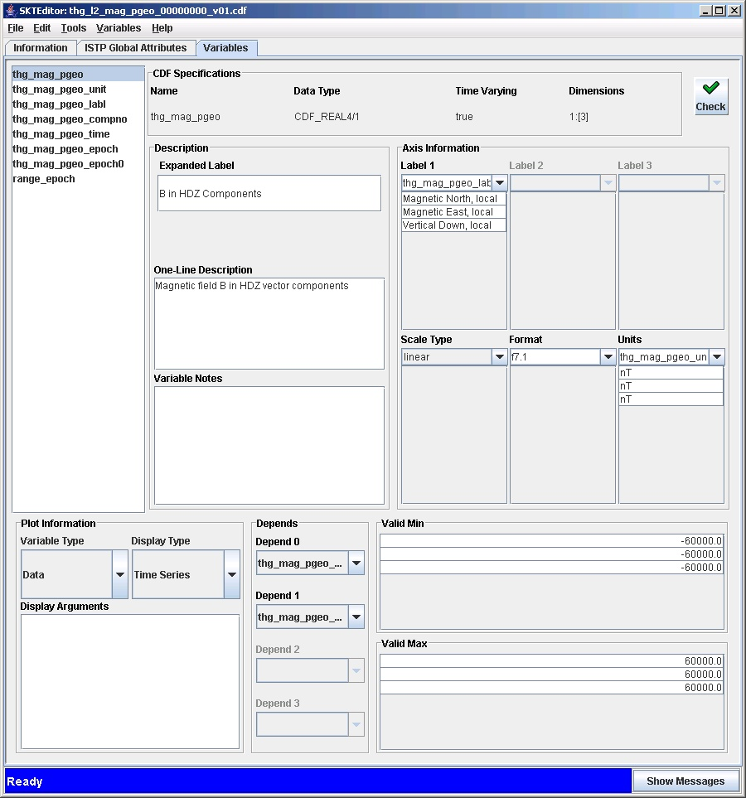

Calibration files used
The calibration files utilized for the production of the L1DAT data shall be documented in the L2 Data file by pointing to the web site http://www-ssc.igpp.ucla.edu/themis_data/calib_files/ where the files reside. Attached is a copy of that directory and a copy of a sample file as of Sep 29, 2006. For updates and to check current status please consult the above web page.

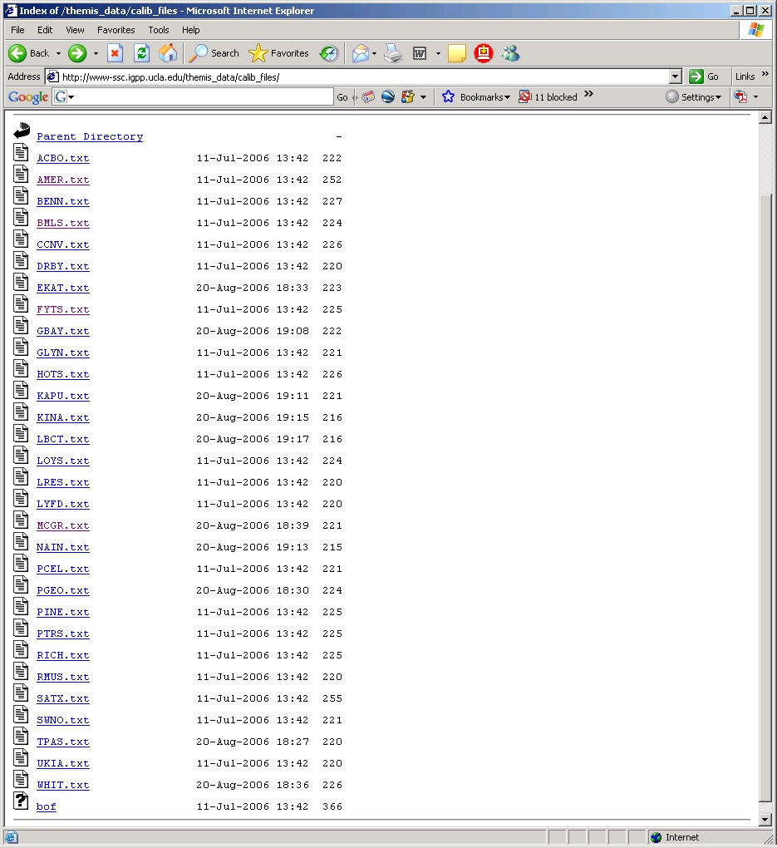

# EKAT Lac de Gras
Start date = 6/23/2004
calx = 89.50
caly = 90.95
calz = 89.70
dacx = 462.1
dacy = 454.3
dacz = 461.9
offx = -151
offy = -257
offz = 60
# Calibration determined 6/23/2004
# END OF CAL RECORD

Coordinate System
Calibrated data are not rotated out of instrument coordinate system. Ground Magnetometers are installed such that the instruments are geomagnetically aligned. In THEMIS this coordinate system is called HDZ and is described in detail in the document thm_soc_110_COORDINATES_yyyymmdd.pdf. Corrections are not routinely applied to correct for drift after installation, so end-users who need accurate orientation information should determine orientation by comparing mean measured field over some interval(e.g. 1 month), to expected local field for that location. Note that the site PTRS is the exception. Because it was installed in a bog, it can drift much more rapidly than other gmags. (Also note that due to installation error the second-component of PTRS points in the -D direction).

