FAST AURORAL SNAPSHOT (FAST) EXPLORER
CONTAMINATION REQUIREMENTS AND CONTROL PLAN
SECTION 1. OVERVIEW
The Fast Auroral Snapshot Explorer (FAST) is the second spacecraft in the Small Explorer (SMEX) series. The FAST instrument will study plasma acceleration and wave production associated with the auroral phenomena at distances between 350 km and 4200 km above the earth. The FAST instrument's four detector assemblies will take measurements for seven different experiments.
1.1 PURPOSE
The purpose of this document is to define the contamination requirements for the Fast
Auroral Snapshot (FAST) Explorer of the Small Explorer Project (SMEX) from fabrication
through launch and to outline methods to ensure these requirements are satisfied.
1.2 OBJECTIVES
The objectives of the FAST Contamination Requirements and Control Plan are as follows:
- Define the contamination requirements tor FAST.
- Identify contamination sources for FAST.
- Establish contamination controls for each phase of FAST development to
maintain required cleanliness levels.
- Establish a cleaning schedule for FAST hardware.
- Establish a plan for cleanliness monitoring and verification.
- Establish overall responsibility for executing provisions of this plan.

1.3 RESPONSIBILITY
Each organization providing flight hardware for the FAST mission is responsible for
complying with the provisions of this plan, and the applicable documents cited herein.
The SMEX Project will resolve conflicting interpretations of this document, should they
arise. The instrument provider is responsible for cleaning exterior instrument surfaces and
maintaining interior instrument surfaces.

SECTION 2. APPLICABLE DOCUMENTATION
2.1 SMEX DOCUMENTS
a. SMEX-QA-002 Small Class Explorer (SMEX) Program Performance
Assurance Requirements, Revision B (July 1990)
b. FAST-SPEC-005 Requirements Document for SMEX, FAST Mission,
Final (June 1992)
c. FAST-PROC-002 FAST Cleaning and Verification Procedure (expected
out 11/92)
d. FAST-PROC-003 FAST Clean Area and Personnel Operations Procedure (expected out 1 /93)
e. FAST-MGMT-013 FAST Launch Site Implementation Plan (expected out
1/94)
f. FAST-MGMT-014 FAST Subsystems Bakeout Plan (expected out 6/93)

2.2 REFERENCE DOCUMENTS
a. FED-STD-209D Clean Room and Work Station Requirements,
Controlled Environment
b. MIL-STD-1246B Product Cleanliness Levels and Contamination Control Program
c. NASA-JSC-SP-R-0022A Specification Vacuum Stability Requirements of Polymeric Material for Spacecraft Application

d. NASA-JSC-SN-C-005 Specification Contamination Control Requirements for
the Space Shuttle Program, Revision C
e. NASA-RP-1124-87 Outgassing Data for Selected Spacecraft Materials
f. GSFC-TLS-PR-7324-01 Contamination Control Procedure for the Tape Lift
Sampling of Surfaces
g. NASA LRC Document Pegasus User's Manual
h. UCB Space Sciences Contamination Control Plan for the Fast Auroral
Laboratory Document Snapshot Instrument

SECTION 3. ACRONYMS & TERMINOLOGY

3.1 ACRONYMS
CCM Contamination Control Manager
EESA Electron Electrostatic Analyzer
ESD Electrostatic Discharge
FAST Fast Auroral Snapshot Explorer
GSFC Goddard Space Flight Center
I&T Integration and Test
IPA Isopropyl Alcohol
ITO Indium Tin Oxide
LPARL Lockheed Palo Alto Research Laboratory
MLl Multi Layer Insulation
NASA National Aeronautics and Space Administration
NVR Non-Volatile Residue
QCM Quartz Crystal Microbalance
SMEX Small Explorer
TEAMS Time-of-flight Energy Angle Mass Spectrograph
UCB University of California, Berkeley
UCLA University of California, Los Angeles

3.2. TERMINOLOGY

a. Clean Area Area where airborne particulate contamination levels are strictly controlled.
b. Contamination Unwanted material causing degradation in the desired function of an instrument or flight hardware.
c. Contamination Control Organized action to control contamination levels.
d. Fiber Particle whose length-to-width ratio exceeds 10:1, with a minimum length of 100 microns.
e. Gross Cleaning Cleaning hardware surfaces in a normal work area to visual inspection standards.
f. Nitrogen Purge Pressurized flow of clean, dry nitrogen through a system to displace impurities and reactive species.
g. Non-Volatile Residue Soluble material causing degradation in the desired function of an instrument or flight hardware.
h. Particle Small quantity of solid or liquid material with definable shape or mass and a length-to-width ratio less than or equal to 10:1.
i. Particle Size Expressed as the apparent maximum linear dimension or diameter of the particle.
j. Precision Cleaning Cleaning procedure done in a controlled environment to attain a specific level of cleanliness. This procedure follows gross cleaning.
k. Sensitive Surfaces Flight hardware surface requiring a specific cleanliness level to meet minimum performance levels.
i. Solvent Flushing Pressurized stream of filtered solvent directed against a surface to dislodge and rinse away contaminating material.
m. Solvent Washes Quantitative method of verifying MIL-STD-1246B NVR levels by measuring molecular contamination in a solvent washed over a surface.
n. Surface Cleanliness Level Established level of maximum allowable particulate and/or NVR contamination ranging from visibly clean to specific MIL-STD-1246B levels (e.g., level 500B. See Figures 1 and 2).
o. Swab Sample Qualitative method of identifying contaminants by analyzing residue on a solvent-soaked swab that was wiped over a surface.
p. Tape Lifts Quantitative method of verifying MIL-STD-1246B particulate cleanliness levels by measuring particulate contamination on a tape sample that has contacted a surface.
q. Vapor Degrease Item to be cleaned is exposed to heated solvent vapors that condense on the part and wash away contaminants. (NOTE: Halogenated solvents used to vapor degrease plastics are often outgassed or leached out later. Therefore, if halogenated solvents are used to vapor degrease plastics, a bakeout must follow.)
r. Visibly Clean Clean surface as seen without optical aids (except corrected vision) when measured by a specific method. For this project, surfaces should be tested from a distance of 6 to 18 inches using a white light ≥100 ft. candles of power as per NASA-JSC-SN-C-0005 Revision C.

SECTION 4. CONTAMINATION SOURCES FOR FAST
To adequately protect FAST from contamination and more effectively clean contaminated
components, it is essential to identify and understand the possible sources of
contamination. These sources will differ at various stages of hardware development for
FAST.

Table 4.1 presents a summary of contamination sources that could adversely affect FAST.
This Contamination Requirements and Control Plan is designed to minimize the effect of
contamination sources and to maintain a cleanliness level which keeps the spacecraft
within its contamination budget allocation during all phases.

TABLE 4.1. CONTAMINATION SOURCES FOR FAST
Mission Phase | Molecular | Particulate
Fabrication | machining oils, fingerprints,  air fallout | air fallout, personnel, soldering,  drilling, bagging material
Assembly and  Integration | air fallout, outgassing,  personnel, cleaning,  solvents, soldering,  lubricants, bagging material | air fallout, personnel, soldering,  drilling, bagging material
Test | air fallout, outgassing.  personnel, test facilities,  purges | air fallout, personnel, test  facilities, purges, redistribution
Storage | bagging material, purges,  containers | bagging material, containers,  purges
Transport | bagging material,  containers, purges | bagging material, containers,  vibration, purges
Launch Site | bagging material, air fallout,  outgassing, personnel,  purges | bagging material, air fallout,  personnel, checkout activities,  other payload activities
Launch | outgassing, venting | vibration and/or redistribution
FAST On Orbit | outgassing, atomic oxygen,  FAST molecular cloud | micrometeoroid and debris  impingement

SECTION 5. OVERALL CONTAMINATION CONTROL REQUIREMENTS
This section reviews the allowable contamination requirements set for the FAST instrument and subsystems based on mission performance goals.
Surface cleanliness levels are specified in accordance with MIL-STD-1246B or NASA-JSC-SN-C-0005. MIL-STD-1246B defines quantitative surface cleanliness levels for particulate and NVR levels. The particulate level is denoted by a numeric value (i.e. 100, 200,...) and NVR levels are denoted by an alphabetic value (i.e. A, B,...). The quantity of
contamination associated with each level is displayed in Figures 1 and 2. NASA-JSC-SN-
C-0005, Revision C, defines levels of cleanliness which can be verified by visual inspection with a white lamp. For this mission, surfaces designated as visibly clean will be inspected at a distance of 6-18 inches using a white lamp with greater than 100 ft- candles of power. NASA-JSC-SN-C-0005 levels are illustrated in Figure 3.
Note that the surface cleanliness requirements presented in this section should be met
prior to the last possible access point. For external spacecraft surfaces, this will be at the
launch site. For internal surfaces, this will be during fabrication or integration.

5.1 FAST INSTRUMENT
The FAST instrument consists of four EESA assemblies, one TEAMS assembly, six
electrostatic booms, two magnetometer booms, and an electronics box. Upon delivery
to GSFC, all instrument surfaces will meet a cleanliness level of 500A per MIL-STD-1246B. Following delivery, sensitive components will be maintained at or near Level 500A through the use of protective covers, while less sensitive components will be maintained at a Visibly Clean, Highly Sensitive level per NASA-JSC-SN-C-0005.
The most contamination sensitive components in the FAST instrument are found in the
EESA and TEAMS assemblies. MicroChannel plates found in EESA and TEAMS are
subject to degradation if exposed to very small amounts of particulates, hydrocarbons,
or humidity. Thin film filters found in TEAMS are sensitive to paniculate and molecular
contamination. "Gold-Black" surfaces in both EESA and TEAMS are relatively insensitive
to contamination, but must be kept contamination free due to very limited cleanability.
During typical integration and test operations, the sensitive components in EESA and
TEAMS will be purged with Ultra High Purity GN₂ and sealed by internal aperture cover
mechanisms. EESA and TEAMS will be purged at all possible times, unless prohibited
by test activities. The instrument purge cannot be interrupted for periods longer than foui
hours.
CHART I
PRODUCT CLEANLINESS LEVELS
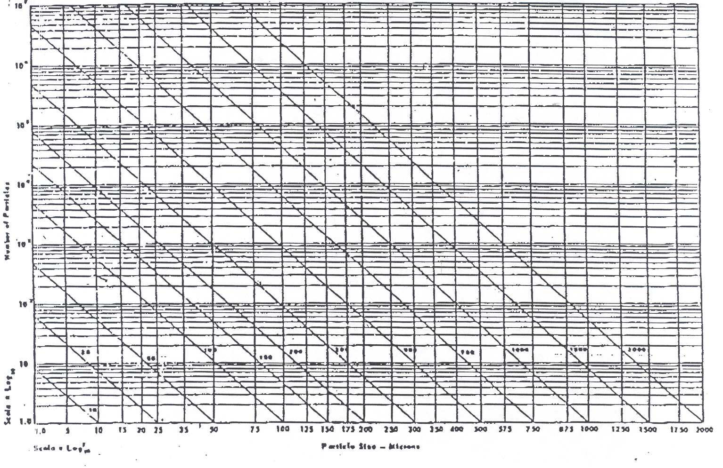
Figure 1. Cleanliness Levels. Taken from MIL-STD-1246B. The plot displays the total number of particles above a specific size allowed per square fool of surface for the cleanliness level Indicated next to each curve.

Table 1a Table 1b
Derivation of Cleanliness Levels1 Non-Volatile Residue
Cleanliness  Level | Range  Surface and Fluids | Quantity  of Particulates |  | Level | Quantity  NVR
1 | 1 | 1
5 | 1  2  5 | 3  2  1
10 | 5 | 3 |  | A | Less than 1.0 mg
25 | 5  15  25 | 23  3  1 |  | B | 1.0 mg  to  2.0 mg
50 | 5  15  25  50 | 165  25  7  1 |  | C | 2.0 mg  to  3.0 mg
100 | 15  25  50  100 | 265  78  11  1 |  | D | 3.0 mg  to  4.0 mg
200 | 15  25  50  100 | 4190  1240  170  16 |  | E | 4.0 mg  to  5.0 mg
300 | 25  50  100  250 | 7450  1020  95  2 |  | F | 5.0 mg  to  7.0 mg
500 | 50  100  250  500 | 11800  1100  26  1 |  | G | 7.0 mg  to  10.0 mg
750 | 100  250  500  750 | 8900  210  7  1 |  | H | 10.0 mg  to  15.0 mg
1000 | 250  500  750  1000 | 1020  40  5  1 |  | J | 15.0 mg  to  25.0 mg
Figure 2. Classification of Cleanliness Levels. Taken from M1L-STD-1246B. Table la lists the total quantity of particulates greater than a specific size (in microns) allowed per square foot of surface area. Table 1b expresses the quantity of non-volatile residue (NVR) per quare foot associated with different NVR levels.

VC Level | Incident Light  Level (1) | Observation  Distance | Remarks
Standard | ≥ 50 foot-candles | 5 to 10 feet | (2) (3) (5)
Sensitive | ≥ 50 foot-candles | 2 to 4 rwt. | (2) (3) (5)
Highly  Sensitive | ≥ 100 foot-candles | 6 to 18 inches | (3) (4)

NOTES: (1) One foot-candle (lumens per square foot) is equivalent to 10.76 lumens per square meter.
(2) Cleaning is required if the surface in question does not meet VC under the specified incident light and observation distance conditions.
(3) Exposed and accessible surfaces only.
(4) Initial cleaning is mandatory; Note (2) applies thereafter.
(5) Areas of suspected contamination may be examined at distances closer than specified for final verification.
Figure 3. Visibly Clean Levels. Taken from NASA-JSC-SN-C-0005. FAST hardware will be inspected to a Visibly Clean, Highly Sensitive level.
Non-flight covers will prevent contamination from accumulating on critical portions of the
external surfaces of EESA and TEAMS in excess of the Level 500A delivery value. The
non-flight covers will remain installed at all possible times, and may only be removed at
the instrumenter's request or as required for environmental testing. If the non-flight
covers must be removed, all spacecraft surfaces must be cleaned to Level 500A per MIL-
STD-1246B beforehand. In addition, the external surfaces of EESA and TEAMS, as well
as the interior surfaces of the non-flight covers, will be cleaned to Level 500A prior to re-
installation of the covers. The external surface of the non-flight covers may be kept at a
Visibly Clean, Highly Sensitive level per NASA-JSC-SN-C-0005 while installed for routine
integration and test operations.
Since the microchannel plates are susceptible to hydrocarbon contamination, precautions
must be taken to prevent damage from solvents during spacecraft cleaning. Spacecraft
cleaning should only be performed with the non-flight covers installed and the instrument
purge operational. The FAST Instrument Manager and FAST CCM should be notified
before spacecraft level cleaning operations are performed. Reagent grade IPA is the
recommended solvent for all spacecraft cleaning,
The humidity in the instrument environment should be kept between 35 and 50 percent
to prevent condensation. The humidity must always be maintained above 35 percent in
spacecraft facilities to reduce the likelihood of ESD. The temperature should be
maintained at 70±5 °F.
Other contamination sensitive components in the FAST instrument include the spherical
electric field probes used on the electrostatic booms. These probes are coated with DAG
213, a material with very limited cleanability. The electric field probes will be housed in
protective covers at all times to prevent contamination accumulation on probe surfaces,
The electric field probes and their protective covers will only be handled by the
instrumenter or the instrumenter's representative.
The magnetometer booms and electronics box have no specific contamination
requirements. These components will be maintained at the same cleanliness level as
integrated subsystem surfaces.
A schedule for instrument cleaning and inspection is included in Table 7.1. The
instrument providers are responsible for cleaning the exterior surfaces and maintaining
the interior surfaces of the FAST instrument. All handling of internal instrument
components will be done by the instrumenter in a Class 1000 or better clean bench.

5.2 FAST SUBSYSTEMS
Unlike the instrument components described above, the FAST subsystems do not have
any specific quantitative contamination requirements. There are, however, some
subsystem surfaces which must remain clean for effective operation. For instance, the
thermal properties of optical solar reflectors (OSRs) used in spacecraft radiators can be
degraded if molecular contaminants accumulate on OSR surfaces and undergo
photopolymerization on-orbit. The optical properties of solar cells employed by the power
subsystem can also be diminished if the ceils become obscured by contaminants. Some
other spacecraft surfaces, such as indium tin oxide (ITO) coated thermal blankets, are
relatively insensitive to contamination, but must remain contamination-free because the
surfaces are too fragile to be effectively cleaned,
Precautions need to be taken to maintain the cleanliness of sensitive surfaces and
surfaces with limited cleanability. The surfaces should be covered with approved bagging
material during contamination generating activities, periods of inactivity, and occasions
when the components must be removed from the clean area.
All integrated subsystem surfaces will be maintained at a Visibly Clean, Highly Sensitive
level per NASA-JSC-SN-C-0005 during routine integration and test operations. The
integrated subsystems will be cleaned to Level 500A per MIL-STD-1246B for instrument
integration, occasions when the non-flight covers are removed from EESA and TEAMS,
and at any time such cleaning is deemed necessary by the CCM or PI.

SECTION 6. CONTAMINATION CONTROL IMPLEMENTATION
The FAST contamination requirements described in Section 5 will be met through a variety
of contamination control measures. These measures are summarized in Table 6.1 and
detailed in the following section.

6.1 MANUFACTURING
The design of the FAST spacecraft provides for contamination precautions and/or
inhibitors. All planned operations must include contamination reduction considerations.
A list of contamination control procedures for common fabrication operations is provided
below. Any situations not described below should be referred to the CCM for resolution.
All hardware except for the instruments will be cleaned according to the FAST Cleaning
and Verification Procedure. FAST-PROC-002.
6.1.1 FAST INSTRUMENTS
The instrumenters are responsible, for their own contamination control prior to delivery to
GSFC. Upon delivery, the instruments must meet an external cleanliness level of 500A,
as verified by Code 724.4 according to Section 10 of this document.
6.1.2 FAST SUBSYSTEMS
Most of the subsystems hardware manufacturing will occur in areas exceeding a Class 300,000 clean room specification, per FED-STD-209D. During manufacturing, the
following handling requirements must be followed:
- During contamination generating operations such as drilling, welding, soldering, etc.
contaminants (metal chips, dust, excess solder, etc.) will be cleaned off hardware
as generated by vacuuming, and/or wiping.
- Lubricant deposits (grease/oil) will be cleaned off immediately using the appropriate solvents.
- Prior to applying coatings, paints, etc., surfaces will be cleaned and visually
inspected to be visibly clean per Section 5 of this document.
- All areas that become inaccessible during the fabrication and assembly process will
be thoroughly cleaned and visually inspected to be visibly clean per Section 5 of
this document.
- After manufacturing, all hardware and components will be subjected to non-
damaging gross cleaning procedures (particulate removal and washing with
solvents) to result in a visibly clean article. The hardware and components will then
be bagged to protect from recontamination.
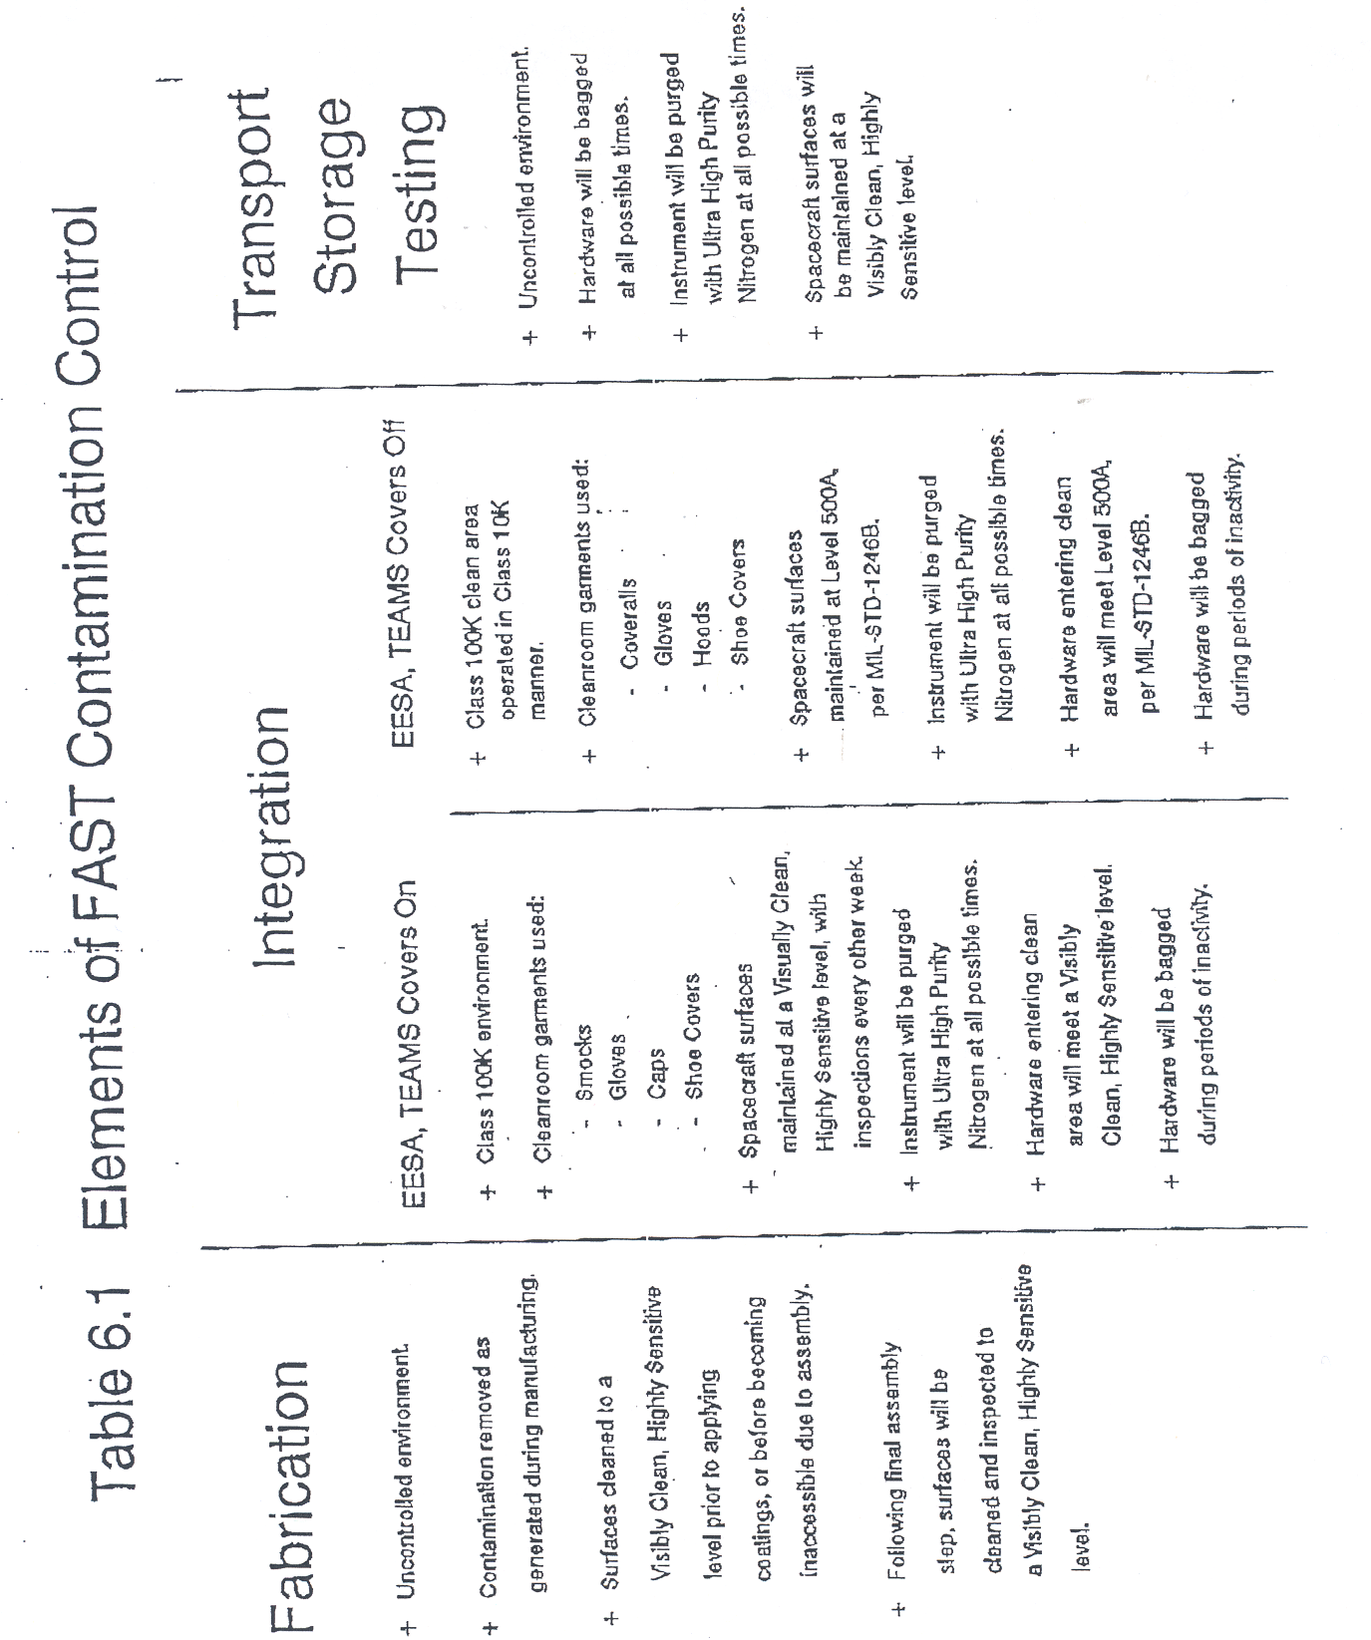
6.2 ASSEMBLY
6.2.1 FAST INSTRUMENTS
The instrumenters are responsible for their own contamination control prior to delivery to
GSFC. Upon delivery, the instruments must meet an external cleanliness level of 500A.
This cleanliness level will be verified by Code 724.4 according to Section 10 of this
document.
6.2.2 FAST SUBSYSTEMS
Assembly of subsystems will occur in a Class 100,000 clean area or better. During
assembly, hardware will be inspected at the end of each shift and cleaned if necessary
to prevent collection of contaminants. All cleaning will be done in accordance with the
FAST Cleaning and Verification Procedure, FAST-PROC-002. The following procedure
summarizes the cleaning process to be used for piece parts prior to assembly:
- Piece parts will be wiped with solvent-dampened extracted wipes until no
contamination is visible on the wipes.
- All surfaces, holes, penetrations, and crevices will be cleaned with IPA using
extracted wipes. If the wipes are found to be inadequate, precleaned (IPA soaked)
swabs may be used. Continue cleaning until surfaces appear visibly clean per
Section 5 of this document and no contamination is visually seen on wipes. Painted
surfaces must be cleaned by Code 724.5.
- Items remaining contaminated after solvent wiping should be vapor degreased.
Parts should be re-positioned periodically so all blind holes are degreased on the
downward surface. If plastics are vapor degreased with halogenated solvents, a
bakeout of the degreased parts must follow.
- Inspect to be visibly clean per Section 5 of this document.
Before final assembly, the following cleaning procedure will be followed:
- Vacuum the entire surface of the previous assembly, giving attention to crevices,
riveting surfaces, rivet and hillock holes, etc,
- Blow all crevices and riveting surfaces with filtered dry nitrogen. Vacuum off any
remaining paniculate matter.
- Inspect assembly for grease marks and deposits.
- Clean surfaces and grease marks with 1PA soaked wipes until no contamination is
visible on the wipes,
- Vapor degrease surfaces remaining visibly contaminated. If plastics are vapor
degreased with halogenated solvents, a bakeout of the degreased parts must
follow.
The following procedure will be used during and after assembly:
- During assembly (riveting, etc.), wipe and/or vacuum surfaces as contamination is
generated, inspect and clean all surfaces to a Visibly Clean, Highly Sensitive level
before the surfaces become inaccessible during assembly.
- Following each assembly step, inspect assembled surfaces for accumulated
contamination and wipe surface with 1PA when the surface is no longer visibly
clean.
- After assembly is complete, all surfaces will be cleaned. Follow the same cleaning
procedure as before assembly (vacuum, nitrogen clean-off, 1PA wipes, vapor
degrease). Once all contamination appears to have been removed, inspect to be
visibly clean per Section 5 of this document.

6.3 INTEGRATION
FAST will be integrated at NASA GSFC in Building 5 in a class 100,000 clean area per
FED-STD-209D (see Figure 4). The facility will be cleaned by NSI every two weeks or
when additional cleaning is deemed necessary by the CCM or I&T Manager. The facilities
and operations will be governed by the FAST Clean Area and Personnel Operations
Procedure, FAST-PROC-003. Personnel must attend a cleanroom training class prior to
working in the clean area. Cleanroom compatible smocks, hoods or caps, shoe covers
and latex gloves will be worn in the clean area. Cleanroom coveralls and hoods will be
substituted for smocks and caps when the non-flight covers are removed from EESA and
TEAMS and at the request of the CCM or I&T Manager. Polyethylene gloves will be worn
when working with solvents. NSI will supply the cleanroom garments and re-stock the
facility with clean garments every two weeks.
6.3.1 FAST INSTRUMENT
The FAST instrument must meet an external cleanliness level of 500A per MIL-STD-1246B as verified by Code 724.4 according to Section 10 of this document before being admitted into the Class 100,000 integration area. The instruments will be purged continuously with Ultra High Purity GN₂ during integration. The purge may be interrupted for a period of no longer than four hours if absolutely necessary due to integration activities. After verification and during the integration process, the external surfaces of the instrument (or the external surface of the instrument cover for EESA, TEAMS, and the electric field probes) will be inspected for visible cleanliness per Section 5 of this document every two weeks. If the instrument surfaces are not visibly clean, cleaning will take place until the surface passes inspection. The instrument provider is responsible for cleaning the instrument exterior surfaces and maintaining interior instrument surfaces. The hardware will be covered with project approved bagging material during periods of inactivity or when outside controlled areas. The EESA and TEAMS non-flight covers will remain installed during routine integration activities and at all times when the instrument is outside the clean area. Any hardware that has been taken out of the clean area will be inspected for visible cleanliness per Section 5 of this document prior to re-entering the clean area.
6.3.2 FAST SUBSYSTEMS
All hardware referred to in Section 8 of this document must be baked out according to
the requirements in the FAST Subsystems Bakeout Plan, FAST-MGMT-014, before
integration takes place. Prior to instrument delivery, subsystems hardware may be
brought into the Class 100,000 clean area in a visibly clean state per Section 5 of this
document. Once in the clean area, hardware will be re-inspected for visible cleanliness
every two weeks. Items failing inspection will undergo spot cleaning until visibly clean,
Integrated subsystems will be cleaned to level 500A just before instrument integration, when the EESA and TEAMS non-flight covers will be removed, and at the request of the
CCM or I&T Manager. If the EESA and TEAMS non-flight covers are installed,
subsystems hardware must be verified to be visually clean per Section 5 before being
brought into the clean area. If the EESA and TEAMS covers are not installed, all
subsystems hardware must be verified to meet Level 500A before entering the clean area.
Once in the clean area, hardware will be re-inspected for visible cleanliness every two
weeks. Items failing inspection will undergo spot cleaning until visibly clean. Hardware
will be covered with approved bagging material during periods of inactivity or when
removed from the class 100,000 clean area.
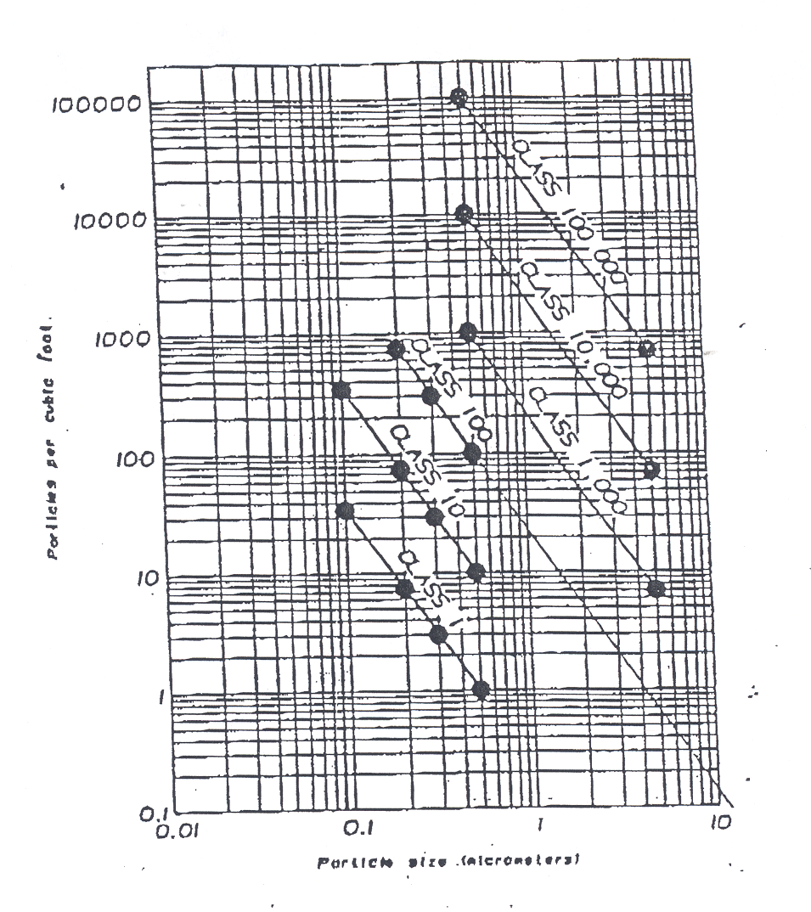

Figure 4. Class Umlts. Taken from FED-STD-209D. The plot denotes the maximum number of particles equal to or greater than a specific size allowed per cubic foot of air.
6.3.3 FAST GROUND SUPPORT EQUIPMENT
All ground support equipment will be cleaned with IPA and bagged with Llumalloy or
NMD-48100-PA1N prior to being taken into the clean area. Equipment that will come in
contact with the flight hardware must be inspected for visible cleanliness as per Section
5 of this document.
6.4 TESTING
The FAST spacecraft will be moved from GSFC Building 5 to GSFC Building 7 and
Wallops Flight Facility (WFF) for environmental testing. All other testing will be done in
Building 5 in a class 100,000 clean area. The spacecraft will be bagged and the
instruments will be continuously purged with Ultra High Purity GN₂ during transport. The
environmental tests are mass properties, vibration, acoustics, electromagnetic
compatibility, magnetic calibration, spin balance and thermal balance/thermal vacuum.
The bag and purge will remain on at all times except when prohibited by test activities.
If the bag is removed for testing, personnel who come in the vicinity of the flight hardware
will wear cleanroom compatible smocks, hoods, shoe covers and latex gloves. A wrist
strap and grounding wire may also be required to control electrostatic discharge. The
wrist strap must he in contact with the bare skin of the wrist. The instrument purge can
be interrupted for no longer than four hours. If the bag is removed for testing, the
spacecraft must be cleaned and recertified for visible cleanliness before being taken back
into the clean area.
The thermal balance/thermal vacuum testing will be done in a cryo-pumped chamber.
The chamber will be instrumented with a Quartz Crystal Microbalance (QCM) and a
coldfinger. If the EESA and TEAMS internal apertures need to be opened during thermal
vacuum testing, the chamber must also be equipped with a residual gas analyzer (RGA)
to measure the partial pressure of contaminants. In addition, an oil-free vacuum system
must be used and pre-test chamber particulate levels must be measured if the internal
apertures are opened.
Prior to thermal balance/thermal vacuum testing, a chamber bakeout and certification will
be performed. With the ground support equipment and a 10 MHz QCM installed, the
chamber will be baked out at 90° C. The QCM should be maintained at -20° C throughout
the test. The chamber is certified when the QCM registers ≤TBD Hz/hr for five
consecutive hours. Following chamber certification, a coldfinger will be turned on for
eight hours and a wash sample will be taken by NSI. Chamber contamination will be
measured and identified prior to installation of flight hardware.
For the test, the flight hardware must fill the field of view of the QCM. At the end of the
thermal balance/vacuum test, if the QCM registers >TBD Hz/hr, a bakeout will be
performed on the flight hardware at the highest allowed hardware temperature until the
QCM registers ≤TBD Hz/hr for five consecutive hours. Following the bakeout, a
coldfinger will be turned on for eight hours and the chamber will be backfilled with Ultra
High Purity GN₂. Once the chamber reaches ambient pressure and is accessible, the
instrument purge will be re-started and a coldfinger sample will be taken.

6.5 TRANSPORTATION AND STORAGE
6.5.1 FAST INSTRUMENT
It is the instrumenter's responsibility to deliver the instrument to GSFC at cleanliness level
500A. After delivery, the instrument will be bagged with project approved bagging
material when outside a class 100,000 clean area except when prohibited by integration
and test activities. While in the clean area, the instruments will be covered with project
approved bagging material during periods of inactivity. The instruments will be
continuously purged with Ultra High Purity GN₂ unless prohibited by integration and test
activities. The instruments will be bagged with project approved bagging material during
any transportation activities.
6.5.2 FAST SUBSYSTEMS
Subsystem hardware that is not yet integrated has no special transportation and storage
cleanliness requirements. At the time of integration, the hardware will be verified to the
level specified in Section 6.3.2 by NSI, Code 313, and Code 724.4. The hardware will be
bagged with project approved bagging material when outside a class 100,000 clean area
except when precluded by integration and testing activities. While in the clean area, the
hardware will be covered with project approved bagging material during periods of
inactivity. Once integrated, subsystems hardware will be bagged with project approved
bagging material during transportation activities.
6.5.3 FAST SPACECRAFT
The spacecraft will be bagged when outside a class 100,000 clean area except when
integration and test activities prohibit. While in the clean area, the spacecraft will be
covered during periods of inactivity. The spacecraft will be bagged and transported from
the integration area to the environmental testing area in the shipping container. During
transportation to the launch site, the spacecraft will be bagged and stored in a Class
100,000 shipping container. The spacecraft will be continuously purged with dry, oil-free
air or nitrogen after installation in the Pegasus shroud.

6.6 LAUNCH SITE OPERATIONS
FAST is being launched on a Pegasus launch vehicle from the Western Test Range
(WTR). FAST will be bagged at all times when outside of a class 100,000 clean area,
except when precluded by testing activities. The instrument's nitrogen purge will remain
operational, and cannot be interrupted for periods longer than four hours. Once FAST
is mated to the Pegasus, the fairing will be purged with dried and filtered oil-free air or
nitrogen. The environment and handling requirements for DFRC will be discussed in
greater detail in the FAST Launch Site Implementation Plan, FAST-MGMT-013.

SECTION 7. HARDWARE CLEANING AND VERIFICATION

7.1 CLEANING AND VERIFICATION SCHEDULE
During fabrication and initial assembly, visible gross contamination (oil, metal chips, etc.)
will be cleaned from surfaces as it is generated. All mating surfaces will be vacuumed
and solvent (acetone or IPA) wiped prior to mating. All areas to be sealed during the
fabrication/assembly process (compartments, boxes, modules, etc.) will be vacuumed
and solvent cleaned before being sealed. Hardware will be cleaned to a visibly clean level
per Section 5 prior to final assembly. Any contamination generated during assembly and
integration will be immediately cleaned and the hardware surface inspected again.
Recleaning will occur as necessary.
Prior to instrument delivery, all hardware being brought into the clean area will be
inspected to be visibly clean per Section 5 by Code 724.4. Once the instruments have
been delivered and integrated, cleanliness requirements will depend upon whether the
non-flight covers are installed on EESA and TEAMS. If the non-flight covers are installed,
hardware will be inspected to be visibly clean per Section 5 by Code 724.4. If the non-
flight covers are not installed, all hardware entering the clean area must be verified to be
Level 500A by Code 724.4, Code 313, and NSI.
Spacecraft level inspection and cleaning will be performed on a regular basis throughout
integration and test. Table 7.1 presents a baseline schedule of spacecraft level inspection
and cleaning operations. Additional cleaning or inspections may be scheduled at the
request of the CCM, I&T Manager, or PI. The instrument provider is responsible for
cleaning exterior instrument surfaces and maintaining interior instrument surfaces.
Molecular contamination levels will be verified with wash samples taken by NSI and
analyzed by Code 313. Particulate contamination levels will be verified with tape lift
samples taken by Code 724.4 and analyzed by NSI. Results of both tests will be sent to
the CCM (Code 724.4). All visibly clean inspections will be performed by the SMEX
Contamination Engineer (Code 724.4) or NSI.

TABLE 7.1 SPACECRAFT CLEANING AND INSPECTION SCHEDULE
Reason for Cleaning | Items to be Inspected,  Cleaned | Cleanliness  Required | Approximate  Cleaning Date
Instr. Integration | Spacecraft | 500A | 1/5/94
Bi-Weekly Inspection | Spacecraft, Instrument | VC-HS | 1/19/94
Bi-Weekly Inspection | Spacecraft, Instrument | VC-HS | 2/2/94
Bi-Weekly Inspection | Spacecraft, Instrument | VC-HS | 2/16/94
Bi-Weekly Inspection | Spacecraft, Instrument | VC-HS | 3/2/94
Bi-Weekly Inspection | Spacecraft, Instrument | VC-HS | 3/16/94
Bi-Weekly inspection | Spacecraft, Instrument | VC-HS | 3/30/94
Bi-Weekly inspection | Spacecraft, Instrument | VC-HS | 4/14/94
Post-Mass Properties | Spacecraft, Instrument | VC-HS | 4/27/94
Post-Vibration | Spacecraft, Instrument | VC-HS | 5/6/94
Post-EMI | Spacecraft, Instrument | VC-HS | 5/14/94
Pre-Thermal Vacuum  (Post-Magnetic Cal.) | Spacecraft, Instrument | 500A | 5/19/94
Post-Thermal Vacuum | Spacecraft, Instrument | VC-HS | 6/16/94
Bi-Weekly Inspection | Spacecraft, Remaining  instrument | VC-HS | 7/2/94
Re-Integrate Particle  Instruments, Pre-  Acoustics | Spacecraft, Remaining  Instrument | 500A | 7/15/94
Pro-Spin Balance | Spacecraft, Instrument | VC-HS | 7/21/94
Launch Site Delivery | Spacecraft, Instrument | VC-HS | 8/5/94
Fairing Installation | Spacecraft, Instrument | 500A | 8/20/94
Pre-Launch | Spacecraft, Instrument | 500A | 9/2/94

Notes: VC-HS = Visibly Clean, Highly Sensitive per NASA-JSC-SN-C-0005.
"Remaining Instrument" refers to components not removed following thermal vacuum.

7.2 CLEANING AND VERIFICATION ROLES AND RESPONSIBILITIES
The cleaning/verification rotes and responsibilities listed below apply to the FAST
instrument and subsystems upon arrival at GSFC:
- The surface cleanliness requirements Tor each element will be established by the
FAST CCM (Code 724.4).
- The cleaning/verification procedures will be written by Code 754 and Code 724.4.
- The implementation of the FAST Contamination Control Plan, which includes
coordination, scheduling, transport, storage, and actual cleaning of hardware, will
be the responsibility of Code 750.
- Molecular surface wipes/washes will be taken by Code 754 and analyzed by Code
313.
- Particle tape verification tests and monitoring of hardware operations listed above
will be the responsibility of Code 303.
- The FAST CCM (724.4) will receive and assess documented results.
- The instrument provider is responsible for cleaning exterior instrument surfaces and
maintaining interior instrument surfaces.

SECTION 8. BAKEOUT REQUIREMENTS
A vacuum bakeout is required for FAST’s thermal blankets, electrical harness, and solar
arrays. Additional bakeouts may become necessary if it is determined that material
outgassing from other hardware jeopardizes the mission. Specifications for the FAST
bakeouts will be detailed in the FAST Subsystems Bakeout Plan, FAST-MGMT-014.
8.1 CHAMBER BAKEOUT AND CERTIFICATION
Prior to baking out each piece of hardware, a chamber bakeout and certification will be
performed. With the ground support equipment and a 10 MHz QCM installed, the
vacuum chamber will be baked out at 90° C. Following the bakeout, the chamber
temperature will be dropped to the maximum operating temperature the flight hardware
will see on-orbit; The chamber is certified when the Q.CM, set at -20° C, registers a
change of less than or equal to the rate indicated in the bakeout plan for five consecutive
hours. Following chamber certification, a coldfinger will be turned on for eight hours- A
wash sample will be taken by Code 754 and analyzed by Code 313. For details, refer to
the FAST Subsystems Bakeout Plan.

8.2 HARDWARE BAKEOUT AND CERTIFICATION
Immediately following the chamber bakeout and certification, the flight hardware will be
installed in the vacuum chamber. The hardware will be baked out at the highest allowable
temperature as determined in the bakeout plan. The hardware is certified when it is at
its maximum on-orbit operating temperature and the 10 MHz QCM, set at -20° C, registers
readings equal to or less than the rate indicated in the bakeout plan for five consecutive
hours. Following the hardware certification, a coldfinger will be turned on for eight hours.
A coldfinger wash will be taken by Code 754 and analyzed by Code 313 after the
chamber has been opened. For details, refer to the FAST Subsystems Bakeout Plan.
8.3 BAKEOUT DOCUMENTATION
Output from each of the bakeouts will include the QCM readouts, coldfinger wash test
results (Code 313) and temperature and pressure history. This-information will be sent
to the SMEX CCM (Code 724.4).

