GALEX MAGNETICS CONTROL PRESENTATION

AND BRIEF TUTORIAL

By:

Pablo Narvaez

JPL Electromagnetics Compatibility Group

MAGNETICS CONTROL BACKGROUND

- The Galaxy Evolution Explorer (GALEX) satellite will study the history of star formation.

- It will be launched from a Pegasus XL in July of 2002 into a 29 degree 690 km orbit.

- GALEX will conduct surveys using two UV detectors identified as the Far UV (1350-1850 Angstroms) and Near UV (1800-3000 Angstroms).

- The telescope and science instruments are located above the satellite’s instrument deck and contains a 50 cm diameter telescope assembly (TA), grism/optical wheel mechanisms, Back Focal Assembly (BFA), electronics and two microchannel plate detectors. Below the instrument deck are the Orbital satellite engineering assemblies (batteries, telecom, attitude control, etc.).

- The instrument Telescope and BFA struts are made of Invar. Invar can easily magnetize in the presence of a strong external magnetic field. The Near UV (NUV), Far UV (FUV), and Thee-Axis Magnetometer (TAM) are susceptible to magnetic fields.

- In order to minimize magnetic field exposures to the Invar Telescope structure, Invar BFA Struts, NUV and FUV detectors, as well as the TAM, magnetic control is required over external magnetic fields produced by sources such as tools and GSE used during integration and test.
MAGNETICS CONTROL PHILOSOPHY

- Magnetic control emphasis is placed on achieving, within available resources, a low magnetic remnant field on satellite assemblies and in particular the telescope assembly’s INVAR material.

- The level of magnetic control is the result of concern about GSE magnetic materials and devices that could produce magnetic fields. These fields could potentially magnetize the FUV and NUV detectors and the INVAR Telescope Tower and BFA struts. The trajectory of the electron cloud traveling from the MCP to the anode will be affected by a magnetized Telescope Tower/and or BFA Invar Struts. High fields will also impact the TAM.

- The required magnetic control is governed by the magnetic sensitivities of the Invar Tower, Invar BFA Struts, FUV and NUV detectors. The basic magnetic requirement for this program is for the detectors and Invar material not to be exposed to an external magnetic field of greater than 1.0 Gauss.

- Ground Support Equipment magnetic sources capable of impacting the FUV, NUV and Invar material on the GALEX instrument are permanent magnets on GSE motors and test equipment, ferromagnetic tools, and any measuring device with an analog display.

- The magnetics control program will place emphasis on demagnetizing tools used on the GALEX satellite and controlling the fields that are within 1 meter from the GALEX satellite. GSE found to be highly magnetic should not be placed within 1-meter distance from the GALEX satellite. The GALEX magnetics control engineer should be contacted for further action.

MAGNETIC RECORDERS

- In order to ensure that the GALEX satellite was never subjected to high perm conditions during transport to ETR, calibrated magnetic sensors will be placed, before satellite shipment, on the surfaces of the instrument or on surfaces that are as close as possible to the GALEX instrument.

- These calibrated magnetic sensors are easily magnetized in the presence of a strong magnetic field and, hence, will be able to determine the extent of the external magnetization that the GALEX instrument was subjected. These sensors will then be measured at ETR to determine the extent of magnetization.

- GALEX instrument parts which are known to be easily magnetized when exposed to an external magnetic field (i.e. INVAR struts, hub assembly etc.) will be monitored closely during shipment to the Eastern Test Range (ETR) using these sensors.

- The magnetic sensors will be mounted on internal and/or external surfaces of the shipping container before the satellite is shipped to ETR.

- Upon arrival at ETR these recorders will immediately be removed and measured and an assessment made as to the extent of the magnetization the GALEX underwent during shipping activities.

- At least two sensors will be mounted on the Pegasus rocket prior to being flown to ETR. The sensors will determine the expected residual magnetic field from the rocket.
MAGNETICS SURVEYS OF ETR FACILITIES

- Thorough magnetic surveys of all facilities used for satellite integration and storage such as ETR’s PHSF building shall be performed prior to moving the satellite to such facilities and locations.

- The surveys should be conducted well before satellite delivery to allow time for correction in case a magnetic cleanliness problem has been found. In addition, magnetic surveys of all mechanical vehicles and support structures used during satellite integration should be performed. These items include transport dollies/containers.

- Surveys are performed by scanning all surfaces with a Gauss meter probe such as the F.W. Bell Model 9500 Gauss meter. Storage cabinets, workstations, nearby air-handlers, etc., can be quickly checked by scanning an object’s surface and checking for any significant magnetic fields.

- If surfaces are determined to have fields above 5 Gauss and cannot cost effectively be demagnetized to less than 1 Gauss, these areas are to be noted and assessed if they pose a significant threat to the GALEX instruments (NUV/FUV and TAM).

- A 1-meter area around the satellite shall be designated as a “Magnetically Clean” area. Visible signs shall be placed near the satellite designating the area as such.

- Technicians that will be working within this “Magnetically Clean” area should be made aware of the magnetic concerns. A reading of this package will suffice.

DEMAGNETIZATION OF SATELLITE ASSEMBLY TOOLS

- In order to ensure that the GALEX satellite assembly tools do not magnetize the GALEX Invar material and the FUV/NUV instruments, the tools planned for use during satellite integration shall be first demagnetized and checked and demagnetized again if their maximum field on the surface of the tools exceeds 0.1 mT (1 Gauss).

- Demagnetization of tools will be done at a magnetic survey station located in the satellite integration area. A magnetics control tutorial and training session at Vandenberg and ETR will be conducted by the JPL Magnetics Control Engineer.

- Following the magnetics cleanliness check and demagnetization of tools, any magnets in the toolboxes shall be removed from the assembly area. In addition, care must be taken that the demagnetized tools do not acquire further magnetization by coming in close contact with analog meters or any other instrument that uses permanent magnets for its operation (a Simpson 260 meter has a field of several hundred Gauss on the meter face).

- Repeated checks on assembly tools will not be made except on a selective basis. The transferring of unmeasured and potentially magnetized tools or support equipment into the satellite integration area shall be avoided. Tool boxes containing non-magnetic tools or previously demagnetized tools conforming to the less than 0.1 mT (1 Gauss) level should not be contaminated with other magnetized tools.

- Good working practice includes the use of non-magnetic (or degaussed) tools everywhere, especially anywhere near the FUV/NUV detectors and near all of the INVAR structures on the telescope assembly.

DEMAGNETIZATION OF TOOLS

- Demagnetization of the GSE tools, also referred to as deperming, is performed to protect flight hardware from being magnetized.

- To avoid contamination of previously demagnetized tools, all new tools introduced into the satellite assembly area which are to be used within 1 meter of the satellite shall be magnetically tested and degaussed if necessary.

- A magnetics survey station is required to check and control the tools used near the satellite. This is shown in Figure 1 on the next page. Note that the required tools for a magnetics work station are:

  - Gauss meter to check the tools’ magnetism before/after demagnetization

  - Tape degausser for demagnetizing larger tools

  - Small coil degausser for demagnetizing long/small tools

MAGNETICS SURVEY STATION

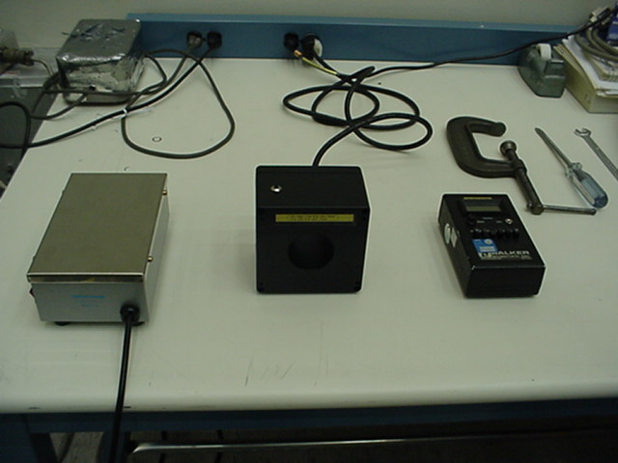
Bulk Eraser
Small Tool Degausser
Gaussmeter To
Check Tools

Figure 1 – Magnetics Demag Work Station

DEMAGNETIZATION PROCEDURE

- Demagnetization is performed on tools in order to erase their residual magnetism.

- Demagnetization is performed by exposing the tools to a peak alternating magnetic field and decreasing this field exponentially by removing the tools slowly away from this field.

- On small hand-held non-electronic components, a convenient demagnetizing process is to use a small coil or solenoid operating on 60 Hz power. This is shown in Figures 2 and 3. The degaussing coil is powered on and the tool is passed through the solenoid front end and out the other. This best works on long tools that are capable of fitting inside the coil’s diameter.

- The method used with larger tools is the “swiping” or tumbling method. A large tape demagnetizer is powered on and the magnetized tool is “swiped” past the top of the demagnetizer, or tumbled end-over-end as it is pulled away from the demagnetizer surface (Figures 4 and 5).

- After the tool has been demagnetized, a Gauss meter is used to check its magnetism (Figure 6 and 7). Typical acceptable field is 1 Gauss or less at 1 cm from on the surface.
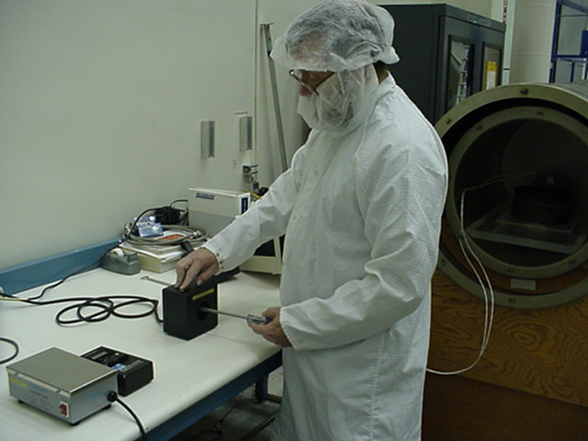 (2) 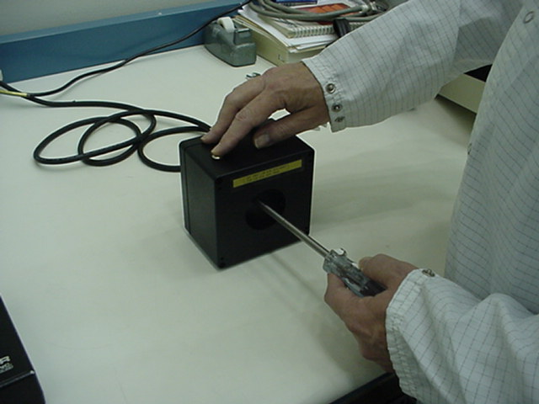 (3)

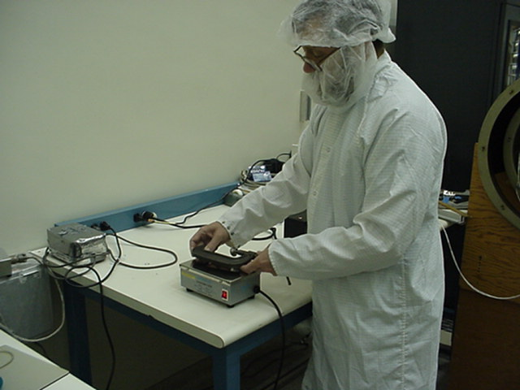 (4) 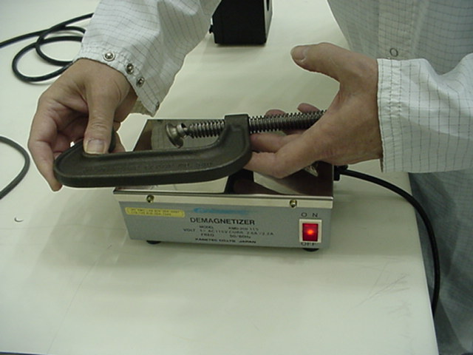 (5)

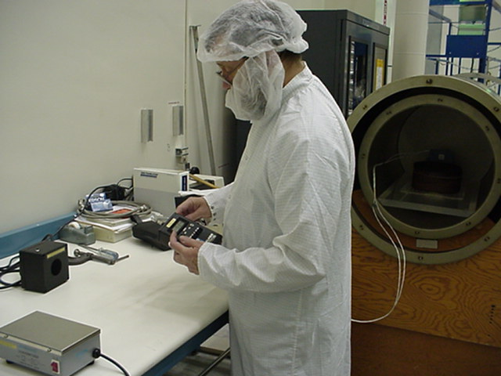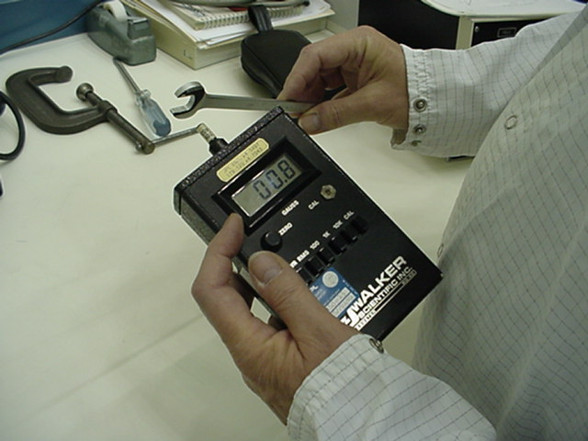

Figures 6 and 7 – Checking Tools For Magnetism After Undergoing Demagnetization

QUALITY ASSURANCE COVERAGE FOR MAGNETICS CONTROL

- QA shall ensure that the satellite integration area is properly identified as a “Magnetically Clean Area” by ensuring that appropriate signs are visible.

- During satellite integration, QA shall ensure that all tools used for satellite integration and all support equipment brought in to within 1 meter of the satellite are magnetically surveyed and demagnetized if found to be greater than 1 mT (1 Gauss) on any surface.

