DC MOTOR MAGNETIC CHARACTERIZATION
FOR THEMIS PROJECT

Gregory Dalton (gdalton@ssl.berkeley.edu)
John Bonnell (jbonnell@ssl.berkeley.edu)
Space Sciences Lab – UCB
January 7, 2004

Purpose: This test was conducted to analyze the magnetic signature of a brushed DC
motor similar to those used on the radial EFI for the THEMIS project. Characterization was also completed on brushless motors for potential future use.

Facilities: Tests were conducted at the Institute of Geophysics and Planetary Physics at
UCLA under the supervision of Robert Snare, Principal Engineer on 19 December 2003. Data was taken using a hand-held magnetometer that read in milli-Gauss in a magnetically clean room with walls consisting of two layers of 0.090in mu-metal. Background fields were less than 100 nT (nano-Tesla).

Motors: A Flight Spare, brushed DC motor assembly was used from the FAST project to most accurately predict the magnetic signature of motors to be used on the THEMIS EFI radial booms. The FAST assembly consists of a Globe SS gearmotor A-1430, mu-metal shielding, and hard-anodized aluminum casing. Non-permeable Bardon bearing replaced the stock bearings, and the output shaft was of 400 series magnetic stainless steel.

The other motors characterized were brushless DC motors: Globe P/N 547A116-1, and Faulhaber Minimotor SA #2444 S 024 B. Neither motor was modified, but the output shaft of the Faulhaber was made of non-magnetic stainless steel.
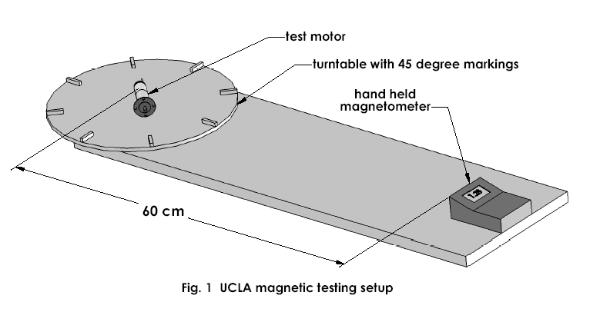

Procedure: The non-magnetic test stand consisted of a turntable with markings at 45 degree increments. Each gearmotor was placed with the motor portion centered on the turntable. The hand held magnetometer was placed at a 60 cm distance and data was recorded for each of the three planes at 45 degree intervals. The readout was converted to give magnetic strength at a one meter distance assuming a dipole falloff in field strength (multiplication by a factor of (0.6)³=0.216; see tables).

Results: The data is recorded in the tables and graphs below. The mu-meter shield in the FAST assembly had a small amount of residual magnetization before degaussing, but this was on the order of tenths of nT at one meter. All motors exhibited a normal sinusoidal signature of magnetic flux when spun on the turntable. The dipole direction of the brushless motors would change after the motors were run because the permanent magnets are on the rotor, rather than fixed to the motor housing. The output shaft of the Globe brushless could also add to the dipole moment due to the permeability or magnetization of the 400-series stainless steel from which it is constructed.

The “FAST assy, after degauss” is of primary concern for the THEMIS project. To determine the maximum total field values at one meter, take the square root of the sum of the squares of the dipole values for each plane. This gives 0.055 nT at one meter, or 69 pT at two meters. Assuming a worst case scenario that all four SPB motors contribute equally to magnetic budget would give 274 pT at two meters. The THEMIS SPB budget is 750 pT at two meters, which put the motor under by a factor of approximately 2.7 based on the FAST assembly.

Conclusions: Based on this test of magnetic moment using a similar motor in a similar shielding assembly, we expect the THEMIS EFI SPB motors to meet the magnetic moment requirement set by the THEMIS EMC document without significant changes to the choice of motor or design of magnetic shielding. Actual examples of the Globe/Avnet flight motors will be available in Jan. 2004, and will be subjected to similar testing to establish the validity of this prediction.

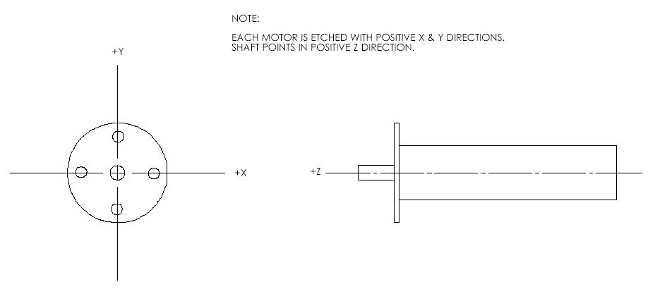

Fig. 2 Motor orientation (each motor was marked with +X and +Y)
FAST motor only, before degaussing 12/12/03
 | X-Z plane |  | Y-Z plane |  | X-Y plane
angle | field (60cm) | field (1m) | field (60cm) | field (1m) | field (60cm) | field (1m)
0 | -102 | -22.032 | -100 | -21.6 | -191 | -41.256
45 | -52 | -11.232 | -176 | -38.016 | -92 | -19.872
90 | -37 | -7.992 | -212 | -45.792 | 1 | 0.216
135 | -62 | -13.392 | -184 | -39.744 | 33 | 7.128
180 | -113 | -24.408 | -113 | -24.408 | -19 | -4.104
225 | -159 | -34.344 | -38 | -8.208 | -122 | -26.352
270 | -175 | -37.8 | -3 | -0.648 | -214 | -46.224
315 | -153 | -33.048 | -28 | -6.048 | -242 | -52.272
360 | -102 | -22.032 | -100 | -21.6 | -191 | -41.256
P-P | 138.00 | 29.81 | 209.00 | 45.14 | 275.00 | 59.40
avg | -106.11 | -22.92 | -106.00 | -22.90 | -115.22 | -24.89
dipole | 69.00 | 14.90 | 104.50 | 22.57 | 137.50 | 29.70
FAST motor only, after degaussing 12/12/03
 | X-Z plane |  | Y-Z plane |  | X-Y plane
angle | field (60cm) | field (1m) | field (60cm) | field (1m) | field (60cm) | field (1m)
0 | -111 | -23.976 | -112 | -24.192 | -208 | -44.928
45 | -52 | -11.232 | -196 | -42.336 | -110 | -23.76
90 | -32 | -6.912 | -237 | -51.192 | -17 | -3.672
135 | -65 | -14.04 | -207 | -44.712 | 17 | 3.672
180 | -132 | -28.512 | -125 | -27 | -30 | -6.48
225 | -192 | -41.472 | -46 | -9.936 | -131 | -28.296
270 | -210 | -45.36 | -10 | -2.16 | -224 | -48.384
315 | -176 | -38.016 | -37 | -7.992 | -254 | -54.864
360 | -111 | -23.976 | -112 | -24.192 | -208 | -44.928
P-P | 178.00 | 38.45 | 227.00 | 49.03 | 271.00 | 58.54
avg | -120.11 | -25.94 | -120.22 | -25.97 | -129.44 | -27.96
dipole | 89.00 | 19.22 | 113.50 | 24.52 | 135.50 | 29.27

Globe brushless motor only, before degaussing
 | X-Z plane |  | Y-Z plane |  | X-Y plane
angle | field (60cm) | field (1m) | field (60cm) | field (1m) | field (60cm) | field (1m)
0 | -113 | -24.408 | -113 | -24.408 | -106 | -22.896
45 | -108 | -23.328 | -111 | -23.976 | -105 | -22.68
90 | -102 | -22.032 | -106 | -22.896 | -104 | -22.464
135 | -99 | -21.384 | -101 | -21.816 | -102 | -22.032
180 | -99 | -21.384 | -99 | -21.384 | -104 | -22.464
225 | -101 | -21.816 | -99 | -21.384 | -107 | -23.112
270 | -105 | -22.68 | -102 | -22.032 | -108 | -23.328
315 | -112 | -24.192 | -109 | -23.544 | -108 | -23.328
360 | -113 | -24.408 | -113 | -24.408 | -106 | -22.896
P-P | 14.00 | 3.02 | 14.00 | 3.02 | 6.00 | 1.30
avg | -105.78 | -22.85 | -105.89 | -22.87 | -105.56 | -22.80
dipole | 7.00 | 1.51 | 7.00 | 1.51 | 3.00 | 0.65
FAST assy, after degauss 12/12/03
 | X-Z plane |  | Y-Z plane |  | X-Y plane
angle | field (60cm) | field (1m) | field (60cm) | field (1m) | field (60cm) | field (1m)
0 | -120 | -25.92 | -119 | -25.704 | -122 | -26.352
45 | -120 | -25.92 | -120 | -25.92 | -122 | -26.352
90 | -122 | -26.352 | -121 | -26.136 | -123 | -26.568
135 | -123 | -26.568 | -123 | -26.568 | -123 | -26.568
180 | -123 | -26.568 | -123 | -26.568 | -122 | -26.352
225 | -123 | -26.568 | -123 | -26.568 | -122 | -26.352
270 | -122 | -26.352 | -122 | -26.352 | -122 | -26.352
315 | -120 | -25.92 | -121 | -26.136 | -122 | -26.352
360 | -120 | -25.92 | -119 | -25.704 | -122 | -26.352
P-P | 3.00 | 0.65 | 4.00 | 0.86 | 1.00 | 0.22
avg | -121.44 | -26.23 | -121.22 | -26.18 | -122.22 | -26.40
dipole | 1.50 | 0.32 | 2.00 | 0.43 | 0.50 | 0.11

Globe brushless motor, after degaussing
 | X-Z plane |  | Y-Z plane |  | X-Y plane
angle | field (60cm) | field (1m) | field (60cm) | field (1m) | field (60cm) | field (1m)
0 | -119 | -25.704 | -119 | -25.704 | -121 | -26.136
45 | -118 | -25.488 | -120 | -25.92 | -120 | -25.92
90 | -117 | -25.272 | -120 | -25.92 | -117 | -25.272
135 | -117 | -25.272 | -120 | -25.92 | -116 | -25.056
180 | -119 | -25.704 | -119 | -25.704 | -117 | -25.272
225 | -120 | -25.92 | -118 | -25.488 | -120 | -25.92
270 | -121 | -26.136 | -117 | -25.272 | -121 | -26.136
315 | -120 | -25.92 | -118 | -25.488 | -121 | -26.136
360 | -119 | -25.704 | -119 | -25.704 | -121 | -26.136
P-P | 4.00 | 0.86 | 3.00 | 0.65 | 5.00 | 1.08
avg | -118.89 | -25.68 | -118.89 | -25.68 | -119.33 | -25.78
dipole | 2.00 | 0.43 | 1.50 | 0.32 | 2.50 | 0.54
Micromoh motor, before degauss
 | X-Z plane |  | Y-Z plane |  | X-Y plane
angle | field (60cm) | field (1m) | field (60cm) | field (1m) | field (60cm) | field (1m)
0 | -54 | -11.664 | -54 | -11.664 | -118 | -25.488
45 | -45 | -9.72 | -79 | -17.064 | -142 | -30.672
90 | -68 | -14.688 | -119 | -25.704 | 146 | 31.536
135 | -109 | -23.544 | -148 | -31.968 | 126 | 27.216
180 | -152 | -32.832 | -152 | -32.832 | 94 | 20.304
225 | -171 | -36.936 | -135 | -29.16 | 68 | 14.688
270 | -149 | -32.184 | -102 | -22.032 | 65 | 14.04
315 | -97 | -20.952 | -67 | -14.472 | 86 | 18.576
360 | -54 | -11.664 | -54 | -11.664 | -118 | -25.488
P-P | 126.00 | 27.22 | 98.00 | 21.17 | 288.00 | 62.21
avg | -99.89 | -21.58 | -101.11 | -21.84 | 23.00 | 4.97
dipole | 63.00 | 13.61 | 49.00 | 10.58 | 144.00 | 31.10

Micromoh motor, after degauss
 | X-Z plane |  | Y-Z plane |  | X-Y plane
angle | field (60cm) | field (1m) | field (60cm) | field (1m) | field (60cm) | field (1m)
0 | -93 | -20.088 | -94 | -20.304 | -126 | -27.216
45 | -76 | -16.416 | -109 | -23.544 | -152 | -32.832
90 | -82 | -17.712 | -131 | -28.296 | -158 | -34.128
135 | -107 | -23.112 | -144 | -31.104 | -142 | -30.672
180 | -142 | -30.672 | -142 | -30.672 | -112 | -24.192
225 | -166 | -35.856 | -129 | -27.864 | -88 | -19.008
270 | -161 | -34.776 | -110 | -23.76 | -81 | -17.496
315 | -129 | -27.864 | -96 | -20.736 | -97 | -20.952
360 | -93 | -20.088 | -94 | -20.304 | -126 | -27.216
P-P | 90.00 | 19.44 | 50.00 | 10.80 | 77.00 | 16.63
avg | -116.56 | -25.18 | -116.56 | -25.18 | -120.22 | -25.97
dipole | 45.00 | 9.72 | 25.00 | 5.40 | 38.50 | 8.32

