

The Radiation Environment
for
THEMIS

draft

Christian Poivey
SGT, Inc
Greenbelt, Maryland

Michael Xapsos
NASA/Goddard Space Flight Center
Greenbelt, Maryland

August 26, 2003

Table of Contents

1 Scope 3
2 Description of the mission 3
3 Solar protons 3
4 Trapped protons 3
5 Trapped electrons 4
6 Total ionizing dose curve 4
7 Single Event Effects (SEE) 5
7.1 Heavy Ion induced SEE 5
7.1.1 Galactic Cosmic Rays 5
7.2 Proton induced SEE 6
7.2.1 Trapped protons 6
8 Appendices 7

Scope
The purpose of this document is to define the THEMIS radiation environment for a 32 months mission and a launch date on August 21, 2006.

Description of the mission
THEMIS will be launched on August 21, 2006. There are two different phases in the mission. During Phase 1 all probes will have the same trajectory: 640x71059 km elliptical orbit with a 9 degrees inclination. The duration of Phase 1 is 120 days. The orbit of each probe during phase 2 is presented in table 1. The duration of phase 2 is 28 months.

Probe  # | Perige altitude  (km) | Apogee altitude  (km) | Orbit inclination  (degrees)
1 | 3200 | 196128 | 7
2 | 1075 | 120128 | 7
3 | 755 | 71213 | 9
4 | 755 | 71213 | 9
5 | 2240 | 57882 | 4.5
Table 1: Phase 2 orbit information.

Solar protons
The whole THEMIS mission will be flown during the minimum phase of the solar cycle; therefore, the solar proton contribution to the THEMIS radiation environment will be negligible.

Trapped protons
The NASA AP8 Solar minimum model has been used to determine the trapped proton environment. Table A1 gives the incident trapped proton fluence for the different mission phases. Figure 1 is a plot of the energy fluence spectra.
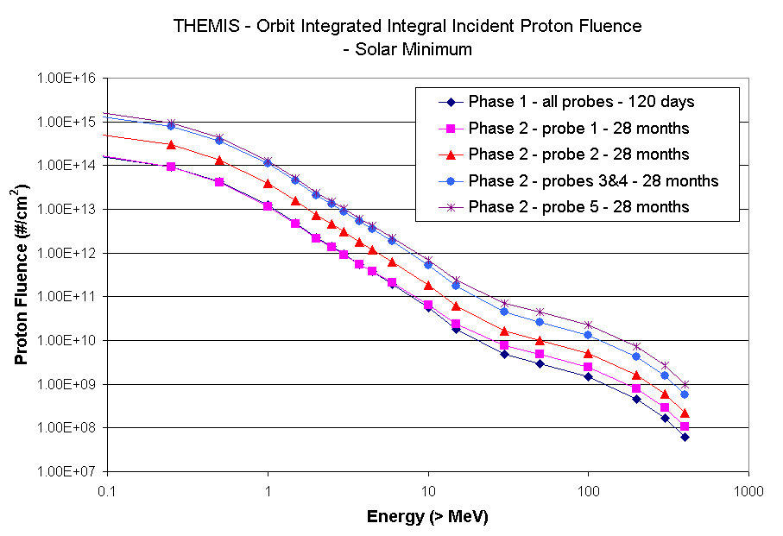
Figure 1 : Integral incident trapped proton Fluences

Trapped electrons
The NASA AE8 solar minimum model was used to determine the trapped electron environment. We considered three years of minimum solar activity (SOLMIN model). Table A2 gives the incident trapped electron fluence for the different probes and mission phases. Figure 2 is a plot of the energy fluence spectra.
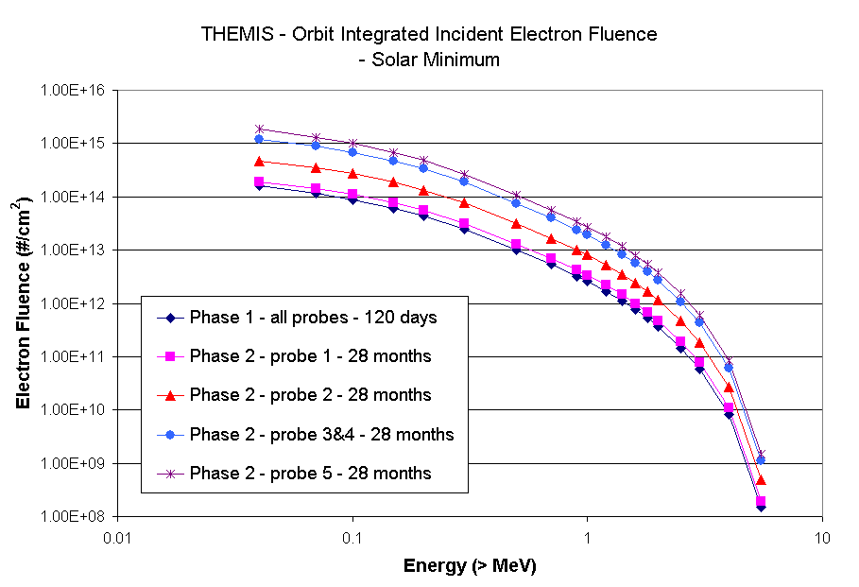
Figure 2: Integral incident trapped electron fluence

Total ionizing dose curve
Total dose has been calculated from the surface incident integral particle fluences as a function of aluminum shield thickness of a solid sphere. The solid sphere doses represent an upper boundary for the dose inside an actual spacecraft and are used as a top-level requirement. In cases where the amount of shielding surrounding a sensitive location is difficult to estimate, a more detailed analysis of the geometry of the spacecraft structure may be necessary to evaluate the expected dose levels. Table A3 and Figure 3 give the dose-depth curves for each probe for a 120 days first phase, a 28 months second phase, and a launch in August 2006.
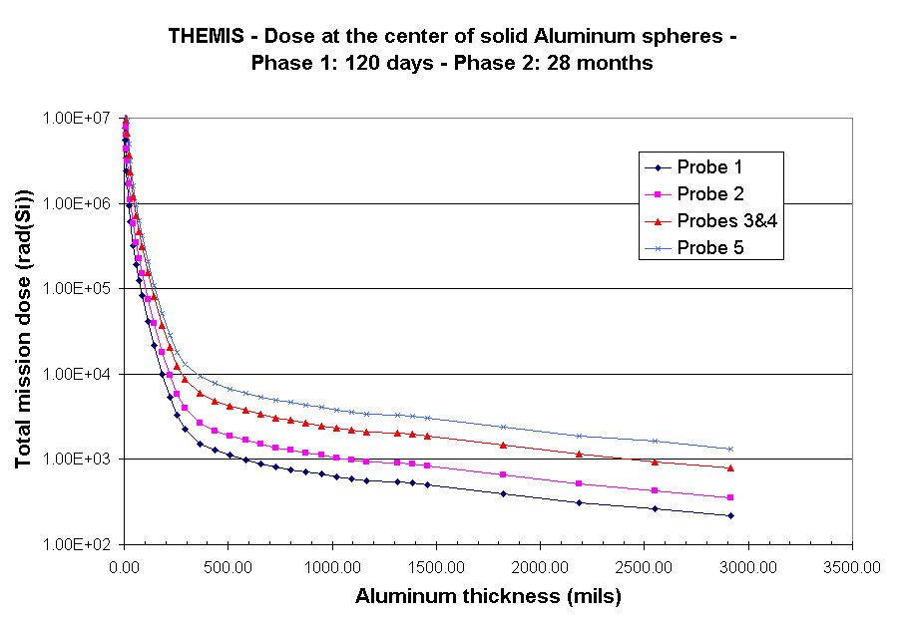
Figure 3: Total Ionizing Dose-Depth curve for the mission

Single Event Effects (SEE)

Heavy Ion induced SEE

Galactic Cosmic Rays
The Cosmic Ray fluxes for elements Hydrogen to Uranium were used to calculate daily LET spectra for 100 mils aluminum shielding as given in Table A4 and Figure 4. The range of cosmic ray abundance is bounded by the extremes of the solar active and inactive phases of solar cycle with the highest values occurring during the solar inactive phase and the lowest during the solar active phase. The LET fluence values are given for the lowest point of the solar cycle (worst case values). The CREME96 model was used to obtain the cosmic heavy ion abundance. The input parameters used for this calculation are given in the following table.

CREME96 input parameter | Value
Magnetic weather condition | Quiet
Solar condition | Quiet, solar minimum
Atomic number of lightest element included | Z=1
Atomic number of heaviest element included | Z=92
Shielding material | Aluminum
Shielding thickness | 100 mils

TBD
Figure 4: Integral LET spectra for Galactic Cosmic Rays

Proton induced SEE

Trapped protons
The daily average and peak trapped protons fluxes for a 100 mils Al shielding are given in Figure 5 and Table A5. These spectra can be used to calculate the proton induced SEE rates on sensitive devices. The peak spectrum will allow calculation of the maximum instantaneous SEE rate and the daily average spectrum will allow calculation of the daily average SEE rate.

TBD
Figure 5 : trapped proton fluxes for Single Event Effects evaluation

Appendices

Table A1 : Spacecraft Incident Proton Fluences

Energy | Phase 1 | Phase 2  Fluence – 28 months
 | Fluence –120 days
 | All probes | Probe 1 | Probe 2 | Probes 3&4 | Probe 5
(>MeV) | (#/cm²) | (#/cm²) | (#/cm²) | (#/cm²) | (#/cm²)
0.05 | 2.17E+14 | 2.37E+14 | 6.91E+14 | 1.76E+15 | 2.23E+15
0.25 | 9.24E+13 | 9.48E+13 | 2.95E+14 | 7.72E+14 | 9.48E+14
0.5 | 4.19E+13 | 4.11E+13 | 1.34E+14 | 3.59E+14 | 4.31E+14
1 | 1.25E+13 | 1.17E+13 | 4.00E+13 | 1.11E+14 | 1.30E+14
1.5 | 4.90E+12 | 4.54E+12 | 1.57E+13 | 4.43E+13 | 5.12E+13
2 | 2.26E+12 | 2.11E+12 | 7.26E+12 | 2.08E+13 | 2.40E+13
2.5 | 1.42E+12 | 1.34E+12 | 4.54E+12 | 1.32E+13 | 1.52E+13
3 | 9.35E+11 | 9.05E+11 | 3.01E+12 | 8.71E+12 | 1.02E+13
3.75 | 5.51E+11 | 5.50E+11 | 1.78E+12 | 5.21E+12 | 6.16E+12
4.5 | 3.71E+11 | 3.80E+11 | 1.20E+12 | 3.52E+12 | 4.21E+12
6 | 1.93E+11 | 2.08E+11 | 6.30E+11 | 1.84E+12 | 2.26E+12
10 | 5.57E+10 | 6.58E+10 | 1.83E+11 | 5.32E+11 | 6.91E+11
15 | 1.82E+10 | 2.40E+10 | 6.10E+10 | 1.73E+11 | 2.42E+11
30 | 4.81E+09 | 7.62E+09 | 1.66E+10 | 4.41E+10 | 7.18E+10
50 | 2.87E+09 | 4.81E+09 | 9.99E+09 | 2.60E+10 | 4.45E+10
100 | 1.45E+09 | 2.49E+09 | 5.08E+09 | 1.32E+10 | 2.30E+10
200 | 4.52E+08 | 7.82E+08 | 1.60E+09 | 4.15E+09 | 7.22E+09
300 | 1.66E+08 | 2.87E+08 | 5.85E+08 | 1.53E+09 | 2.66E+09
400 | 6.12E+07 | 1.06E+08 | 2.17E+08 | 5.64E+08 | 9.82E+08

Table A2 : Spacecraft Incident Trapped Electron Fluences

Energy | Phase 1 | Phase 2  Fluence – 28 months
 | Fluence –120 days
 | All probes | Probe 1 | Probe 2 | Probes 3&4 | Probe 5
(>MeV) | (#/cm²) | (#/cm²) | (#/cm²) | (#/cm²) | (#/cm²)
0.04 | 1.58E+14 | 1.94E+14 | 4.71E+14 | 1.21E+15 | 1.85E+15
0.07 | 1.15E+14 | 1.45E+14 | 3.52E+14 | 8.88E+14 | 1.31E+15
0.1 | 8.88E+13 | 1.13E+14 | 2.74E+14 | 6.87E+14 | 9.99E+14
0.15 | 6.14E+13 | 7.83E+13 | 1.90E+14 | 4.73E+14 | 6.84E+14
0.2 | 4.36E+13 | 5.56E+13 | 1.34E+14 | 3.33E+14 | 4.79E+14
0.3 | 2.47E+13 | 3.17E+13 | 7.65E+13 | 1.87E+14 | 2.68E+14
0.5 | 1.00E+13 | 1.29E+13 | 3.11E+13 | 7.50E+13 | 1.07E+14
0.7 | 5.34E+12 | 6.91E+12 | 1.67E+13 | 3.98E+13 | 5.62E+13
0.9 | 3.24E+12 | 4.21E+12 | 1.02E+13 | 2.42E+13 | 3.40E+13
1 | 2.58E+12 | 3.36E+12 | 8.10E+12 | 1.92E+13 | 2.70E+13
1.2 | 1.69E+12 | 2.21E+12 | 5.32E+12 | 1.26E+13 | 1.77E+13
1.4 | 1.11E+12 | 1.46E+12 | 3.51E+12 | 8.29E+12 | 1.16E+13
1.6 | 7.54E+11 | 9.91E+11 | 2.38E+12 | 5.61E+12 | 7.86E+12
1.8 | 5.21E+11 | 6.84E+11 | 1.65E+12 | 3.88E+12 | 5.43E+12
2 | 3.61E+11 | 4.76E+11 | 1.14E+12 | 2.69E+12 | 3.77E+12
2.5 | 1.45E+11 | 1.93E+11 | 4.64E+11 | 1.08E+12 | 1.52E+12
3 | 5.82E+10 | 7.67E+10 | 1.85E+11 | 4.31E+11 | 5.98E+11
4 | 8.27E+09 | 1.09E+10 | 2.66E+10 | 6.12E+10 | 8.41E+10
5.5 | 1.49E+08 | 1.96E+08 | 4.87E+08 | 1.11E+09 | 1.50E+09

Table A3 : Total Ionizing Dose at the Center of Aluminum spheres
Al shielding thickness |  |  | Dose (rad-Si)
 |  |  | Phase 1 | Phase 2 |  |  |  | Total mission
g/cm2 | mm | mils | all probes | probe 1 | probe 2 | probe3&4 | probe 5 | probe 1 | probe 2 | probe3&4 | probe 5
0.03 | 0.11 | 4.37 | 3.51E+06 | 4.17E+06 | 1.10E+07 | 2.89E+07 | 3.92E+07 | 7.68E+06 | 1.45E+07 | 3.24E+07 | 4.27E+07
0.04 | 0.15 | 5.83 | 2.52E+06 | 3.05E+06 | 7.85E+06 | 2.04E+07 | 2.81E+07 | 5.56E+06 | 1.04E+07 | 2.29E+07 | 3.07E+07
0.05 | 0.19 | 7.29 | 1.91E+06 | 2.34E+06 | 5.93E+06 | 1.54E+07 | 2.13E+07 | 4.25E+06 | 7.84E+06 | 1.73E+07 | 2.32E+07
0.06 | 0.22 | 8.75 | 1.53E+06 | 1.90E+06 | 4.76E+06 | 1.23E+07 | 1.71E+07 | 3.43E+06 | 6.29E+06 | 1.38E+07 | 1.86E+07
0.08 | 0.30 | 11.67 | 1.06E+06 | 1.33E+06 | 3.30E+06 | 8.43E+06 | 1.18E+07 | 2.38E+06 | 4.35E+06 | 9.49E+06 | 1.28E+07
0.10 | 0.37 | 14.58 | 7.56E+05 | 9.57E+05 | 2.37E+06 | 5.98E+06 | 8.36E+06 | 1.71E+06 | 3.13E+06 | 6.74E+06 | 9.12E+06
0.15 | 0.56 | 21.87 | 4.15E+05 | 5.25E+05 | 1.30E+06 | 3.24E+06 | 4.54E+06 | 9.40E+05 | 1.71E+06 | 3.66E+06 | 4.95E+06
0.20 | 0.74 | 29.16 | 2.68E+05 | 3.40E+05 | 8.39E+05 | 2.08E+06 | 2.88E+06 | 6.07E+05 | 1.11E+06 | 2.35E+06 | 3.15E+06
0.30 | 1.11 | 43.74 | 1.38E+05 | 1.77E+05 | 4.36E+05 | 1.05E+06 | 1.47E+06 | 3.16E+05 | 5.74E+05 | 1.19E+06 | 1.61E+06
0.40 | 1.48 | 58.31 | 8.29E+04 | 1.08E+05 | 2.62E+05 | 6.30E+05 | 8.77E+05 | 1.91E+05 | 3.45E+05 | 7.13E+05 | 9.60E+05
0.50 | 1.85 | 72.91 | 5.36E+04 | 7.00E+04 | 1.70E+05 | 4.09E+05 | 5.67E+05 | 1.24E+05 | 2.24E+05 | 4.63E+05 | 6.21E+05
0.60 | 2.22 | 87.48 | 3.64E+04 | 4.76E+04 | 1.16E+05 | 2.76E+05 | 3.85E+05 | 8.40E+04 | 1.52E+05 | 3.13E+05 | 4.21E+05
0.80 | 2.96 | 116.65 | 1.78E+04 | 2.35E+04 | 5.68E+04 | 1.36E+05 | 1.92E+05 | 4.13E+04 | 7.47E+04 | 1.54E+05 | 2.10E+05
1.00 | 3.70 | 145.83 | 9.25E+03 | 1.23E+04 | 2.98E+04 | 7.13E+04 | 1.00E+05 | 2.15E+04 | 3.90E+04 | 8.06E+04 | 1.09E+05
1.25 | 4.63 | 182.28 | 4.27E+03 | 5.77E+03 | 1.37E+04 | 3.28E+04 | 4.71E+04 | 1.00E+04 | 1.80E+04 | 3.71E+04 | 5.13E+04
1.50 | 5.56 | 218.74 | 2.26E+03 | 3.14E+03 | 7.37E+03 | 1.81E+04 | 2.62E+04 | 5.40E+03 | 9.63E+03 | 2.03E+04 | 2.85E+04
1.75 | 6.48 | 255.16 | 1.34E+03 | 1.92E+03 | 4.43E+03 | 1.11E+04 | 1.67E+04 | 3.26E+03 | 5.77E+03 | 1.24E+04 | 1.81E+04
2.00 | 7.41 | 291.61 | 9.19E+02 | 1.36E+03 | 3.07E+03 | 7.84E+03 | 1.22E+04 | 2.28E+03 | 3.99E+03 | 8.76E+03 | 1.31E+04
2.50 | 9.26 | 364.53 | 5.98E+02 | 9.32E+02 | 2.04E+03 | 5.31E+03 | 8.71E+03 | 1.53E+03 | 2.64E+03 | 5.91E+03 | 9.31E+03
3.00 | 11.11 | 437.40 | 4.89E+02 | 7.87E+02 | 1.68E+03 | 4.34E+03 | 7.27E+03 | 1.28E+03 | 2.17E+03 | 4.83E+03 | 7.76E+03
3.50 | 12.96 | 510.24 | 4.25E+02 | 6.88E+02 | 1.46E+03 | 3.76E+03 | 6.30E+03 | 1.11E+03 | 1.88E+03 | 4.18E+03 | 6.72E+03
4.00 | 14.81 | 583.07 | 3.80E+02 | 6.13E+02 | 1.30E+03 | 3.35E+03 | 5.64E+03 | 9.93E+02 | 1.68E+03 | 3.73E+03 | 6.02E+03
4.50 | 16.67 | 656.30 | 3.41E+02 | 5.55E+02 | 1.18E+03 | 3.04E+03 | 5.08E+03 | 8.96E+02 | 1.52E+03 | 3.38E+03 | 5.42E+03
5.00 | 18.52 | 729.13 | 3.11E+02 | 5.03E+02 | 1.06E+03 | 2.74E+03 | 4.63E+03 | 8.14E+02 | 1.37E+03 | 3.05E+03 | 4.94E+03
5.50 | 20.37 | 801.97 | 2.88E+02 | 4.72E+02 | 9.92E+02 | 2.59E+03 | 4.33E+03 | 7.60E+02 | 1.28E+03 | 2.88E+03 | 4.62E+03
6.00 | 22.22 | 874.80 | 2.67E+02 | 4.39E+02 | 9.22E+02 | 2.40E+03 | 4.04E+03 | 7.07E+02 | 1.19E+03 | 2.66E+03 | 4.31E+03
6.50 | 24.07 | 947.64 | 2.51E+02 | 4.17E+02 | 8.61E+02 | 2.23E+03 | 3.79E+03 | 6.69E+02 | 1.11E+03 | 2.49E+03 | 4.04E+03
7.00 | 25.93 | 1020.87 | 2.35E+02 | 3.92E+02 | 8.13E+02 | 2.10E+03 | 3.59E+03 | 6.27E+02 | 1.05E+03 | 2.33E+03 | 3.83E+03
7.50 | 27.78 | 1093.70 | 2.22E+02 | 3.68E+02 | 7.62E+02 | 1.98E+03 | 3.39E+03 | 5.90E+02 | 9.85E+02 | 2.21E+03 | 3.61E+03
8.00 | 29.63 | 1166.54 | 2.12E+02 | 3.51E+02 | 7.29E+02 | 1.90E+03 | 3.22E+03 | 5.63E+02 | 9.41E+02 | 2.11E+03 | 3.43E+03
9.00 | 33.33 | 1312.20 | 2.06E+02 | 3.38E+02 | 7.05E+02 | 1.84E+03 | 3.09E+03 | 5.44E+02 | 9.11E+02 | 2.04E+03 | 3.29E+03
9.50 | 35.19 | 1385.43 | 1.99E+02 | 3.27E+02 | 6.84E+02 | 1.77E+03 | 2.99E+03 | 5.26E+02 | 8.82E+02 | 1.97E+03 | 3.19E+03
10.00 | 37.04 | 1458.27 | 1.89E+02 | 3.14E+02 | 6.52E+02 | 1.68E+03 | 2.88E+03 | 5.04E+02 | 8.41E+02 | 1.87E+03 | 3.07E+03
12.50 | 46.30 | 1822.83 | 1.48E+02 | 2.45E+02 | 5.12E+02 | 1.32E+03 | 2.24E+03 | 3.93E+02 | 6.60E+02 | 1.47E+03 | 2.39E+03
15.00 | 55.56 | 2187.40 | 1.16E+02 | 1.93E+02 | 4.00E+02 | 1.04E+03 | 1.76E+03 | 3.09E+02 | 5.16E+02 | 1.16E+03 | 1.88E+03
17.50 | 64.81 | 2551.57 | 9.96E+01 | 1.61E+02 | 3.29E+02 | 8.26E+02 | 1.53E+03 | 2.61E+02 | 4.29E+02 | 9.26E+02 | 1.63E+03

Table A4: Integral LET for Galactic Cosmic Rays (Z=1-92)
100 mils Aluminum shielding, Solar minimum

TBD

Table A5: trapped proton fluxes
100 mils Aluminum shielding

TBD

