Request For Action | Number: Recommendation

Project | THEMIS
Review: | Systems Requirements Review (SRR)
Date: | July 8-9, 2003

Originator: | J.B. Joyce |  | Phone: | 410-647-8853 | Organization: | Independent
Category: |  | Operations
Title: |  | Detail the Processes for Orbit Determination
Action  Requested: |  | Detail, by the PDR, the processes required for providing orbit determination services for THEMIS including implementation of hardware and software for BGS, training of the operations team, MOC automation plans, metric tracking, data evaluation (for BGS and the USN site), the optimized tracking strategy to achieve the required orbital accuracy and test plans.
Supporting  Rationale: |  | Capturing and processing metric tracking data to provide the required orbital products must be planned prudently to contain costs. Several “new” systems need to be implemented, tested and integrated into the MOC.

Project Response:

THEMIS orbit determination is based on two-way Doppler tracking of the probes, using radiometric data from the Berkeley Ground Station and from secondary ground stations.
The Berkeley Ground Station will be upgraded with an Apogee Labs Carrier Doppler Measurement System (CDMS) which extracts the two-way Doppler shift from the 180 MHz second local oscillators (2nd LO) in the Microdyne 700-MRB telemetry receivers.
An Apogee Labs Track Data Formatter (TDF) will record the tracking data in Universal Tracking Data Format (UTDF). The recorded data files will be transferred post-pass to the Flight Dynamics Center, which may be viewed as part of the MOC. The SatTrack Monitor and Control System (SatTrack/MCS) of the ground station will be upgraded to automatically configure both the CDMS and the TDF for individual pass supports, based upon configuration stored in THEMIS mission configuration files. GTDS will be used to perform orbit determination functions based on converted UTDF input files from the Berkeley Ground Station and from the secondary ground stations.

The Berkeley team actively collaborates with GSFC/GNCD to model the expected accuracy of the radiometric tracking data and the resulting accuracy of the orbit solution. The quality of the orbit solution and the number of iteration steps required for convergence depends heavily on the signal-to-noise ratio of the Doppler data.

Since estimation of the 1-σ standard deviation of the Doppler signal is difficult for the modulation schemes to be used with THEMIS (PCM/PSK/PM for symbol rates of 64 kbps or lower, and BPSK for symbol rates above 64 kbps, it was suggested in discussions with GSFC Code 450 and Wallops Flight Facility that test be performed with the Berkeley Ground Station. WFF kindly loaned equipment to UCB for a duration of 8 weeks, namely a CDMS, TDF and a TrueTime DC-XL GPS Receiver. This equipment has been installed in the Berkeley Ground Station. A schematic of the test configuration is shown in Figure 1. Initial functional tests revealed that time synchronization is very critical for optimum performance, including reduction of noise and Doppler bias.

A set of initial tests have been performed to prove basic functionality of the system. These tests include long loop round-trip tests without Doppler shift in order to determine the noise floor and accuracy limit. In addition, test tracks have been recorded with the FAST spacecraft. The first noise floor measurement is reproduced in Figure 2 below and the first track with FAST in Figure 3.

Within the following two weeks a more detailed series of tests will be performed to determine the Doppler accuracy for various signal-to-noise ratios as a function of modulation scheme and receiver demodulator loop bandwidth. The results will then be used by GSFC/GNCD to model the number of tracking arcs required to perform orbit determination for THEMIS with the required accuracy.

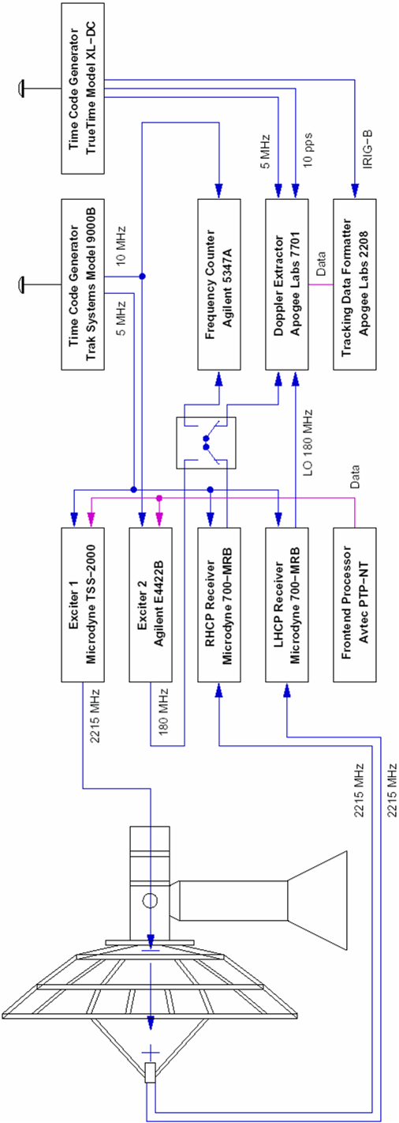
Figure 1: BGS Doppler Test Configuration

Figure 2: Doppler loop back test of 6 minutes duration. The average range rate is −0.00000470 km/s, and the range rate error (1-σ) is 0.00012869 km/s in this trace. Note that the integration time was 0.1 s for this measurement, and no filtering was applied.

Figure 3: Test Doppler track of FAST, performed on 06-Nov-2003. The integration time was 0.1 s during this track. The calculated range rate is based on a 2-day old TLE set.

While these initial tests appear to be very encouraging, there is more work to be done. The baseline noise shown in Figure 2 is 16 times larger than what is typically obtained with the 8-m TOTS system at Wallops and Poker Flat. However, no attempt was made yet to optimize the performance of the measurements with the Berkeley Ground Station or to filter the data. Note that the data presented in Figure 2 were recorded in BPSK mode, while those in Figure 3 were obtained in PCM/PSK/PM mode.

Mark Beckman at GNCD has used the initial test data to determine what orbit solution for THEMIS would be obtained. Using the 4-day orbit of THEMIS P1, and a total of 18 anticipated 30-minute passes, the worst case position error at apogee is less than 15 km, which is much smaller than what is required for THEMIS (see Figure 4). However, while this error is small, there is a problem with overall convergence. The convergence of the orbit solution is in this case entirely dominated by the noise floor in the measurement. A significant performance improvement is expected once the configuration of the BGS receiver system has been explored and optimized. Much progress is expected to be made within the next two weeks.

U.C. Berkeley will purchase an identical CDMS and TDF system in early 2004 (as soon as Phase C funding is available). Integration into the ground station will be very quick, now that experience with the Wallops system has been gained already. Also, in early 2004 members of the Berkeley flight dynamics team will be trained on using the orbit determination functions of GTDS, including quality assessment and selection of tracking data, determination of biases, and assessment of the quality and reliability of the orbit solutions. Further tests will be performed with the FAST spacecraft. Orbit solutions obtained locally will then be compared against two-line element sets provided by NORAD.

The plots shown in Figures 2 and 3 have been obtained using the SatTrack UTDF processing Tool which is available already. This tool will be enhanced to provide output data in 60-byte format, which is what GTDS needs as input.

System automation will be considered, once the Berkeley team has familiarized itself firmly with the manual procedures. It is anticipated that THEMIS orbit determination will be automated eventually during normal operations.

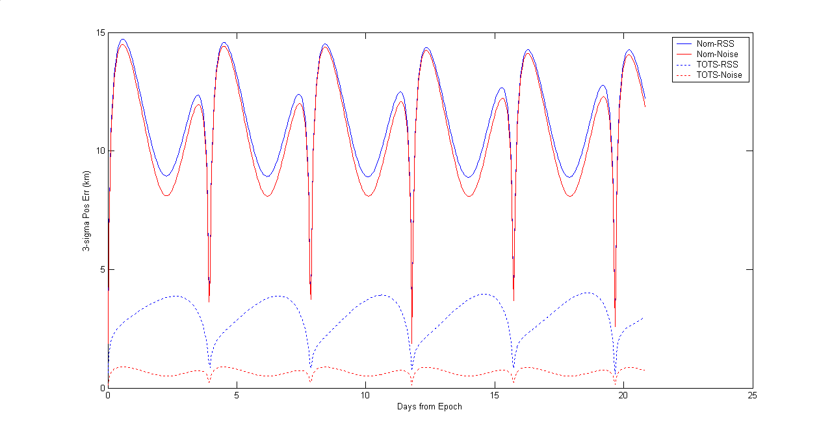

Figure 4: Preliminary orbit solution for THEMIS P1, based on the initial range rate noise floor measurement of 0.13 m/s. While the overall error fulfills the mission requirement, the convergence is too slow.

