Request For Action
Number: Recommendation

 | Project  Response: | Currently, the Berkeley Ground Station only supports two missions – namely RHESSI with typically 6 passes per day and CHIPS with typically 4 passes per day. FAST uses the BGS only occasionally for special supports. Only under the most unlikely circumstances will these three missions be supported with the same number of passes in the time frame overlapping with the THEMIS mission. Aside from THEMIS there is no other mission currently scheduled to use the BGS in the 2006-2008 time frame. Therefore, a BGS loading study is not really an issue since THEMIS will have almost exclusive access to the facility.  During THEMIS Phase B, a trade study was performed which compared coverage and costing of the Universal Space Network stations with the NASA Ground Network, enhanced with additional supports from Santiago and Hartebeesthoek. It turns out that for a variety of reasons the NASA Ground Network option is more favorable. The THEMIS team has been in contact with CSOC (or its successor organization) to perform a loading study for the Wallops 11-m antenna. CSOC confirmed that Wallops can support THEMIS with the number of passes required during the launch and early orbit phase, and also during the two years of normal mission operations. Similarly, the Berkeley team has been in touch with and obtained cost quotes from Santiago and Hartebeesthoek. The ground stations at Wallops and Santiago are currently used by RHESSI, and Wallops is also used by CHIPS and FAST, so there is already an existing, working relationship between the Berkeley MOC and these facilities, including the White Sands Scheduling Group that performs the pass scheduling functions for these ground stations.  There are six figures attached below showing various pass schedule scenarios, using the NASA Ground Network and also Universal Space Network as secondary ground stations with Berkeley as prime. It is shown in either scenario that the Berkeley Ground Station can easily support about 80% of all required passes with a sufficient link margin to maintain a bit error rate of 10E-6. The remaining 20% are split amongst the other ground stations. See figure captions for more details.  The only formal requirement for ground station coverage during normal operations is to support one up to 30-minute long pass near perigee of each orbit to transmit all stored science and engineering data. This amounts to 3.75 passes per day on average for the entire constellation  (3 x 1/day + 1 x 1/2days + 1 x 1/4days) (see Table 1). Additional passes will be supported at lower data rates, depending upon range (see Table 2). These passes will be used to monitor probe state of health, collect Doppler tracking data and set the onboard clocks. Each probe allows 30 minutes of transmitter-on time per day. Therefore, up to five 30-minute passes can be supported every day for all probes combined. If only 15 minutes are required near perigee to downlink all data at the highest rate of 1,024 Mbps, then correspondingly more passes can be afforded at other parts of the orbits. The schedule plots shown below actually demonstrate that all data can be recovered with 15-minute passes at a data rate of 1,024 Mbps.
Probe | L&EO Passes | First Year Passes | Second Year Passes
1 | 120 | 92 | 92
2 | 120 | 183 | 183
3 | 120 | 365 | 365
4 | 120 | 365 | 365
5 | 120 | 365 | 365
Total | 600 | 1370 | 1370
Table 1: Number of passes required to support all L&EO, first year and second year activities.

Downlink Mode | Schedule | Duration | Range | Modulation | Data Rate
Stored Science and Engineering Downlink | 1 x / Orbit / Probe | 30 min | 750 – 15,000 km | BPSK | 1,024 kbps
Stored Science and Engineering Downlink | 1 x / Orbit / Probe | 30 min | 2,500 – 20,000 km | BPSK | 512 kbps
Stored Science and Engineering Downlink | 1 x / Orbit / Probe | 30 min | 10,000 – 30,000 km | BPSK | 256 kbps
Stored Science and Engineering Downlink | 1 x / Orbit / Probe | 30 min | 20,000 – 40,000 km | BPSK | 128 kbps
Real-time Engineering Downlink with Ranging | 1 x / Day / Probe | 30 min | 30,000 – 60,000 km | PCM/PSK/PM  1.024 MHz S/C | 64 kbps
Real-time Engineering Downlink with Ranging | 1 x / Day / Probe | 30 min | 50,000 – 75,000 km | PCM/PSK/PM  1.024 MHz S/C | 32 kbps
Real-time Engineering Downlink with Ranging | 1 x / Day / Probe | 30 min | 65,000 – 100,000 km | PCM/PSK/PM  1.024 MHz S/C | 16 kbps
Real-time Engineering Downlink with Ranging | 1 x / Day / Probe | 30 min | 80,000 – 150,000 km | PCM/PSK/PM  1.024 MHz S/C | 8 kbps
Real-time Engineering Downlink with Ranging | 1 x / Day / Probe | 30 min | 120,000 – 200,000 km | PCM/PSK/PM  1.024 MHz S/C | 4 kbps
Real-time Engineering Downlink via TDRSS | Real-time Maneuver & Contingency Support | 30 min | 5,000 – 42,500 km | PCM/PSK/PM  1.024 MHz S/C | 1 kbps

Table 2: A total of 10 different telemetry data rates are provided to allow for optimal link closure with all THEMIS probes at various range intervals. The 1 kbps data rate will be used with TDRSS and during contingency supports.
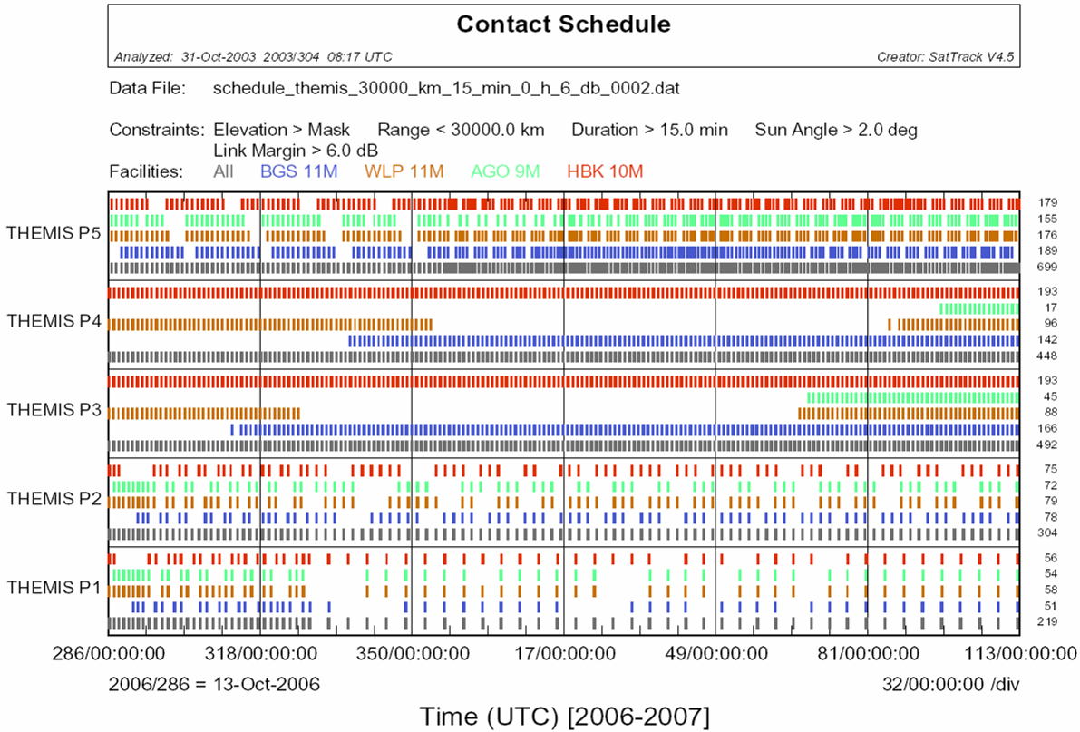

Figure 1: Typical SatTrack pass schedule for BGS, WLP, AGO and HBK as well as all stations combined. Constraints: Elevation > Mask, Range < 30,000 km, Duration > 15 min, Link Margin > 6 dB for a data rate of 1,024 Mbps with a donut shaped probe antenna pattern with a 90 deg opening angle (-3 dBic gain points). Each colored mark represents a pass that fulfills all of the above constraints. It is obvious that with all stations combined there is ample of margin in terms of available coverage. This and the following pass schedules were generated by SatTrack, ingesting external ephemeris data generated by GTDS. In other words, GTDS was used to produce a forward run including all orbit maneuvers, resulting in an ephemeris file, i.e. ECI XYZ position and velocity of each probe in 1-minute time increments. These files were ingested by SatTrack to provide all other subsequent analyses such as contact schedules, shadow analyses, and any other mission planning product required to support the mission. Likewise, SatTrack can also ingest ephemeris files generated by GMAN to perform the same types of analyses. Note that the time between passes for P1 changes from approximately one per day to eventually one per four days as a result of the mission orbit placement.

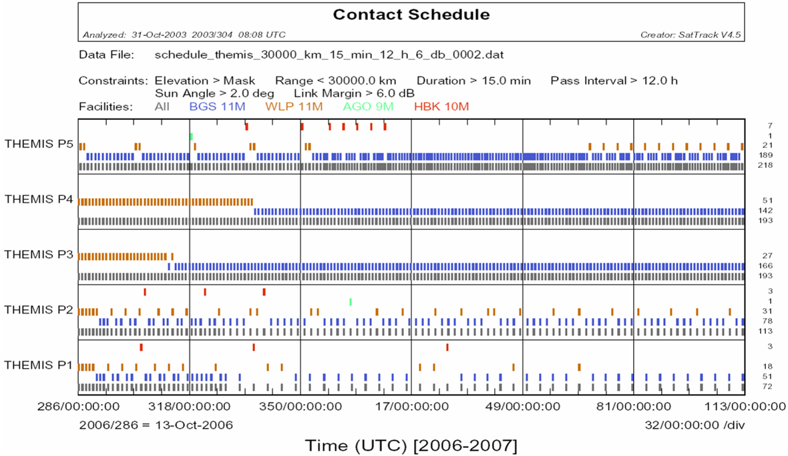

Figure 2: Typical pass schedule for BGS, WLP, AGO and HBK as well as all stations combined. Constraints: Same as in Figure 1, except that now another constraint has been added: Minimum time between passes is 12 hours. As a consequence, a large number of passes have been removed following a simple priority scheme. If a pass can be supported with BGS, then remove all others within +/- 6 hours. If it cannot be supported with BGS, try WLP, then AGO, then HBK. It is now obvious that 80% of all passes can be supported by the Berkeley facility, while the other stations fill in the gaps or serve as back-up stations, in case the BGS is temporarily out of service.

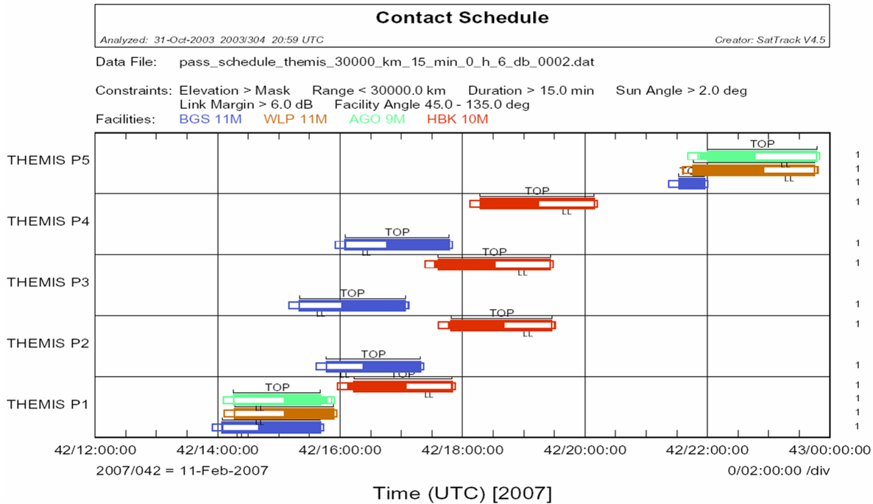

Figure 3: Expanded, 12-hour view of a typical pass schedule for BGS, WLP, AGO and HBK for a day on which all 5 probes have a perigee pass. Constraints: Same as in Figure 1 plus the antenna cone angle. The latter constraint is used only for display purposes since the true antenna pattern is used to model the dynamic link margin. Passes are displayed in the following way: Each pass begins with a 10-min pre-pass period and ends with a 3-min post-pass period, as indicated by the smaller open rectangles. The wider bars indicate the period during which the ground station has a view into the nominal; +/- 45 deg antenna cone, here called the ‘Top’ antenna. The open area of the wider bar indicates a period during which the link margin falls below 6 dB, as indicated by the ‘Link Loss’ (LL) symbol. While probes 1-4 have an apparent conflict at the Berkeley Ground Station, the periods for which the link margin is in excess of 6 dB are much longer than the required 15 minutes for a telemetry dump at 1,024 Mbps. Therefore, passes can be easily de-conflicted, and supports by the other stations which also have a view are not required and would drop out of the schedule.
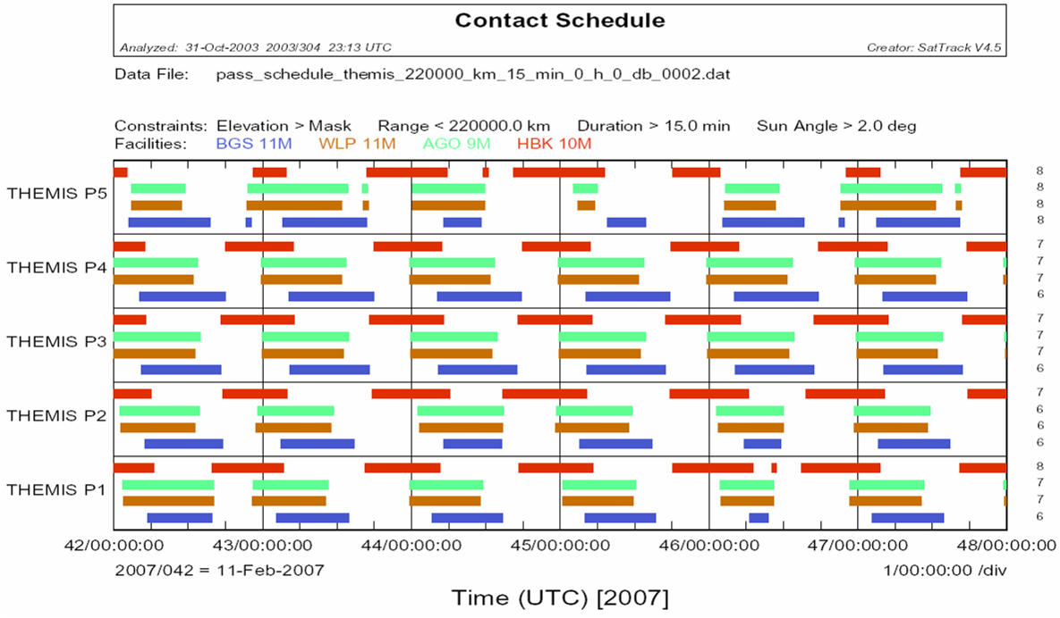

Figure 4: Schedule plot with the link margin constraint completely removed, and the range widened out to 220,000 km. The resulting schedule shows view of all probes at all four stations whenever they are above the station mask, regardless of range. Since the data rates can be selected to close the links at any range, these colored bars indicate periods during which state of health can be checked, Doppler tracking data can be collected, and probe clocks can be adjusted. There is a very large amount of scheduling flexibility since views are on average longer than 12 hours per day for each probe and each station. Typically a number of rules will be used to optimize the pass schedule, such as minimum and maximum time between contacts with a given probe, maximum transmitter-on time per day, memory fill level, Doppler tracking requirements and others.
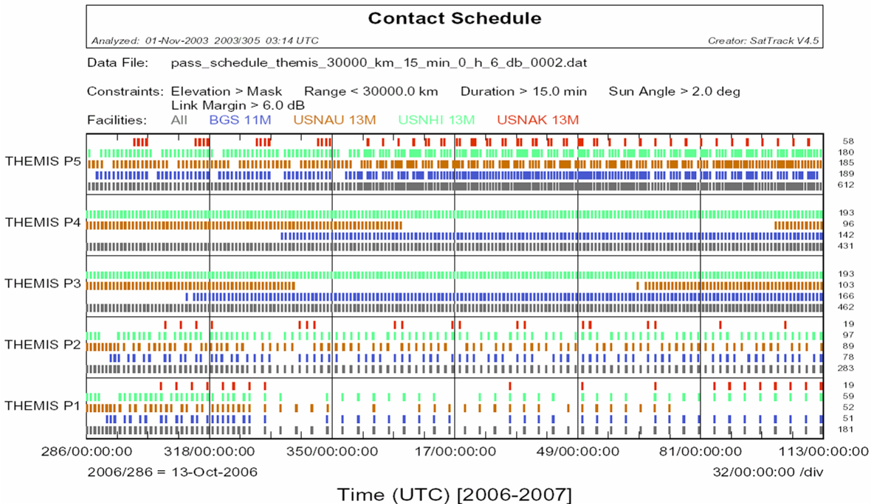

Figure 5: Same as Figure 1, except that BGS is shown in combination with the USN ground stations in Australia, Hawaii and Alaska.
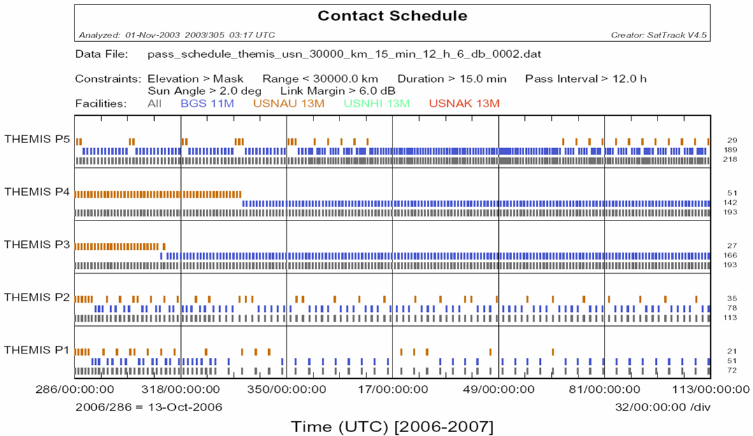

Figure 6: Same as Figure 2, except that BGS is shown in combination with the USN ground stations in Australia, Hawaii and Alaska. From a pass coverage point of view the BGS+WLP+AGO+HBK option is very similar to the BGS+USNAU+USNHI+USNAK option.

Project | THEMIS
Review: | Systems Requirements Review (SRR)
Date: | July 8-9, 2003

Originator: | J.B. Joyce |  | Phone: | 410-647-8853 | Organization: | Independent
Category: |  | Operations
Title: |  | Provide Optimized Ground Station Strategy
Action  Requested: |  | Provide, at the PDR, an optimized ground station acquisition strategy (a week in the life of THEMIS) that meets all nominal requirements.
Supporting  Rationale: |  | With the addition of 5 satellites, the load on BGS and the use of the USN site must be planned to contain costs.

