CENTRE UNIVERSITAIRE DE VELIZY; Map of buildings. CETP is on buildings 2&5. Our meeting room will be on building 2 (batiment Boucher), level 3. As indicated by arrows, after the gate, go to A (entrance of building 2), and take the lift to level 3.

Hotel Vol de Nuit is at about 100 meters (to the left on this map). Holiday inn is also to the left, at about 200-300 meters.
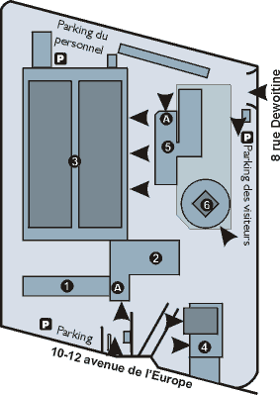
  BATIMENTS
  A) ACCUEIL
  1) GARROS
  2) BOUCHER
  3) BASTIE (HALLE)
  4) SAINT EXUPERY
  5) MERMOZ
  6) BLERIOT

