Mr. Frank Snow, Code 410.0
THEMIS Mission Manager
Goddard Space Flight Center
Greenbelt, MD. 20771

Subject: THEMIS Monthly Technical Report

Dear Frank,

Enclosed is a copy of the monthly technical report for the THEMIS project. Copies have been distributed as itemized below.

Additional details on the status of the program are available at any time at the THEMIS ftp site:

ftp://apollo.ssl.berkeley.edu/pub/THEMIS/1.1%20Management/REPORTS/

If you have any questions, please don’t hesitate to call.

Sincerely,

Peter R. Harvey
THEMIS Project Manager
University of California, Berkeley

Cc: Michael P. Riley, Contractor Officer, Code 210S
Technical Information Services Branch, Code 239
Dr. Vassilis Angelopoulos, Principal Investigator
Dr. David Sibeck, Project Scientist, Code 696

Summary Status and Accomplishments
  - Mission Management
Written by Peter R. Harvey

In July, UCB completed environmental tests of all probes and the Probe Carrier Assembly and went on to complete the spin balance and magnetic verification in the first week of August. At that time, UCB placed the probes on purge and plans to maintain the Probes at JPL.

Launch date is most recently estimated as December 19th assuming that the 2nd stage tank issues are resolved shortly.

1.2 System Engineering
Written by Dr. Ellen Taylor

1.2.1. Requirements and Verification

All RFAs from the Mission PER and past reviews are actively being worked. The MRD was not updated in the last period. The latest release is Rev I provided at the PER.

1.2.2. Integration and Test

All Probes were shipped down to JPL for Environmental Test and have completed the Environmental Test Program with good results all around (see I&T Report).

1.2.3. Resource Budgets

Power and Mass budgets are no longer continually tracked. The Probes were weighed before going to JPL and final weights were determined in Spin Balance. Mass margin continues to hold even though balance weights came in heavier than expected to meet the CG requirement.

1.2.4. Reliability, Safety and Risk

- Risk: Swales and UCB risks were updated in the last period. IV&V risks continue to be discussed. A PCA level test was baselined and performed to better address a “test-as-you-fly.” The successful test retires this risk.
- Safety: Safety issues continue to be actively worked with Safety Working Groups (SWG) Meetings. The final MSPSP was submitted.
- Reliability: Operating time of Flight Actels is being tracked. Operating time on most of the Instrument Suites is above 800 hours.

1.2.5. Engineering and System Change Notices (ECRs and SCNs)

- No SCNs or ECNs were initiated in the last period.

1.2.6. Problem Failure Reports (PFRs)

Two significant PFRs were closed in the last period. The F1 SST sensor was swapped with the spare and F3 FGM Sensor noise was found to be a GSE problem.

Space Segment Development
2.1 Electro Static Analyzer (ESA)
Written by Christopher Scholz

2.1.1. General

The THEMIS ESA team has successfully finished up the full build of all six sets of ESA Analyzers. All units except for the FM 6, which is our spare, are currently mounted on their respective probes, which are down at JPL for build up onto the PCA and ready for environmental testing.

2.1.2. ESA PWB Assembly tasks

The THEMIS ESA PWB’s for FM 1 thru FM 6 are complete. All six units have gone through bench level PWB testing and also an integrated test as a complete analyzer.

The THEMIS ESA PWB’s for FM 6 have finished up their electrical build. All of the FM 6 ESA boards have been cleaned, staked and conformal coated and have been assembled into a complete analyzer.

2.1.3. ESA Testing

The FM 2 thru FM 5 ESA Analyzer are complete and have been installed onto all five Probes. The F2 probe has successfully undergone Environmental Testing at the Probe Level at JPL and now the remaining four probes are ready for Environmental testing at JPL. The F3 and F4 probes have gone through environmental testing, including vibration, magnetics and thermal vacuum. The remaining tasks for the F3 and F4 probes are spin balance and FARO arm alignment measurements. The F1 and F5 probes have undergone their magnetics testing and are currently in Thermal Vacuum Testing and still have spin balance to be redone.
The FM 6 ESA has gone through ESA analyzer level testing and initial calibration. Suite level testing with the IDPU is ongoing. Vibration and thermal vacuum testing will be performed in the future as required.

The ESA team is proud to report that we have completed all necessary testing on the Probe units and that we are now ready to fly. We have overcome some small glitches that are now all resolved.

2.2 IDPU Flight Software
Written by Peter Harvey

Development Efforts. Version 4.01 was installed on the Probes and successfully supported testing at environments. Three change requests were submitted and Version 4.02 modifications made.

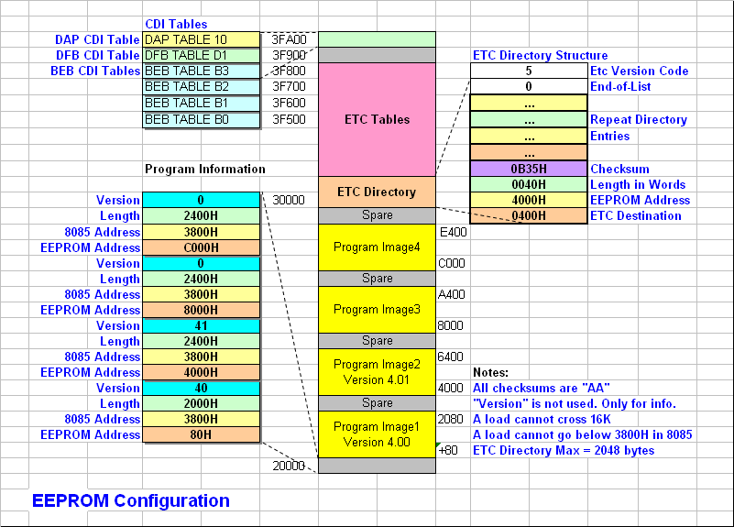

Flight Configuration. The configuration of Flight EEPROMs is shown below. Green indicates the EEPROM is up to date with the latest revision. Orange indicates that the EEPROM has an earlier configuration.

Explanation:
During the period, we had both V4.00 and V4.01 available for tests.
ETC Version 5 was installed on all flight systems.
BEB Tables (rev a) have had their “relay setting” commands removed in rev c.
DFB Table D1 (new transformation matrix) was installed on all but Probe 2.
DAP Table continues to be the non-flight “I&T” version.

Documentation.
The current telemetry database was updated to thm_fsw_003_ctm_v4.13.xls and changes were recorded in thm_fsw_007O_Changes.doc. All changes #55 through #57 are complete.

On Board Scripts.
During the period, FSW developed an On Board Script Database for keeping track of the scripts we load into the IDPU. Each script has an 8 bit Identifier and there can be 16 scripts loaded at a time. These scripts will provide instrument configuration changes needed to handle the various plasma environments expected. Scripts will be started by ATS commands at the appropriate location in space. The database management is documented in thm_fsw_03

3 Mission Integration and Test

3.1 Photo Summary
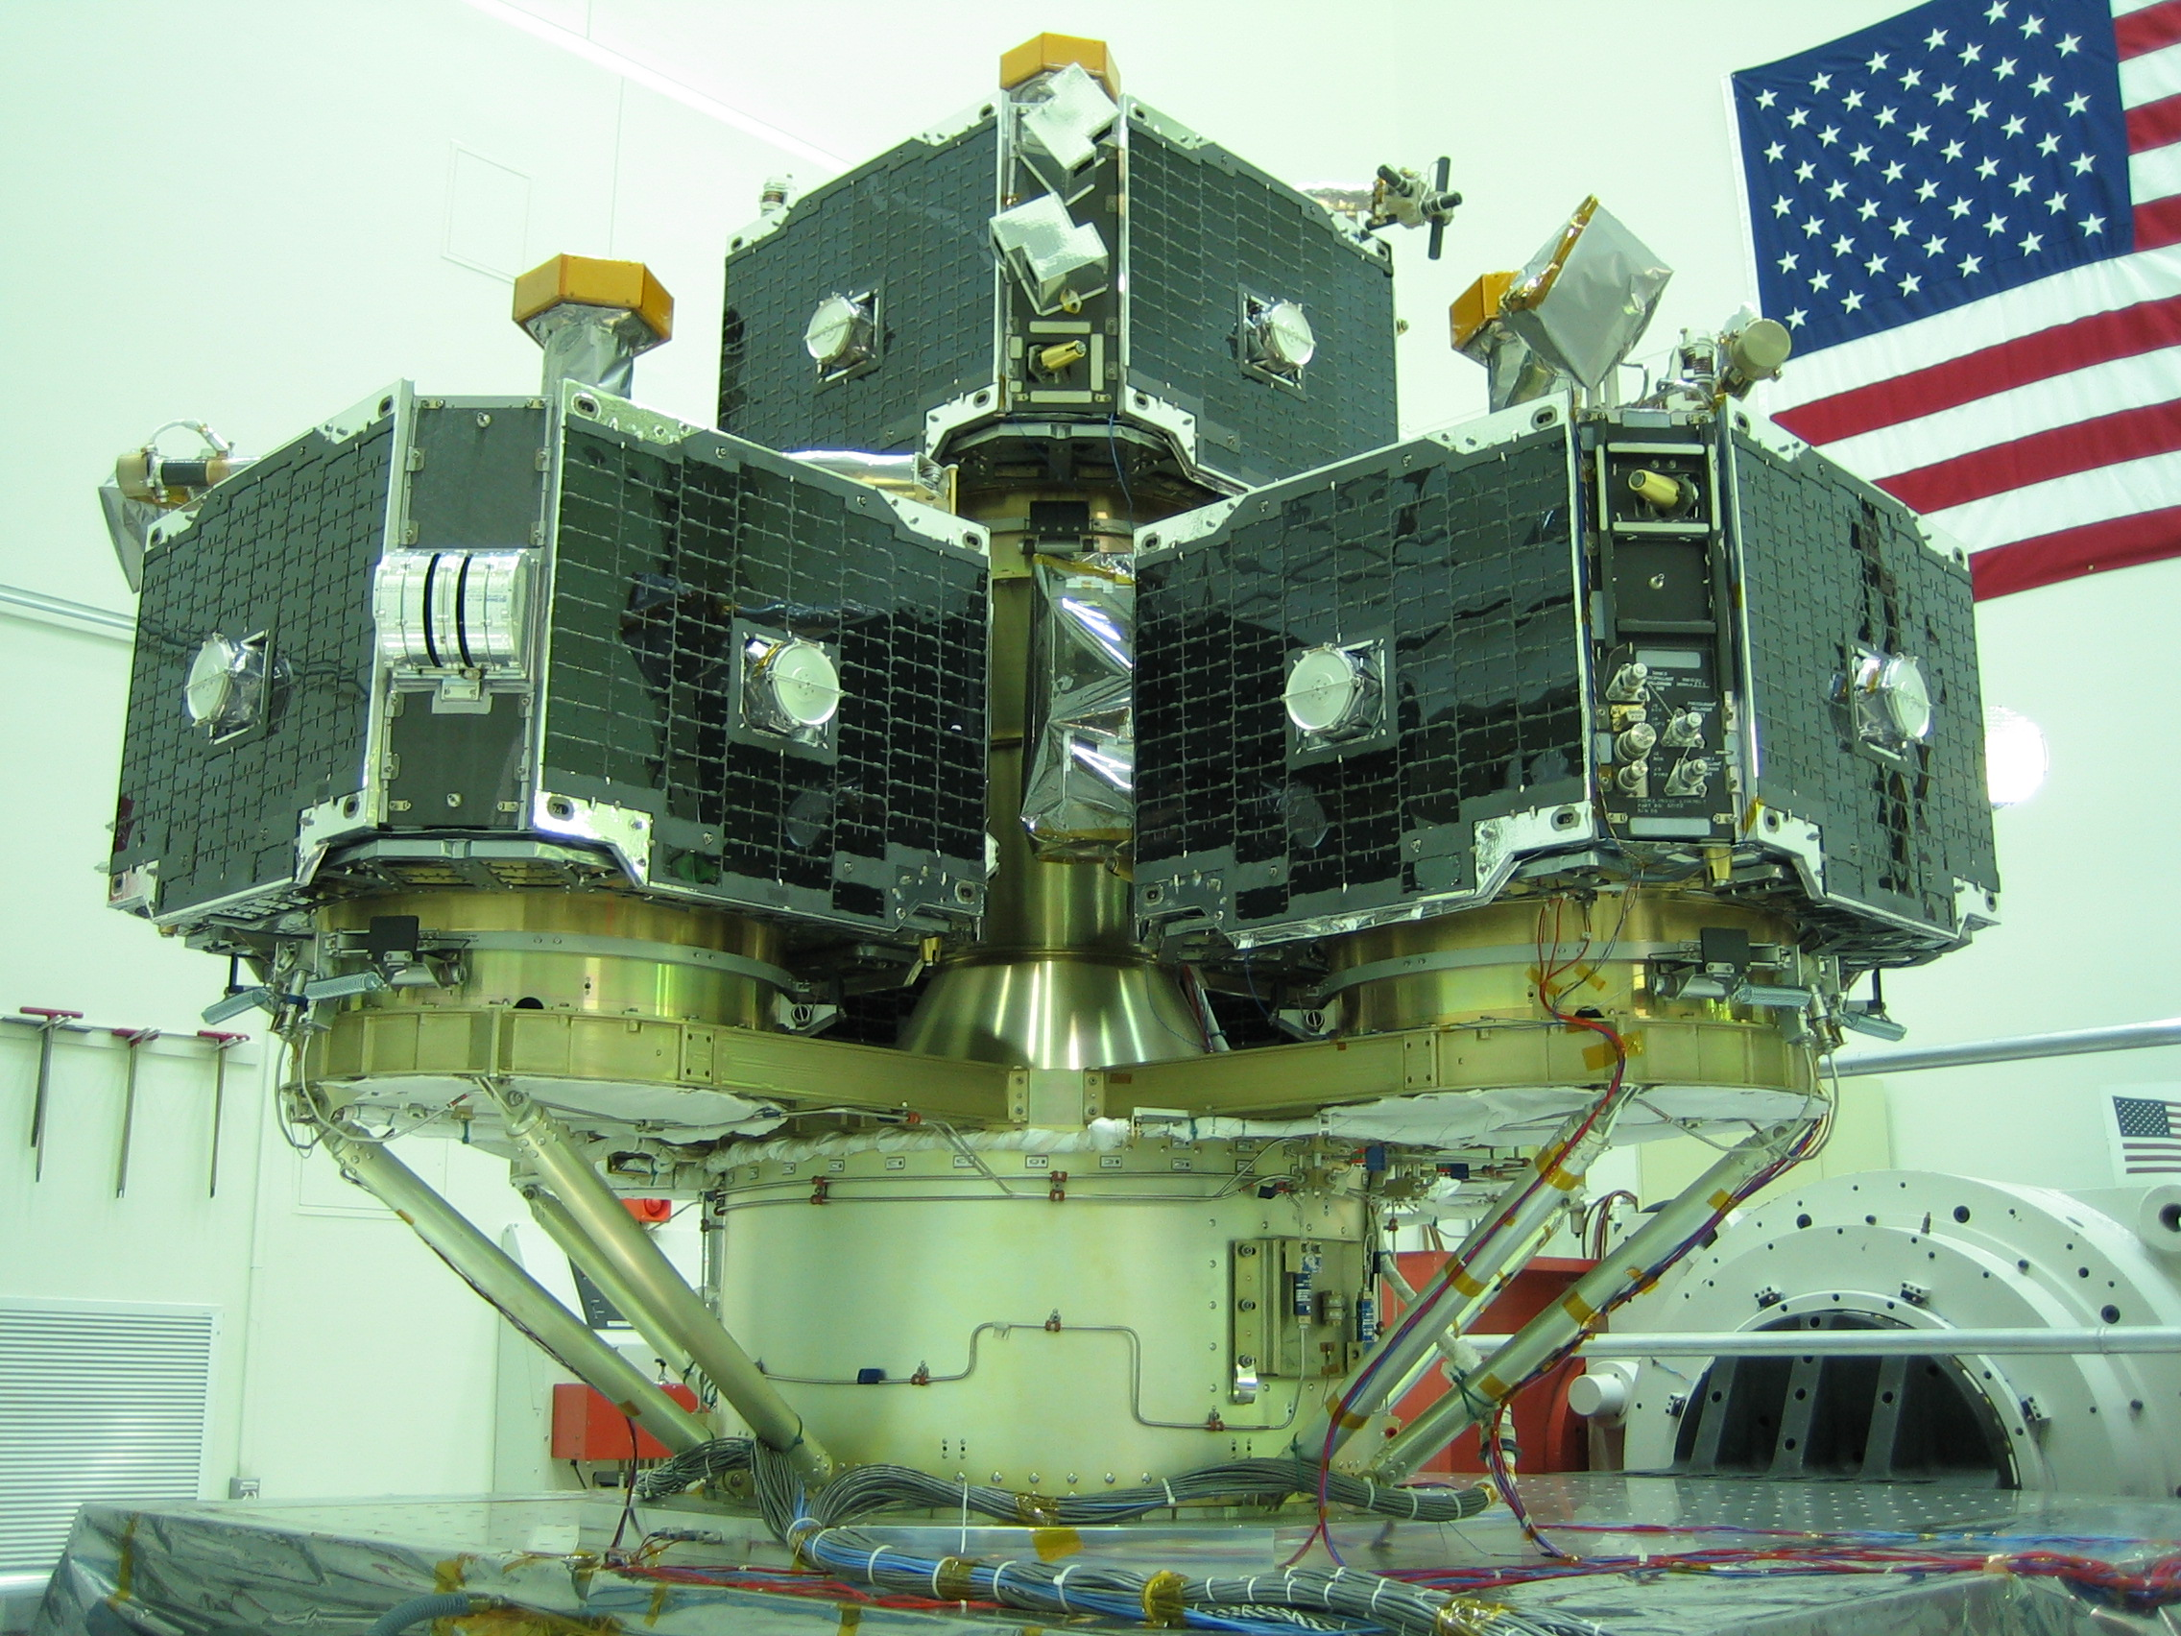
Probe Carrier Assembly (PCA) on Vibration Table

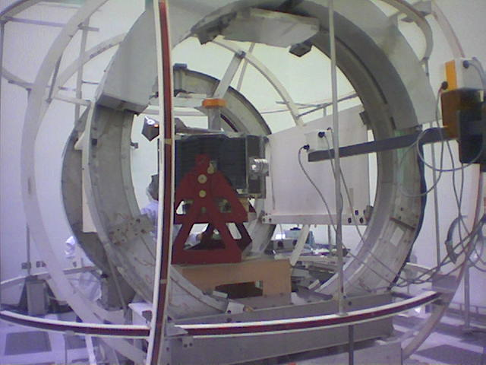
Probe at Magnetic Testing

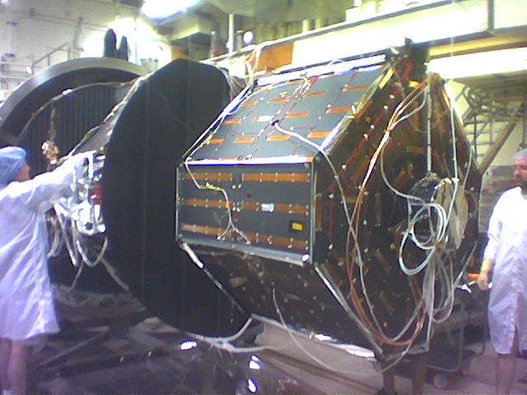
Probes In Their Thermal Boxes Ready for Thermal Vacuum

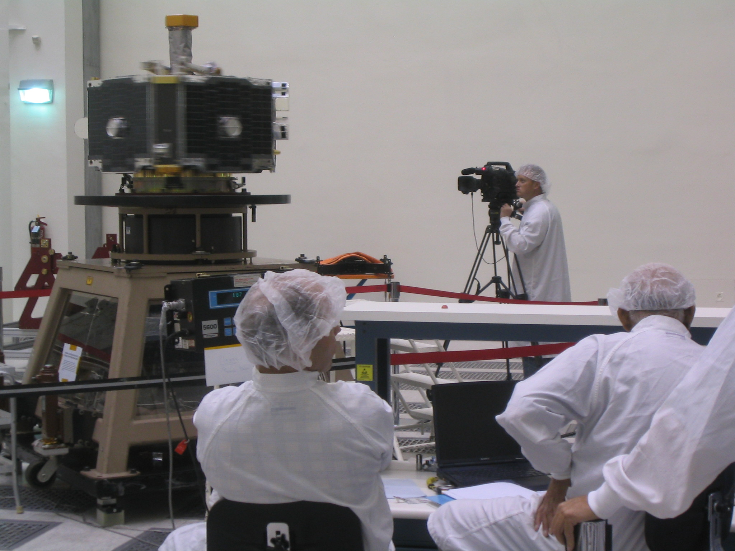
Probe at Spin Balance on the Miller Table

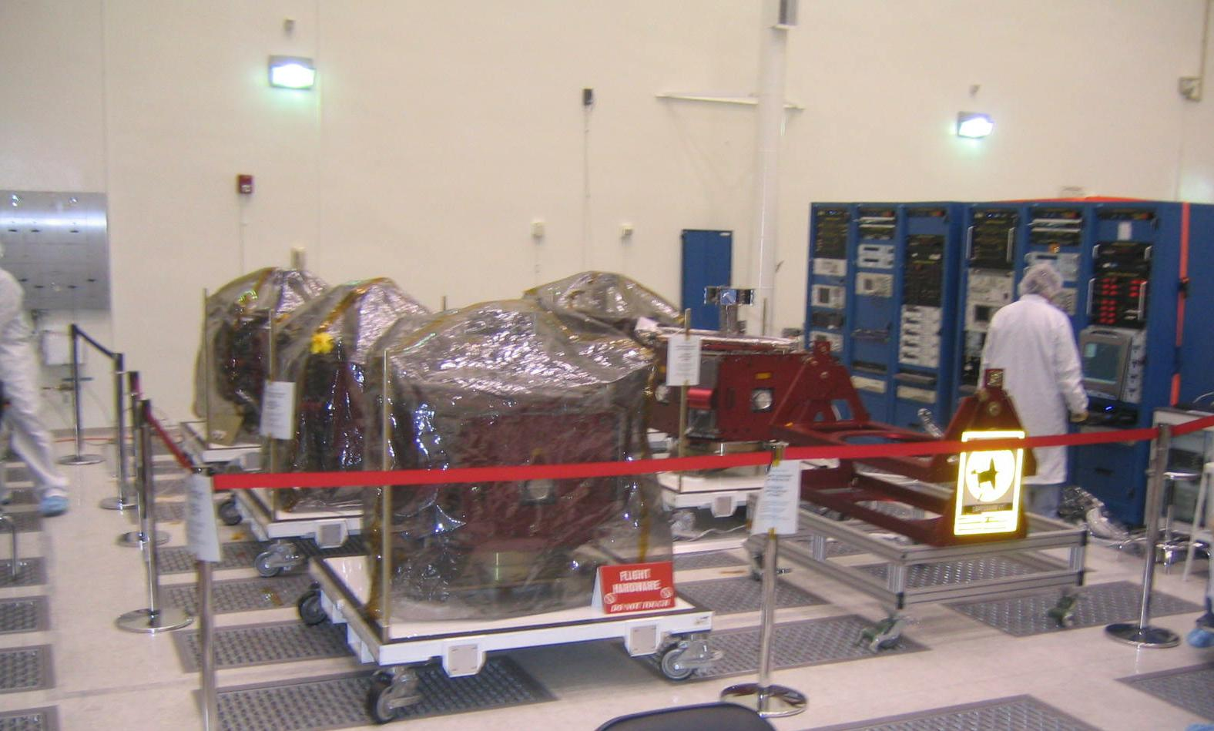
Probes are Stored in Purged Condition at JPL Spacecraft Assembly Facility

4 Integration & Test Preparations for JPL and KSC
Written by Rick Sterling

4.1 Overview

This report covers the period from the second week of July through the second week of August. In this period we completed environmental testing at JPL. Preparations for Astrotech and KSC are ongoing.

4.2 Overview of Environmental Test at JPL
Environmental Testing at JPL is now complete! The sequence of major tests and operations during the past month were as follows.

Week | Major Tests and Activities
July 10 | - Install all satellites on the probe carrier in Launch Configuration  - X and Y axis Vibrations of Probe Carrier Assembly (PCA)
July 17 | - Z axis vibration  - Acoustics Test of PCA  - Separation-Shock test of each probe  - Pressurize/Depressurize Fuel Tanks each probe
July 24 | - Setup for Thermal Vacuum of F3, F4  - Thermal Balance F3, F4  - Hot and Cold Cycles F3, F4  - Magnetics survey of F1, F5  - Spin Balance F1, F5  - Alignment Measurements F1, F5
July 31 | - Magnetics survey F2  - Setup F1, F5 for Thermal Vacuum  - Thermal Balance F1, F5
Aug 7 | - Hot and Cold Cycles F1, F5  - Alignment Measurements F2, F3, F4  - Spin Balance F2, F3, F4  - Move F1, F5 to Bldg 179
Aug 14 | - Spin Balance F1, F5 (repeat/adjustment)  - Post Environmental CPT

  - Overview and Notes on the Environmental Test

Environmental testing of the five satellites was completed on schedule with no major anomalies. Detailed reports and data from each of the major test areas have been or are being prepared by the appropriate engineers.
Following are a few notes and conclusions from the experience:
- The decision to shake the full probe carrier assembly rather than individual probes (or pairs of probes) was a significant improvement. It made the test more flight like, saved schedule time and provided useful experience with the full probe buildup.
- During vibration testing the decision was made to halt the testing at less than the full level. This was a good move. We were able to verify probe and probe carrier assembly integrity without risking a failure due to over-test.
- Performing the thermal vacuum test with two probes at a time worked well and saved considerable schedule time and costs. Suggestion and decision to operate the probes within individually controlled thermal enclosures added substantial work and complexity. Despite this, conclusion of the thermal engineers is that it resulted in significantly better test and resultant thermal modifications.
- Environmental test of the “pathfinder” F2 was very useful and resulted in numerous improvements especially in thermal blanketing. For example the transmitter quickly got hot during thermal testing of F2 and could only be operated for limited time. Thermal blanket modifications were made and then verified during the subsequent thermal vacuum testing of the other probe pairs.
- Spin balance of the five Themis satellites resulted in all five being balanced within specification with approximately 1.6 kgs total balance mass. Substantial benefits were realized with the number of probes. The balancing of the first two satellites was time consuming and initially indicated need for substantially more balance mass (over 3 kgs.). Corrections made with the later probes showed that balance could be improved and the balance mass reduced. The two probes which were the first to be balanced were then re-balanced. The five satellites were shown to have very high degree of uniformity – almost identical balance mass and degree of accuracy.
- Magnetics testing also indicated a high degree of consistency with test results well within specification.

The five Themis satellites and support EGSE are now set up in Bldg 179 at JPL. Plan is to stay there until we receive the ‘green light’ to proceed to KSC.

The probe carrier is temporarily being stored in the Acoustics room at Building 144 at JPL.

We will continue regular electrical, battery and other testing during this time period.
SST and ESA instruments will be maintained on nitrogen purge. There is house supply of nitrogen gas.

  - Preparations for KSC and Launch

- Deliverables – In the past period the following deliverables were submitted:
- MSDS documentation
- New version of the Transportation Plan including information for Astrotech and KSC
- Launch Site Test Plan
- Probe Carrier Lifting and Handling Procedure.
More documents are due in the upcoming period – for example the Process Waste Questionnaire and Chemicals List, Personnel Medical Certifications and Procedures to be run at Astrotech. Completing these documents and plans will be a focus of attention in the coming month.

- EGSE at the KSC and the Pad – In the past month we completed fabrication and testing of the Probe Carrier Assembly (PCA) EGSE. This was used during vibration and acoustic testing which was the first time the PCA was fully assembled. PCA EGSE is working as planned.

- The Payload to Blockhouse Harness as designed by Boeing was reviewed by UCB and Swales. It was confirmed that previously suggested changes/corrections were implemented.

- Test Harness for use at the Pad. To minimize the risk of finding an anomaly in the harness running from the White Room to the Blockhouse we plan to test this harness in advance of the payload arrival at the pad. To do this, we are building a test harness which will connect a Probe Simulator Box with the 2nd stage connector interface. We (Berkeley) have obtained the two necessary connectors which mate with the 2nd Stage. Swales will design and build the interface harness. With this harness we can test the command, telemetry and power signals before the payload arrives at the pad.

- We are ready to support a Side By Side Test whenever the PAF is ready and we receive the ‘go ahead’ from KSC. The Probe Carrier is in its container in a safe location at JPL (Acoustics room). We can transport it to KSC/ASO when the arrival time is agreed. The test can be performed without having to remove the probe carrier container. After the test the probe carrier can be stored in any clean and safe location.

- Some weeks ago we submitted a diagram showing the network requirements for our operations at Astrotech and the pad. There has been discussion and review of the need for a second T1 line running from GSFC to UCB MOC. We have recommended that this request/requirement be cancelled. The reasons are as follows:

  - It is not mandatory to have UCB MOC communication at launch.
  - The existing T1 line has very high reliability.
  - The addition of a second T1 line will take test time and effort on the part of UCB MOC personnel thereby reducing their time available for other necessary tests and preparations.

5 Education and Public Outreach
Respectfully Submitted,
THEMIS E/PO scientists Nahide Craig

5.1 Formal Education

5.1.1. Teacher Professional Development THEMIS/GLOBE Bay Mills Community College workshop at Brimley, MI

N. Craig and S. Odenwald will lead the THEMIS section of the workshop on August 8 – 10. The workshop Materials are shipped to Bay Mills Community College Michigan for the workshop for the tribal school teachers from Mississippi and Oklahoma, Kansas, and Michigan Charter Schools.

5.1.2 GEONS Teacher finalized the Classroom Research with THEMIS Ground Based Data

Alaska GEONS teacher Mr. V. Trautman finished his classroom research calculated the Local B value for Petersburg, AK and Loysburg PA from the archived Magnetometer data and compared. Wisconsin Teacher Wendy Esch also stared a similar magnetometer data research for Wisconsin and will compare it to Carson City NV site.

Mr. Trautman will present this research to GEONS teachers and other colleagues in the future conferences. In the coming school year his high school physics classes will start research with the ground-based magnetometer data.

5.2 Informal Education

5.2.1. THEMIS E/PO Webpage
The E/PO site is updated on the News and Events with the buzzing activities taking place at JPL for the 5 probes and their environmental tests, foreign press from Austria and Canada are posted as well. Recent movies, images are posted as the JPL tests are progressing in The Gallery section.
http://cse.ssl.berkeley.edu/themis.newsandevents
http://ds9.ssl.berkeley.edu/themis/gallery.html

5.2.2. Public Outreach/OPA support:
THEMIS Patch is being updated and KSC will produce copies. We are supporting the GSFC and KSFC PAO groups with resources such as, text, images, E/PO activities and science validation of their materials.
Formal education activity support for NASA GSFC and KSC:
N. Craig provided to the NASA PR and KSC requests for a THEMIS Lithograph for Activity.
Maryland Science Center THEMIS science talk and activity:
As part of the GSFC outreach effort, we set up a THEMIS Science talk and activity for MD Science Center on September 21. The MD Science center staff will present THEMIS activities coordinated by our E/PO group. MD Science Center will also invite teachers to join to the Center via the telephone.
Management: E/PO Sub awards for the Planetarium and Evaluation partners are updated.

6 Problems

New Problems / Problem Avoidance
- None.

Outstanding Problems
- LV oxidizer tank has a leak.

Resolved Problems:
- RCS backup thermostat turns ON at 2.8 degrees and there is concern that the hydrazine will freeze in the lines. The primary circuit is very reliable and we believe capable of flying the mission without the backup.
- LV 2nd stage cannot maintain 6 degree per second roll rate. The proposed 3 degree roll rate was studied by Swales and the array and corner panel temperatures were fine.

7 IV&V
Written by David A. King

7.1 BUS Avionics Flight Software

Build 3.19 of the BAU FSW has been installed on all Probes. A new version of ITOS has been delivered to UCB. It has been tested at UCB and installed into use.
Hammers and Swales personnel continue to support IV&V requests for artifacts or answers to questions.

7.2 Instrument Data Processing Unit Flight Software

UCB Themis personnel continue to support weekly meetings and continue to respond to TIM's written by IV&V by priority. There are currently no open TIM's

9 Safety
Written by David A. King

9.1 System Safety Program Plan

The revision to the SSPP has been completed and has been delivered to GSFC Explorers.

9.2 Final MSPSP and Hazard Reports

The Final MSPSP and Hazard Reports have been delivered to GSFC, KSC, Range and Boeing. Almost all comments written against these documents have been closed. The remaining comments will be closed by the end August.

9.3 Final EWR127-1 Tailoring

The Final EWR127-1 Tailoring has been delivered to GSFC, KSC, Range and Boeing. Almost all Comments written against this document has been closed. The remaining comments will be closed by the end of August..

9.4 Verification Test Log (VTL)

The Initial VTL has been distributed. Assignments to project Safety resources has been completed and due dates set for the verification to be complete.

