Mr. Frank Snow, Code 410.0
THEMIS Mission Manager
Goddard Space Flight Center
Greenbelt, MD. 20771

Subject: THEMIS Monthly Technical Report

Dear Frank,

Enclosed is a copy of the monthly technical report for the THEMIS project. Copies have been distributed as itemized below.

Additional details on the status of the program are available at any time at the THEMIS ftp site:

ftp://apollo.ssl.berkeley.edu/pub/THEMIS/1.1%20Management/REPORTS/

If you have any questions, please don’t hesitate to call.

Sincerely,

Peter R. Harvey
THEMIS Project Manager
University of California, Berkeley

Cc: Mike Riley, Contracting Officer, Code 410
Technical Information Services Branch, Code 239
Dr. Vassilis Angelopoulos, Principal Investigator
Dr. David Sibeck, Project Scientist, Code 696

Summary Status and Accomplishments

1.1 Mission Management
Written by Peter R. Harvey
September 2004 was a very tough month for the project. The bus mass has increased to the point that we will have to remove the Axial E-Field sensors in order to achieve the required orbits. Bus structural fabrication has run into problems making panels. And the Avionics has a tiger team assigned to it.
The schedule is a hot topic of each meeting and every change has schedule impact in mind. It is hoped that everyone in the project is approaching their schedule with the same enthusiasm and commitment to get the job done.
There are many positive steps detailed in the following pages, notably the successful integration of circuit boards in the IDPU ETU, completion of qualification vibrations throughout the instrumentation, and the completion of all ETU layouts. Thirteen flight boards are through assembly and are in test, and fourteen more are in assembly at this point.

1.2 System Engineering
Written by Ellen Taylor

1.2.1. Requirements and Verification - Draft of Revision F of the MRD was released for review. Minor revisions to the MRD were incorporated in response to FSW IV&V review and requests. Verification Plans and Procedures for Instrument testing continue to be developed and formalized.

1.2.2. ICDs and Control Documents - Rev AB of all Instrument ICDs have been signed off except for AXB ICD. Ground System ICDs are in signature cycle.

1.2.3. Resource Budgets - Power, Mass and Data budgets continue to be tracked. Mass of the Probe has increased since the last Systems reporting period. Mass of Instruments has held. Swales has developed and is actively pursuing mass reduction plans. Delta V budget was presented at the FDMO peer review and will be further assessed in detail by AI Solutions.

1.2.4. Reliability, Safety and Risk -
Risk: No new risks were formally added during the last period, although mass continues to be tracked as a high risk.

Safety: Safety issues continue to be actively worked with Safety Working Groups (SWG) Meetings. A Safety Splinter will be held early in the next period at the GOWG.

Reliability: Flight Actels designs for Instruments have started to be reviewed.

1.2.5. Engineering and System Change Notices (ECRs and SCNs) -
No SCNs were initiated in the last period.
No ECRs was initiated in the last period although a few have been discussed to address IV&V concerns about tracking deleted requirements in the MRD.

Space Segment Development

2.1 Instruments

Instrument Data Processor Unit

Boom Electronics Board (BEB).
Written by Stu Harris and Hilary Richards

Activities to report for September.

1. BEB ETU FPGA failure. The Actel ETU FPGA failure report, THM_PRF_001, was written and submitted for sign-off.

2. BEB flight unit status. Jackson and Tull completed their assembly of the flight units, F1 - F6. Minor board rework, due to the problem with the AMUX and Actel interface, was completed on F6. This unit was set up with a socket for commercial Actel FPGAs, to facilitate testing of the flight board layout with a programmed controller. The basic functionality test of this unit began in September. Once the FPGA design has been fully verified, flight quality Actel parts will be installed on the other flight units.

3. EFI GSE unit construction. The construction of a second GSE box, designed to support EFI preamp and BEB testing was close to completion at the end of September.

Planned activities for next period:

1. BEB flight unit, F6, testing will be completed. F1 will begin testing as soon as possible thereafter.

2. EFI GSE #2 unit construction will be completed, and it will be tested.

Digital Fields Board (DFB ).
Written by Jim Westfall

September Accomplishments:

- Implemented a redesign of the Analog to Digital converter interface to change timing and method of time slot allocation in order to reduce cross-talk between channels.
- Designed and implemented derived quantities processor.
- Designed and implemented long-term E offset filter.
- Designed and implemented RAM table upload capability in the command and telemetry controller.
- Implemented an overhaul of the command and telemetry controller to include all telemetry quantities. Also implemented a telemetry processor to provide binning, peak detection, and averaging support.
- Designed and implemented a configuration register transfer protocol to allow configuration of external FPGAs (#2 and #3) using minimal pins.
- Performed parameter cleanup and started code cleanup.
- Updated FPGA pin-outs to provide best estimate of the final pin-outs.
- Updated the command and telemetry section of the FPGA document.
- Updated the schematics to incorporate all the modifications implemented during the ETU and breadboard testing.
- Updated the Parts list and sent to SSL (Jorg) for review.

October Objectives:

- A great deal of functionality was added to the code in September. The code and the documentation need to be updated and cleaned to make them consistent and to ensure that things were implemented correctly.
- Functional and algorithm verification using the VHDL simulation and the breadboard to produce a fully functional version of the ETU board (i.e. includes the recent addition of spectra and derived quantities).
- Flight board designs will be released to the PWB layout house early in October to complete modifications from ETU to FM but the gerber files should not be released for fabrication until a fully functional ETU has been tested and the final pinout has been thoroughly confirmed (through test).
- Work on logic size reduction efforts for the final flight version of the FPGA coding. Currently, FPGA #1 is getting tight…93% C-Cells and 78% S-Cells and FPGA #2 is over its limit 111% C-Cells and 86% S-Cells. To address this situation, emphasis will first be placed on getting a working prototype in the breadboard and then subsequently on reducing the logic size and/or porting the logic to a third FPGA once we have a known quantity to work with. Putting efforts to address sizing before functionality have been a major factor affecting the amount of time required to implement the design to this point and we would like to remove this inefficiency in order to more quickly get a working prototype to begin full-on testing of the algorithms.

Data Controller Board (DCB)/ Flight Software
Written by Dorothy Gordon

1. DCB Integration
Performed second interface test during the last week of September (BAU Processor board to IDPU Processor board) at Swales: exercising the Command, Slow Telemetry and "High Speed" Telemetry I/Fs using the DCB running the IDPU flight software.

2. DCB-PCB
One of the Rev. B Printed Circuit boards (which will serve as the 4th DCB-ETU) has been populated and tested. The Rev. B boards are ready for flight part population, which we expect will occur at the end of October.

3. DCB-FPGA
DCB-FPGA Rev. 5 is stable, and installed on all four DCB-ETUs. The goal now is to generate test software which stresses the DCB subsystems to their maximum capacity, and thus verifies both design functionality and performance.

Work is ongoing to generate the automatic checking programs (which run on the host PC) that verify the High Speed Telemetry frames as the DCB runs dedicated test suites. (Still need to splice the "instrument simulator" into the procedure -- the GSE firmware to support this is almost completed.) This test software will be used to verify both the
FPGA/PCB design and the Flight DCBs (migration to the flight FPGA die as well as general flight board checkout).

IDPU Software (FSW)
Written by Peter Harvey

I&T. The IDPU processor was interfaced to the BAU processor card and the interface signals were checked. While the sun pulse, the UART commands and telemetry were checked, there was no success on the high speed telemetry. While the IDPU cranked out high speed telemetry upon command, the BAU was neither able to properly receive the transfer in hardware nor process the data through to the ground ITOS. Thus, we were unable to verify that any IDPU telemetry product is acceptable to the ground system. This, test will have to be repeated again when the BAU is ready for it.
Memory Utilization. PROM, EEPROM and RAM utilization is tracked periodically. The overall strategy, of course, will be to put all LEO-required modules into the PROM, followed by as many other modules as can fit. The rest will be put into the EEPROM and loaded in the first few seconds after turn-on.

IV&V. During the last period, we collected together the changes IV&V required and distributed a new SRS (Rev E) for signature.

Power Control Board (PCB)
Written by Craig Domeny

The first assembled PCB-FGE flight unit has arrived; the FGE circuitry has undergone an initial checkout. The PCB portion is awaiting test. The next four flight units are due by October 22nd. The final flight spare unit is being assembled in-house.

The PCB Tester/Load Simulator is functioning on the bench and is in final checkout. The PCB/FGE test plan is 80% complete and will be finalized as a PCB/FGE ETU is being tested in preparation for TV testing at the end of October.

Electric Field Instrument (EFI)

Spin-Plane Boom Mechanisms
Written by Bill Donakowski

Progress
- EM Unit Status
  - Second Generation’ prototype (new Snout Doors and Release Mechanism) completed and ready to be tested
  - Mods to prototype incorporate slight design changes; retesting to ensure qualification of flight design
  - Vibration Testing scheduled for 12 October 2004
  - Thermal Vac to follow, approx. 13-15 October 2004
- Test Fixtures
  - All Test fixtures completed and ready for use
  - Design and fab of shipping containers started

- Facilities
  - Room 20 TV Tank ‘Bayside’ working without problems
  - Large TV Tank Development
    - Most hardware being completed; assembly continuing

- Flight Hardware Procurement Status
  - All Flight Hardware in-house

- Flight Units Build: F1 Units
  - Most Sub-Assys completed and sitting on shelf
    - Motors
      - F1 units built up and mag tested (UCLA)

    - Key Reel/Sphere Assy begun
      - Sphere Dag Coating taking place this week
      - All Key Reels completed

    - Electrical wiring of first 4 units started

    - Spools done

    - Structure
      - All magnesium Panels in-house
      - X-Ray testing completed (no rejections)

    - Coaxial Cable fabrication approx 80% complete

  - F1 Flight Build to continue this month.

Concerns
- None at this time

2.1.2.2 Axial Booms Boom Mechanisms
Written by Robert Duck

- Design
- AXB tube height will be shortened. Swales is working on antenna design and height should be finalized soon.
- Waiting on Swales for pressure tank mount design, and antenna mount design.
- A new ground wire was added to connector assembly, and solder lugs were ordered.

- Deliverables
- A second horizontal deployment track was ordered to reduce testing times.
- F1 AXB tube has been received.
- Horizontal TV track components have been received.
- More electrical solder lugs ordered and received.
- All mechanical parts received for all flight units.
- F2 stacers painted and received.

- FLIGHT Assembly
- Sensors for F1 have been tested and new tip pieces are being made to custom diameters for each sensor.
- Approximately 50% of the smaller AXB sub-assemblies have been made for F1 - 6.
- Pre-cable assemblies will be built once stacer lengths have been frozen.
- ProtoFlight has stacer trimmed and installed, next stage is cable integration.

- Documentation
- All electrical procedures have been revised, reviewed and approved.
- Approx. 80% of the mechanical assembly procedures are in place and approved.

- Testing
- Flight sensor testing is ongoing. Flight 1 sensors have been screened and tip pieces are being made to fit each sensor. Subsequent flight sensors will be tested and fitted as flight boom are built.
- Horizontal deployment track is assembled and protoflight will be used to test and debug the track prior to operation within thermal chamber and flight 1 assemblies.

Electro Static Analyzer (ESA)
Written by Bill Elliott

- Inventory of currently identified Flight Parts is complete with the exception of the SMA Actuators which are partly complete with the rest scheduled to be available in the next two weeks.

- Continued sub-assembly of ESA Mechanical Components.

- Continued to Work With the Electronics Group to Finalize the Mechanical-Electronic Package Interface Specifications and design and procure the small number of minor mechanical parts associated with the electronics systems.

- Performed Successful Qualification T-V Test of Release Plate Assembly and SMA Actuators. Four Cycles of Successful Actuation of the Mechanism at -40C and +50C Using each SMA’s Individually.

- Performed Successful Qualification Vibration Test of Combined ESA + IDPU ETU on 10-5-04. No problems observed. Frequencies and Levels within acceptable limits. SMA Actuators fired without incident.

- Prepared Spreadsheet Analysis Predicting SMA Wire Temperatures and Cooling Times. Used this data in conjunction with T-V data to develop SMA Actuator power pulse length requirements.

- Prepared and Released Assembly and Test Procedures: THM-ESA-PRC-003 (ESA Mechanical Assembly Procedure), THM-ESA-PRC-006 (SMA Cycle Test Procedure), THM-SST-PRC-015 (SMA Assembly Procedure) and ESA TORQUE CHART WME

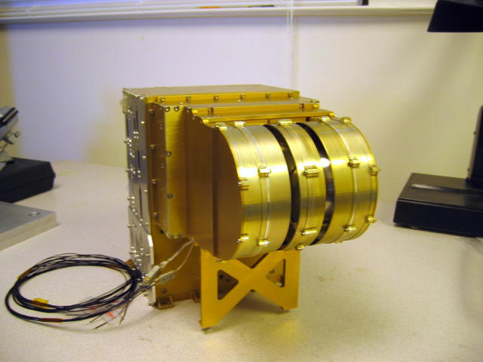
ESA + IDPU ETU
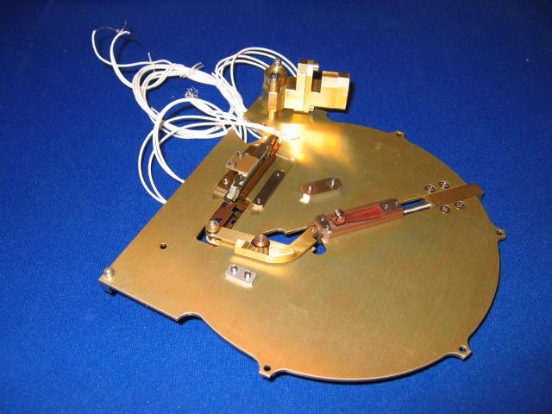
ESA Release Plate Mechanism

- ESA Mechanical Activities This Month (September):

- Continue Sub-Assembly of Mechanical Components of ESA Flight Units.

- Design and Procure ESA Calibration Manipulator Fixture Components.

- Prepare ESA Ground Support Equipment such as the Nitrogen Purge System.

- ESA Mechanical Activities Next Month (October):

- Assembly of 6 FLIGHT ESA-Mechanical Units

Solid State Telescope (SST).
Report written by Robert Lee

Flight Units:
- Design:
- No actions taken

- ICD for Integration with Bus:
- Updated and verified SST sensor mass

- ETU Testing:
- Mechanical fixturing for instrument level thermal-vacuum test fit checked
- Qualification level thermal vacuum test performed from September 14-17, 2004
  - Attenuator mechanism successfully operated at hot and cold operating limits under vacuum
  - Post-test inspection of mechanical components performed
    - Fasteners intact and did not show loosening
    - Support structure undamaged
    - Attenuator mechanism undamaged

- Received mechanical fixturing and support components for ion beam measurement

- Flight Units:
- Flight collimators, for FM2 through FM6, being plated and coated (ETA: late October 2004)
- Baked out bronze components for FM1 through FM6 (September 7 through 9, 2004)
- Flight switch assembly components received (September 15, 2004)
- Flight magnet yokes received (September 10, 2004)
- Flight support structure components received (September 30, 2004)
- Flight attenuator assembly cams sent out for titanium nitride coating received (September 3, 2004)
- Flight attenuators received (September 15, 2004)
- Flight aluminized foils received (September 17, 2004)
- Backshells for 26 pin high-density connector to allow for cable potting (THM-SST-MEC-605 and THM-SST-MEC-607) received (September 30, 2004)

Search Coil Magnetometer (SCM).
Written by Abdel Bouabdellah, Christophe Coillot, Bertrand Delaporte, Olivier Lecontel, Alain Roux.

- Sensors
- EM: Manufacturing of sensors:
- Ready to be delivered to UCB.
Qualification of potting during thermal cycling (3 cycles : [-100°C; +85°C]), five technical solution have been tested in a cold chamber (figure 1) and in a hot one (figure 2). All solutions have withstood the temperature cycling. So, we have chosen the easiest solution to implement for FM :
  - Extra thickness of potting of 0.5mm (remains compliant with specified mass).
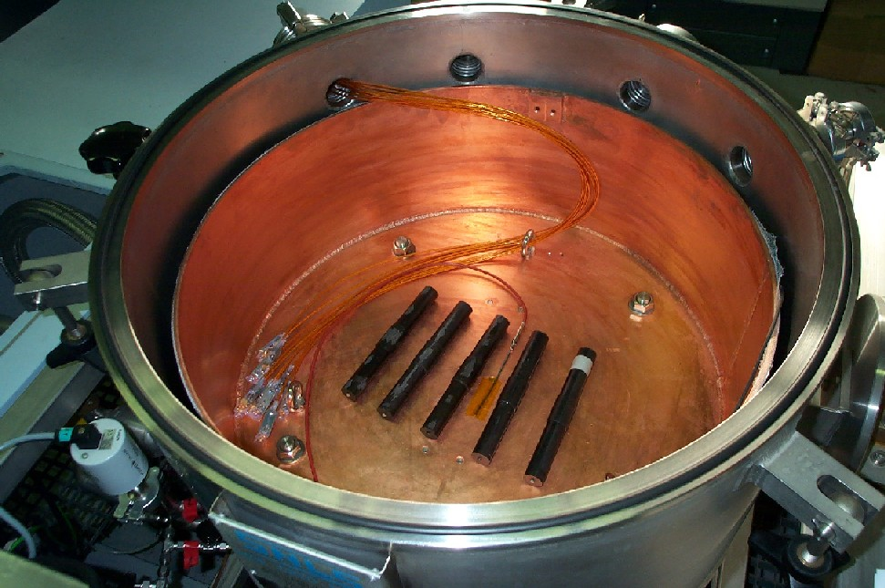  Figure 1 | 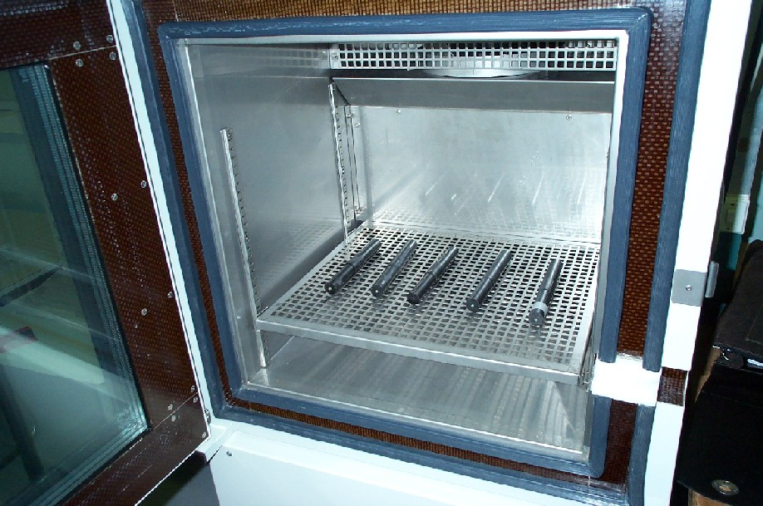  Figure 2

FM:
Manufacturing of sensors :
FM1-2 & 3 :
- Winding is finished.
- Magnetic core assembled and potted inside the wound tube (Figure 3 shows 3FM sensors at this step, just before potting, electrostatic shielding of the sensors can also be observed).
- Potting is undergoing
FM4-5 & 6:
- Winding is finished
- Magnetic core assembly & tests are in progress
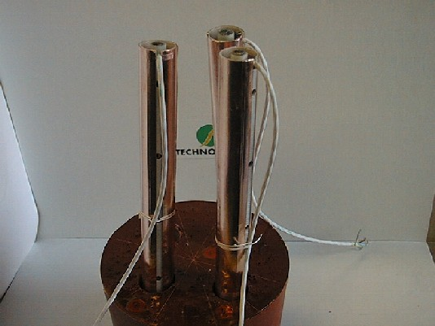
Figure 3

- Preamplifier
- EM : Already delivered to UCB by CETP.
- FM1, 2 & 3 : Assembly, vibration test and electrical verification of FM1, 2 & 3 have been done. One PA (FM3) presents a different level of calibration signal. A NCR is in process.
- FM4, 5 & 6 : Assembly has started on October 11
- Preamplifier box
- All 6 FM boxes have been delivered.

- Mechanical structure of tri-axis antennas
- FM manufacturing has begun (as vibration test & thermal tests were compliant), delivery expected in mid October.

- Harness SCM to PA
- FM : Expected to be delivered from UCB.
- EGSE
- Bench test has been manufactured and used for temperature tests, 3 models are under manufacturing to support tests and integrations (CETP).
- Interface for Calibration at Chambon la Foret is still under definition (CETP/GDTECH).

- FM Tests
- Following tests have been completed successfully:
  - Mechanical vibration of PA FM1,2 & 3 (at IAS) : compliant.
  - Potting qualification from –100°C to +85°C : compliant.

- Following tests are scheduled :
  - Thermal cycling of PA FM1, 2 &3 (at Saint Maur): end of October (tbc).
  - Thermal cycling of SC FM1, 2 & 3 (at IAS : tbc): beginning of November (tbc).
  - Mechanical vibration of SC FM1, 2 & 3 (at IAS): mid of November (tbc).
  - Calibration at “Chambon la Forêt” FM1, 2 &3: mid of November (tbc)
- Integration at UCB:
  - Date to be confirmed (UCB)

Magnetometer Booms
Written by Tien Fak Tan

- Design.
- All flight hinge parts released to machine shops after accommodating final harnesses.
- Developed alternate, lighter design for composite booms and constructed a set of prototypes tubes. These tubes will be evaluated and tested.

- Fabrication
- Fabrication of hinge parts in progress.

- Testing
  - Designed and fabricated vibration test fixtures. Test in early October.
  - Designed and fabricated deployment test fixtures. Test in early October.

- Others:
- AXB Mandrel reworked to 3.991". One FLT layup tube produced.

2.1.7 Facility Development

2.1.7.1 Calibration Chamber (Ion Gun Facility)
Operational.

2.1.7.2 Thermal Vacuum Facilities
Written by Sharon Jelinski

- Bayside (Small) T/V System, Room B20, in use.
- Bayside system is in use practically full-time. Instrument tests in Bayside include: engineering test units of SPB, SST, and Preamps for IDPU
- Bayside system operations have ranged from 80C to –145C, while maintaining a base pressure of 5 e-6 torr.
- TQCM outgassing rates have steadily decreased with successive users and bake-outs. Setting the TQCM to –20C for periods of at least 30 min, recorded rates are:
  - 2.2 KHz per hour when everything is baking at 60 degrees C.
  - 20 Hz per hour when everything is chilled to –125 degrees C.
  - Below 100 Hz per hour when everything is at room temperature.
- Final tasks that have been closed out include:
  - Final cleaning of chamber and replacement of TQCM head.
  - Final measure of baseline TQCM and RGA.
  - Upgrade LN2 valves, buy larger units and build a new manifold.
- Remaining tasks that are needed:
  - Check fine-tuning of cooling system control for less overshooting.
  - Finalize system documentation with user procedures for the full system, with additions for data storage and retrieval procedures.
  - Eventual LN2 connection to large LN2 bulk tank if and when available.

- THEMIS Snout T/V System – Fabrication in progress

- SSL successfully installed and wired Arcol resistors to the baseplate and shroud.
- SSL painted inside surfaces of shroud with Z307 and then returned baseplate and shroud to Transfer Engineering for final assembly.
- Transfer Engineering integrated the shroud and baseplate into the Snout vacuum chamber and found small leaks in the LN2 pluming system. There were multiple attempts with multiple repairing of leaks at the following locations:
  - The copper tubing line below the shroud, which had been Ni coated, was bent slightly to fit into the chamber. That bend caused a small leak.
  - The copper tubing along the top of the main shroud had a few fine holes.
  - The door shroud had a bellows that had been visibly scratched.
  - A few of the baseplate square copper tubing to mini conflat joints had to be re-welded. Most likely the tightening of Cu gaskets strained the joints.
- As of today the Snout system has been verified by SSL as leak free at TE
- TE will ship the Snout system and 2 lengths of 10 ft snout tubing to SSL on 10/13
- The Snout system shall be fully integrated at SSL within a week and ready for it’s first instrument test user by October 20^{h} .
- Therm-X thermal system controller is already installed into vacuum cart, but must be connected to electrical systems once cart arrives at SSL.
- Support systems to be installed at SSL include:
LN2 lines mounted to the cart, connect Therm-X lines and test, snout supports put in place and snout tubing installed, false door installed over cart midsection.

- BERTHA T/V System, Room B20, Fabrication in progress.

- All shroud section and baseplate have been received from vendors.
- Shroud pieces and resistor clamping plates have been painted with Z307.
- SSL shop has completed insertion of copper tubing in baseplate and cleaned.
- Shroud Arcol resistors are currently being installed and wired.
- Baseplate resistors will soon be installed and wired.
- Therm-X thermal system controller is due for an SSL acceptance check on 10/13.
- Thermal control rack and support equipment have arrived.
- Electrical feedthru flanges are on order to mate in house 4” SSL flanges to standard 2.75” Conflat flanges. This is to facilitate using new FT’s similar to the other two chambers. Butt the existing 4” SSL flanges still have useful FT’s.

Probe and Probe Carrier
See Reference: ftp://apollo.ssl.berkeley.edu/pub/THEMIS/1.1 Management/REPORTS/thm_monthlyreport_0409_ppc.pdf

3 Ground Segment Development
Written by Manfred Bester

3.1 Mission Operations Development

3.1.1 Mission Design
Contributed by Sabine Frey

The THEMIS flight dynamics team further improved the IDL and GTDS based mission design code which is used to develop detailed orbit placement strategies and timelines for all five probes, independent of the launch date. The orbit placement is optimized for maximum conjunction time, minimum shadow duration and minimum number of maneuvers. The maneuver sequence itself is optimized for lowest delta V with the least amount of operational complexity and built-in slack to allow for probe and instrument commissioning, orbit determination and recovery from various contingencies.

The effect of different launch RAAN values of 322, 312, 308 and 302 deg on shadow durations, conjunctions and accumulated delta V was explored. It appears that the most favorable RAAN falls near 308 deg, resulting in acceptable shadow durations and conjunction hours. The accumulated delta V for P1 for the entire mission is 720 m/s. Further refinement of the orbit placement is under way. The current state of the mission design was presented at the THEMIS Flight Dynamics and Mission Operations Review, held at Swales on October 5, 2004.

A statement of work for AI Solutions to configure their FreeFlyer software for THEMIS maneuver planning is being finalized. FreeFlyer will be used to obtain the optimum trajectory and to verify the delta V usage for each orbit maneuver. A second statement of work for orbit determination training has been developed and will be submitted to obtain a quotation.

3.1.2 Ground System Development
The development of the THEMIS ground data system is well on its way. The envisioned architecture for THEMIS is built on top of the existing multi-mission operations environment already in place at the Berkeley MOC. Additional software tools will be implemented to streamline data flows, to generate constellation overview displays and to populate databases with probe telemetry points. The latter will allow efficient access to telemetry archives for data trending and event analyses.

The MOC expansion has been completed and the operational consoles for FAST and RHESSI have been moved into the new room (237) to provide desk space for THEMIS consoles in the larger room (239). The workspace configuration for THEMIS mission operations and I&T was nearly finalized. A Linux workstation was procured and is currently configured to test the first THEMIS version of ITOS. The final design for the THEMIS Attitude Determination System is complete, and a requirements document has been released for review.

3.1.3 Mission Operations Planning
Regular telecons between Swales, Hammers and Berkeley operations team members were held to discuss operations related matters in the areas of telemetry and command processing, flight and ground software development and configuration, I&T related issues, development of operational procedures, flight rules and recovery from contingencies. A timeline for early orbit and normal operations is under development in collaboration with systems engineering and pertinent instrument scientists.

3.1.4 Ground Station and TDRSS Support
An RF ICD covering all interfaces between the probes and the ground stations as well as TDRSS is developed in collaboration with GSFC Code 451 and will be signed shortly. The PSLA for FY04 covering THEMIS support activities for NASA/GN, SN and FDF was signed in September.

3.1.5 Berkeley Ground Station
All items for BGS hardware upgrades have been delivered and are currently tested off-line prior to integration into the ground station. These include the Carrier Doppler Measurement System, Tracking Data Formatter, 200-W transmit power amplifier, receiver IF filters to match THEMIS data rates, a precision timing system, and a solid-state matrix switch for routing of baseband signals. Redundant serial servers that allow for remote control of RS-232 devices via TCP/IP network sockets have been fully integrated placed into operational status already. Plans to supply the antenna subsystem with back-up power provided by a Diesel generator are developed. All systems within the MOC are connected to the back-up power circuits already.

A matter of concern is the recent gear failure of the DataLynx 11-m antenna at Poker Flat, which is the twin of the Berkeley antenna. UCB is working with GSFC Code 544 and with the antenna manufacturer (L-3 Communications / ESSCO) to assess whether the BGS gearbox upgrades implemented in 2002 fixed the original design flaw, or if other measures need to be taken to maintain a reliable operational status. An inspection of the gear boxes is scheduled for October 26, 2004. For this purpose the azimuth motors and gear box covers will be removed temporarily. The system will be out of service for approximately 8 hours.

3.1.6 NTIA License
The Berkeley team worked with the GSFC Spectrum Management Office to prepare the application for the THEMIS NTIA license. Preliminary S-band frequencies were assigned to THEMIS and approved by the DoD. The GSFC Spectrum Management Office submitted the Stage 2 application to the NTIA, and approval is expected by late 2004.

3.1.7 Personnel
An additional member of the Flight Dynamics Team has been hired on September 3, 2004 to support mission design, maneuver planning and orbit determination. A second position for ground systems software support, in particular ITOS and MPS is still open and is expected to be filled by end of October 2004.

3.2 Ground Based Observations Developments
Written by Stewart Harris

1. Activities reported for September

1. Production Unit Deployments Status.
- GBO#3 - Deployed and operating in Prince George, BC, Canada since September 24th. All Sky Imager is mounted on 40' tower, erected by site custodian, Frank VanderZande. See attached photo.
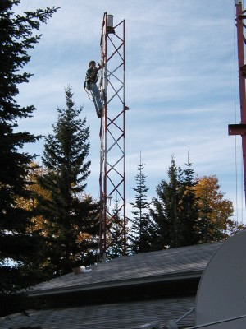

- GBO#4 - Contruction was completed during this period and detailed check out was begun. While this unit was scheduled to be deployed in McGrath, AK, it is being rerouted to the Ekati Diamond Mine in Northwest Territory, Canada. The reason for this is largely so that deployment can take place before harsh weather sets in. In addition, the contract for custodian help in McGrath has been delayed.

2. Production unit fabrication.
Construction of units is slipping behind deployment schedule somewhat. This is largely due to competition for technician time building flight instrumentation. Some design modifications in ASI sun shade driver and ASI temperature sensing were incorporated in ASI systems with long cables.

3. Schedule for GBO deployment.
- GBO#4 - Scheduled for installation at Ekati Diamond Mine near Lac de Gras in mid-Oct.
- GBO#5 - Scheduled for installation at McGrath, AK in mid-Nov.
- GBO#6 - Scheduled for installation at Flin Flon (Canada) TBD.

4. Software activities.
. Software for both ASI and GMAG has continued to be upgraded, especially in response to field activities.

Planned activities for next period:

1. Deployment and construction activities will continue.

2. A visit to Athabasca is planned to repair the ASI, which is exhibiting power problems.

3.3 Science Operations Centre Developments
No report this month

4 Education and Public Outreach
Respectfully Submitted,
THEMIS E/PO scientists Nahide Craig, Laura Peticolas

Formal Education:

The UCB E/PO team ordered magnets and compasses for 12 GEONS teachers. Only 40 magnets were in stock at Arbor Scientific so the E/PO team sent magnets and compasses to 4 teachers and waited for the backorder request to be shipped. A CD with the THEMIS GEONS July workshop PowerPoint presentations on them were sent to all 12 teachers.

S. Odenwald’s teacher guides titled: “The Northern Lights”, “Solar Storms and You”, and “Exploring the Earth’s Magnetic Field” were printed for distribution to the 12 teachers and sent.

School started for the GEONS teachers. Many of them have planned on using the lessons that were presented at the THEMIS GEONS teacher workshop in July in their classes as well as incorporating auroral and magnetospheric physics in their classes in a way that makes most sense for their curriculum.

Informal Education and Public Outreach

N. Craig and L. Peticolas participated in the Idaho National Engineering and Environmental Laboratory (INEEL) Science and Technology Expo in Idaho Falls, ID September 23-25. For this intensive outreach event, we had several tables set up to hand out materials and perform hands-on activities. Over 6,500 students and over 3,000 teachers, parents, and chaperons attended this three day event. At our booth we handed out THEMIS flyers and demonstrated four hands-on activities through our Exploring Magnetism Teacher’s Guide. We took a Sun-Spotter which the Idaho Falls Astronomical Society used at their booth outside. We partnered with Montana and Idaho Space Grant Consortiums, which provided travel funds, and the SECEF, which provided materials from the Sun-Earth scale model activity to aurora books and posters to star pencils. To find out more visit the URL: http://www.inel.gov/techtransfer/expo/

We also gave two different talks for the Astronomy Club of the Idaho Falls Astronomical Society; one about Sun-Earth Connection science and the other one about the UCB’s SEC Missions and their E/PO programs.

The THEMIS informational flyer was updated with comments from THEMIS scientists: V. Angelopoulos and C. Russell, and from an outside science reviewer, R. McPherron. 15,000 copies of the updated version were printed and 10,000 sent to CORE for dissemination of other SEC-themed materials as part of the Ancient Observatories Theme for this year.

S. Odenwald of E/PO partner wrote a Press Release for the teachers to use with their local communities when the magnetometer at their school is installed.

With the PI and PM and the IDEUM design group, we have finalized the design of the THEMIS Logo.

w/ GBO science team:

L. Peticolas helped S. Harris and J. Keenan with the McGrath site installation and contract.

Cross Cutting:

We reported more than a dozen events/activities of THEMIS to EDCATS

5 Problems

Outstanding Problems

New Problems / Problem Avoidance
The first two probe bottom panels have been manufactured with serious defects, so that neither is able to be used for flight probes. As the bottom panel is on the critical path for the fabrication of the probe, these failures will have impacts in the probe assembly schedule.

The Bus Avionics Unit

Resolved Problems
ESA layouts have completed.

6 Risk Management
The Risk Management Board (RMB) is ready and waiting.

7 Performance Assurance
Reported by Ron Jackson

Equipment Calibration
Equipment calibrations proceeding on schedule and working well.

Compliance to ESD requirements
Training and certification is 95% complete.
3 new workstations setup and working.
ESD table top audits checkout ok.

Workmanship Procedures/Processes
ESA anode boards, THANC and TLANC sent to Valley circuits for fabrication.
DCB at board at J&T for assembly.
Flight assembly at Jackson & Tull - PCB/FGE 70% complete
Motors assembly inspections- complete by UCB QA/GSFC
SPB assembly inspections- complete by UCB QA/GSFC
AXB assembly inspection- complete by UCB QA/GSFC
Assembly Instructions/ BOM
PCB/FGE - complete
DCB, DAP,DFE - AI and BOM complete
ESA LVPS kit complete, RFQ in process.
DFB BOM complete- Gerber scheduled to complete by week 3 of October.
Motor assembly BOM complete
SPB assembly BOM complete
.

Evaluate/Audit Contractor Shipments
Total number of EEE items received 86 shipments
Total number of EEE items received discrepant-20%
Type of EEE part discrepancies:
No date code or lot number provided
Missing Certificate of Conformance.
Qty delivered different than PO.
Vendor audits - UCLA cable harness assembly - Checked out OK

Clean Room Control
Large clean room is still under renovation- Operational by 11/1/04
Bayside is operational and weekly particle counts will start by 11/1/04

Data Packages and Logbooks
BEB testing in progress
PCB/FGE ETU testing in progress

Nonconformance Reports and Problem Reports
None

Material Handling and Shelf Life Storage
None

8 IV&V
Reported by David King
1. Themis has now responded to all BAU and IDPU IV&V Flight Software Requirements comments. BAU 104 of 104 (100%), IDPU 54 of 54 (100%) and the two System comments will be responded to in October.
2. A Flight Software Data Format Spec was sent to IV&V.
3. Themis will be beginning to respond to IV&V Flight Software Design comments in October.
4. A revised MRD, Telecommand Format Specification and IDPU Flight Software Spec will be sent to IV&V in October.

9 Safety
Reported by David King

The following Themis Safety Issues are to be reviewed in October at the GOWG (Safety Splinter) at KSC:
- Review current design of the RCS System
- Pyro Category Classification
- Off Loading Fuel
- Number of Doors
- EWR127-1 Feedback from KSC/Range
- Materials Assessment Report
- SMAO Deliverables

