Mr. Frank Snow, Code 410.0
THEMIS Mission Manager
Goddard Space Flight Center
Greenbelt, MD. 20771

Subject: THEMIS Monthly Technical Report

Dear Frank,

Enclosed is a copy of the monthly technical report for the THEMIS project. Copies have been distributed as itemized below.

Additional details on the status of the program are available at any time at the THEMIS ftp site:

ftp://apollo.ssl.berkeley.edu/pub/THEMIS/1.1%20Management/

If you have any questions, please don’t hesitate to call.

Sincerely,

Peter R. Harvey
THEMIS Project Manager
University of California, Berkeley

Cc: Mike Riley, Contracting Officer, 410
Technical Information Services Branch, 293 (3 copies)
Dr. Vassilis Angelopoulos, Principal Investigator
Dr. David Sibeck, Project Scientist, Code 696

Summary Status and Accomplishments

1.1 Mission Management
CDRs. During the period, a week-long Mission CDR was held at UCB. The Bus thermal design, a concern raised by the IIRT, continues to be worked very hard. A follow-up report on the final design is expected. Earlier in the period, all bus and project peer reviews were completed and a schedule review was held. (reported by Ellen Taylor)

1.2 Systems Engineering
Written by Ellen Taylor.

1.2.1. Requirements and Verification - Revision E of the MRD was released prior to the MCDR. Cognizant engineers approved all changes and most TBDs were resolved. It is expected that remaining TBDs will be resolved once a detailed performance analysis by Boeing has been completed.

Updates to the MRD Verification Matrix were made in accordance to Subsystem Performance Verification Plans as presented during Peer Reviews. The Mission Verification Matrix (a GSFC CDRL) was completed and delivered.

The Probe and Probe Carrier Environmental Test and Verification Plan has been released and reviewed. The Mission Environmental Test Matrices for both the Instrument and the Probe (GSFC CDRLs) were completed and delivered.

1.2.2. ICDs and Control Documents - All ICDs (Probe-to-Instruments and Instruments-to-IDPU) and Control (ESC, Magnetics, and Contamination) Plans have been released and signed off.

1.2.3. Resource Budgets - Power, Mass and Data budgets continue to be tracked. Mass of the Probe has increased slightly. Delta-V required has increased, reducing the Program Managers margin available for dry mass growth. Power margin by mission phase is being looked at carefully in conjunction with the thermal analysis and expected heater power required.

1.2.4. Reliability, Safety and Risk - Weekly risk meetings continue to be held at UCB.

Safety issues continue to be actively worked by both Swales and UCB. A Safety
Peer Review was held in the last period.

All reliability analyses including the Mission FMEA, FTA, and PRA (GSFC CDRLs) were completed and delivered.
1.2.5. Engineering and System Change Notices (ECRs and SCNs) - Two SCNs have been initiated and signed since the last reported summary. These include:

- SCN 013 All TLX. THEMIS will baseline an all TLX separation system.

- SCN 014: No Quaternion Propagation On-board. During the ACS peer review, the accuracy and utility of the on-board quaternion propagation was examined. It was decided that the algorithm unnecessarily complicated FSW w/ little benefit. Therefore, propagation will be done in ground software.

Instrument ECRs: None initiated in the period.

Space Segment Development

2.1 Instruments

Instrument Data Processor Unit
Chassis
Written by Heath Bersch

Currently putting together the flight IDPU chassis drawing package to send out for quote. We successfully test fit the boards into the IDPU ETU Chassis.

Boom Electronics Board (BEB).
Written by Stu Harris

1. BEB ETU status. Integration with EFI preamps and boom wire was carried out in June. With preamps connected, a characterization of the DC and AC response of all BEB channels was then completed. This was accomplished using the EFI GSE/Data Acquisition box so that the automated test procedures were also completed, and are now ready for use during flight unit build. Measurements and characterization of bias slew rate and inter-channel cross talk were also begun this period.

2. EFI GSE/Data Acquisition Box development. This device was upgraded to support DFB testing. Calibration of the test signal generator and all the data acquisition channels was also completed.

3. DFB and BEB integration tests. Initial integration of these two boards, with the DCB was supported, and we successfully operated all boards in the EFI GSE box.

4. BEB flight unit design. Revisions to the BEB pc board layout were carefully planned out to minimize the changes required to support flight unit fabrication. Most of the planned changes were then completed and reviewed during June.

Planned activities for next period:
1. ETU BEB testing and characterization will continue, with emphasis on making the most discriminating tests possible so that flight board design can be finalized. It is very likely that the flight unit pc board design will be released in July.

2. EFI system testing will continue, with additional preamps and boom units to be tested using the BEB engineering unit. A system level test of all IDPU boards, including the BEB and DFB, is also planned for July.

Digital Fields Board (DFB ).
No report this month

Data Controller Board (DCB)/ Flight Software

1. DCB Board

We now have three DCB-ETUs fully tested and being used for Hardware Test (both DCB and ETC), software development and IDPU Integration.

Instrument I/F Diagnostics have been written, but still needs GSE in order to drive DCB Inputs with known patterns at maximum data rates.

The relayout process (ETU->Flight -- minor incremental changes from the original PCB layout) has been initiated.

2. DCB-FPGA

DCB-FPGA (Rev. 4) has been released and initial test has gone well. It incorporates all DCB functionality except the ECC module, which will be a "transparent" addition (requiring trivial software support) in a future FPGA release. Prior to the design/release of the scrubber, the goal is to have the instrument data diagnostics in place.

Power Control Board (PCB)
Written by Craig Domeny

After some initial layout problems caused by schematic errors, the PCB is now undergoing bench testing. The Actel has been used to receive/process CDI commands. The circuit breakers have been shown to function correctly; however the default CB state is affected by the order/level in which the input supplies come up. This is no surprise, but does have an impact on bench testing and will need to be monitored when the LVPS design is finalized in order to ensure correct operation. Most of the switches have been installed; the next step will be to verify the instrument switches. After that we can exercise the actuator paths.

Low Voltage Power Supply Board (LVPS)
Reported by Peter Berg

The LVPS is 35% assembled. Progressing on winding ETU coils, and having the 2.5 volt converter built alone on a second board. Test documentation started, tester about 60% complete. We've advertised a short duration position for an engineer, and we're moving ahead at a good clip now.

ESA/SST Combination Board (ETC)
No report this month.

Ground Support Equipment (GSE)
No report this month.

Electric Field Instrument (EFI)

Spin-Plane Boom Mechanisms
Written by Bill Donakowski

Progress
- EM Unit Status
  - Unit Completed
  - Vibration Testing completed successfully on 30 June 2004 to qualification vibration levels
  - Post-Vibe inspection (visual, functional, electrical check-out) revealed no problems from testing; unit has passed.
  - First natural frequency 142 Hz (minimum requirement: 75 Hz)
  - Deployments to verify full functionality (clicks counter, wire spring back, etc) to be done this week and next.
  - Thermal Vacuum to begin earliest 19 July 2004

- Test Fixtures
  - Redesigned take-up spool being assembled

- Facilities
  - Various problems discovered in check-out of small Room 20 TV tank
    - Vendor installed non-vacuum compatible components
    - Heaters (quartz lights) vacuum compatibility suspect
    - Overall vacuum design of shroud and baseplate by vendor not satisfactory
    - Rework by SSL and vendor ongoing
  - Large TV Tank Development
    - Design completed
    - All hardware being fabricated
    - Components should be completed by 01 August 2004

- Flight Hardware Procurement Status
  - All Long-Lead items (Gearmotors, bearings, coaxial wire) received.
  - Approximately 40% of all Flight Machined parts received; remainder due by end of July 2004.

- Flight Units Build
  - Set-up of Flight Gearmotors vacuum burn-in begun
  - Motor burn-in to start next week
  - Inserts installation on various parts starting

Outstanding Issues
- Door/Sensor Interface
  - Release Door Torsion Springs required to close around coaxial wire to hold pivot point following deployment
  - Torsion springs selected holding wire pivot point but with little margin
  - Bench-Top testing, analysis, and design being performed to evaluate if design change is required.

Concerns
- Thermal Vacuum Tank problems is impacting EM Qual schedule

2.1.2.2 Axial Booms Boom Mechanisms
Written by Robert Duck

Design
- Completed flight part revisions to ETU design.
- All boom machined flight parts were sent to shop for fabrication.
- Started design on horizontal deployment track for thermal vacuum chamber.
- Electrical parts list has been submitted and all parts are ordered.
- Ordered storage bins & trays for flight parts.
- Contracted the UCB lab to paint the stacers with DAG 154.
- Ordered DAG paint.
- Designed AXB mass dummies for Swales testing.

Deliverables
- Received sensor assembly parts.
- Received new ETU sensor from Ametek.
- Received new deployment assist device parts.
- Flight parts have started to arrive.

Assembly
- Began integration of new DAD parts to AXB.
- Replaced broken sensor with new sensor.
- Sent sensor parts to Ametek for sensor assembly integration.

Documentation
- ICD released.
- Assembly and test schedule for AXB flight 1 outlined.
- Modeled the assembly matrix for the AXB build.
- Began written assembly procedures for AXB build.
- Generated stacer paint procedure document for painting process.
- Wrote draft BOM / inventory document.

Testing
- Completed mechanical vibration testing.

EFI Preamps
No report this month

Electro Static Analyzer (ESA)
Written by Bill Elliott

- Answered Action Items and Recommendations from the THEMIS Instrument CDR Peer Review.

- Designed HV Interlock Connector Plug and Low Voltage Box Assembly.

- Redesigned the ESA Mounting Foot to accommodate the new location of the ESA relative to the spacecraft corner panel.

- Assembled and Successfully Tested the ETU Nitrogen Purge System.

- Updated the ICD Drawing with HV Plug Cutout and Thermal Finishes. [THM-IDP-ICD-001 Rev AB]

- Ordered and Received Elgeloy Diaphram Springs.

- Wrote ESA Cocking Tool Procedure. THM-ESA-PRC-001

- Began washing and bagging FLIGHT Parts.

- Conducted Vibration Test of the combined IDPU + ESA instrument on 6-9-04. While some problems were discovered, we feel we have a good handle on solving them quickly. We will retest next month.

- Completed detail design of Radiation Shield Package, finished final drawing package, sent out RFQ’s, selected Vendor and placed Flight Parts Order with a delivery date of 7-30-04.

- Ordered Last of the Flight Parts: Foot, Purge System, LV Box Assembly, Dust Shield, Ebanol-C Hemispheres etc, HV Blocks etc.

- This Month:

- Test SMA Actuator in Thermo Vacuum
- Test Release Plate Assembly in Thermo Vacuum
- Prepare Traveler Form/Test Procedure for Assembly of ESA Mechanical
- Begin Assembly and Test of Flight SMA Actuators
- Re-Test Vibration

- Next Month:
Assembly of 6 FLIGHT ESA-Mechanical Units

Solid State Telescope (SST).
Report written by Robert Lee

Design
- Thermal spacer and baseplate washer dimensions updated to increase clearance to support structure
- Attenuator mechanism sapphire bearings replaced with ball bearings
- Detector stack flex circuit and beryllium copper gaskets modified with new mounting hole locations
- Designed new auxiliary actuator roller arm to replace commercial unit currently being used
- Aluminized foil mounting moved from DFE detector board to support structure for better access and to reduce potential for foil damage

ICD for Integration with Bus
- No actions taken

ETU Testing
- Attenuator cycling test started at 13:00 on June 25, 2004
  - Target of 150,000 cycles (10x maximum number of expected on-orbit operations)
  - Cycling test target of 150,000 cycles reached on July 7, 2004
- DFE electronics mounted inside ETU mechanical assembly in preparation for vibration test
- Attenuator mechanism on ETU operated for 1000 cycles prior to vibration testing to verify functionality
- Qualification level vibration test performed with ETU on June 11, 2004 at Quanta Labs in Santa Clara, CA
  - No damage to ETU mechanical components
  - Fasteners inspected following test; None found to be loose or missing
  - Attenuator mechanism successfully operated for 1000 cycles after vibration testing to verify functionality
- Unit being prepared for qualification level thermal vacuum test scheduled for mid July 2004
- Assembled fixture to perform SMA operational checkout
- Programmed microcontroller for SMA operational checkout

Flight Units
- Thermal spacers and baseplate washers ordered (ETA: 7/8/04)
- SMA components ordered (ETA: 7/16/04)
- Detector stack flex circuits ordered (ETA: 7/9/04)
- Detector stack beryllium copper gaskets ordered (received 6/28/04)

Search Coil Magnetometer (SCM).
Written by Abdel Bouabdellah, Christophe Coillot, Bertrand Delaporte, Olivier Lecontel, Alain
Roux. (As reported June 14th, 2004)

Sensors
EM:
Manufacturing of sensors:
- Different solutions for final assembly and wires connection have been investigated (glue CV2640 and CV2646, soldier (thin/lead) and splice). Tests have been done: electrical resistance, temperature behaviour, etc… 2 solutions of wire connections are compliant: solder and splice. Solder solution have been used for EM sensor. Splice solution will be used for FM sensors.
On going:
- External potting for mid June (TECHNOPOINT)

FM:
Beginning of sensors manufacturing:
- Winding is under progress.

Preamplifier voltage regulator 3D+
EM : Finished
FM : manufacturing of Flex is completed (3D+)
Tests of flex is completed
Potting and assembly of Flex is under progress (3D+)

Preamplifier 3D+
EM : Finished
FM : manufacturing of Flex is completed (3D+)
Tests of flex is completed
Potting and assembly of Flex is under progress (3D+)

Preamplifier

Calibration function : Finished
PA assembly (EM) :
EM unit has been glued, potted and assembly is finished.
PCB routing (FM) :
FM Routing is completed (CETP), FM PCB has been done (UCB) and drill plan must be sent to UCB.

Preamplifier box

FM preamplifier box: manufacture will start at the end of June.

Mechanical structure of tri axis antennas

Finished

Harness SCM to PA

The shielding principle of the cable is now agreed within UCB and CETP and it this is reported in the ICD

UCB has provided EM harness to CETP.
Validation with Preamplifier has been realized: compliant.
Validation with sensor: to be done (expected end of June)

Interface Preamplifier

Sent by CETP and received by UCB.

Sniffer

Sent by CETP and received by UCB.

EGSE

Definition of bench test is in progress (CETP).
Interface for Calibration at Chambon la Foret is under definition (CETP/GDTECH)

EM Tests

Following tests have been completed successfully:
Functional test of PA at CETP
Mechanical vibration of PA at IAS
Thermal cycling of the PA at IPGP (Saint-Maur)

Following tests are scheduled (cf. last version of SCM schedule):
Functional test of SC at CETP
Mechanical vibration of SC at IAS
Thermal cycling of SC at SOPEMEA (SC)
Calibration in Chambon la Forêt (PA +SC)
Thermal Vacuum at UCB (PA only, mounted on the IDPU).

Integration at UCB :
August

Others
MCDR preparation.

Magnetometer Booms
Written by Tien Tan

Design.

- Design was reviewed successfully at the Mission Comprehensive Design Review on June 17.
- Design of bonding fixtures and mass mockups completed.

Testing

- Design, fabricated and tested a lightweight, prototype gravity offset device from air bearings for low friction travel, and an air cylinder for gravity offset.
- Designing Al fittings for CTE mismatch test in production.
- Designing vibration test fixtures.
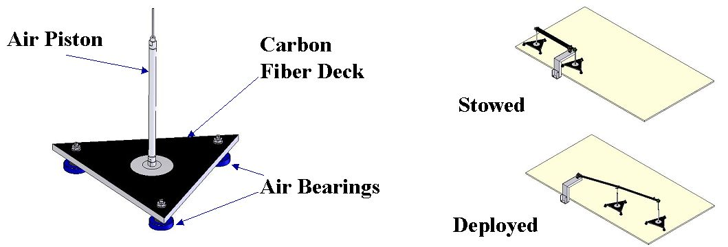
Schematic of gravity offset device

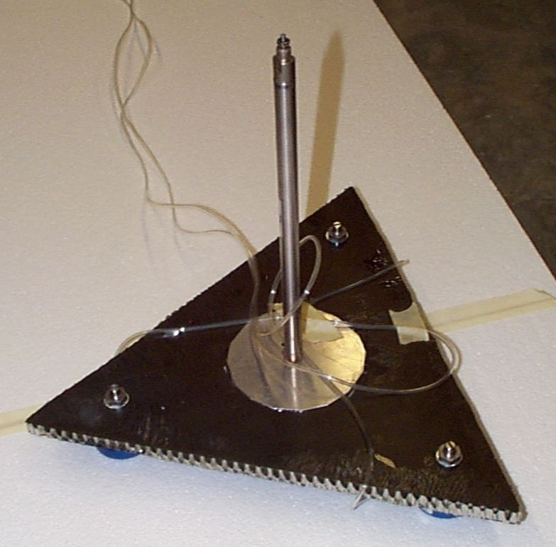
Prototype gravity offset device

Fabrication

- ETU hinges assembled and reworked. Current rework of springs in progress.
- Composite boom tube fabrication is in progress.

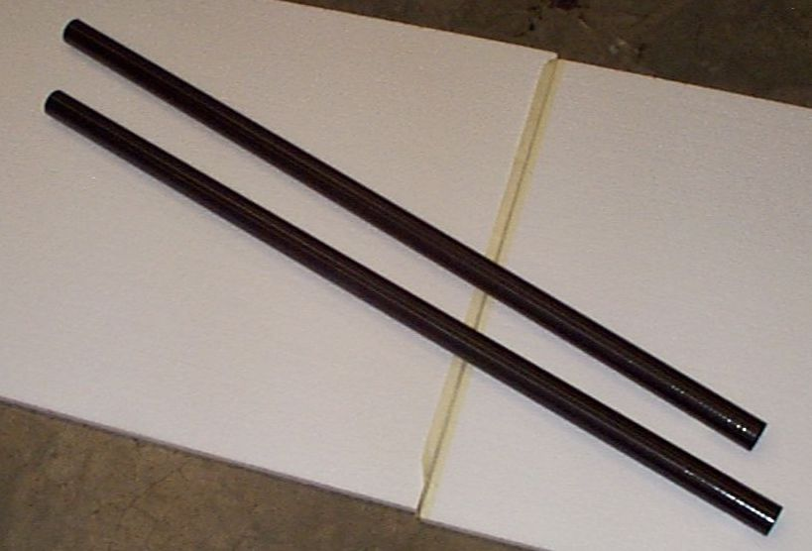  Examples of carbon fiber mag boom tubes (1.25” diameter, 38” long) produced. | 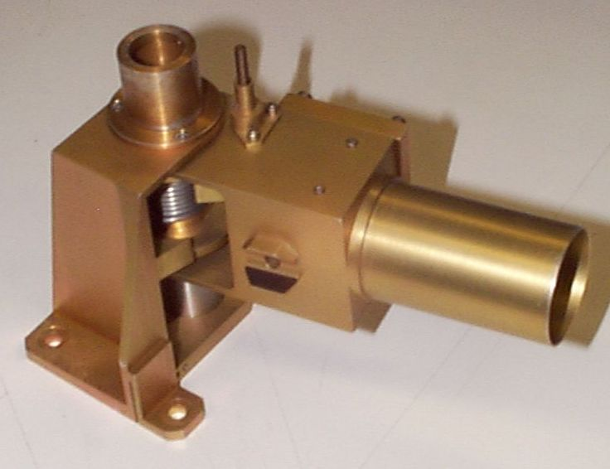  ETU mag boom base hinge

Others:
- AXB EM tube completed. Process to fabricate 4” diameter tube is successful.
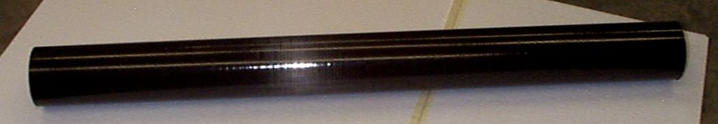
AXB EM boom tube (4” diameter, 42” long)

Facility Development

2.1.7.1 Calibration Chamber (Ion Gun Facility)
No report this month

2.1.7.2 Thermal Vacuum Facilities
Written by Sharon Jelinski and Steve Marker

Bayside (Small) T/V System, Refurbishment in progress

- Transfer Engineering agrees to have baseplate blanchard ground at Allied Eng. to flatten face to meet spec of +-0.010”, currently up to 0.200” from flat.
- Copper baseplate flatness achieved with new surface ground PLUS 4-point mounting heights adjusted. When installed in tank, measures +- 0.009” flat.
- SSL assembles the TE baseplate and shroud with end shrouds for the first time and finds matting difficulties between shroud reflector and LN2 lines.
- Transfer Engineering re-machines a new shroud reflector so the shroud fits into the vacuum chamber. Lamps’ mounts moved from reflectors to shrouds.
- Shroud, end and door are coated with primer and Aeroglaze Z307 then cured.
- Chamber vacuum system reaches high vacuum when empty, LN2 lines were sealed at mini conflats and chamber door o-ring seal needed Apiezon applied.
- Vacuum system and control is fully operational, safety interlocks function.
- Full Thermal System assembled and installed in the chamber with three TC ends insulated in Kapton and fixed to monitor and control the temperatures.
- Full Thermal System pumped to 100 microns(milliTorr) within 37 minutes, base pressure after 24 hours of high vacuum is 7x10-6 Torr.
- TQCM readings with everything in vacuum at room temperature gave an out-gassing rate of zero, but with the TQCM at –20C gave 5870 Hz/hr rate.
- Watlow thermal control was successfully operated manually, but computer viruses prevented us from running the Anawin software thermal controls.
- Thermal system was held to 100C +-5C for 42 hours under rough vacuum, then crossed over to high vacuum while 100C for another 90 minutes.
- Thermal system was cooled at full LN2 flow, and within 30 minutes the baseplate went from +80 to –120, and the shroud from +90 to –80C. Then they taken to room temperature with a 50% heat rate within 50 minutes.
- The TQCM stopped reading a frequency after the first night of heating, upon opening the vacuum chamber we could see why, there had been a contamination event. All the cooler surfaces were coated with a pale yellow sticky film that could be removed with Isopropyl alcohol.
- We have determined three potential sources of contamination, the primary being the two G10 spacers that were burned near the heater lamps below the baseplate. The second source could be the blanchard grinding fluid used on the baseplate, and the third is that the heat lamps are not designed for vac.
- Steps are being taken to rid our system of above sources and cleaning the contaminated surfaces with Iso. Cleanliness will be verified using the TQCM.

THEMIS Snout T/V System – Purchasing in progress

- Snout T/V System delivery is slipping, new date is 7-22, original date 6-11.
- Transfer Engineering visit SSL on May 21 to discuss the Snout Design.
- Engineering team from SSL viewed design on laptop and approved for fab.
- Baseplate for Snout system design changed to maintain flatness, Aluminum with square copper cooling tubes provided and inserted by SSL machine shop.
- Since the contamination event in Bayside the Snout choice of heater will change to either sealed quartz-halogen lamps or Kapton heaters per SSL.
- Thermal control system yet to be placed with vendor, 3 week lead time items. Had hoped to use performance evaluation of Bayside sys to determine spec’s.

Large Vacuum Thermal System - Design of refurbishment in progress

- Mechanical design of the shroud and baseplate thermal system is complete.
- Baseplate shall be Al with Square copper tubing inserted by SSL.
- Shroud faces will be copper with copper cooling tines tig welded, Ni coated.
- Ken McKee with SSL engineering team is leading the SSL mechanical effort in the Thermal System fabrication and assembly, parts to be sent out for fab.
- Discussion of LN2 supply needed for full operation suggests new holding tank be leased from Praxair and supply line installed, pending EH&S approval.
- Thermal control system yet to be placed with vendor, 3 week lead time items. Had hoped to use performance evaluation of Bayside sys to determine spec’s. Preliminary plans call for 32 channel control panel from Therm-X.
- SSL still discussing choice of heaters, Kapton heaters looking favorable.

Large Clean Room, Preparations for use in progress

- Miscellaneous parts need to be removed from the clean room.
- Particle count measurements give 10K grade to room.
- HEPA filters forced air system off temporarily while motor belt on order.

Probe and Probe Carrier
See Reference : ftp://apollo.ssl.berkeley.edu/pub/THEMIS/1.1 Management/REPORTS/thm_monthlyreport_0406_ppc.pdf

3 Ground Segment Development
Written by Manfred Bester

3.1 Mission Operations Development

3.1.1 Mission Design
Contributed by Sabine Frey

The THEMIS flight dynamics team further improved the IDL and GTDS based mission design code which facilitates the development of detailed orbit placement strategies and timelines for all five probes, independent of the launch date. A forward run for the entire mission duration was completed for the first time for all five probes, based on a nominal launch date of 21-Oct-2006 and an insertion RAAN of 322 deg, and was presented at the Mission CDR. Orbit placement was optimized for maximum conjunction time, minimum shadow duration and minimum number of maneuvers.

Since MCDR the mission design was further improved, yielding good conjunctions of 205 hours for the first tail season with the 21-Oct-2006 launch date and with an alternate launch date of 21-Nov-2006. Development of the maneuver sequence itself aims for lowest fuel consumption and the least amount of operational complexity with built-in slack to allow for probe and instrument commissioning, orbit determination and recovery from various contingencies.

The effect of a different launch RAAN of 312 deg on shadow durations was investigated. With this RAAN value, shadow durations are more robust with respect to variations in the maneuver timeline, in particular for the second tail season, and generally fall within 160-180 minutes. More work in the near future will further optimize the mission design. Additional orbit and attitude analyses were performed to support the thermal design of the probes.

3.1.2 Ground System Design

The design of the THEMIS ground data system was completed and its implementation is well on its way. The envisioned architecture for THEMIS is built on top of the exiting multi-mission operations environment already in place at the Berkeley MOC. Additional software tools will be implemented to streamline data flows, to generate constellation overview displays and to populate databases with probe telemetry points. The latter will allow efficient access to telemetry archives for data trending and event analyses.

Mission Operations Planning

Regular telecons between Swales, Hammers and Berkeley operations team members were held to discuss operations related matters in the areas of telemetry and command processing, flight and ground software development and configuration, I&T related issues, development of operational procedures, flight rules and recovery from contingencies. A timeline for early orbit and normal operations is currently developed in collaboration with systems engineering and pertinent instrument scientists.

Ground Station and TDRSS Support

An RF ICD covering all interfaces between the probes and the ground stations as well as TDRSS was submitted to GSFC Code 450. A draft PSLA for THEMIS support via TDRSS and NASA/GN was submitted also. Both documents will be signed in the near future.

Berkeley Ground Station

Purchase orders have been placed for various hardware upgrades, namely the Carrier Doppler Measurement System, Tracking Data Formatter, 200-W transmit power amplifier, receiver IF filters to match THEMIS data rates, a precision timing system, and a solid-state matrix switch for routing of baseband signals. Plans to place the antenna subsystem under back-up power provided by a Diesel generator are developed. All systems within the MOC are connected to the back-up power circuits already.

A matter of concern is the recent gear failure of the DataLynx 11-m antenna at Poker Flat, which is the twin of the Berkeley antenna. UCB is working with GSFC Code 544 and with the antenna manufacturer to assess whether the BGS gearbox upgrades implemented in 2002 fixed the original design flaw, or if other measures need to be taken to maintain a reliable operational status.

NTIA License

The Berkeley team worked with the GSFC Spectrum Management Office to prepare the application for the THEMIS NTIA license. Preliminary S-band frequencies were assigned to THEMIS and approved by the DoD. The GSFC Spectrum Management Office submitted the Stage 2 application, and approval is expected by late 2004.

Personnel

The first round of attempts to hire additional operations and flight dynamics personnel was unsuccessful, primarily because of salary equity issues. A new job advertisement for an additional member of the flight dynamics team to support mission design, maneuver planning and orbit determination will be posted shortly. A second position for ground systems software support, in particular ITOS and MPS is open also. Both positions are expected to be filled by August 2004.

3.2 Ground Based Observations Developments
Written by Stewart Harris

Activities reported for June

1. Prototype GBO Test. Testing of the prototype GBO continued in Athabasca. The unit was upgraded in May with UCLA GMAG, and Linux driver software for the GMAG was installed and operated during June. Currently, the GMAG acquires data sporadically, and this is believed to be a bug in the GMAG firmware. The UCLA team is investigating the problem.

2. Production unit fabrication. Construction of the first production level GBO units was begun in June. Construction of GBO-1 was largely completed, and GBO-2 was started. The first delivery of GMAG hardware (GMAG-1) was received at UCB. Upgraded housings for the ASI were also received. Calibration and unit acceptance test of the all sky imagers for the initial deployments were completed. Integration of Iridium modems was completed in June. The only outstanding issue is ASI sunshade fabrication, which is lagging. This will be completed early in the next period.

3. Schedule for GBO deployment. First GBO will be deployed in Canada, in late July, and should go "live" in early August. Two other Canadian deployments are scheduled for August and September. Two Alaskan deployments are scheduled for August and September.

4. Mission CDR supported. The GBO effort was briefed during the Themis Mission CDR on June 17. All RFAs recorded during the GBO Peer Review were answered and closed prior to the M-CDR, and no additional RFAs were generated at M-CDR.

Planned activities for next period:

1. Deployment of GBO-1 will be completed in Canada.

2. Construction of GBO-2 and GBO-3 will be completed at UCB.

3. Delivery of GMAG-2 and GMAG-3 to UCB will be completed.

4. Calibration and acceptance testing of all sky imagers will continue.

3.3 Science Operations Centre Developments
Written by Tim Quinn

- Additional edits to the Project Data Management Plan (PDMP) were made and the document is now out for signature

- Work on data processing software continues. This includes:
    - Data Decommutators
    - Level Zero Processing
    - Common Data Format (CDF) conversion
    - Data Access

Education and Public Outreach
Respectfully Submitted,
THEMIS E/PO scientists Nahide Craig, Laura Peticolas

Formal Education:

We received biographies and cameras from five of the 10 teachers. We developed the photographs and we plan to incorporate these photographs onto a web page for each of the towns hosting a magnetometer. These web pages will include information about the schools and the teachers who teach where the magnetometers will be located as well as schools that are partnering with these school in the same town.

N. Craig, L. Peticolas, and A. Shutkin continued to organize the GEONS teacher’s workshop at the Space Sciences Laboratory at UCB, arranging travel and lodging, firming up the details of the workshop itself, and purchasing materials needed for the workshop and to give to the teachers. We also had several THEMIS E/PO teleconferences with the E/PO partners regarding primarily the GEONS workshop.

N. Craig presented a poster at the American Astronomical Society in Denver, CO titled Education and Public Outreach with THEMIS Ground-based Research Grade Magnetometers with Drs. N. Craig, L. Peticolas and the Mission PI V. Angelopoulos.

N. Craig and L. Peticolas participated in the Student Observation Network training at NASA AMES to learn about this program so that we can leverage from it with our magnetometer program.

We met with Don Don Robinson-Boonstra of S.O.N. at the Space Sciences Laboratory at the University of California at Berkeley to discuss the potential THEMIS E/PO participation in the SON Magnetosphere and Auroral Friends component.

Cross Cutting:

N. Craig and L. Peticolas attended the THEMIS CDR and presented the design and activities from our E/PO program the morning of June 18th.

Problems

Outstanding Problems
- The Probe thermal design continues to be a major concern. Additional Swales personnel have been added. Thermal activities are being tracked daily at Swales with weekly telecons w/UCB and GSFC.

New Problems / Problem Avoidance

Resolved Problems
Reported by David King
Peer Review CDR RFA's
Only two Instrument Peer Review RFA's have not been closed by the reviewers.
However these two have been submitted.
All GBO Peer review RFA's have been closed by the reviewers.

Risk Management
The Risk Management Board (RMB) now meets regularly to determine risk posture and mitigations and communicates using the a email list processor. All THEMIS personnel are encouraged to submit risk information to the RMB for review by sending issues to themis-risk@ssl.berkeley.edu. The RMB meets Monday afternoons.

Performance Assurance

7.1 Equipment Calibration
Equipment Storage Cabinets are on order, expected delivery is approximately July 16, 2004

7.2 Compliance to ESD requirements
Trained and certified personnel using computer CD.

7.3 Workmanship Procedures/Processes
None

7.4 Assembly Instructions/ BOM
ETU assembly instructions complete for the following boards: DFB,DAP,BEB,DCB,DFE,PCB/FGE and LVPS

7.5 Evaluate/Audit Contractors
- VMI had six minor infractions that were corrected on initial ISO audit
  - VMI corrected minor infractions and received ISO 9001:2000 Certification

7.6 Clean Room Control
- The large clean room, room 20, was particle checked prior to cleaning
  - Particle Count Reading 85,000 ppm
- The Small Clean room, room 20 Bayside, was particle checked
  - Particle Count Reading 187 ppm
  - Rooms are being cleaned

7.7 Workmanship Procedures/Processes
PWB Coupons sent to GSFC for the SCM and DFE on June 23, 2004

  - SCM S/N 7-12 Passed, S/N 13-18 Failed - return boards to vendor Valley Circuits to build new boards, due 7/13/04
  - DFE Boards fab completed, and coupons are at GSFC for approval.

7.8 Materials Handling and Shelf Life Storage
None

7.9 Data Packages and Logbooks
None MSDS, Datasheets and Limited shelf life tracking to start soon

7.10 Nonconformance Reports and Problem Reports
Nonconformance’s
Five discrepancies were noted during this period for incoming materials:
- TTI: shipped part does not match part number on PO- (2) resistors: K07's ordered, E07's shipped - use as is, received better part.
- Partminer: resistor date code of 95+ promised, DC=N/A on certificate - use as is- called vendor for date code
- Wright Caps: shipped part does not match part number on PO: modified part number reflects capacitor leads and coating- use as is - corrected part number on PO.
- Universal Semi: order filled with 2 separate date codes- PO specifies one dc.- use as is
- GFSC: date code of tested part incorrect in data books of test results. -use as is- corrected date code on paperwork to match part tested

7.11 Parts and Materials
No major THEMIS part or material procurement issues to date.

IV&V
Reported by David King

A representative from the Hammer's company has joined the weekly IV&V meeting.
This representative will access the IV&V database weekly to work off the top five priority items as deemed by IV&V each week.

Safety
Reported by David King

A Themis Safety Working Group (SWG) has been formed consisting of representatives of UCB, Swales, GSFC, KSC and the Range. The SWG meets weekly and reviews all open items on the SWG Issues and Action List as well as any other Safety related topics.

The SSPP (Final), MSPSP (Initial), EWR127-1 Section 3 Tailoring Sheets have been delivered to GSFC.

