THEMIS
Data Analysis Software User’s Guide
THM-SOC-120
February 13, 2007

Timothy Quinn, THEMIS Science Operations

Ken Bromund, THEMIS Science SFW

Jim McTiernan, THEMIS Science SFW

Dr. John Bonnell, THEMIS EFI

Dr. Alain Roux, THEMIS SCM

Dr. Uli Auster, THEMIS FGM

Dr. Davin Larson, THEMIS SST

Dr. Jim McFadden, THEMIS ESA

Dr. Harald Frey, THEMIS ASIs

Dr. Hannes Schwarzl, THEMIS Science ACS

Manfred Bester, THEMIS Mission Operations Manager

Vassilis Angelopoulos, THEMIS Principal Investigator

Document Revision Record

Rev. | Date | Description of Change | Approved By
1 | 2006-11-13 | Draft | -
2 | 2006-12-11 | Refine naming conventions. Reformat, reorganize.
3 | 2006-12-20 | Document thmsw_0_3b_20061220, incorporate comments received from post-AGU meeting.
4 | 2007-02-13 | Document for pre-Launch configuration, thmsw_1_0_20070213

Distribution List
Name | Email
Jim Lewis, U.C. Berkeley | jwl@ssl.berkeley.edu
Dr. Tai Phan, U.C. Berkeley | phan@ssl.berkeley.edu
Dr. Forrest Mozer, UCB | fmozer@ssl.berkeley.edu
Dr. Robert Ergun, LASP | ree@fast.colorado.edu
Dr. Robert Lin, UCB | rlin@ssl.berkeley.edu
Dr. Chris Cully, LASP | cully@colorado.edu
Dr. Michael Ludlam | mludlam@ssl.berkeley.edu
Dr. Ellen Taylor, U.C. Berkeley | ertaylor@ssl.berkeley.edu
Dr. Krishan Khurana, UCLA | kkhurana@igpp.ucla.edu
Dr. David Sibeck, NASA GSFC | david.g.sibeck@nasa.gov

TBD List
Identifier | Description
Table of Contents

Document Revision Record 2
Distribution List 2
TBD List 2
1. Introduction 5
1.1 Purpose and Scope. 5
1.2 Applicable Documents. 5
2. Brief Overview of the Software 6
2.1 How to Get Started 6
2.2 Availability of Code and Documentation. 7
2.2.1 Tested Software Releases 8
2.2.2 Latest Software Under Development 8
2.3 Graphical User Interface 8
3. User’s Guide 9
3.1 System Requirements 9
3.2 Installation and configuration. 9
3.2.1 IDL PATH setup 9
3.2.1.1 IDL PATH Setup on Windows (and IDLDE on UNIX, Linux and Mac) 9
3.2.1.2 IDL PATH Setup for IDL Command Line (UNIX, Linux or Mac OS X) 10
3.2.2 Data Directory Setup 10
3.3 Software Functions – Command Line examples 11
3.3.1 Loading THEMIS Data 11
3.3.2 Plot ground or space data 12
3.3.3 Calibrations and Beyond 12
3.3.4 Coordinate Transformations 12
3.4 Managing Your Data Cache 13
3.4.1 Configuring Local Data Cache and Remote Access Behavior 13
3.4.1.1 Configuration at startup 13
3.4.1.2 On-the-Fly configuration 14
3.5 Graphical User Interface Usage 14
3.5.1 Getting Started 14
3.5.2 THM_GUI widget definitions 15
3.5.3 TPLOT Data Processing Widget: 17
3.5.4 Example, Load and plot GMAG data 19
3.5.5 Example, Load and Calibrate FBK data 23
3.6 General Conventions used in THMSW routines 27
3.7 Software Organization 27
3.8 How to modify code for your own use 28
3.9 How to contribute code and modifications 29

Introduction

Purpose and Scope.

The THEMIS analysis software is derived from an IDL set of routines that operate on CDFs from existing missions such as Cluster, Wind, Polar and FAST. This software is being re-organized by the THEMIS software developers and scientists, and checked into a software management database—using the freeware Subversion (SVN)—for maintenance, tracking updates and contributions by a distributed team, and ensuring self-compatibility. In addition to the command-line invoked IDL routines, a graphical user interface that prompts the user for opening, analyzing and plotting the THEMIS data is being developed, and is intended to facilitate use of the most useful of the THEMIS routines.

Applicable Documents.
- THM_SYS_012_PDMP THEMIS Project Data Management Plan
- THM_SOC_101_TIME THEMIS TIME Definition
- THM_SOC_108_GMAG_L1_VARNAMES THEMIS GMAG Variable Name Def’s
- THM_SOC_111_SUNSENSPROC THEMIS SUN SENSOR Science Processing
- THM_SOC_112_ATTPAIPROC THEMIS Science ATT & Inertia Determ.
- THM_SOC_113_FGM_CALPROC THEMIS FGM CAL File and Processing
- THM_SOC_114_SCM_CALPROC THEMIS SCM CAL File and Processing
- THM_SOC_115_EFI_CALPROC THEMIS EFI CAL File and Processing
- THM_SOC_116_ESA_CALPROC THEMIS ESA CAL File and Processing
- THM_SOC_117_SST_CALPROC THEMIS SST CAL File and Processing
- SAI-SPEC-1079A (Oct 26, 2005) THEMIS Coordinate systems
- SAI-RPT-0722a (September, 2006) Probe Alignment Report (MSSS data, p18)
- pturin e-mail on Faro alignment results (9/28/06) FGM, SCM mag alignments
- THM-MB-MEC-005-Magnetometer clocking r7.pdf MAG clocking angles

Brief Overview of the Software

The THEMIS Data Analysis Software (hereafter referred to as THMSW) is IDL-based. THMSW routines can be used to download, open, analyze and plot L1 or L2 data and process L1 data into L2 data quantities. There are two main ways to use the programs: with the command line interface, or with the GUI interface.

Future features will include the ability to create L2 data files the L2 data quantities, utility routines to translate data into other products (e.g., ascii) as necessary.

How to Get Started
Assuming you have the software installed, the best place to start is with a crib sheet. The crib sheets in the idl/themis/examples folder give end-to-end examples of how to load, process and plot the highest level data available for a given instrument.

Crib sheets in idl/themis/examples:
thm_crib_gmag | Crib sheet for GMAG, including wavelet demo.
thm_crib_mom | Crib sheet for particle Moments.
thm_crib_sst | Crib sheet for Solid State Telescope.
thm_crib_fgm | Crib sheet for Flux Gate Magnetometer
thm_crib_scm | Crib sheet for Search Coil Magnetometer – Linux or Windows, only.
thm_crib_efi | Crib sheet for Electric Fields Instrument.
thm_crib_fbk | Crib sheet for Filter Bank.
thm_crib_scm | Crib sheet for Search Coil Magnetometer – Linux or Windows, only.
thm_crib_asi | Crib sheet for loading and displaying All Sky Keogram data.
thm_crib_tplot | Crib sheet for using tplot plotting package, using GMAG data as an example.

You can run any of the crib sheets by typing
.run <thm_crib_xxx>

when execution stops at a 'stop' command in the crib sheet, type
.c
to continue.

Alternatively, you can cut and paste from the crib sheet to the command line.

To find more information on any of the THMSW routines used in the crib sheets, use:
- The source code of the crib sheets, which is included in the idl/themis/examples directory of the software distribution.
- HTML help included with the software distribution
- IDL XDOC widget. At the IDL prompt, type:
xdoc
- IDL doc_library procedure. At the IDL prompt, type:
doc_library, ‘command_name’

Sample THEMIS routine documentation:

;+
;Procedure: THM_LOAD_GMAG,
; thm_load_gmag, site = site, datatype = datatype, trange = trange, $
; level = level, verbose = verbose, $
; subtract_average = subtract_average, $
; subtract_median = subtract_median, $
; varname_out = varname_out, $
; subtracted_values = subtracted_values, $
; downloadonly = downloadonly, $
; valid_names = valid_names
;keywords:
; site = Observatory name, example, thm_load_gmag, site = 'bmls', the
; default is 'all', i.e., load all available stations . This
; can be an array of strings, e.g., ['bmls', 'ccmv'] or a
; single string delimited by spaces, e.g., 'bmls ccnv'
; datatype = The type of data to be loaded, for this case, there is only
; one option, the default value of 'mag', so this is a
; placeholder should there be more that one data type. 'all'
; can be passed in also, to get all variables.
; TRANGE= (Optional) Time range of interest (2 element array), if
; this is not set, the default is to prompt the user. Note
; that if the input time range is not a full day, a full
; day's data is loaded
; level = the level of the data, the default is 'l2', or level-2
; data. A string (e.g., 'l2') or an integer can be used. 'all'
; can be passed in also, to get all levels.
; /VERBOSE : set to output some useful info
; /SUBTRACT_AVERAGE, if set, then the average values are subtracted
; from the loaded variables,
; /SUBTRACT_MEDIAN, if set, then the median values are subtracted
; from the loaded variables,
; varname_out= a string array containing the tplot variable names for
; the loaded data, useful for the following keyword:
; subtracted_values = returns N_elements(varname_out) by 3 array
; containing the average or median (or 0) values
; subtracted from the data.
; /downloadonly, if set, then only download the data, do not load it
; into variables.
; /valid_names, if set, then this will return the valid site, datatype
; and/or level options in named variables, for example,
;
; thm_load_gmag, site = xxx, /valid_names
;
; will return the array of valid sites in the
; variable xxx
;
;Example:
; thm_load_gmag, site = 'bmls', trange =
; ['2007-01-22/00:00:00','2007-01-24/00:00:00']
;
;Written by: Davin Larson, Dec 2006
; 22-jan-2007, jmm, jimm@ssl.berkeley.edu rewrote argument list, added
; keywords,
; 1-feb-2007, jmm, added subtract_median, subtracted_value keywords
; $LastChangedBy: kenb-mac $
; $LastChangedDate: 2007-02-05 22:58:50 -0500 (Mon, 05 Feb 2007) $
; $LastChangedRevision: 303 $
; $URL: svn+ssh://thmsvn@ambrosia.ssl.berkeley.edu/repos/thmsoc/trunk/idl/themis/ground/thm_load_gmag.pro $
;-

Availability of Code and Documentation.

Tested Software Releases
Zipped and tested code releases along with corresponding documentation are available in release folders which can be found at the following URL:
http://themis.ssl.berkeley.edu/socware
For example, the latest release as of the writing of this document is in:
http://themis.ssl.berkeley.edu/socware/thmsw_1_0_20070213/

Each release folder contains
- idl folder for browsing the source and documentation.
- zip file for download of entire contents of the idl folder.
- doc folder containing the version of this document corresponding to the released software.
The zip file includes IDL files and HTML documentation. HTML-browsable documentation of the IDL routines is available within each release folder at idl/thmsw_doc.html.

Latest Software Under Development
The latest THEMIS code being developed and/or integrated at the THEMIS SOC is visible at
http://themis.ssl.berkeley.edu/socware/bleeding_edge. The idl subdirectory of bleeding_edge is a link to /disks/socware/idl, which is the integration/testing area for the latest data analysis software at UCB SSL. There is no guarantee that the software and/or HTML documentation available for browsing is the most up-to-date version available at any given time. The /disks/socware/idl workspace can be made up-to-date and a snapshot can be created on demand, to allow access to the latest THEMIS software. The software included in these snapshots is made available without warranty or guarantee. The snapshots will be available as zip files within the bleeding_edge folder. Each snapshot zip file contains the complete set of IDL source files and corresponding automatically generated HTML documentation. The snapshot file name corresponds to the SVN revision number and date of the last change that was committed to the THEMIS SVN repository at the time the snapshot was made.

Even more up-to-date and detailed access to the THEMIS code will be available through a web interface to the SVN repository (read-only) http:// or svn:// URL to be determined. This is for access to the very latest version of the code, plus possibly access to the SVN change log.

Graphical User Interface

The philosophy of the graphical user interface GUI is to provide a convenient interface to the most generally useful capabilities of the command-line THEMIS IDL routines. General users can use the GUI without being required to know the individual IDL routines. However, users who want a jump-start to using the more powerful and customizable IDL programming interface may begin with the GUI and then use the GUI to generate a script of the underlying IDL commands which perform the same function. This script can then be used as a starting point for creating an IDL program to process THEMIS data, or can be used as a crib sheet for using the THEMIS IDL programming interface.

The GUI code is bundled together with the THEMIS IDL code distribution, they are downloaded and installed as a single package.

Documentation for the GUI are found within the software distribution at idl/themis/examples/thm_gui.txt.

In the future, we hope to make the GUI available as an IDL save file runnable on the IDL Virtual Machine.

User’s Guide

System Requirements
The THEMIS Data Analysis Software requires IDL on Windows or a UNIX-like operating system like Solaris, Linux, or Mac OS X. You must have IDL 6.3 to read the THEMIS CDF data files. Alternatively, you can use an earlier version of IDL, and apply the patch available at http://cdf.gsfc.nasa.gov/html/idl62_or_earlier_and_cdf3_problems.html
Even if you have IDL 6.3, you will want to install the patch if you use IDL to write CDF files. This is because of a bug in IDL 6.3 which will be fixed in 6.4.

Mac OS X notes:

You need X11 to view plots and use the GUI in IDL. You can search for X11 in the Spotlight to see if the X11 application is installed on your system. X11 is available on your Mac installation disks, but may not be installed by default.

There is a known problem, mentioned in the IDL 6.3 release notes, which affects all IDL users running Mac OS 10.4 (Tiger) The tlimit command will lock up IDL because the plot window will not receive any mouse clicks.
Workaround: Change the X11 start-up parameters. Do the following:
- Open any terminal window (in the X11 application menu bar, you can choose xterm from the applications menu)
- Enter the following at the shell prompt:
defaults write com.apple.x11 wm_click_through -bool true
- Quit X11 (if it is running).
The new default will take effect the next time you start X11, and it will persist from that point (i.e., you will not have to make the change again).
.

Installation and configuration.

Getting started is usually as simple as of downloading the code and setting up your IDL path, according to the instructions, below.

You can download the code from the locations described above in Availabililty of Code and Documentation.

Once you've downloaded the zip file, choose a location where you want to place the software directory heirarchy.

Unzip the .zip file. It will create a folder with the same name as the zip file. The folder will contain an idl directory.

IDL PATH setup

IDL PATH Setup on Windows (and IDLDE on UNIX, Linux and Mac)

For Windows or IDLDE on UNIX, you can use the File->Preferences widget to set up the path so IDL can find the THEMIS IDL files.

UNIX Note: If you use IDLDE on UNIX-like systems, these instructions only work if you do not set the IDL_PATH environment variable before you call IDLDE. If IDLDE does not allow you to set the path by following these instructions, then follow the instructions for UNIX installation, below.

Start IDL (Windows) or IDLDE (UNIX, Linux, Mac).

Go to File->Preferences
Select the ‘Path’ tab.

If <IDL_DEFAULT> is not present, press ‘Insert Standard Libraries’

Press Insert
Browse to find your installation and select the ‘idl/external’ directory
Check the box to indicate “search subdirectories”

Press Insert
Browse to find your installation and select the ‘idl/ssl_general’ directory
Check the box to indicate “search subdirectories”

Verify that ‘idl_external’ is last in the list.

Press Insert
Browse to find your installation and select the ‘idl/themis’ directory
Check the box to indicate “search subdirectories”

IDL PATH Setup for IDL Command Line (UNIX, Linux or Mac OS X)
For the command line version of IDL, installation consists of setting up the IDL_PATH environment variable. The THEMIS Data Analysis Software distribution includes setup scripts, which help set the IDL_PATH variable correctly.

If you use csh or tcsh, the recommendation is to put the following in your .cshrc
setenv IDL_BASE_DIR /path/to/thmsw_v_sb_yyyymmdd/idl
source $IDL_BASE_DIR/themis/setup_themis

If you use bash shell, the recommendation is to put the following in your .bashrc (Linux) or .bash_profile (Mac)
IDL_BASE_DIR=/path/to/thmsw_v_sb_yyyymmdd/idl
. $IDL_BASE_DIR/themis/setup_themis_bash

In the above examples, IDL_BASE_DIR should be set to the full path name to the idl directory inside the THEMIS Data Analysis Software release.

Data Directory Setup
The THEMIS Data Analysis Software requires a local data directory in which THEMIS data files can be cached. The THEMIS will attempt to create the local data directory for you at the following default location, depending on your operating system.

OS | LOCAL_DATA_DIR
Windows | C:\data\themis
Solaris, Linux, Mac OS X | ~/data/themis

These locations should work as-is for most installations; however, if you don’t have administrative privileges to create the data directory in the above locations, you can have your system administrator create it for you, or you can configure the THEMIS Data Analysis Software to use an alternate location. See Remote Data Access and Local Data Cache for information about configuring an alternate location.

Software Functions
This section described the functionality of the THEMIS software. The examples are given using the command line interface, but the concepts are the same for the GUI.

Loading THEMIS Data
The THEMIS software will automatically create a local data cache which mirrors the structure of the THEMIS data archive. The software is written such that the default settings will work for the majority of users. The location of the THEMIS data archive is also found automatically by the software.

To download some data and load it into IDL, you simply specify a timespan and type of data you want to load. If the data does not exist locally on your local_data_dir, it will be downloaded automatically before it is loaded into IDL.

At the IDL prompt, type:

timespan, '2006-11-11', 1, /day
Then, use one of the thm_load commands, e.g.

thm_load_gmag, site='ccnv'

Examples of routines for loading data:
thm_load_mom | loads moments data
thm_load_efi | loads efi waveforms
thm_load_fgm | loads all fgm waveforms (choice of fgl, fgh…)
thm_load_scm | loads SCM waveform.
thm_load_gmag | loads ground mag data for any ground station (by keyword) or all available.
thm_load_ask | Loads All Sky Keogram data for all observatories.
thm_load_asi | Loads All-Sky Imager data for any ground station (by keyword) or all available.
thm_load_fit | Load On-Board Fields Spin-Fit data
thm_load_fbk | Load Filter Bank data
thm_load_sst | Load Solid State Telescope data.
thm_load_hsk | loads housekeeping data – all or one by keyword. Important for FGM (temperatures) but also other instruments. Not implemented yet.
thm_load_state | Loads Orbit and Attitude data
Standard Load Procedure Keywords:
SITE | string: ground station name, or a list of ground station names, or ‘all’
PROBE | string: probe name, or a list of probe names, or ‘all’. e.g. ‘a b c’
DATATYPE | type of CDF file for the given instrument.
LEVEL | Level of data file to load: 'l1' or 'l2'
VALID_NAMES | Return valid names for DATATYPE, SITE, PROBE, and LEVEL
VERSION | Version of CDF file to load (useful for STATE data): 'v01', 'v02'
GET_SUPPORT_DATA | Get support data quantities from CDFas well as data quantities.
CDF_DATA | Return a structure containing data and metadata from CDF.

Plot ground or space data
In the command line, type
tplot_names
to see available data quantities. Type, e.g.,
tplot, 1
to plot the first quantity.

tplot, [1,2,3]
plots a stack plot of the first 3 data quantities.

Plotting routines:
tplot | General purpose time plotting utility for creating stack plots of waveforms and sonograms.
tlimit | Zoom into or out of a tplot
get_data | Get data out of a tplot variable into a structure containing a time tag array and a data array.
store_data | Store a data array structure into a tplot variable.

Refer to thm_crib_tplot for examples of using get_data and store_data.

Calibrations and Beyond

Refer to the crib sheet for each instrument for usage of the calibration routines. The interface to the various calibration routines has not yet been standardized.

Calibration: from L1 data to physical quantities
thm_cal_mom | calibrates all (ESA and SST) moment data
thm_cal_sst* | calibrates SST data provides counts, eflux, flux and psd (phase space density or distribution function) data. *not yet available.
thm_cal_fit | same as thm_cal_sst, above, but for ESA data.
thm_cal_efi | Electric Fields Instrument
thm_cal_fbk | Filter Bank
... scm ... | Software distribution includes FORTRAN executable to calibrate SCM

Beyond calibration: combining physical quantities to create higher level data products: These routines
are not implemented yet.
thm_pa_sst * | Combines SST psd, and FGM and provides pitch angles dist.
thm_pa_esa* | same as above, but combines ESA and FGM.

Coordinate Transformations

A coordianate transformation example can be found in thm_crib_fgm.pro. The coordinate transformation routines currently work on tplot variables only.

Coordainate transformation routines include:
cotrans | Transform between geophysical coordinate systems
ssl2dsl | Transform between spinning and despun L-vector aligned coordinate system,using data from the STATE file.
dsl2gse | Transform between despun L-vector aligned coordinate system and GSE, using data from the STATE file.

Managing Your Data Cache
There currently exist some experimental routines for managing your THEMIS data file cache. These routines serve as an example of how you will be able to download all data for a given time range with a single command.
- thm_file_download – can be used to download all types of THEMIS data for a given time span.
- thm_file_cleanup – delete empty directories. This is a function call. It searches the hierarchy and return files matching a given pattern, sorted by access time. Currently does not delete files, but can be used as a tool for finding old data.

Configuring Local Data Cache and Remote Access Behavior
Data locations may be configured at IDL startup (for example, if you want the data to reside in a non-standard location), or dynamically during an IDL session.

The following table summarizes the controls that can be used, in order of precedence:
- !THEMIS system variable
- environment variable settings
- thm_config.pro

The following table summarizes the settings available:
!themis structure element | Environment Variable | Description
local_data_dir | THEMIS_DATA_DIR | a writable, local directory in which to cache data files
remote_data_dir | THEMIS_REMOTE_DATA_DIR | URL to a data archive where THEMIS data can be found. By default, http://sprg.ssl.berkeley.edu/data/themis
no_download | N/A | 1: don’t access remote_data_dir
no_update | N/A | 0: download only if file on server differs or if local file does not exist.  1: download only if local file does not exist. i.e. no clobber.
progress | N/A | 0: don’t show progress bar  1: show progress bar for each file downloaded.
verbose | N/A | level of verbosity for themis commands,  0=silent. Values >1 are generally for debugging.

Configuration at startup
For initial configuration, you can set the environment variables specified in the above table. Depending on your operating system and/or shell, this can be done in .bashrc, .cshrc, or ‘System Properties’ Window. Alternatively, the thm_config.pro file provides a platform-independent and more flexible way of configuring your initial configuration.
- Make a copy of the idl/themis/common/thm_config.pro in a directory outside the THEMIS Data Analysis Software distribution (or edit it in place, if you don’t mind losing your changes when you update your software)
- Add the directory which contains your copy of thm_config.pro to your IDL PATH, making sure that it is before the idl/themis directory. (See IDL PATH setup, above).
- Edit your thm_config file to set the environment variables to your liking. See the above table for the names of relevant environment variables.

On-the-Fly configuration
The local data directory location can be changed on-the-fly by setting the !themis.local_data_dir system variable. For example, when you are connected to the network, you may choose to use a networked data dir:
!themis.local_data_dir = ‘\\justice\data\themis\’

The remote_data_dir structure element can also be updated to a different URL.

If you want the software to use only locally available data, and don’t want the software to try to download data, you can set:
!themis.no_download = 1

Note that you can only set the !themis variable in an IDL session after a thm_ command has already been run, or after explicitly calling thm_init.

Graphical User Interface Usage

Getting Started

There are two ways to start the THEMIS GUI.

1 Licensed IDL Installation: start an IDL session. At the IDL prompt, type: thm_gui,
2 IDL Virtual Machine (no IDL License required): start the IDL Virtual Machine, select the file: thm_gui.sav *This option is not currently working.

Once you perform either of the above options the widget will pop up:

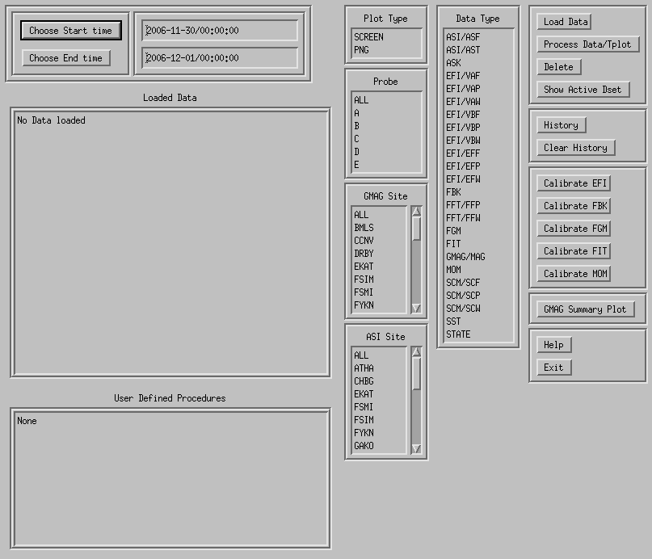

THM_GUI widget definitions

Starting at the top left: 1st column

Choose Start Time button : Pops up a widget that allows you to choose a start time for data to be loaded. You may also type a string value of the form yyyy-mm-dd/hh:mm:ss in the window next to the button.

Choose End Time button : Pops up a widget that allows you to choose an end time for data to be loaded. You may also type a string value of the form yyyy-mm-dd/hh:mm:ss in the window next to the button.

Loaded Data Box: When data is loaded, information appears in the box, for each datatype loaded, the appropriate variable name and time range are listed. To choose a particular data set for plotting, or other processing, left-click. Multiple datasets can be selected by holding the "control" key, and clicking more that one. Also, you can click on an option, then hold "shift", and the left mouse button, and drag the cursor over the other datasets.

User Defined Procedures: In the future we will have the option for the user to define procedures and call them from the GUI. Just click on the procedure name and it will run using an IDL CALL_PROCEDURE call.

Second Column:

Plot Type: click on "SCREEN" for screen plots. If you click on "PNG" a png plot will be created, with filename = "thm_gui_plot_yyyymmddss.png" in your local working directory. The time stamp on the file is the local system time. (Relatively UNTESTED)

Probe: For loading data, Click on "ALL" to load data for all spacecraft, or select individual spacecraft. Multiple probes can be selected, using the "control" or "shift" keys, as described for the "loaded Data" list. The default value, which is set when the widget is realized, is "ALL".

GMAG Site: For loading data, Click on "ALL" to load data for all sites, or select individual sites. Multiple sites can be selected, using the "control" or "shift" keys, as described for the "loaded Data" list. The default is "ALL".

ASI Site: For loading data, Click on "ALL" to load data for all sites, or select individual sites. Multiple sites can be selected, using the "control" or "shift" keys, as described for the "loaded Data" list. The default is "ALL".

Third Column:

Data Type: For loading Data, Click on the type of data to load. Multiple datatypes can be selected, using the "control" or "shift" keys, as described for the "loaded Data" list. The default datatype, set when the widget is realized, is "GMAG": ground magnetometer data.

Fourth Column: The BUTTONS

1st group: Data buttons

Load Data: Click on this button to load the selected data. All selected datatypes will be loaded.

Process Data/Tplot: This button will pop up a separate widget with various data processing and plotting options, described below.

Delete: Click here to delete the "active" data sets. Note that the "active" data sets can be (1) the data most recently loaded, (2) the data most recently processed, plotted, or calibrated, or (3) the data most recently selected from the "loaded Data" window. If you want to delete datasets, it’s always best to click on the datasets you want to delete.

Show Active Dset: Click here, and the "active" datasets will be denoted in the "loaded Data" window by "Active -> " before the variable name.

2nd Group: History buttons

History: Click this to show a record of the IDL commands used to this point. A separate widget will pop up that shows the IDL commands, and two buttons. The "save" button will save the history in an IDL source file called "thm_gui_yyyymmddss.pro" in your local working directory. The time stamp on the file is the local system time. (Note that there are some issues in the history with respect to typing in time strings, and also selection of multiple datatypes, probes, sites, etc...)

Clear History: Click this to clear the history.

3rd Group: Calibration buttons

Calibrate EFI: Runs THM_CAL_EFI on any EFI data that is loaded. Note that the EFI data does not have to be selected from the "Loaded Data" window. The program will operate on whatever EFI data has been loaded. After calibration, the "active" datasets are the calibrated EFI data.

Calibrate FBK, FIT, FGM, MOM: Same as Calibrate EFI for those datatypes. (Calibrate FGM is not yet implemented).

4th Group: Summary plots

GMAG Summary Plot: Runs the THM_GMAG_STACKPLOT routine for any loaded GMAG data. This is the routine that is used to create the online summary plots. It is intended that there will be a program like this for each of the datatypes eventually, and these will be incorporated when they come online.

5th Group:

Help: This button pops up a text widget with the descriptions of the buttons and windows on the widget.

Exit: The exit button kills the widget. Note that it does not touch the tplot common block, so any data loaded may still be there.

TPLOT Data Processing Widget:

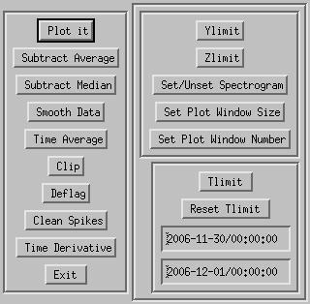

This widget pops up when you click on the Process Data/Tplot button on the main widget. The first thing that will happen is that all of the active datasets are plotted.

1st Column: Buttons

Plot It: Plots the active datasets. Note that the other buttons do not automatically replot the data, so if you want to see results, click here.

Subtract Average: For each dataset, the average value is subtracted. new variables are created, with the syntax: new_var = old_var+"-d", and the new variables become the "active" datasets.

Subtract Median: For each dataset, the median value is subtracted. new variables are created, with the syntax: new_var = old_var+"-m", and the new variables become the "active" datasets.

Smooth Data: Boxcar smoothing of the data. A widget will pop up, asking how many data points to smooth over. Choose a value, and click on "accept and close". The default is 11 points. New variables will be created, with "_sm_npts" appended to the old variable names, where npts is the smoothing resolution.

Time Average: Click this button to average that data over time, a window will pop up, if you want to change the time resolution, the default time resolution is 60 seconds. New variables will be created, with "_av_tres" appended to the old variable names, where tres is the time resolution.

Clip: Clips data above and below a set maximum and minimum, a widget pops up which allows these values to be set. Then data outside the set range is set to NaN. New variables will be created, with "_clip" appended to the old variable names.

Deflag: Interpolates or repeats the most recent valid data value over gaps in the data (gaps are denoted by NaNs). A window pops up which is used to set the method, there are two choices: "repeat" will repeat the last good value over the gap. "linear" will interpolate over gaps. (Probably the text widget will be replaced with buttons.) New variables will be created, with "_deflag" appended to the old variable names.

Clean Spikes: Removes spikes from messy data. New variables will be created, with "_dspk" appended to the old variables.

Time derivative: Take the time derivative of the active datasets. New variables will be created, with "d_" prepended to the old variable names.

Exit: Exit the widget.

Second column: Plot Options

Ylimit: Set the y limits of the active datasets. A text widget pops up, allowing the limits to be set, and also log plotting can be set/unset. (Not exhaustively tested.)

Zlimit: Same as Ylimit, for the Zlimits for spectrogrsm data. (Untested)

Set/Unset Spectrogram: Pops up a text widget. if set to 1, then the active data is set to be plotted as a spectrogram, if set to 0, then line plots. (Should be changed to buttons.)

Set Plot Window Size: Pops up a widget for the window size. For screen plots you can just drag the window for resizing. The set plot window size window can be used to set the window size for png plots.

Set Plot Window Number: Sets the window number for the screen plots.

Tlimit: Calls the tlimit routine, to set time limits using the cursor. Just click twice on the plot to set the time limits.

Reset Tlimit: Resets the time limits for the active datasets to the whole time range.

Start time box: The start time limit can be changed in this box.

End time box: The end time limit can be changed in this box.

Example, Load and plot GMAG data

The first step is to load the data, the available data types are listed in the data type window. Left click on the data type that you want to load; multiple data types can be selected by holding the control key while clicking. For this example, we will load ground magnetometer data. The default start and end times are in the start and end time windows.
Here we will not reset them, but just load the data for that day. We will load two ground station sites. “bmls” and “drby”.(Why not “ccnv”? It had bad data for that day…)

Next we click on the “Load Data” button. Once loaded, the variable names and time ranges appear in the “Loaded Data” window.

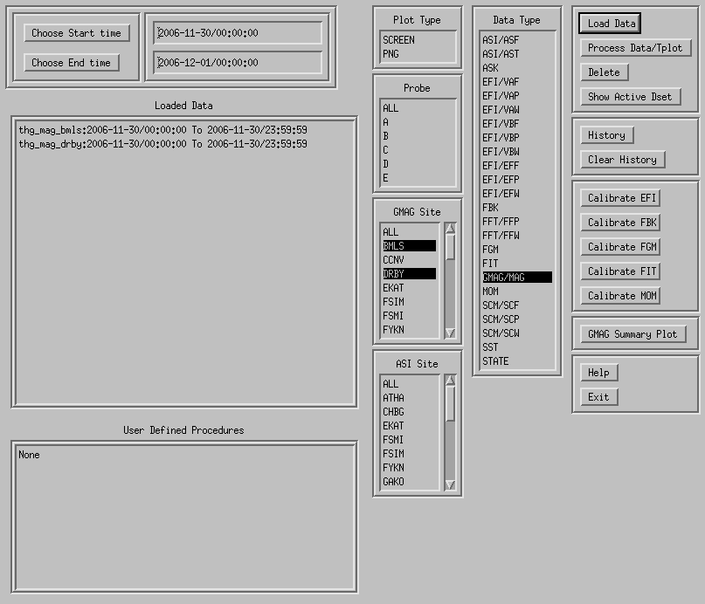

Ok, now we have loaded the data, what next? We hit the “Process Data/Tplot” button. And a plot window will pop up. 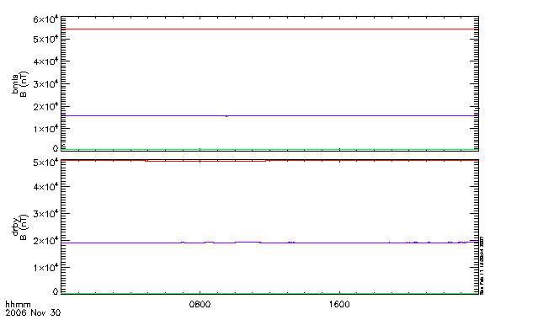
Also another widget pops up.

This allows you to manipulate and plot the data. We cannot tell much from the plot as shown, and we suspect that if we normalize the data in some way, we can get a better plot. So we click the “Subtract Median” button, and then the “Plot it” Button.

Then, two new variables appear in the “Loaded Data” box on the main window, and these data, which are now the “active” data sets, are plotted.

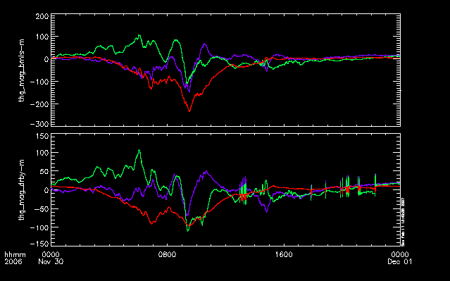
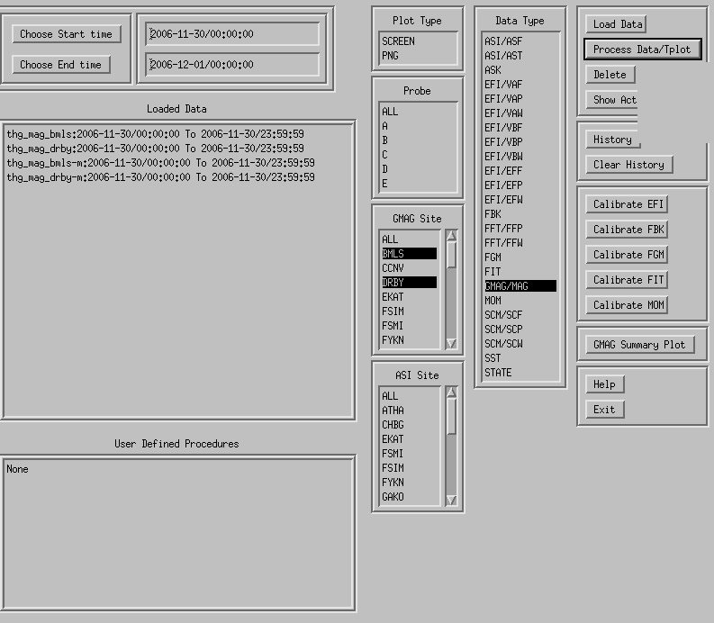
The new variables have the same names of the old variables, with “-m” appended.

Example, Load and Calibrate FBK data

Next we will go back and load and calibrate the FBK data for that day. Click on data type “FBK” and probe “ALL” (For that day, there is FBK data for probes “A”, “C” and “E”.)
Then Click on the “Load Data” button: All sort of new data have been loaded.

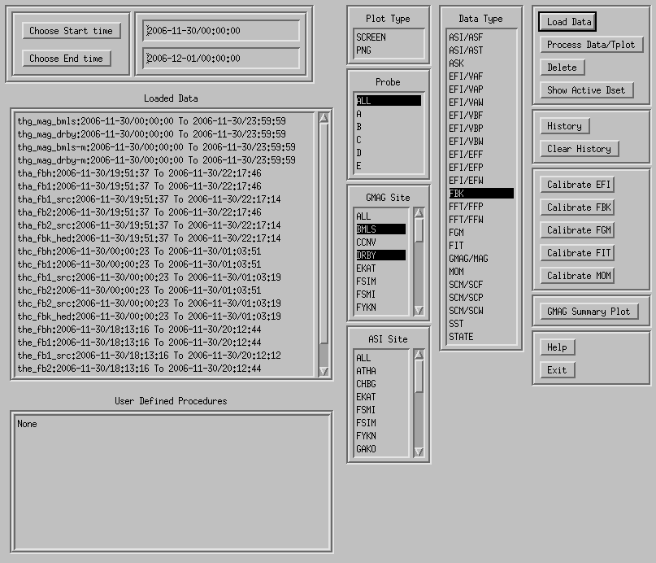

To calibrate, click on the “Calibrate FBK” button. Note that you don’t have to click on the FBK datasets in the “Loaded Data” window, all available FBK data will be calibrated.
After this, even more variables are created, but the “active” datasets are the recently calibrated ones. To see those, click on the “Show Active Dset” button, and the string “Active ->” will show up in front of the active datasets. In this case, the calibrated data are the “th*_fb1”, “_fb2”, “_fbh” data. The original uncalibrated datasets, which originally had these names, have now had “_raw” appended to the variable names.
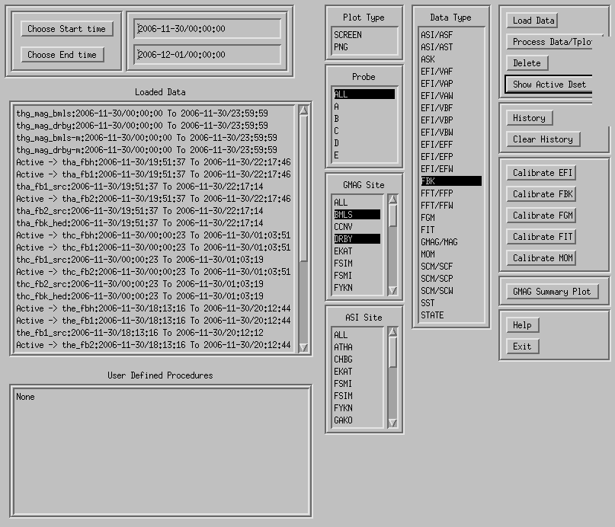

You can plot the active data now. Click the “Process Data/Tplot” button, and the “TPLOT Data Processing” widget will pop up, then click “Plot it”.
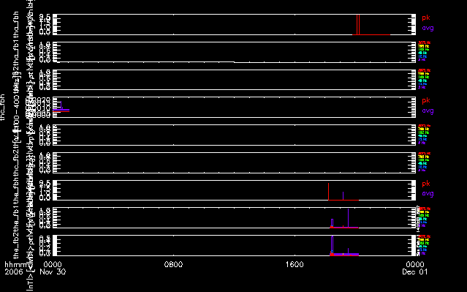
It doesn’t look like much this way. Click on the “tha_fb1”, “tha_fb2” and “tha_fbh” variables to reset the active data, and plot again.

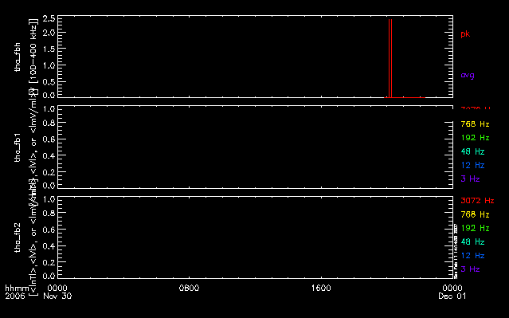

Well, it still doesn’t look so great, but it will when there is real flight data….

General Conventions used in THMSW routines

The naming convention is that all THEMIS-specific routines begin with thm_ followed by the function (action) followed by the type of data operated upon. E.g., thm_load_xxx reads xxx data.

Non THEMIS-specific routines have a generic name, such as cotrans.

Some routines operate on (as input and/or output) arrays (or structures of arrays returned by get_data). Others operate on tplot variables (i.e. handles to structures which contain data as well as information about how to display that data in time plots), while in the future we may upgrade the routines to give an option to do either one.

Software Organization
The themis directory contains THEMIS-specific routines. The general directory (currently named ssl_general) contains routines which are useful for more than one space-science mission for which THEMIS team members are developing code. The external directory contains packages developed and maintained by other groups, but which are required for writing (and running) the themis and/or general routines.

The idl directory of the distribution includes the following files and sub-directories.

_thmsw_doc.html | Documentation in HTML format, including alphabetical list of all routines.
themis/ | setup_themis | Sample setup script for csh (UNIX)
themis/ | ground/ | routines for loading, processing and plotting ground-based data. e.g. thm_load_gmag, thm_gmag_stackplot, imageplot, mosaicplot
themis/ | spacecraft/ | fields/ | routines for loading, processing and plotting particles data, e.g. thm_proc_fgm
themis/ | spacecraft/ | sst/ | (Should be particles/) routines for loading, processing and plotting particles data, e.g. thm_load_sst, thm_cal_sst
themis/ | state/ | Routines for reading state and performing coordinate transformations, e.g. thm_load_state, cotrans, ssl2dsl, dsl2gse.
themis/ | examples/ | Crib sheets, like thm_crib_ask
themis/ | common/ | THEMIS-specific tools useful to multiple data types and instruments, eg thm_gui, thm_file_download, thm_init
ssl_general/ | CDF/ | CDF utilities, including cdf2tplot, and other utilites like cdf2tplot, cdf_info, cdf_load_vars (into IDL structure representation of CDF)
ssl_general/ | science/ | Routines useful for specific scientific analysis.
ssl_general/ | cotrans/ | Coordinate transformations: Vectorized version of ROCOTLIB.
ssl_general/ | tplot/ | General time-plotting utilites
ssl_general/ | misc/ | Miscellaneous routines used by tplot and other ssl_general routines.
ssl_general/ | key_param/ | Load routines for ACE, KP, WIND, POLAR data.
external/ | SSW_gen_idl | direct import of a portion of SSW general IDL routines
external/ | CDAWeb

The _themis_doc.html file contains a complete listing of all routines in the hierarchy, along with links to complete documentation.

How to modify code for your own use

This section gives ideas about you can move beyond the generic capability provided by the GUI and crib sheets.

For command line-based analysis the process of creating new capability would be

- Modify code generated with the thm_gui 'History' feature.
- Modify existing analysis crib sheets
- Write your own analysis module – an IDL routine - that operates on data
- Transfer between data arrays and tplot variables
- Plot the data

You can build on the basic functions of the GUI by:

- Stringing multiple operations on a pipeline
- Creating a new operation and corresponding GUI in your local toolkit (not yet implemented).
- Save a pipeline into a crib sheet (transfer to command line based analysis)
  - Use the History and ‘Clear History’ buttons

How to contribute code and modifications
If you want to contribute code to the THEMIS IDL SW distribution, you can email us your routines, or you can become part of the THEMIS development team and work directly with the SVN repository. We can give you access if you provide us with your SSH public key. See the THEMIS SOC SW document for details on working with the THEMIS SVN repository.

