THEMIS and ARTEMIS Science Data Analysis Software Monthly Accomplishments - April 2012

THEMIS and ARTEMIS Science Data Analysis Software (TDAS) - Post v7.00
1. TDAS has been enhanced to read CDFs which contain TT2000 times and correctly convert those times to a TDAS compatible
format so that TT2000 data may be compared to non-TT2000 data within TDAS. A crib is available in the bleeding edge at
ssl_general/CDF/tt2000/crib_tt2000.pro.
2. New routines to calculate the distance to the neutral sheet (several models are available) Geo2Mag coordinate conversions
are now available in cotrans and thm_cotrans.
3. Axis titles and subtitles can now be added to plots in the TDAS GUI. Users will still be able to add labels to the axes for each line
in a plot. When plotting data quantities in the TDAS GUI the default titles and labels will now be very similar to those when
plotting the quantity using tplot from the command line.
4. Data from Antarctic stations PG1 and PG2 can now be loaded through TDAS.
5. The following enhancements have been made to the Slices functionality of TDAS:
a. The standard set of field-aligned coordinates (e.g. xgse, rgeo, phigeo, etc.) has been added to the 2D velocity slices.
b. Custom orientations may now be used with 2D interpolation method.
c. The slice plane's x-axis can now be specified by the user.

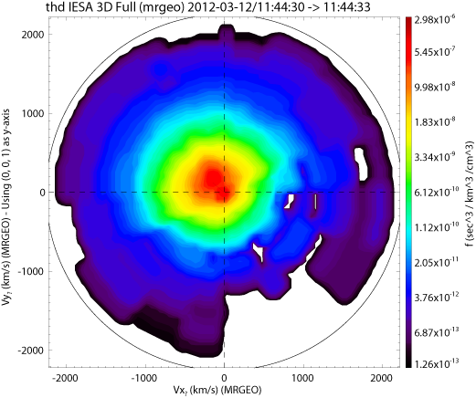
Sample slice using the new field aligned coordinates option.
The y-axis is parallel to the magnetic field and the x-axis is pointing towards the earth.

THEMIS and ARTEMIS Data Products
1. FGM data for all probes for dates after 5-Aug-2011, has been reprocessed with new calibration data.
2. Data from Antarctic GMAG stations PG1 and PG2 (PENGUIN) has been provided by Bob Clauer and Virginia Tech, and is now
available through the TDAS Software. PG1 and PG2 are the first stations on a chain being deployed conjugate to the West
Greenland magnetometers. PG1 in nominally conjugate to Uunmannaq (UMQ) and PG2 is nominally conjugate to
Qeqertarsuaq (GDH).
3. SLP data reprocessed to include June 2012 leap second.
4. GMAG data from ABK, FCC, YKC has been reprocessed to rotate from geographic coordinates to approximate local
geomagnetic coordinates.
5. All Sky Imager (ASI) products are available as follows:
a. Thumbnail cdf files and overview plots are available through 04/30/2012, movies are available through 04/30/2011.
b. Full resolution raw data is available and complete for 2007-2011. Full resolution cdf’s and Keograms are available and complete for 2007-2011.
c. Web site - Mosaics are up to date and available through 12/2011.

THEMIS and ARTEMIS Documentation, Web Site and Trainings
1. A new document "THEMIS/ARTEMIS timekeeping conventions" (thm_soc_135_time_conventions), documents the spacecraft
clock management practices and representation of timestamps in THEMIS/ARTEMIS data products. A copy can be found at:
ftp://apollo.ssl.berkeley.edu/pub/THEMIS/3 Ground Systems/3.2 Science Operations/Science Operations Documents/.
2. The THEMIS Science Data Analysis Software (TDAS) Users' Guide, both word and pdf document’s Table Of Contents,
are now clickable and will jump to the requested section within the document.
3. The GMAG Antarctic Stations PG1 and PG2 have been added to the GMAG Station List. A complete list of GMAG Stations is
available (with their longitude and latitude) at: http://themis.ssl.berkeley.edu/images/ASI/THEMIS_GMAG_Station_List_Apr_2012.xlsx.

