THEMIS and ARTEMIS Science Data Analysis Software Monthly Accomplishments
September 2011

THEMIS and ARTEMIS Science Data Analysis Software (TDAS) - Post v6.0
1. Harald Frey's program ("thm_asi_merge_mosaic.pro") has been modified to adjust image projection heights at station
interfaces, in order to remove unrealistic, sharp transitions at camera field-of-view boundaries.
2. An option to use nearest neighbor interpolation has been added to both the GUI and the command line routine
tinterpol_mxn (use keyword /nearest_neighbor).
3. thm_cotrans has been updated to allow for integer input.
4. A message has been inserted in the ESA load routine warning for time ranges that are longer than two days.
5. The FFT load routine had been modified so that support data is only saved after loading when requested.
6. Both the gui and tplot now support filled symbols. The tplot crib, 'thm_crib_tplot_annotation' has command line examples.
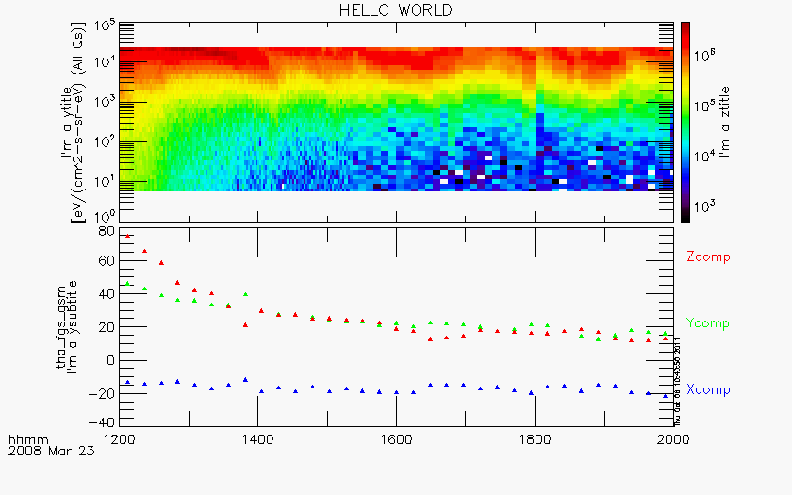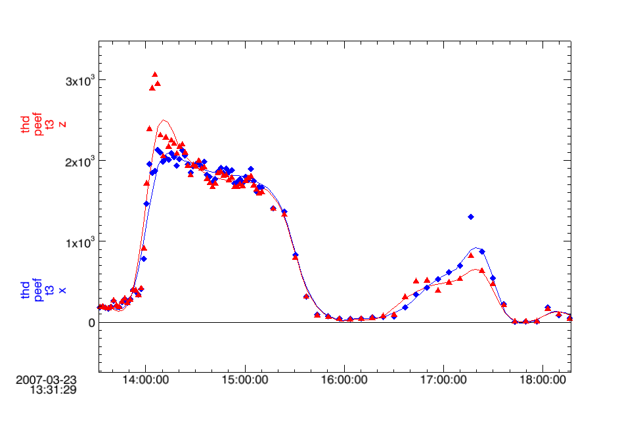

THEMIS and ARTEMIS Data Products
1. L2 FGM data was reprocessed for all probes from 2010-10-15 on, to replace missing FGH data
2. All Sky Imager (ASI) products are available as follows:
a. L1 cdf’s and Mosaics are up to date and available through 8/31/2011.
b. Thumbnail cdf files and overview plots are available through 8/31/2011.
Thumbnail movies are available through 12/31/2010.
c. Full resolution raw data is available and complete for 2007-2010. 2011 complete through April 2011.
Full resolution cdf’s and keograms are available and complete for 2007-2010. 2011 complete through April 2011.
d. Web site - Mosaics and movies reprocessed for 2007-2010 seasons. They are up to date and available
through December 2010.
3. The Bay Mills magnetometer was installed facing south rather than north in September 2010. The data has now been rotated
so that the components are correct. Data from Pine Ridge and Hot Springs has also been reprocessed back to June 2009 and
May 2008, respectively, due to calibration changes.

THEMIS and ARTEMIS Documentation
1. L2 File Definitions and Science Data Variables Descriptions documents have been updated.

THEMIS Web Site
1. Summary plot keys created for all THEMIS probe subplots.
2. Summary Plot navigation keys now at the top and bottom of the web page.
3. Remaining Links activated on the Data Overview web page.
4. Revised publications web page with new articles including the THEMIS/ARTEMIS Articles from the
new AGU book “Substorm Perspectives with Modern Magnetospheric and Ground Observations”.

