THEMIS and ARTEMIS Science Data Analysis Software Monthly Accomplishments
August 2011

THEMIS and ARTEMIS Science Data Analysis Software (TDAS) - Post v6.0
1. TDAS GUI Layout Option Enhancements:
a. Various new formatting enhancements were added to assist in more user friendly layout control
b. Adding variables will automatically create a new "plot" and much of the page formatting has been automated
2. thm_cotrans support for coordinate transforms in/out of SEL, state CDFs with SSE and SEL
probe positions and velocities, has been released to the Science team for QA and validation.
3. The Symbol for lunar orbit plots was moved from the end of the time series to the beginning of the time series.
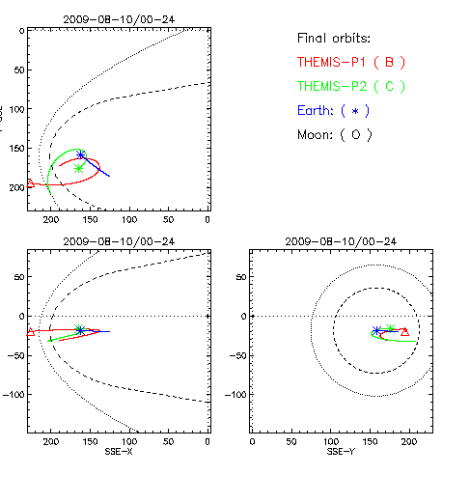

THEMIS and ARTEMIS Data Products
1. FGM data from August 2010 for all probes has been reprocessed with new calibration data.
2. THEMIS/ARTEMIS spin axes offsets are up to date.
3. Reprocessed Artemis (probes B&C) FGM level 2 files from 2011-05-11 on with new calibration data. Inner probes were also
reprocessed for files from July and August 2011, for new calibration data.
4. All Sky Imager (ASI) products are available as follows:
a. L1 cdf’s and Mosaics are up to date and available through 8/31/2011.
b. Thumbnail cdf files and overview plots are available through 8/31/2011.
Thumbnail movies are available through 12/31/2010.
c. Full resolution raw data is available and complete for 2007-2010. 2011 complete through April 2011.
Full resolution cdf’s and keograms are available and complete for 2007-2010. 2011 complete through April 2011.
d. Web site - Mosaics and movies reprocessed for 2007-2010 seasons. They are up to date and available
through December 2010.
5. University of Alberta’s GMAG data for listed sites (FSIM, FSMI, GILL, PINA, RANK, SNKQ, ATHA) after May 2011 has been
retrieved. In addition MACCS network data for listed sites (CDRT, CRVR, GJOA, NAIN, PANG, IGLO, RBAY)
after April 2011 has been recovered as well.

THEMIS Web Site
1. The THEMIS Data Processing Page has been updated with new reports for Probe Data Processing File Recovery and Stats.
An option “BDPS Description” is available which describes how to use and the contents of the new reports.
2. The 2011 THEMIS/ARTEMIS publications and nuggets list has been updated.

