THEMIS Science Data Analysis Software Monthly Accomplishments – June-July, 2010

THEMIS Science Data Analysis Software (TDAS) - Post v5.21
1. Implemented patch to L0->L1 processing to eliminate double-correction of DFB internal delays for FBK and FFT data types.
2. Enhanced the TDAS spinmodel_get_info routine to improve detection of shadow time intervals - now uses the
eclipse flag from the BAU telemetry. This has been added to L1 STATE CDFs in the last reprocessing.
Note - this eliminates the need for checking eclipse geometry due to telemetry gaps being mistaken for eclipses.
3. The following on-board moments calibrations modifications were made:
a. ESA on-board moment calibrations were updated for normal operation, so results will be consistent with ground moments.
b. ESA on-board moment calibrations were updated to apply new calibrations when instrument is in solar wind mode.
c. EFLUX units were modified for SST and ESA on-board moments to be consistent with ground moments.
Previous units were eV/cm3 * km/s, new units are eV/cm2/sec
Corrections will be applied automatically if the TDAS software is updated and L1 moment data is loaded.
Note - #3a corrections will be applied even if software is not updated.
4. New software has been added to TDAS to allow calibration of SST full/burst distribution data using text files. Software can
be activated by setting the /sst_cal keyword when calling the moment or angular spectra routines. Calibration files are stored
in the themisdata/th?/l1/sst/0000/ directory. Calibrations can vary with time. Calibration parameters follow:
a. 4-energy scales(one for each sensor head) b. 4-energy offsets(one for each sensor head)
c. 1-nominal/theoretical geometric factor d. 4-gfactor corrections(one for each sensor head)
e. 1-dead time correction f. 4-attenuator corrections(one for each sensor head)
g. 4x16 efficiency corrections(one for each sensor head and energy bin combination)
Note - New calibration parameters are not yet available. But end users can construct their own calibration files.
5. A new beta version of 2-D Slices for both GUI and Command Line (CL) is available. At the CL prompt enter thm_ui_slice2d to use. The new beta version has numerous new plotting options for velocity slices. Also an updated crib sheet for CL (thm_crib_part_slice2d.pro ) is now available.
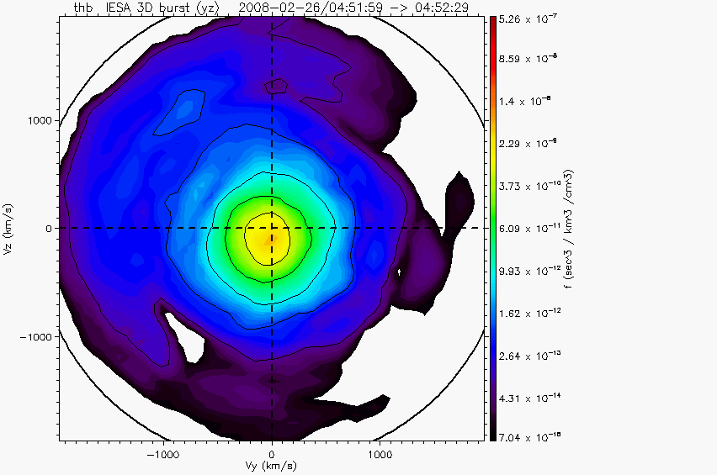
THEMIS Data Products
1. Full resolution all-sky imager data processed and available until January 31, 2010.
2. The L2 data for ESA, FGM, FIT, SCM, MOM have been reprocessed to add solar wind mode flags,
new FGM calibrations and new formats for time variables.

THEMIS Documentation
1. Revised documentation is available that more accurately describes the HDZ coordinate system of gmag data. Links:
ftp://apollo.ssl.berkeley.edu/pub/THEMIS/3%20Ground%20Systems/3.2%20Science%20Operations/Science%20Operations%20Documents/thm_soc_110_COORDINATES_20100729.pdf
ftp://apollo.ssl.berkeley.edu/pub/THEMIS/3%20Ground%20Systems/3.2%20Science%20Operations/Science%20Operations%20Documents/thm_soc_108_GMAG_L2_VARNAMES_20060929.pdf
ftp://apollo.ssl.berkeley.edu/pub/THEMIS/3%20Ground%20Systems/3.2%20Science%20Operations/Science%20Operations%20Documents/Science%20Data%20Variable%20Descriptions/THEMIS%20Science%20Data%20Variables%20Descriptions.pdf

