THEMIS Science Data Analysis Software Monthly Accomplishments – May 2010

THEMIS Science Data Analysis Software (TDAS) - Post v5.21
1. Released new processing tools for VC->L0 and L0->L1 processing.
New features include:
a. relaxed consistency checks for frame vs. packet timestamps, to support deep-space operations for outer probes
b. support for new FFF (survey FFT) data type
c. added solar wind mode flags to L1 SST and L1 MOM CDFs
d. where available, enhanced eclipse spin model processing incorporating FGM data
2. tplot_gui has been modified to support x/y/zstacklabels.
3. A "raw" checkbox has been added to the THEMIS GUI load panel to allow the loading of uncalibrated THEMIS data.

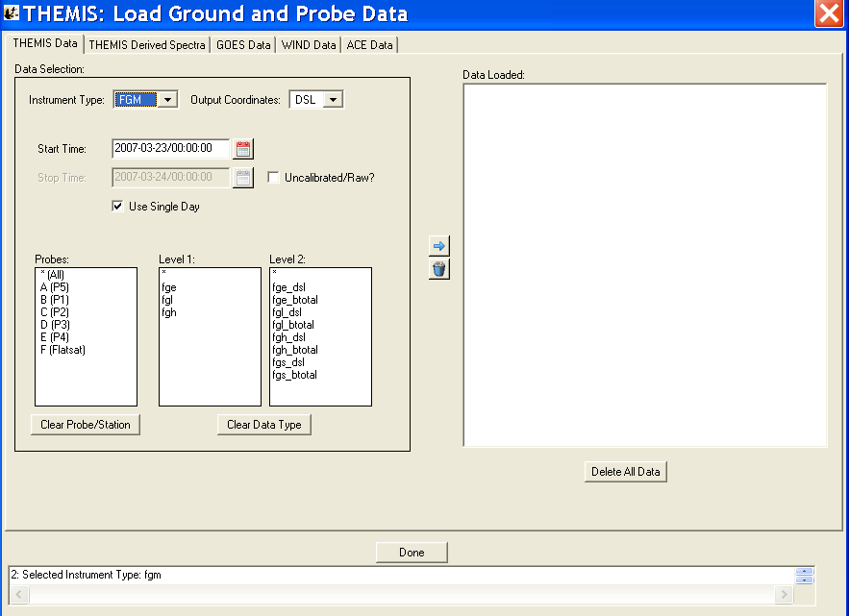

THEMIS Web
1. GMAG Site List has been updated (see http://themis.ssl.berkeley.edu/gmag_desc.shtml).

THEMIS Data Products
1. Level 2 SCM CDF data files have been processed and reside on the UCB SSL data base. They will be released to
CDAWeb in June 2010.
2. The L1 STATE, L1 SST, and L1 MOM data were reprocessed for entire mission due to enhanced spin model
and solar wind flags.
3. The VC->L0 and L0->L1 data for TH-B and TH-C, from the start of deep space operations, were reprocessed to recover
packets previously rejected due to frame vs. packet timestamp checks.

