THEMIS Science Data Analysis Software Monthly Accomplishments – September - October 2009

THEMIS Science Data Analysis Software (TDAS) - Post v5.1
1. The program thm_cotrans now works on non-THEMIS data and will now detect the SM coordinate
system from a tplot variable name.
2. Enhancement for largely removing 2nd and 3rd spin harmonics from X_DSL & Y_DSL and largely
removing 1st and 2nd spin harmonics from Z_DSL completed.
3. GUI enhancements:
a. Now supports settings templates, to save favorites to defaults for plotting.
b. Layout panel modified so user can create line or spectral plots with single button click
(no more switching modes).
c. Two new buttons 'Line' and 'Spectra' have been added to the Plot/Layout option under the
Graph pull down to allow for easier, quicker, and more intuitive selection of plot data types.
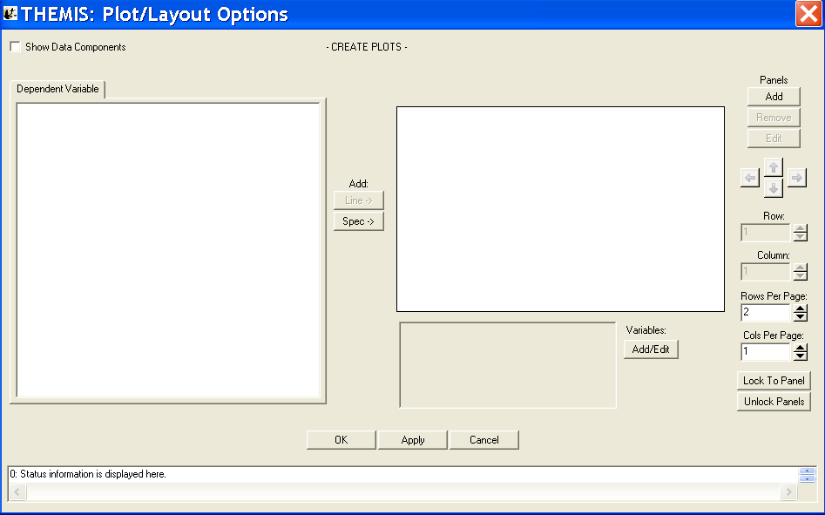
4. Added new data product that stores actual spacecraft mode (wave,particle,fast,slow), rather than
requested spacecraft mode. Can be loaded with routine thm_load_scmode.
5. Added routine to transform between GOES coordinate systems ENP (PEN) and GEI, or vice versa.
Routine is enp_matrix_make, crib can be found in ssl_general/cotrans/special/enp/enp_crib.pro
6. Improved time-smoothing algorithm to avoid over-resolution (i.e., interpolation to unrealistically
small time resolution before smoothing).

THEMIS Web
1. The online summary plot interface was modified so that it will remember the time interval of plots
when the spacecraft selection is changed.
2. TH*_L2_MOM files are now in all public CDAWeb views.

THEMIS Data Products
1. All ASI mosaics, movies, overview plots and cdf-files have been processed until 02-28-2009.
2. Completed reprocessing of L1 FGM data using better sensitivity range change detection and
correction algorithms.
3. Updated L1 process for Pseudo_AE index generation to allow for data quality checks, reprocessed
AE index data from July-2009 to present, removing questionable data.
4. Updated L2 data quality flags for ESA and MOM, including maneuver flags and velocity limits for ESA.
5. Reprocessed selected DFB L1 files that were susceptible to timing errors due to sample rate changes.
6. V03 STATE CDFs for 2009 (through mid-September) have been generated using latest batch of
spin phase and spin attitude corrections derived from FGM data.
7. GOES L2 CDFs have been reprocessed with corrected metadata.

