THEMIS Science Data Analysis Software Monthly Accomplishments – April 2009

THEMIS Science Data Analysis Software (TDAS) - V5.01
1. The THEMIS Project has released Version 5.01 of the THEMIS Science Data Analysis Software.
Versions 5.00 and 5.01 contain the New Themis Graphical User Interface (GUI), for viewing and analyzing
THEMIS Science Data. The new Gui contains powerful new features including a user friendly windows-like
environment, the ability to produce publication quality plots and increased user-interaction with graphics options
and visualizations. This version works on Windows, Linux, Mac, Unix and Vista.

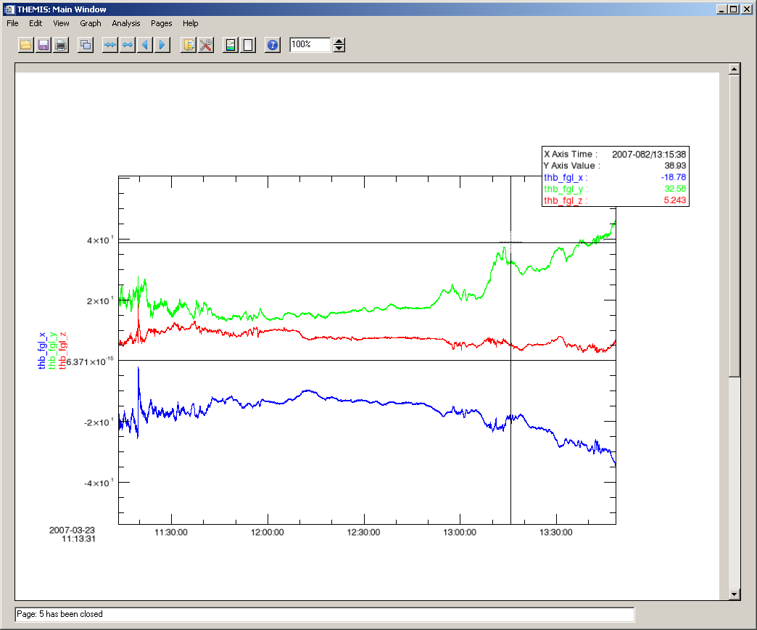

The latest version, 5.01, contains routines to load high-resolution GOES 10-12
Magnetometer and Ephemeris data and Greenland Magnetometer data from the Narsarsuaq (NRSQ)
station (where a THEMIS all sky camera has been deployed) as well as 14 other Greenland stations.

THEMIS Web
1. The THEMIS Website's Data drop down menu has been enhanced to allow the user to display the following
Web pages: Data product Descriptions, Data Product Status and Data Processing Descriptions.
2. A THEMIS Software Quick Reference GUIDE is available for download from the Software Web page.
It allows new users an easy startup for accessing the
THEMIS data.

THEMIS Data Products
1. Now processing 3 stations of the Magnetometer Array for Cusp and Cleft Studies (MACCS) data into THEMIS
data products with more to follow. At this time data from 44 ground magnetometers in networks across
Alaska, Canada, Greenland, and the continental US are being retrieved and processed into THEMIS data sets.

