THEMIS Science Data Analysis Software Monthly Accomplishments – February 2009

THEMIS Science Data Analysis Software –TDAS-V5.00_beta Release
1. The THEMIS Project has released the beta Version 5.00 of the THEMIS Science Data Analysis Software.
The beta Version 5.00 contains the New Themis Graphical User Interface (GUI), for viewing and analyzing
THEMIS Science Data. The new GUI contains powerful new features including a user friendly windows-like
environment, the ability to produce publishing quality plots and increased user interaction with graphics and
animations. The beta version only works on Windows while the official Phase I release, due out in the
coming weeks, will work on Linux, Mac, Unix and Vista.
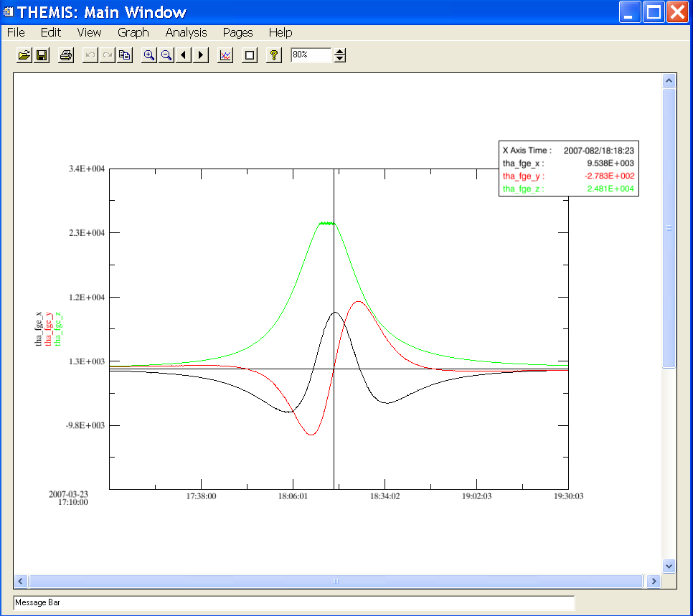

THEMIS Web
1. The THEMIS Web site now has enhanced ASI, FGM and SCM web pages containing Caveats, FAQ’s and
Data Flow diagrams. You can access these pages at http://themis.ssl.berkeley.edu/instruments.shtml.
2. ASI Web pages: a new interactive map of all THEMIS ground instruments and supporting elements are
available using the Google Map API. The map allows a user to access meta data on each site which includes
geocentric and geomagnetic coordinates, as well as service dates. The map also lays out a subgroup of the
magnetic latitude and longitude field lines in close proximity to the sites. Future enhancements will include
cloud cover and the day/night terminator. The map can be found at:
http://themis.ssl.berkeley.edu/beta/asi_map.shtml.
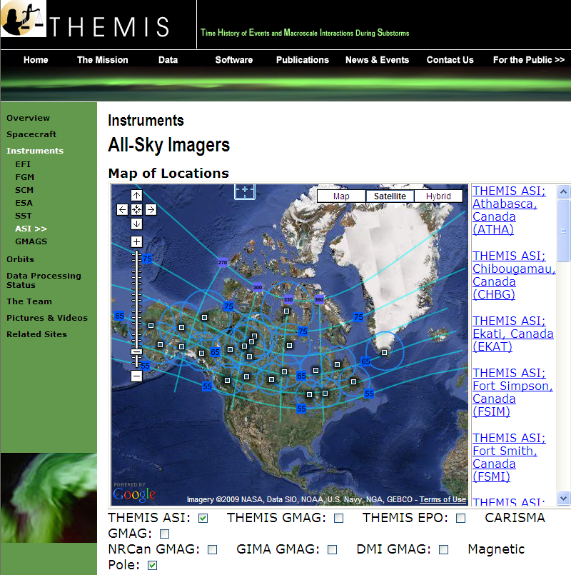

3. Updated the ASI viewer to move forward/back by 1 hour when selecting a movie.

THEMIS Data Products
1. Added a checksum routine to the creation of the GMAG L2 CDF files. Now the top level directory structure
includes a file which lists a 160 bit checksum for each L2 file. This was done in support of the VMO effort.
2. Set up a new process to download GMAG data from Narsarsuaq, Greenland and covert the data to L2 CDF.

