THEMIS Science Data Analysis Software Monthly Accomplishments – May 2008

THEMIS Science Data Analysis Software – TDAS (Bleeding Edge Distribution - post v4.00)
1. Released v4.00 of the THEMIS Science Data Analysis Software.
2. Thm_part_getspec has been modified so that angular spectra with time ranges that contain more than one
angle mode plot correctly.
3. A more rigorous despike process has been added to the gmag stackplots.
4. A THEMIS software solution to a CDF patch error with IDL v6.4 and v7.0 such that loading L1 FIT data
for more than one day will now work properly.
5. The following mods were made to the THEMIS GUI:
a. The 'Data Input Options' window for SCM data has been modified to include a new section which
allows the user to modify SCM calibration parameters. Default values are used when the window is
first displayed. When the user clicks the 'Accept and Close' button, the parameter values displayed in
the window, will be used to calibrate the data.
b. Two new buttons, Spacecraft and Component, have been added to the Plot Menu window. The buttons
can be used to regroup active tplot variables, either by Spacecraft or Component. By default, data
loaded from the GUI is grouped by Spacecraft. The user can use the buttons to toggle back and forth.
If new tplot variables were created, they will be made active and plotted.
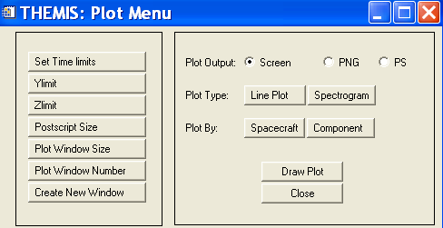
6. The thm_cal_fit.pro now calibrates the 'efs' datatype using EFI calibration parameters.
7. The thm_ui_wavelet.pro now checks for at least two finite data points before allowing wavelet calculations.
8 Andreas Keiling's thm_make_ae.pro, and crib sheet thm_crib_make_ae.pro are now part of the distribution.
9. Fixed bin2d, plotxy, plotxyz and bin1d so that these routines will handle NaNs properly
10. Thm_load_fft now loads flatsat data.
11. Program developed to read ACE ascii data.
12. A routine has been added o the distribution (kyoto_load_ae.pro) that queries the Kyoto servers directly
to load 'ae', 'ao', 'au', 'al', and 'ax' datatypes. See thm_crib_load_ae.pro.

THEMIS Web
1. All ASI overview plots for the web site for 2007 and 2008 are replaced with overviews from
full resolution data where possible.
2. Created new web-based listings of ASI L1 CDFs created. These are:
http://themis.ssl.berkeley.edu/data_inventory/ground_data/asi/ast_l1_cdf_list.txt and
http://themis.ssl.berkeley.edu/data_inventory/ground_data/asi/asf_l1_cdf_list.txt
3. Tthe publications and latest news web pages have been updated. Nuggets and reports/proposals
web pages.web pageshave been added.

THEMIS Data Products
1. All asf cdf files are up to date as much as possible covering the whole tail season.
Just a few stations are still missing.
2. The thm_crib_asi.pro has been updated such that the Mozaic time is in the tail season and the spacecraft
foot print is in the appropriate place.
3. Files for MOM and FIT (onboard) added to L2 processing.
4. A more detailed description of the FGM instrument for VMO has been delivered.

