THEMIS-ARTEMIS Tips of the Month September 2011 - Slices

Velocity Distribution Slices

Overview:
- 2D cuts of particle distribution data plotted against Cartesian velocities.
- Field aligned orientations available plus option for user specified orientations.
- ESA and SST data can be combined.
- Contamination removal options identical to thm_part_getspec.
- Graphic user interface for ease of use.

IDL Routines:
- Slices GUI: thm_ui_slice2d
- Command line crib: thm_crib_part_slice2d
- Main routines:
  - Loading particle data: thm_par_dist_array
  - Getting slice data: thm_part_slice2d
  - Plotting/exporting slice: plot_part_slice2d

Comparison:
- The new slices software is designed to show exact bin boundaries based of their angle and energy ranges. Two interpolation methods are also available.
  - The 2D interpolation method mimics the old slices code (thm_esa_slice2d) by linearly interpolating a thin slice of data.
  - The 3D interpolation method will linearly interpolate the entire data set and then pull a slice from the interpolated data.

Recent Optimizations:
- The software has been optimized to automatically change some plotting and basic options when switching between different types of slices. The defaults for 2D interpolation should now match the old defaults from thm_esa_slice2d.
- The behavior of some plotting keywords may have changed with recent updates. Many common features will be “on” by default and the associated keywords may now be used to turn them off (plotting axes, energy limits, bulk velocity).
- Plots can now be exported to image or postscript with a simple keyword call to the plotting routine.

Examples:

- Field/velocity aligned ESA slice:

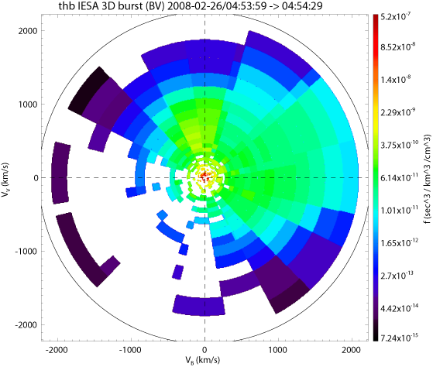

- Previous plot with combined SST and ESA data (Sun contamination has been removed from the SST data):

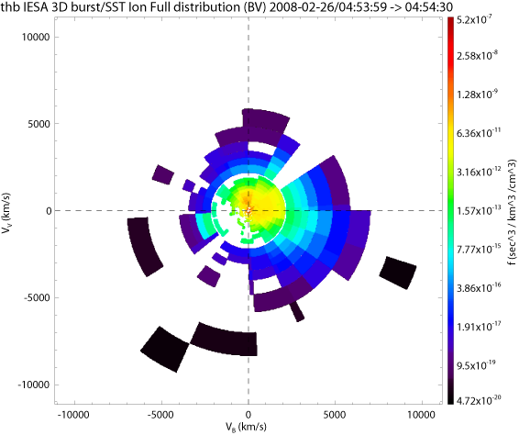

- ESA data in GSM coordinates (cut along the x-y plane). Bins that measured less than one count have been removed from the bottom plot:

