THEMIS
Science Data Analysis
Software User’s Guide
THM-SOC-120
May 2008

Jim McTiernan, THEMIS Science Software Engineer

Jim Lewis, THEMIS Science Software Engineer

Pat Cruce, THEMIS Science Software Engineer

Brian Kerr, THEMIS Science Software Engineer

Michael Feuerstein, THEMIS Science Software Engineer

Cindy Goethel, THEMIS Science Software Engineer

Timothy Quinn, THEMIS Science Operations

David A. King, THEMIS Science Software Manager

Vassilis Angelopoulos, THEMIS Principal Investigator

Document Revision Record

Rev. | Date | Description of Change | Revised By
01 | 08/06/2007 | v2.01 Incremental Changes | D. King
02 | 11/06/2007 | v3.00 Release Changes | D. King / J. McTiernan / Andreas Keiling
03 | 11/19/2007 | Replace Data Variable Description Tables | D. King / Andreas Keiling
04 | 05/2008 | v4.00 Release Changes | Software Team

Distribution List
Name | Email
Dr. Davin Larson, UCB | davin@ssl.berkeley.edu
Dr. Tai Phan, U.C. Berkeley | phan@ssl.berkeley.edu
Dr. Forrest Mozer, UCB | fmozer@ssl.berkeley.edu
Dr. Robert Ergun, LASP | ree@fast.colorado.edu
Dr. Robert Lin, UCB | rlin@ssl.berkeley.edu
Dr. Chris Cully, LASP | cully@colorado.edu
Dr. John Bonnell, UCB | jbonnell@ssl.berkeley.edu
Dr. Charles Carlson, UCB | cwc@ssl.berkeley.edu
Dr. Krishan Khurana, UCLA | kkhurana@igpp.ucla.edu
Dr. Uli Auster, TUBS, Austria | uli.auster@tu-braunschweig.de
Dr. Alain Roux, CETP, France | Alain.roux@cetp.ipsl.fr
Dr. Jim McFadden, UCB | mcfadden@ssl.berkeley.edu
Dr. Manfred Bester, UCB | manfred@ssl.berkeley.edu
Dr. Steven Mende, UCB | mende@ssl.berkeley.edu
Dr. Harald Frey, UCB | hfrey@ssl.berkeley.edu
Dr. Karl-Heinz Glassmeier, TUBS, Germany | kh.glassmeier@tu-braunschweig.de
Dr. David Sibeck, NASA GSFC | david.g.sibeck@nasa.gov

TBD List
Identifier | Description
Table of Contents

DOCUMENT REVISION RECORD

DISTRIBUTION LIST

TBD LIST

1. INTRODUCTION
1.1 Purpose and Scope
1.2 Applicable Documents

2. THEMIS WEB DATAAND SOFTWARE INTERFACE
2.1 THEMIS Web Site - Home Page
2.2 THEMIS Data Web Pages
2.3 THEMIS Software Web Page
2.4 THEMIS Software - For Developers Web Page
2.5 THEMIS Contact Us Web Page

3. THEMIS SCIENCE SUPPORT HELP SYSTEM
3.1 THEMIS Science Support Help Process
3.2 THEMIS Science Support Help Form
3.3 THEMIS Science Support Help Form - GUI Text Form
3.4 Help Form Location - GUI Message Window
3.5 Saved History Location - GUI Message Window

4. THEMIS DATA
4.1 THEMIS Data Overview
4.2 THEMIS Data Quantity Summary

5. THEMIS DATA ANALYSIS SOFTWARE
5.1 System Requirements
5.2 Known Limitations
5.3 Installation and Configuration
5.3.1 IDL Path Setup
5.3.1.1 IDL PATH Setup on Windows (and IDLDE on UNIX, Linux and Mac)
5.3.1.2 IDL PATH Setup for IDL Command Line (UNIX, Linux or Mac OS X)
5.3.2 Data Directory Set-up
5.4 How to Get Started

5.5 Software Functions
5.5.1 Loading THEMIS Data
5.5.2 General Conventions: variable name construction and reference
5.5.3 Plotting the Data
5.5.3.1 Plotting with Tplot
5.5.3.2 Plotting with Plotxy
5.5.3.3 Plotting with Plotxyz
5.5.3.4 Plotting Angular Spectra
5..5.4 Calibrations and Beyond
5.5.5 Geophysical Coordinate Transformations
5.5.6 Analystical Coordinate Transformations
5.6.1.1 Field Aligned Coordinate Transformations
5.6.1.2 Minimum Variance Transformations
5.5.7 Tsyganenko Model
5.5.7.1 Introduction
5.5.7.2 Installation
5.5.7.3 Model Routines
5.5.7.4 Trace Routines
5.5.8 Data Export
5.5.9 Managing your Data Cache
5.5.10 Define the root_data_dir for other ancilliary (non-THEMIS) data.
5.5.11 Configuring Local Data Cacheand Remote Access Behaviour
5.5.11.1 Configuration at Startup
5.5.11.2 On-the-fly Configuration
5.5.11.3 Note for users who connect using aweb proxy server
5.6 Software Organization

6. GRAPHICAL USER INTERFACE (GUI)
6.1 Main Widget
6.1.1 Loaded Data Window
6.1.2 Choosing Data using Strings
6.1.3 Active Data Window
6.1.4 History Window
6.1.5 Progress Window
6.1.6 Data Choices Selction Buttons
6.1.7 Time Range Selection Buttons
6.1.8 Load Data Button
6.1.9 Clear Load Queue Button
6.1.10 Help Button
6.1.11 Error Button
6.1.12 Config Button
6.1.12.1 Reset
6.1.12.2 Reset to Default
6.1.12.3 Save
6.1.12.4 Message Window
6.1.12.5 Exit Button
6.2 Coordinate Transformation Widget (Coordinate Transform Button - Main Wiidget)

6.3 Data Processing Widget (Data Processing Button - Main Widget)
6.3.1 Message Window
6.3.2 Subtract Average
6.3.3 Subtract Median
6.3.4 Smooth Data
6.3.5 Block Average
6.3.6 Clip
6.3.7 Deflag
6.3.8 Degap
6.3.9 Clean Spikes
6.3.10 Time Derivative
6.3.11 Wavelet Transformation
6.3.12 Dwprspec
6.3.13 Time Limits
6.3.14 Rename
6.3.15 Save
6.3.16 Restore
6.3.17 Save Ascii
6.3.18 Delete
6.3.19 Close
6.4 Plot Data Widget (Plot Button - Main Widget)
6.4.1 Set Time Limits
6.4.2 Ylimit
6.4.3 Zlimit
6.4.4 Spectrogram
6.4.5 Plot Window Size
6.4.6 Plot Window Number
6.4.7 Create New Window
6.4.8 Plot type
6.4.9 Draw Plot
6.4.10 Close
6.4.11 Message Window
6.5 Plot Data (Plot Button - Main Widget)
6.6 Overview Plots Widget (Overview Plots Button - Main Widget)
6.7 Draw Plot
6.8 GUI Tips

Introduction

Purpose and Scope.

The purpose of this document is to present to the worldwide scientific community what tools are available
for viewing, downloading, processing, calibrating and plotting THEMIS data and how to use these tools.

Applicable Documents.
- THM_SYS_012_PDMP THEMIS Project Data Management Plan
- THM_SOC_101_TIME THEMIS TIME Definition
- THM_SOC_103_HKP_VARNAMES THEMIS Housekeeping L1 Variable Name Def's
- THM_SOC_105_FIELDS_VARNAMES THEMIS Fields Variable Names Definitions
- THM_SOC_108_GMAG_L1_VARNAMES THEMIS GMAG Variable Name Definitions
- THM_SOC_110_COORDINATES THEMIS Coordinate Systems Definitions
- THM_SOC_111_SUNSENSPROC THEMIS SUN SENSOR Science Processing
- THM_SOC_112_ATTPAIPROC THEMIS Science ATT & Inertia Determ.
- THM_SOC_113_FGM_CALPROC THEMIS FGM CAL File and Processing
- THM_SOC_114_SCM_CALPROC THEMIS SCM CAL File and Processing
- THM_SOC_115_EFI_CALPROC THEMIS EFI CAL File and Processing
- THM_SOC_116_ESA_CALPROC THEMIS ESA CAL File and Processing
- THM_SOC_117_SST_CALPROC THEMIS SST CAL File and Processing
- SAI-SPEC_1079A (Oct. 26, 2005) THEMIS Coordinate Systems
- SAI-RPR-0722a (September, 2006) Probe Alignment Report (MSSS data, p18)
- pturin e-mail on Faro alignment results (9/28/06) FGM, SCM mag alignments
- THM-MB-005-Magnetometer clocking r7.pdf MAG clocking angles

THEMIS Web Page Interface

THEMIS Web Site - Home Page

The THEMIS Home Web Page can be displayed by using the following URL: http://themis.ssl.berkeley.edu/.
Across the top portion of this web page are a series of drop down menus (Home, The Mission, Data, Software, Publications, News & Events, Contact Us and For the Public). In this document we will be discussing only the Data, Software and Contact Us Web Pages.

The THEMIS Data Drop Down Menu allows you to select the following options: Summary Plots, Orbits
or to Download Data. These options will be discussed in more detail in Section 2.2.

The THEMIS Software Drop Down Menu allows you to Select the following options: Software, Developers and Documentation. These options will be discussed in more detail in Section 2.3.

The THEMIS Contact Us will automatically link you to a web page that will allow you to send
emails to the THEMIS PI or THEMIS Instrument Scientists or send a Help Request to the THEMIS Science Support Team with Comments, Observations, Problems or Questions concerning data, a document, download, GUI, Plot, Software, Web Interface or any other issue not listed.
This Help Request option will be discussed in more detail in Section 2.4.

Please note: Differences between the screen displays presented in this document and what you may see online are due to Web Page Upgrades not yet reflected in this document. The screen displays incorporated into this document are to give the reader a sense of the functionality of the of the Web Interface to THEMIS Science Software.

Please see copy of the Themis Home Web Page on the Next Page.

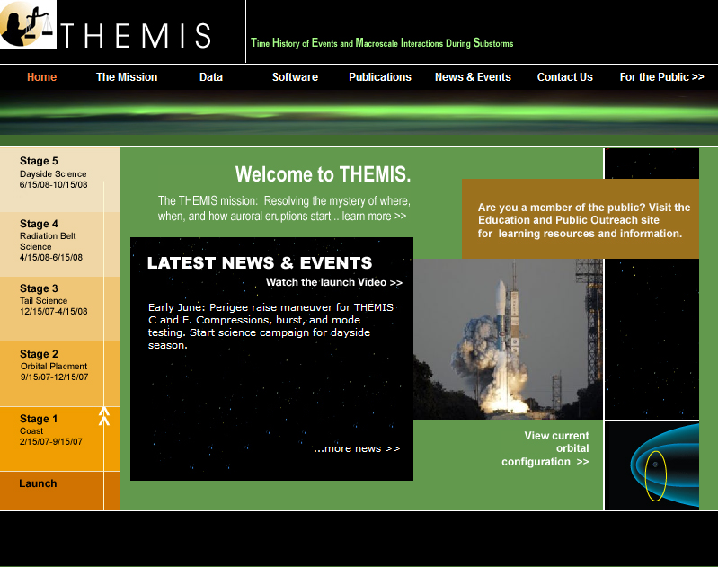

THEMIS Web Site - Home Page

2.2 THEMIS Data Web Pages

The THEMIS Data Drop Down Menu has five Options. Usage Rules which will display the Rules for using the THEMIS Data website (Rules of the Road). Data Descriptions which will lead you to the documentation ftp site where the 'Science Data Variable Descriptions' document can be found. Summary Plots which will allow you to look at Summary Plots of one
Probe, Multiple Probes, Ground Magnetometer, All Sky Imager or Orbits Data. Download Data to Download THEMIS Data.
Substorm List which will display the Events ftp site.
Please note: If using THEMIS Science Software Data Analysis Tools there is no need to use the Download Data option. Please see screen displays below.

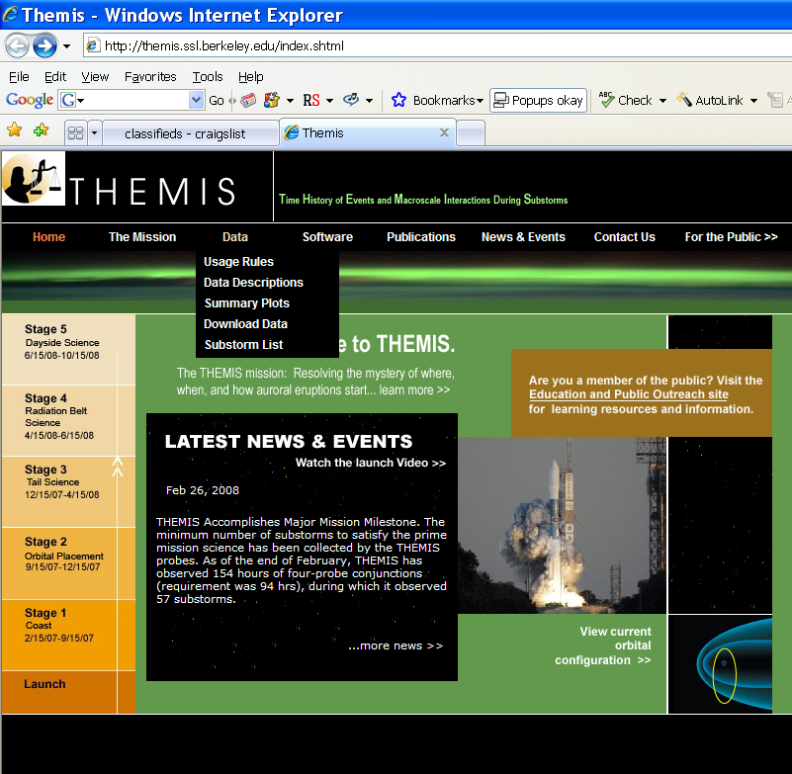

THEMIS Data Dropdown Menu

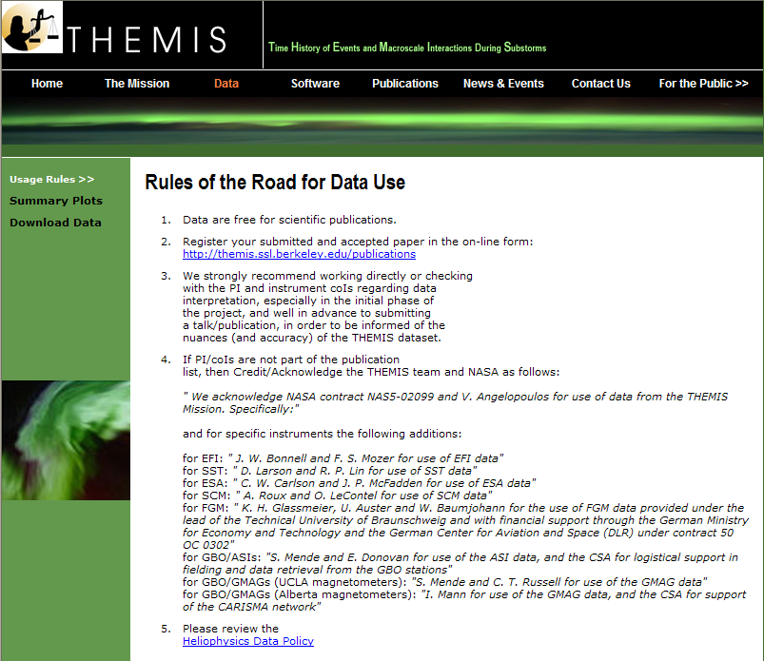

THEMIS Data Usage Rules Web Page

Selecting Data Descriptions will display this web page and then click on ftp

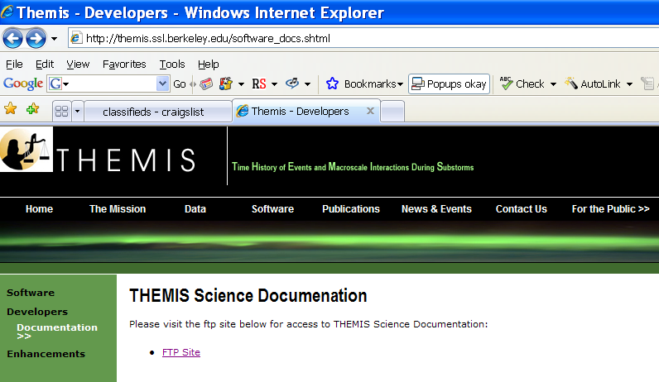

Will display a list of documents on the ftp site - Click on Science_Data_Variable_Descriptions and then choose the .xls or .pdf version
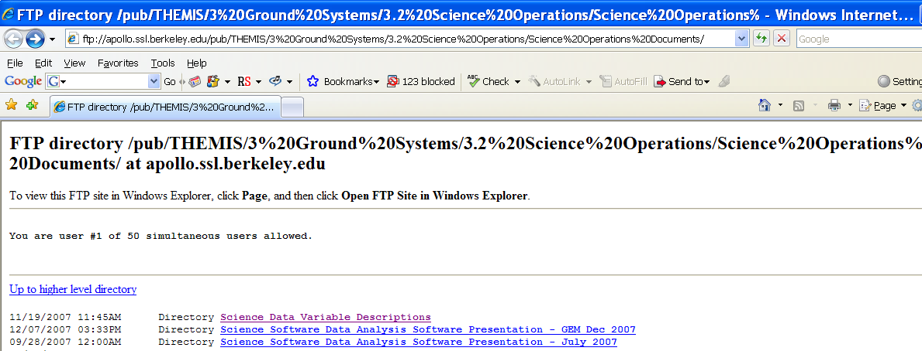
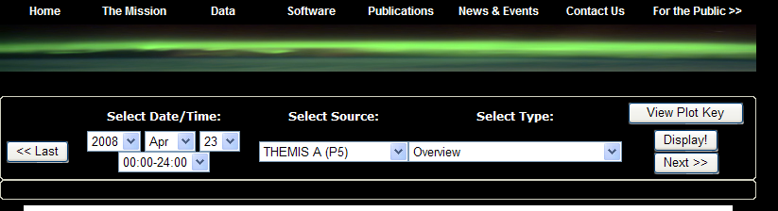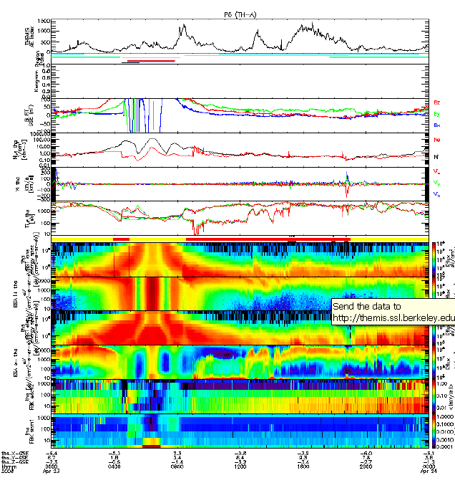

THEMIS Data Summary Plot Web Page

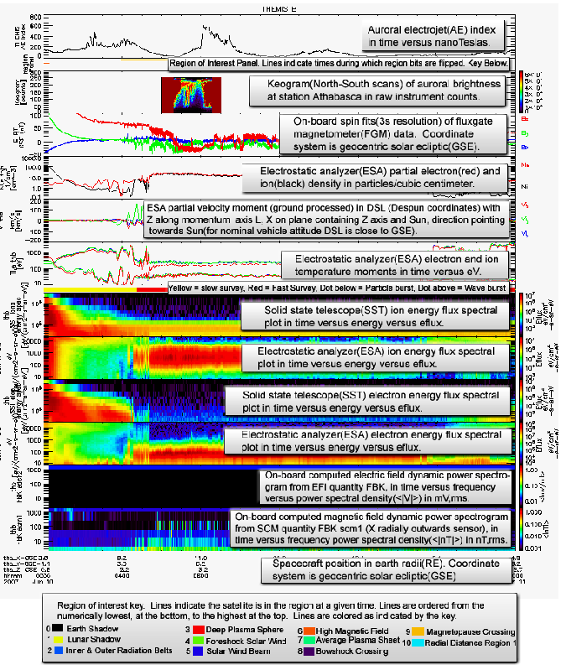

THEMIS Summary Web Page - View Plot Key Button

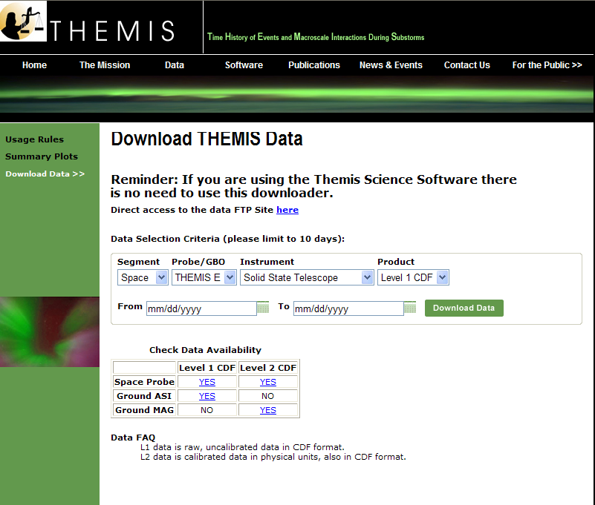

THEMIS Download Data Web Page

When you select the Substorm List on the data dropdown menu the following ftp site and related files re found.

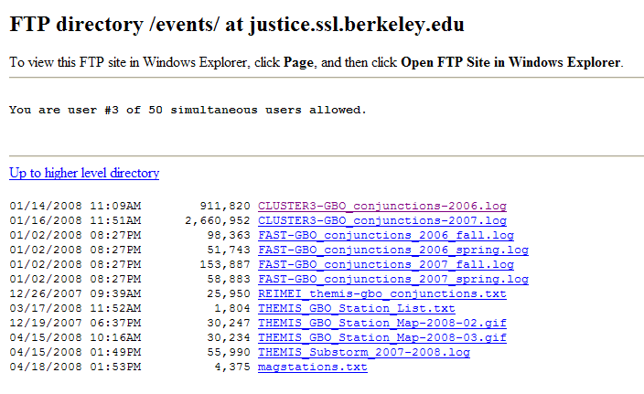

THEMIS Substorm List - ftp site

2.3 THEMIS Science Software Web Page

The THEMIS Science Software Drop Down Menu has three options. Software which displays a web page for downloading the latest release of the THEMIS Science Software Data Analysis Tools, Documentation, Registering to be notified of Future Releases of the Software, Download not yet released Software and Contacting the THEMIS Science Support Team with Help Requests. Developers, options to read about how to develop and contribute Software to THEMIS Science Software. Documentation which provides a link to the THEMIS Science Software Documentation ftp site. Enhancements, which will display the latest Accomplishments and Enhancements (A&E). Previous month's A&E are available as well.
Please note: If you download the not yet released Software, this Software may not have been tested (you are on your own). Please see screen displays below.

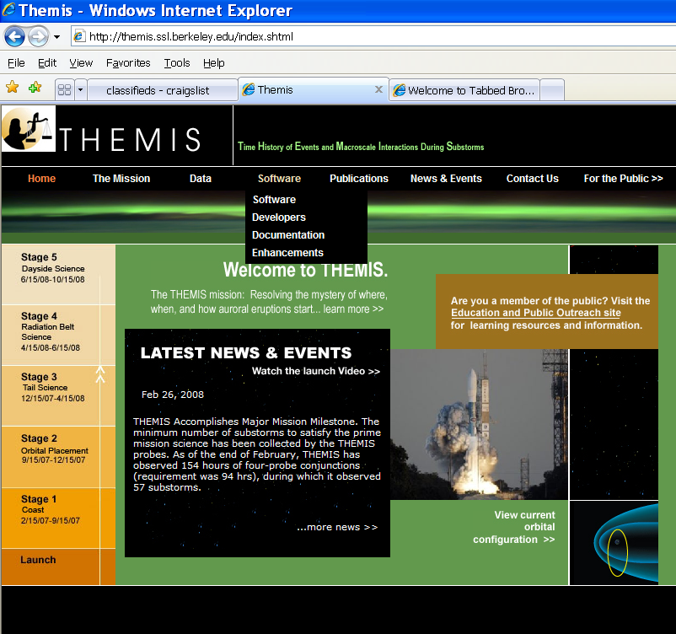

THEMIS Science Software Drop Down Menu

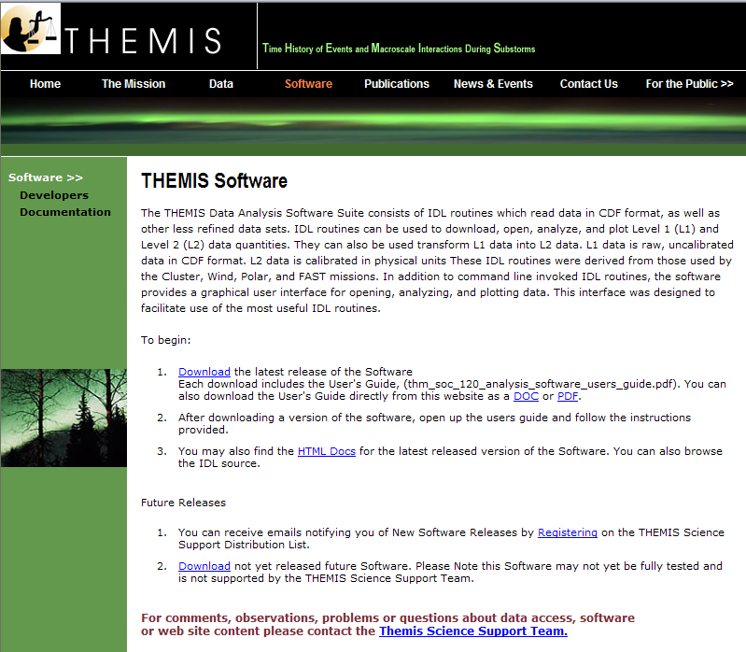

THEMIS Science Software Web Page

When you click on Download the latest release on a Windows machine A File Download dialogue box will be displayed. Click on 'Open' and the WinZip box will appear. Select the Extract icon to download the unzipped versions of the THEMIS Science Software to your computer. Notice the Extract display will ask you where to put the downloaded files. Please see Screen displays on th this and the next page.

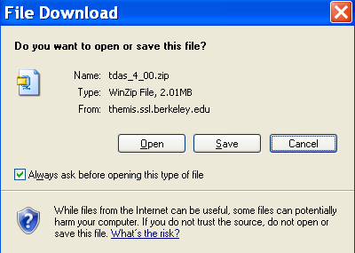

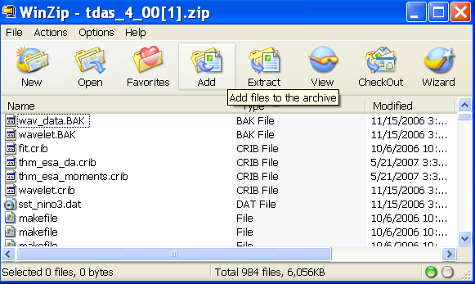

THEMIS Science Software - Download Software

Recommendation is put the Software where you can easily find it as you will need to set the IDL path.

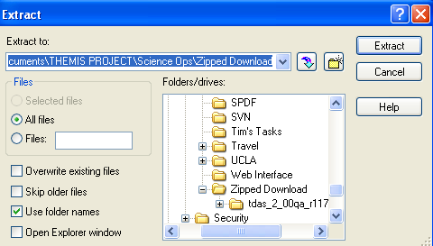

THEMIS Science Software - Download Software

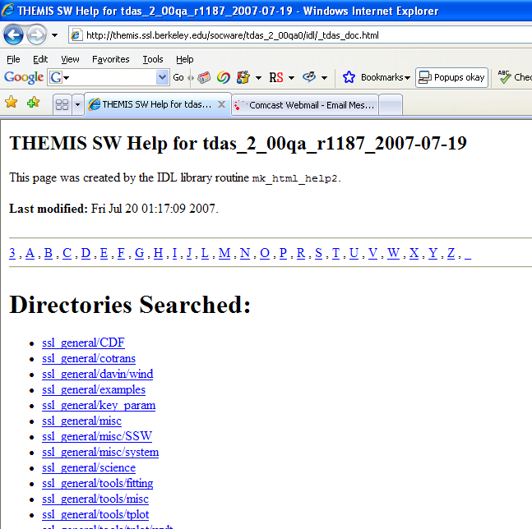

THEMIS Science Software - HTML Docs

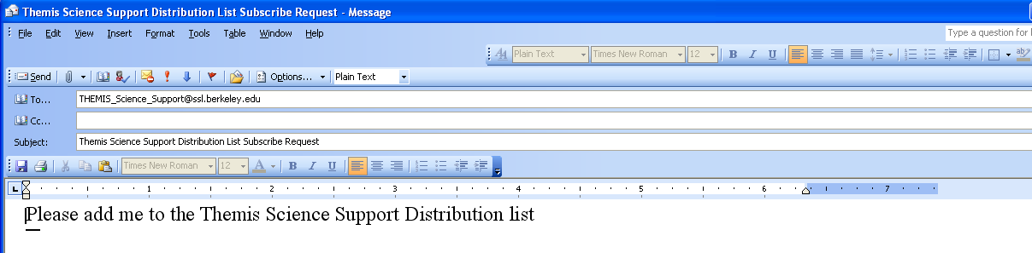

THEMIS Science Software - Registration for Notification

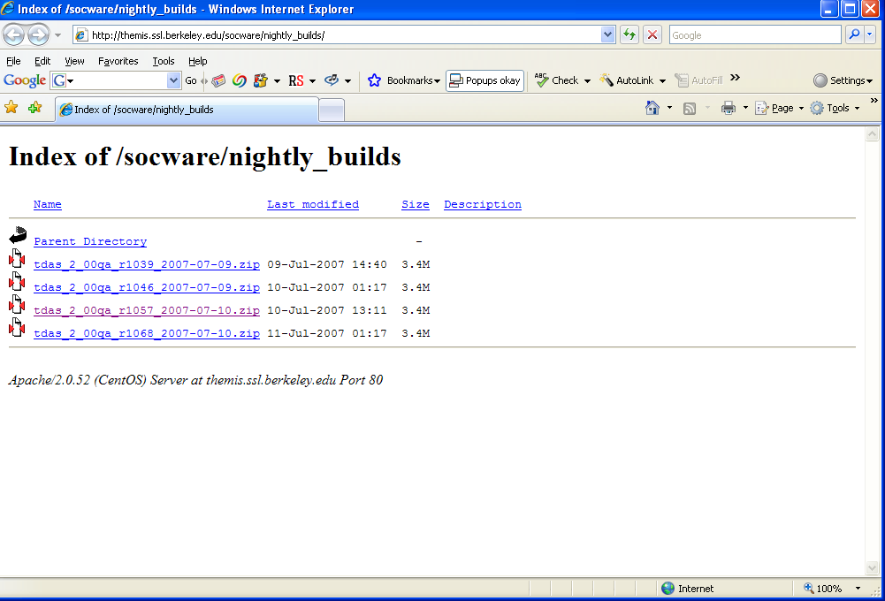

THEMIS Science Software - Download Not Yet Released Software

2.4 THEMIS Science Software - For Developers Web Page

The THEMIS Science Software for Developers Web Page has links to aide software developers how to develop and contribute software to the THEMIS Science Software library. The 'Additional Documentation' option will link you to the ftp site where current THEMIS Science Software documentation can be found.

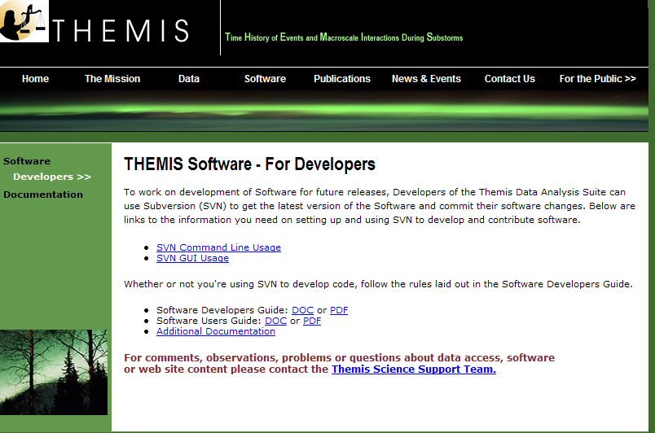

THEMIS Software - For Developers Web Page
When you click on the Documentation Option on the THEMIS Software Dropdown menu the following web page appear.
Click on ftp site and you will be transferred to the THEMIS Document ftp site.

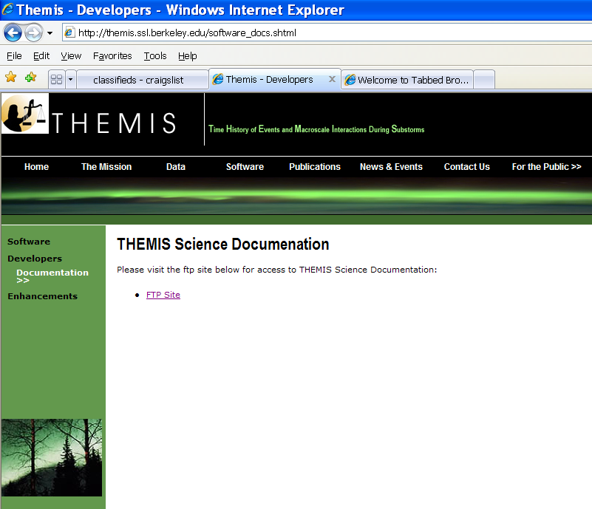

THEMIS Documentation Web Page

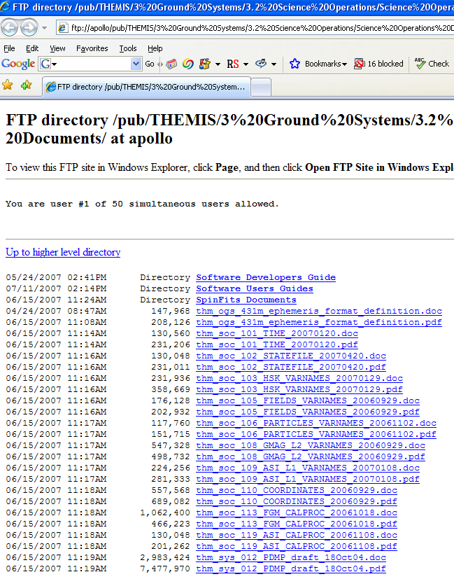

THEMIS Software Drop Down Menu - Documentation ftp site

2.5 THEMIS Contact Us Web Page

The THEMIS Contact Us Web Page lists the contact information for the THEMIS Principal Investigator as well
as the Co-Investigators for each THEMIS Instrument. In addition there is an option to send a Help Request to the THEMIS Science Support Coordinator with comments, observations, problems or questions. The Help Request form and process will be explained in more detail in Section 3. Please see the screen display below.

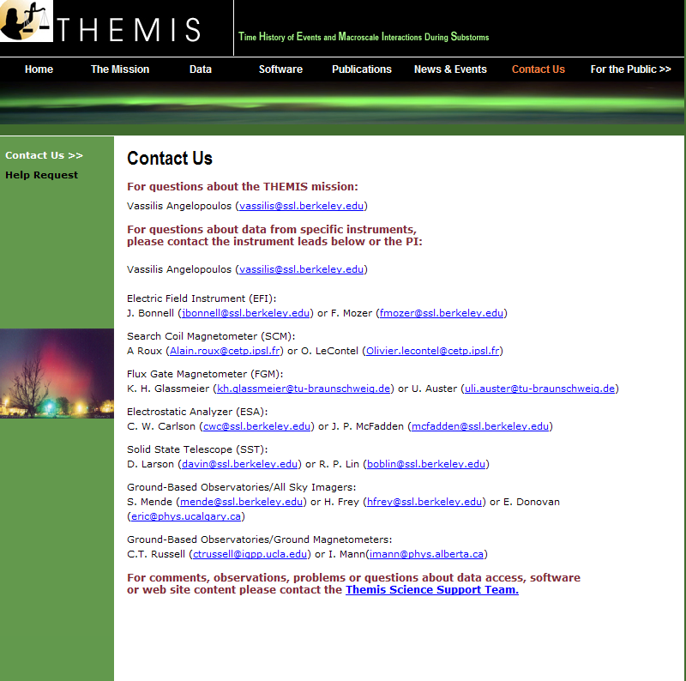

THEMIS Software Contact Us Web Page

3 THEMIS Science Support Help System

3.1 THEMIS Science Support Help Process

The THEMIS Science Support Help Process for users who have Comments, Observations, Problems or Questions concerning data, a document, download, GUI, Plot, Software, Web Interface or any other issue not listed. The Help Process is a bit different for Step 1 if you are using the Web or the GUI Interface.

For the Web to Help Request Form Interface:
Step 1: From either the Software or Contact Us Web Pages (example on previous page) the user will see the following:
For comments, observations, problems or questions about data access, software or web site content
please contact the THEMIS Science Support Team.

If you click on THEMIS Science Support Team a Themis Science Support Help Request Form (example in Section 3.2) will be displayed. The user fills out the form and hits 'Submit'. Depending on your computer and
email application the processing will be different for the email to be sent. Some computers that is all you need
to do and the form is sent automatically.
If you have a PC running Windows a box will be display asking you which email Application you use.
If you use a desktop email application like Outlook, Outlook Express, select that button, hit OK and the Form will be automatically sent to the Support Coordinator. If you choose either of the two other options (Internet Email or Other) Windows will guide you through a three step process to send your email.
Again, if not using windows (e.g. Mac, Linux or Unix) the process maybe different. Yet the main goal is for the
Help Request Form to be sent to THEMIS_Science_Support@ssl.berkeley.edu.

For the GUI to the Help Request Form Interface:
Step 1: By clicking on the 'ERROR" box on the GUI Main widget or if the THEMIS Science Software detects and error, a text version of the Help Request Form will be displayed (example in Section 3.3). Fill out the form and then click on 'Save'. In the message window of the GUI Main Widget will be where the GUI has saved your form (example in Section 3.4). It is also good practice to also save your history file by clicking on 'Save History' on the GUI Main widget. As was with the Help Request Form the in the GUI Main widget's message window will be displayed where the system has put your saved History file example in Section 3.5). At this point you can address your email to THEMIS Science Support Team, attach your Help Request Form and your History file and send.

The remaining steps are the same for either the Web or GUI Interface.
Step 2: User sends any additional information (logs, error messages, etc) to THEMIS_Science_Support@ssl.berkeley.edu.

Step 3: The Support Coordinator will log in your help request, send you back an email confirming receipt of your help request with your Help Request Number. The Support Coordinator will also forward your Help Request and any attachments to the person (Actionee) who will investigate and answer your Help Request.

Step 4: The Actionee will contact the User to respond to the comment, observation, problem or question.

Step 5: Feel free at any time to send an email to the Support Coordinator requesting status of your request.

3.2 THEMIS Science Support Help Form - Web Form

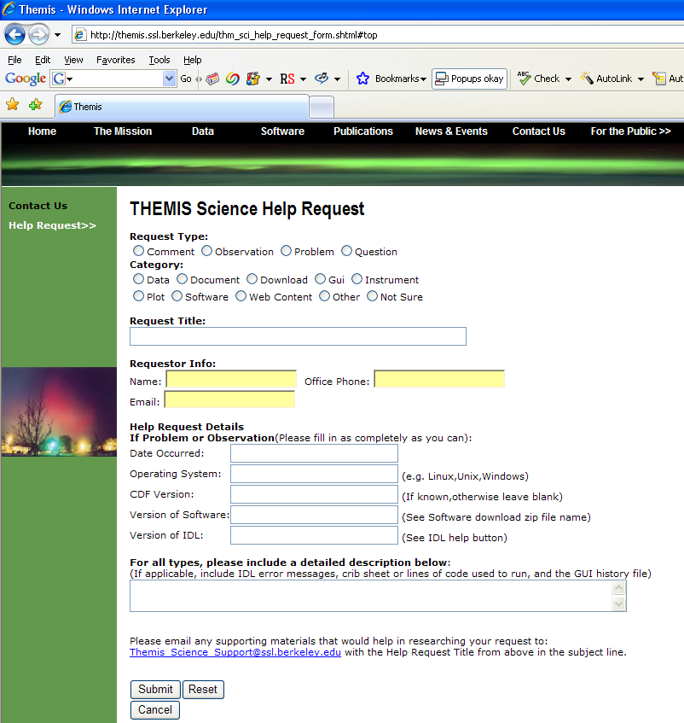

3.3 THEMIS Science Support Help Form - GUI Text Form

THEMIS Science Help Request Form

thm_sci_help_request_xxxx (xxxx number will be sent back to you)

Date Submitted: _________

Request Type: __ (C-Comment, O-Observation, P-Problem, Q-Question)

Category: ___________ (Data, Document, Download, Gui, Instrument,
Plot, Software, Web Content, Other, Not Sure)

Title: ___________________________________________________

Requestor Info:
Name: ________________________ Office Phone: _____________
Email: ________________________

Help Request Details (fill in as much as you can):

If a Problem or Observation:
Date Occurred: _________
Operating System _______ (e.g. Linux, Unix, Windows)
CDF Version ____ Version of Software _____ Version of IDL____

Detail Description of Comment, Observation, Problem or Question:
(if applicable, please include IDL error messages, crib sheet or
lines of code used to run and if using the GUI the History File)
________________________________________________________
________________________________________________________
________________________________________________________
________________________________________________________

Please email any supportive materials that would help in researching
your request to:THEMIS_Science_Support@ssl.berkeley.edu
with the Help Request Title above in the subject line.

Thanks so much,
THEMIS Science Support Team

3.4 Help Form Location - Select Help Button

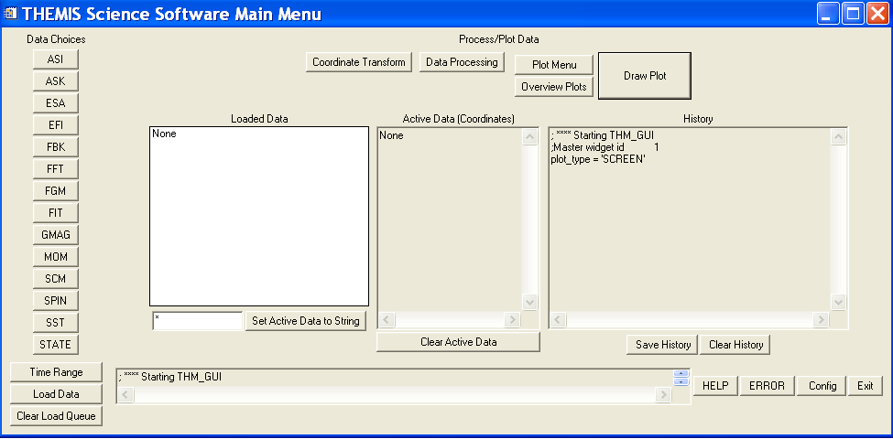

3.5 Saved History Location - Select Save History Button

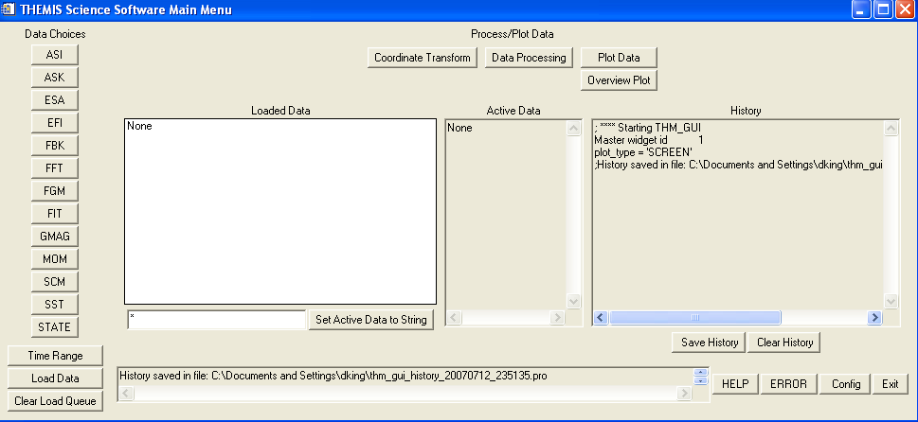

4 THEMIS DATA
This section describes the THEMIS data, as seen by the THEMIS Data Analysis Software.

4.1 THEMIS DATA Overview
THEMIS data is available in 3 levels
Level 0 | telemetry packet format, overlaps removed and formatted into daily files
Level 1 | CDF data files, contain raw telemetry data
Level 2 | CDF data files, calibrated data

4.2 THEMIS DATA Quantity Summary
The table on the next few pages summarizes the data types recognized by TDAS. They will include the variable names as they appear on an Instrument's GUI Widget as well as in the GUI Main widget's Active Data window (GUI concepts will be discussed in Section 6). Please note that in the table below the variable names will not include their probe prefix (e.g. tha_ for a probe 'A' variable).

5. THEMIS DATA ANALYSIS SOFTWARE

The THEMIS Data Analysis Software (hereafter referred to as TDAS) is IDL-based. TDAS routines can be used to download, open, analyze and plot L1 or L2 data and process L1 data into L2 data quantities. There are two main ways to use the programs: with the command line interface or with the GUI interface.

Other features include coordinate transformations and utility routines to translate data into other products (e.g., ascii) as necessary.

5.1 System Requirements
The THEMIS Data Analysis Software requires IDL developers license for Windows or a UNIX-like operating system like Solaris, Linux, or Mac OS X. The software has been tested on IDL 6.3, and 6.4 but should work on any level of IDL above 6.2. There is a patch to IDL, which is recommended for best handling of the CDF file format that is used by the THEMIS data files. See: http://cdf.gsfc.nasa.gov/html/cdf_patch_for_idl6x_new.html
If you are using IDL 6.2, or if you are using Intel Mac with any version of IDL (up to 6.4), or if you are using IDL 7.0 you must install this patch to read CDF files properly.

Mac OS X notes:

You need X11 to view plots and use the GUI in IDL. You can search for X11 in the Spotlight to see if the X11 application is installed on your system. X11 is available on your Mac installation disks, but may not be installed by default.

There is a known problem, mentioned in the IDL 6.3 release notes, which affects all IDL users running Mac OS 10.4 (Tiger). The tlimit command will lock up IDL because the plot window will not receive any mouse clicks.
Workaround: Change the X11 start-up parameters. Do the following:
- Open any terminal window (in the X11 application menu bar, you can choose xterm from the applications menu)
- Enter the following at the shell prompt:
defaults write com.apple.x11 wm_click_through -bool true
- Quit X11 (if it is running).
The new default will take effect the next time you start X11, and it will persist from that point (i.e., you will not have to make the change again).

5.2 Known Limitations
1. Incompatibilities with Solar Software (SSW). There exist some name clashes if both TDAS and SSW are on your IDL_PATH.
2. ASI data: ASF (full resolution ASI data) requires a 64-bit machine to load more than 1 hour’s worth of data.
3. "Warning for IDL 7.0 users. A bug has been found with IDL 7.0 and CDFs that cause crashes on any operating
system when loading CDF data. All IDL 7.0 users must go to:
http://cdf.gsfc.nasa.gov/html/cdf_patch_for_idl6x_new.html and install this patch."

5.3 Installation and Configuration
Getting started is usually as simple as of downloading the code and setting up your IDL path, according to the instructions, below.

For a new installation:
- Download and expand the latest TDAS release .zip file. See section 2.3 THEMIS Science Software – Download Software.
- Create a directory called TDAS into which you will copy the latest software.
- Move the tdas_x_xx folder into the TDAS directory you created.
- Configure IDL to search the TDAS directory for IDL programs. See section 5.3.1 IDL PATH setup.

For an upgrade of an existing installation of TDAS, as per the above 4 steps:
- Remove old tdas_x_xx from the TDAS directory.
- Download and expand the latest TDAS release .zip file.
- Copy the new tdas_x_xx directory into the pre-existing TDAS directory.
- Re-start IDL.

5.3.1 IDL PATH setup

5.3.1.1 IDL PATH Setup on Windows (and IDLDE on UNIX, Linux and Mac)

For Windows or IDLDE on UNIX, you can use the File->Preferences widget to set up the path so IDL can find the THEMIS IDL files.

UNIX Note: If you use IDLDE on UNIX-like systems, these instructions only work if you do not set the IDL_PATH environment variable before you call IDLDE. If IDLDE does not allow you to set the path by following these instructions, then follow the instructions for UNIX installation, below.

Start IDL (Windows) or IDLDE (UNIX, Linux, Mac).

Go to File->Preferences
Select the ‘Path’ tab.

If <IDL_DEFAULT> is not present, press ‘Insert Standard Libraries’

Press Insert
Browse to find the TDAS directory you created (see section 5.3 Installation and Configuration)
Check the box to indicate “search subdirectories”

5.3.1.2 IDL PATH Setup for IDL Command Line (UNIX, Linux or Mac OS X)

For the command line version of IDL, installation consists of setting up the IDL_PATH environment variable

Simply set the IDL_PATH environment to search all subdirectories of the TDAS directory you created in section 5.3 Installation and Configuration.

for csh or tcsh, place the following in your .cshrc file
setenv IDL_PATH ’<IDL_DEFAULT>:+/path/to/tdas’

for bash or sh, place the following in your .bashrc (Linux, Solaris) or .bash_profile (Mac) file:
export IDL_PATH=’<IDL_DEFAULT>:+/path/to/tdas’

Mac OS X Notes:
You can edit your .bash_profile file using the standard Mac TextEdit program (normally, it's impossible to open 'hidden' files beginning with '.' using TextEdit or the Mac Finder)

In the Terminal, type (or cut-and-paste)
/Applications/TextEdit.app/Contents/MacOS/TextEdit ~/.bash_profile

That will open the .bash_profile file in the standard Mac text editor. The following configurations are recommended to enable you to use IDL from the Terminal.
# Configurations to make IDL and TDAS work from the Terminal
export DISPLAY=:0.0
IDL_LOC='/Applications/rsi/idl_6.3'
source ${IDL_LOC}/bin/idl_setup.bash
export IDL_PATH='<IDL_DEFAULT>:/path/to/tdas'
# End configurations for IDL and TDAS

Note that IDL_LOC may vary, depending on version of IDL installed. Search for actual location of IDL using Spotlight.

Tip:
You can drag the 'tdas' directory from the Finder into the TextEdit or Terminal window to paste the actual path for /path/to/tdas.

After saving the file, be sure to exit the TextEdit application from the menu bar, so you can get your command line prompt back!

5.3.2 Data Directory Setup
The THEMIS Data Analysis Software requires a local data directory in which THEMIS data files can be cached. The software will attempt to create the local data directory for you at the following default location, depending on your operating system.

OS | LOCAL_DATA_DIR
Windows | C:\data\themis
Solaris, Linux, Mac OS X | ~/data/themis

These locations should work as-is for most installations; however, if you don’t have administrative privileges to create the data directory in the above locations, you can have your system administrator create it for you, or you can configure the THEMIS Data Analysis Software to use an alternate location. See Remote Data Access and Local Data Cache (Sections 5.5.9 – 5.5.11) for information about configuring an alternate location.

5.4 How to Get Started
Assuming you have the software installed, the best place to start is with a crib sheet. The crib sheets in the idl/themis/examples folder give end-to-end examples of how to load, process and plot the data available for a given instrument.

Crib sheets in idl/themis/examples:
thm_crib_asi | Crib sheet for loading and displaying All Sky Imager and Keogram data.
thm_crib_dproc | Crib sheet for testing some common data processing routines
thm_crib_efi | Crib sheet for Electric Fields Instrument waveforms.
thm_crib_esa_da | Crib sheet for analysis of ESA particle distributions
thm_crib_esa_moments | Crib sheet for ground processed ESA moments
thm_crib_export | Crib sheet for exporting THEMIS data and/or plots in common data formats.
thm_crib_fac | Crib sheet showing how to transform into field-aligned coordinates
thm_crib_fbk | Crib sheet for Filter Bank.
thm_crib_fft | Crib sheet for on-board Fast Fourier Transform data.
thm_crib_fgm | Crib sheet for Flux Gate Magnetometer
thm_crib_fit | Crib sheet for on-board Fields Spin Fit
thm_crib_gmag | Crib sheet for GMAG, including wavelet demo.
thm_crib_mom | Crib sheet for on-board particle Moments.
thm_crib_mva | Crib sheet for transformation into minimum variance analysis coordinates
thm_crib_overplot | Crib sheet for creating overview plots
thm_crib_part_getspec | Crib sheet for generating angular particle spectra
thm_crib_plotxy | Crib sheet with for plotxy, which creates 2d plots for 3d quantities
thm_crib_plotxyz | Crib sheet with for plotxyz, which creates isotropic spectrographic plots
thm_crib_scm | Crib sheet for Search Coil Magnetometer
thm_crib_sst | Crib sheet for Solid State Telescope.
thm_crib_state | Crib sheet for State data – loading and plotting probe position data
thm_crib_tplot | Crib sheet for using tplot plotting package, using GMAG data as an example.
thm_crib_tplotxy | Crib sheet with for plotxy; creates 2d plots for 3d quantities in tplot variables
thm_map_examples | Examples for mapping Ground Base Observatories (GBO)

You can run any of the crib sheets by typing
.run <thm_crib_xxx>

when execution stops at a 'stop' command in the crib sheet, type
.c
to continue.

Alternatively, you can cut and paste from the crib sheet to the command line.

The crib sheet thm_map_examples is not in the same format as the other crib sheets: it defines some procedures which you can then run for yourself, or use as examples for your own code.

To find more information on any of the TDAS routines used in the crib sheets, use:
- The source code of the crib sheets, which is included in the idl/themis/examples directory of the software distribution.
- HTML help included with the software distribution: point your web browser to idl/_tdas_doc.html at the location where your TDAS software is installed locally.
- IDL XDOC widget. At the IDL prompt, type:
xdoc
- IDL doc_library procedure. At the IDL prompt, type:
doc_library, ‘command_name’

Sample THEMIS routine documentation:

;+
;Procedure: THM_LOAD_GMAG,
; thm_load_gmag, site = site, datatype = datatype, trange = trange, $
; level = level, verbose = verbose, $
; subtract_average = subtract_average, $
; subtract_median = subtract_median, $
; varname_out = varname_out, $
; subtracted_values = subtracted_values, $
; downloadonly = downloadonly, $
; valid_names = valid_names
;keywords:
; site = Observatory name, example, thm_load_gmag, site = 'bmls', the
; default is 'all', i.e., load all available stations . This
; can be an array of strings, e.g., ['bmls', 'ccmv'] or a
; single string delimited by spaces, e.g., 'bmls ccnv'
; datatype = The type of data to be loaded, for this case, there is only
; one option, the default value of 'mag', so this is a
; placeholder should there be more that one data type. 'all'
; can be passed in also, to get all variables.
; TRANGE= (Optional) Time range of interest (2 element array), if
; this is not set, the default is to prompt the user. Note
; that if the input time range is not a full day, a full
; day's data is loaded
; level = the level of the data, the default is 'l2', or level-2
; data. A string (e.g., 'l2') or an integer can be used. 'all'
; can be passed in also, to get all levels.
; /VERBOSE : set to output some useful info
; /SUBTRACT_AVERAGE, if set, then the average values are subtracted
; from the loaded variables,
; /SUBTRACT_MEDIAN, if set, then the median values are subtracted
; from the loaded variables,
; varname_out= a string array containing the tplot variable names for
; the loaded data, useful for the following keyword:
; subtracted_values = returns N_elements(varname_out) by 3 array
; containing the average or median (or 0) values
; subtracted from the data.
; /downloadonly, if set, then only download the data, do not load it
; into variables.
; no_download: use only files which are online locally.
; relpathnames_all: named variable in which to return all files that are
; required for specified timespan, probe, datatype, and level.
; If present, no files will be downloaded, and no data will be loaded.
; /valid_names, if set, then this will return the valid site, datatype
; and/or level options in named variables, for example,
;
; thm_load_gmag, site = xxx, /valid_names
; get_support_data = does nothing. present only for consistency with other
; load routines
;
;Example:
; thm_load_gmag, site = 'bmls', trange =
; ['2007-01-22/00:00:00','2007-01-24/00:00:00']
;
;Written by: Davin Larson, Dec 2006
; 22-jan-2007, jmm, jimm@ssl.berkeley.edu rewrote argument list, added
; keywords,
; 1-feb-2007, jmm, added subtract_median, subtracted_value keywords
; 19-mar-2007, jmm, fixed the station list...
; $LastChangedBy: jimm $
; $LastChangedDate: 2007-05-21 19:44:54 -0400 (Mon, 21 May 2007) $
; $LastChangedRevision: 678 $
; $URL: svn+ssh://thmsvn@ambrosia.ssl.berkeley.edu/repos/thmsoc/branches/QA/idl/themis/ground/thm_load_gmag.pro $
;-

5.5 Software Functions
This section described the functionality of the THEMIS software. The examples are given using the command line interface, but the concepts are the same for the GUI.

5.5.1 Loading THEMIS Data
The THEMIS software is set up to work with Level 1 THEMIS data by default. Level 1 data is loaded and calibrated creating data quantities which are the same as the Level 2 products. The exceptions are GMAG (ground magnetometer), FGM (Flux-Gate Magnetometer), and FBK (Filter Bank) data, which are input from Level 2 files. In future versions we will change the default to Level 2 when reliable Level 2 files become available for each instrument. With the exception of ESA data, TDAS does not work with Level 0 data, and instead works with the Level 1 in CDF data format.

It is also possible to load raw Level 1 data. Calibration routines are available for those who want to have full access to intermediate outputs, settings of calibration parameters, diagnostic outputs, etc.

The THEMIS software automatically creates a local data cache which mirrors the structure of the THEMIS data archive. The software is written such that the default settings will work for the majority of users. The location of the THEMIS data archive is also found automatically by the software.

To download some data and load it into IDL, specify a timespan and type of data you want to load. If the data does not exist locally on your local_data_dir, it will be downloaded automatically before it is loaded into IDL.

At the IDL prompt, type:

timespan, '2006-11-11', 1, /day
Then, use one of the thm_load commands, e.g.

thm_load_gmag, site='ccnv'

List of routines for loading data:
thm_load_asi | Load All-Sky Imager data for any ground station (by keyword) or all available.
thm_load_ask | Load All Sky Keogram data for all observatories.
thm_load_efi | Load efi waveforms
thm_load_esa | Load ElectroStatic Analyzer data (for L2 esa data)
thm_load_esa_pkt | Load Level 0 ESA data
thm_load_fbk | Load Filter Bank data
thm_load_fft | Load on-board Fast Fourier Transform data.
thm_load_fgm | Load fgm waveforms (choice of fgl, fgh…)
thm_load_fit | Load On-Board Fields Spin-Fit data
thm_load_scm | Load Search Coil Magnetometer data.
thm_load_gmag | Load ground magnetometer data for any ground station.
thm_load_hsk | Load housekeeping data – all or one by keyword.
thm_load_mom | Load on-board moments data (only density moment is currently valid)
thm_load_scm | Load SCM waveform.
thm_load_spin | Load THEMIS spin model parameters
thm_load_sst | Load Solid State Telescope data.
thm_load_state | Load Orbit and Attitude data
Standard Load Procedure Keywords:
SITE | string: ground station name, or a list of ground station names, or ‘all’
PROBE | string: probe name, or a list of probe names, or ‘all’. e.g. ‘a b c’
DATATYPE | type of CDF variable for the given instrument.
LEVEL | Level of data file to load: 'l1' or 'l2' default is usually ‘l1’.
TYPE | ‘raw’ or ‘calibrated’. applies to ‘l1’ data only. ‘Calibrated’ is the default.
VALID_NAMES | Return valid names for DATATYPE, SITE, PROBE, and LEVEL
VERSION | Version of CDF file to load (useful for STATE data): 'v01', 'v02'
GET_SUPPORT_DATA | Get support data quantities from CDFs well as data quantities, only used for ‘l1’ data.
CDF_DATA | Return a structure containing data and metadata from CDF.

Note that all of these keywords are not present for all of the different load routines. This is true for the ESA, SST and MOM load routines which are under development.

5.5.2 General Conventions: variable name construction and reference
The command line interface of TDAS provides a general interface for referring to a data quantity, based on keywords. The lists in these keywords can be arrays of strings, or scalar strings containing space-separated lists.
PROBE : specifies the probe, or probes of interest: ‘a b c’ or [‘a’, ‘b’, ‘c’]
DATATYPE: specifies the type of data, for a given instrument: corresponds to name in CDF file
SUFFIX: a suffix to the variable name

The data is loaded into variables with the following name:
tha_bbb_suf
where a is the probe designation, bbb is the datatype designation, and _suf is the optional suffix.
For some data, a midfix is added before the datatype: e.g. for all STATE and HSK data a midfix is added before the datatype it in the variable name. e.g.
tha_state_pos
In this example, the datatype is POS, but the state_ midfix had been added before it in the name.

The various thm_load and thm_cal (calibration) routines, as well as thm_cotrans (coordinate transform) accept the above keywords to determine which data to operate upon.

General-purpose routines (e.g. tplot) contained in TDAS can refer to sets of variables using glob-style patterns. For example:

th?_???_raw

refers to data for all probes for all non-state data types, which have the ‘_raw’ suffix.

th[ab]_fg?

refers to FGL, FGH, and FGE for probes A and B.

5.5.3 Plotting the Data

5.5.3.1 Plotting with Tplot
Documentation that explains how to use these routines in detail can be found in the headers at the beginning of the procedure files, in the cribs, or by using the 'doc_library' command. For example: doc_library,'tplot'

Plotting routines:
tplot | General purpose time plotting utility for creating plots of lines and spectragrams.
tplot_names | Lists current stored data names that can be plotted with the TPLOT routines.
tplot_options | Sets global options for the tplot routine.
options | Sets options for specified tplot variable(s)
tlimit | Zoom into or out of a tplot.
xlim | Sets x-axis limits for specified tplot variable(s)
ylim | Sets y-axis limits for specified tplot variable(s)
zlim | Sets z-axis limits for specified tplot variable(s)
get_data | Get data out of a tplot variable into a structure containing a time tag array and a data array.
store_data | Store a data array structure into a tplot variable.

Cribs: idl/themis/examples/thm_crib_tplot.pro
idl/ssl_general/tplot/_get_example_dat.pro
idl/ssl_general/tplot/_tplot_example.pro
idl/ssl_general/tplot/_tplot_demo.pro

tplot – use to create a time series plot of user defined quantities.
idl/ssl_general/tplot/tplot.pro

tplot, 1 ; Plot the first quantity (as revealed by calling tplot_names)
tplot, [1,2,3] ; Plots a stack plot of the first 3 data quantities.
tplot,'amp slp flx2' ; Plots the named quantities
tplot, ‘th?_fgh’ ; Plots a stack plot of High Rate Flux Gate Magnetometer data for all
; available probes.
tplot,'flx1',/ADD_VAR ; Add the quantity 'flx1' to previous plot.
tplot ; Re-plot the last variables.
tplot,var_label=['alt'] ; Put Distance labels at the bottom.

tplot_names – use to print a list of acceptable names to plot and to get info on those tplot variables.
idl/ssl_general/tplot/tplot_names.pro

tplot_names,'*3dp*' ; display all names with '3dp' in the name
tplot_names,'ehspec',/verbose ; print out more info on the data structure in ‘ehspec’
tplot_names,/time_range ; print out the time range for tplot var in memory

tplot_options – use to control the plotting of all tplot variables (e.g. the title, margins, etc. of the plot window).
idl/ssl_general/tplot/tplot_options.pro

tplot_options,'title','My Data' ; Set title
tplot_options,'xmargin',[10,10] ; Set left/right margins to 10 characters
tplot_options,'ymargin',[4,2] ; Set top/bottom margins to 4/2 lines
tplot_options,'position',[.25,.25,.75,.75] ; Set plot position (normal coord)
tplot_options,'wshow',1 ; de-iconify window with each tplot
tplot_options,'version',3 ; Sets the best time ticks possible
tplot_options,'window',0 ; Makes tplot always use window 0
tplot_options,/help ; Display current options
tplot_options,get_options=opt ; get option structure in the variable opt.
tplot_options,'ygap',0.0 ; eliminate the vertical spacing between panels

options – use to control the plotting of one or more tplot panels. This procedure can be used to set all IDL plotting keyword parameters (i.e. psym, color, linestyle, etc) as well as some keywords that are specific to tplot (i.e. panel_size, labels, etc.)
idl/ssl_general/tplot/options.pro

options, ‘tvar_name(s)’,'panel_size',1.5 ; Change the relative panel width
options, ’tvar_name(s)’,'labflag',-1 ; Set evenly spaced labels
options, ’tvar_name(s)’,'labflag',0 ; No labels
options, ’tvar_name(s)’,'spec',1 ; set option to produce a spectrum plot
options, ’tvar_name(s)’,'y_no_interp',1 ; prevent y-axis interpolation
options, ’tvar_name(s)’,'y_no_interp',0 ; allow y-axis interpolation
options, ’tvar_name(s)’,'ystyle',1 ; force exact y-axis limits
options, ’tvar_name(s)’,'ystyle',0 ; return to autoranging
options, ’tvar_name(s)’,'spec',0 ; change to multi-line plot

tlimit – defines time range for tplot.
idl/ssl_general/tplot/tlimit.pro

tlimit ; Use the cursor to set time range
tlimit,'12:30','14:30'
tlimit, 12.5, 14.5
tlimit,t,t+3600 ; t must be set previously
tlimit,/FULL ; zooms to full time range available
tlimit,/LAST ; previous limits

xlim, ylim, zlim – To set plotting limits for plotting routines. zlim typically applies to spectragrams.
idl/ssl_general/tplot/xlim.pro
idl/ssl_general/tplot/ylim.pro
idl/ssl_general/tplot/zlim.pro

xlim ; Set "TPLOT" limits using the cursor.
ylim,'Ne',.01,100,1 ; Change limits of the "TPLOT" variable 'Ne'.
zlim,'ehspec',1e-2,1e6,1 ; Change color limits of the "TPLOT" variable 'ehspec'.
xlim,lim,-20,100 ; create a variable called lim that can be passed to a
; plotting routine such as "SPEC3D".

tplot variables can be stored in files using tplot_save and loaded using tplot_restore. You can also retrieve data from tplot variables and manipulate it in IDL. For example, if you run thm_part_getspec, specifying the /energy keyword, you can get the values corresponding to the center of each energy channel from the 'th*_en_eflux*' tplot variables that are created by using get_data:

get_data, 'thc_pser_en_eflux', x, y, z
print, z[0,*]

You can find these codes at idl/ssl_general/tplot/get_data.pro and idl/ssl_general/tplot/store_data.pro

5.5.3.2 Plotting with Plotxy
Plotxy and plotxyz are routines that are designed to plot two dimensional projections of three dimensional vector data or cuts across a three dimensional space. The ratio of lengths of the axes will be maintained so that relationships between the axes will not be distorted. Another way to say this is that they generate isotropic line plots. Any possible projection can be specified by naming the two axes of the data that identify a plane or by providing a matrix whose columns define a generic plane. The plot will contain a projection of the data within the plane defined by the span of the axes or the span of the two columns of the matrix. Plotxy is used to plot array data and tplotxy is used to plot tplot variables. These routines are useful for plotting spacecraft position data and traces of magnetic field lines. Plots that are generated by plotxy and plotxyz can be arranged in the same window together but there is no option that allows the placement of plotxy and tplot plots in the same window. Plotxy takes an array of vectors as an input. Tplotxy takes the name or names of tplot variables to be plotted as an input.

Documentation that explains how to use these routines in detail can be found in the headers at the beginning of the procedure files, in the cribs, or by using the 'doc_library' command. For example: doc_library,'plotxy' The plots generated by these routines can be exported in the same ways that tplot plots can be exported.

The routines can be found at:
idl/ssl_general/tplot/plotxy.pro
idl/ssl_general/tplot/tplotxy.pro

Cribs for the routines can be found at:
idl/themis/examples/thm_crib_plotxy.pro
idl/themis/examples/thm_crib_tplotxy.pro

The example below demonstrates how to plot the orbit of THEMIS C.

;this sets the time range and loads the position data
timespan,'2008-04-02'
thm_load_state,probe='c d',coord='gse'

;set up a window for the plots
window,xsize=600,ysize=300

;convert data from km to earth radii
tkm2re,'th?_state_pos',/replace

;this will set up a two plot panel one will contain the x vs y plot of the spacecraft orbit
;the other will contain the x vs z plot of the spacecraft orbit. The x axis will run from right to left on the second plot.

tplotxy,'thc_state_pos thd_state_pos',multi='2 1',colors=[2,4]
tplotxy,'thc_state_pos thd_state_pos',versus='xrz',/add,colors=[2,4]

5.5.3.3 Plotting with Plotxyz

Plotxyz is a routine that is designed to plot isotropic or non-timeseries spectrograms. Generally, plotxyz is used in conjunction with bin2d to generate a two dimensional array that contains values that are a function of two other variables. For example, plotxyz can be used to generate a spectrogram of pressure vs. x-y position. Many of the options for plotxyz and plotxy are the same, but there is no version plotxyz that works directly with tplot variables. Plotxyz and plotxy plots can be arranged in the same window together, but there is no option that allows the arrangement of plotxyz plots in the same window as tplot plots. Plotxyz requires three inputs, and accepts many different options keywords. The first input is an M element one dimensional array that contains the values of the x axis. The second input is an N element one dimensional array that contains the values of the y axis. The third input contains an MxN element two dimensional array that stores the z value of each combination of x and y.

Documentation that explains how to use these routines in detail can be found in the headers at the beginning of the procedure files, in the cribs, or by using the 'doc_library' command. For example: doc_library,'plotxyz' The plots generated by this routine can be exported in the same ways that tplot plots can be exported.

The routines can be found at:
idl/ssl_general/tplot/plotxyz.pro
idl/ssl_general/misc/bin2d.pro

The crib for the routines can be found at:
idl/themis/examples/thm_crib_plotxyz.pro

The example below shows how to generate a spectrogram of density versus position using plotxyz.

;load the data and convert to RE
timespan,'2008-02-14'

thm_load_state,probe='a',coord='gsm'
thm_load_mom,probe='a'

tKm2Re,'tha_state_pos',/replace
get_data,'tha_state_pos',data=d_pos

get_data,'tha_peim_density',data=d_den

;interpolate the data onto the same time grid
den = interpol(d_den.y,d_den.x,d_pos.x)

;bin the data using bin2d
;the '$' in the command below shows IDL that this is a single command that is printed on two lines.
;if you want you can remove the '$' and print the next two lines on a single line in IDL
bin2d,d_pos.y[*,0],d_pos.y[*,1],den,binum=20,averages=averages,$ xcenters=x_centers,ycenters=y_centers,flagnodata=!values.d_nan

;plot the spectrogram
plotxyz,x_centers,y_centers,averages,xtitle='X [RE GSM]',ytitle='Y [RE GSM]',/grid

5.5.4 Calibrations and Beyond

Refer to the crib sheet for each instrument for usage of the calibration routines. The interface to the various calibration routines has not yet been standardized.

Calibration: from L1 data to physical quantities
thm_cal_efi | Calibrates Electric Fields Instrument
thm_cal_fbk | Calibrates Filter Bank
thm_cal_fft | Calibrates FFT data
thm_cal_fgm | Calibrates Flux gate magnetometer
thm_cal_fit | Calibrates spin fit data..
thm_cal_mom | Calibrates all (ESA and SST) on-board moment data
thm_cal_scm | Calibrates SCM data

For working with SST or ESA data and creating ground-processed moments, see the crib sheets.

5.5.5 Geophysical Coordinate Transformations
thm_cotrans can be used to transform a THEMIS vector data quantity stored in a tplot variable to any of the following coordinate systems:
Abbreviation | Description
SPG | Spinning Probe Geometric
SSL | Spinning SunSensor L-vectorZ
DSL | Despun SunSensor L-vectorZ
GEI | Geocentric Equatorial Inertal
GSE | Geocentric Solar Ecliptic
GSM | Geocentric Solar Magnetospheric
SM | Solar Magnetic
For details and diagrams, see THM_SOC_110_COORDINATES.

The default output of thm_load routines is DSL. The thm_load routines set metadata in the tplot variable, which indicates the coordinate system of the data. Thm_cotrans is aware of this metadata, so it is not necessary to specify an input coordinate system when calling thm_cotrans.
thm_cotrans usage:

;Procedure: thm_cotrans
;Purpose: Transform between various THEMIS and geophysical coordinate systems
;keywords:
; probe = Probe name. The default is 'all', i.e., transform data for all
; available probes.
; This can be an array of strings, e.g., ['a', 'b'] or a
; single string delimited by spaces, e.g., 'a b'
; datatype = The type of data to be transformed, can take any of the values
; allowed for datatype for the various thm_load routines. You
; can use wildcards like ? and [lh].
; 'all' is not accepted. You can use '*', but you may get unexpected
; results if you are using suffixes.
; in_coord = 'spg', 'ssl', 'dsl', 'gse', 'gsm', or 'gei'
; coordinate system of input.
; This keyword is optional if the coord_sys attribute
; is present for the tplot variable, and if present, it must match
; the value of that attribute. See cotrans_set_coord, cotrans_get_coord
; out_coord = 'spg', 'ssl', 'dsl', 'gse', 'gsm', or 'gei'
; coordinate system of output.
; in_suffix = optional suffix needed to generate the input data quantity name:
; 'th'+probe+'_'datatype+in_suffix
; out_suffix = optional suffix to add to output data quantity name. If
; in_suffix is present, then in_suffix will be replaced by out_suffix
; in the output data quantity name.
; valid_names:return valid coordinate system names in named variables supplied to
; in_coord and/or out_coord keywords.
;Optional Input Parameters:
; in_name Name(s) of input tplot variable(s) (or glob pattern) (space-separated string list or array of strings.)
; out_name Name(s) of output tplot variable(s). glob patterns not accepted.
; Number of output names must match number of input names (after glob
; expansion of input names). (single string, or array of strings.)
;
; Example:
; thm_cotrans, probe='a', datatype='fgl', out_coord='gsm', out_suffix='_gsm'
Several examples of thm_cotrans usage can be found in thm_crib_fgm.pro.
A low-level coordinate transformation routine is available if working with simple arrays rather than tplot variables is desired.
cotrans | Transform between geophysical coordinate systems GSE, GEI, GSM.

5.5.6 Analytical Coordinate Transformations

5.5.6.1 Field Aligned Coordinate Transformations
The TDAS distribution allows transformation of three dimensional vectors into magnetic field aligned coordinate systems.

In order to rotate a vector into a field aligned coordinate system, a coordinate transformation matrix must first be generated using /themis/state/thm_fac_matrix_make.pro. This routine allows the generation of transformations for several different varieties of coordinate system. The primary input to thm_fac_matrix_make is a tplot variable containing the magnetic field vector, which is typically generated by calling thm_load_fgm.pro. Depending on the type of coordinate system variant requested, a tplot variable containing the position vector array (generated by calling thm_load_state.pro) may also need to be supplied via the pos_var_name keyword. The Z axis of the resulting coordinate system (transformation) will always be in the direction of B field vector. The other_dim keyword determines the requested variant of the transformation by specifying the second axis for the field aligned coordinate system. The third dimension will always be the cross product of this Z axis and the other_dim axis. Type doc_library, ‘thm_fac_matrix_make’ at the command prompt to see a description of the different other_dim options or look at the header at the top of the procedure file.

One caveat is that the magnetic field tplot variable must be in gse, gsm, or dsl coordinates, depending on what transformation has been selected. Another caveat is that the position tplot variable must be in gei coordinates, the default coordinate
system of thm_load_state. Also note that the resulting transformation matrices will only correctly transform data from the coordinate system of the input variable to the field aligned coordinate system. So if mag_var_name is in DSL coordinates then you should only use the output matrices to transform other data in DSL coordinates.

Once the transformation matrix has been generated, the vector can be rotated by calling /ssl_general/cotrans/special/tvector_rotate.pro with the transformation matrix as the first argument, and the tplot variable containing the vector to be rotated into the field aligned coordinate system as the second argument. Below is an example:

timespan, '2007-03-23'
thm_load_state,probe='c', /get_support_data
thm_load_fgm,probe = 'c', coord = 'dsl'
;smooth the Bfield data appropriately
tsmooth2, 'thc_fgs_dsl', 601, newname = 'thc_fgs_dsl_sm601'
;make transformation matrix
thm_fac_matrix_make, 'thc_fgs_dsl_sm601', other_dim='xgse', newname = 'thc_fgs_dsl_sm601_fac_mat'
;transform Bfield vector (or any other) vector into field aligned coordinates
tvector_rotate, 'thc_fgs_dsl_sm601_fac_mat', 'thc_fgs_dsl', newname = 'thc_fgs_facx'

See themis/examples/thm_crib_fac.pro for more examples of how to rotate vectors into field aligned coordinates.

5.5.6.2 Minimum Variance Transformations
The TDAS distribution allows transformation of three dimensional vectors into a minimum variance coordinate system defined by an interval or intervals from time series vectors.

This transformation is performed in two steps. First, transformation matrices must be generated from some input time series vector data. Second, the transformation matrices must be used to transform time series vector data. These input data must be stored in tplot variables.

The minimum variance coordinate system is defined by generating the covariance matrix for an interval of data. This matrix is then diagonalized to identify the eigenvalues and eigenvectors of the covariance matrix. The eigenvector with the smallest eigenvalue will be the direction of the z component of the new coordinate system. The eigenvector with the largest eigenvalue will be the direction of the x component of the new coordinate system. The third eigenvector will be the y direction of the coordinate system.

The user should note that the resulting transformation matrices will only correctly transform data from the coordinate system of the input variable to the minimum variance coordinate system. So if the data used to define the coordinate system are in gse coordinates then you should only use the output matrices to transform other data that are in gse coordinates.

The routine to generate the matrices can be found at:
idl/ssl_general/cotrans/special/minvar/minvar_matrix_make.pro
The routine to perform rotations using the minimum variance matrices can be found at:
idl/ssl_general/cotrans/special/tvector_rotate.pro
The cribs for these routines can be found at:
idl/ssl_general/cotrans/special/minvar/mva_crib.pro
idl/themis/examples/thm_crib_mva.pro

Additional documentation can be found in the headers at the top of the procedure files listed above or by typing 'doc_library' from the idl command prompt. For example: doc_library,'minvar_matrix_make' will show the documentation for 'minvar_matrix_make'.

The example below will use fluxgate magnetometer data to generate a minimum variance coordinate system and transform that data into the minimum variance coordinate system.

;this sets the time interval from which data should be loaded
timespan,'2007-07-10/08:10:00',22,/minute
;this loads the data
thm_load_fgm,probe='c',coord='gse'

;this generates the transformation matrices
minvar_matrix_make,'thc_fgs_gse',tstart='2007-07-10/07:54:00',tstop='2007-07-10/07:56:30'

;this transforms the data
tvector_rotate,'thc_fgs_gse_mva_mat','thc_fgs_gse',newname='mva_data_day'

;this sets the axis labels
options,'mva_data_day',labels=['maxvar','midvar','minvar']

options,'mva_data_day',labflag=1

;this plots the original data and the transformed data
tplot,'thc_fgs_gse mva_data_day'

5.5.7 Tsyganenko Model

5.5.7.1 Introduction
Version 4.0 of TDAS allows access to the Tsyganenko Fortran routines via a DLM interface written by Haje Korth. Wrapper code has been provided in IDL to make use of the Tsyganenko model from IDL quick and easy, even for a user that is not familiar with the models. Support has been provided for routines that provide the model B field at a user specified set of locations and for tracing field lines from a position to the ionosphere or the equator. Routines are also available to ease the generation of model parameters from solar wind data. The supported models are the t89,t96,t01 and t04s models.

5.5.7.2 Installation
To run the Tsyganenko routines you will need to install Haje Korth's IDL GEOPACK wrapper for Tsyganeko's original Fortran code. The current version of the IDL GEOPACK can be found at the THEMIS website at the following URL: http://themis.ssl.berkeley.edu/idl_geopack_all_67.zip . Please download this file and unzip it. You then need to place two files in your idl dlm directory. If you do not know what your dlm directory is you can type 'print,!DLM_PATH
' from within idl. The first file is called 'idl_geopack.dlm'. The second file will have a different name depending on your operating system. For windows it will be called 'idl_geopack.dll
'. On most other OS's it will be called 'idl_geopack.so'. This file will be found in a subdirectory of idl_geopack_all_67.zip that is named for your operating system. After you copy these files two files into your idl dlm directory , all you need to do is restart idl. If you want to test that the installation worked type 'print,igp_test()'. If this prints out '1', it worked.

These installation instructions can also be found in the software distribution itself in idl/external/IDL_GEOPACK/README.txt

5.5.7.3 Model Routines
Routines to generate the model field vectors for time series of position vectors can be found in the idl/external/IDL_GEOPACK directory and its subdirectories. These routines take either tplot variables or arrays of times and positions as arguments. They will produce the model magnetic field. Extensive documentation and examples can be found in the cribs and in the headers at the tops of the files.

One caveat is that you should remember to set the period keyword equal to a number of seconds equal to the cadence of your data to prevent the result vectors from sawtoothing when the geomagnetic dipole is recalculated. If your position data is all at a single time do not worry about the period argument.

The cribs for the routines are:
idl/external/IDL_GEOPACK/t89/tt89_crib.pro
idl/external/IDL_GEOPACK/t96/tt96_crib.pro
idl/external/IDL_GEOPACK/t01/tt01_crib.pro
idl/external/IDL_GEOPACK/t04s/tt04s_crib.pro

The tplot based routines are:
idl/external/IDL_GEOPACK/t89/tt89.pro
idl/external/IDL_GEOPACK/t96/tt96.pro
idl/external/IDL_GEOPACK/t01/tt01.pro
idl/external/IDL_GEOPACK/t04s/tt04s.pro

The array based routines are:
idl/external/IDL_GEOPACK/t89/t89.pro
idl/external/IDL_GEOPACK/t96/t96.pro
idl/external/IDL_GEOPACK/t01/t01.pro
idl/external/IDL_GEOPACK/t04s/t04s.pro

The routine that generates model parameters from solar wind data for the t96,t01, and t04s models is:
idl/external/IDL_GEOPACK/get_tsy_params.pro

Here is a simple example:

timespan,'2007-03-23'
thm_load_state,probe='b',coord='gsm'
tt89,'thb_state_pos',kp=2,period=60
tplot,'thb_state_pos_bt89'

5.5.7.4 Trace Routines

Routines to trace field lines from specified positions can be found in the idl/external/IDL_GEOPACK/trace/ directory. The routines will use numerical techniques for solving differential equations to trace the magnetic field lines from a set of specified positions to either the equator or the ionosphere. These routines take as arguments either tplot variables storing three dimensional position data or arrays of vectors and times. They will produce footprints of the field lines on the ionosphere or equator. Full traces of the entire field lines can be returned if requested as well. Plotting of traces can often best be performed with the plotxy or tplotxy plotting routines. The trace routines can trace using any of the four supported Tsyganenko models. The trace routines work equally well if all positions use the same time and are often used to look at field lines traced from several positions at a single instant. More extensive documentation and examples can be found in the headers at the top of files and in the crib.

These routines come with two caveats:
1. As with the model routines, if your data is not all at a single time the period keyword should be set to the cadence of your data to prevent inaccuracies from geomagnetic dipole recalculations.
2. Solving differential equations can take a long time, so please be patient. Sometimes the field lines will continue away from the earth an infinite distance or even fall into an infinite loop condition due to the insolubility of the system. The latter case only occurs rarely. To avoid the former case the R0 and RLIM parameters can be used to set maximum and minimum distance cutoffs at which to stop tracing.

An extensive crib for these routines can be found at:
idl/external/IDL_GEOPACK/trace/ttrace_crib.pro

The tplot based routines can be found at:
idl/external/IDL_GEOPACK/trace/ttrace2equator.pro
idl/external/IDL_GEOPACK/trace/ ttrace2iono.pro

The array based routines can be found at:
idl/external/IDL_GEOPACK/trace/trace2equator.pro
idl/external/IDL_GEOPACK/trace/trace2iono.pro

The trace routines can also use the get_tsy_params routine to generate model parameters. It is at:
idl/external/IDL_GEOPACK/get_tsy_params.pro

Here is a simple example:
timespan,'2007-03-23'

thm_load_state,probe='b',coord='gsm'

ttrace2iono,'thb_state_pos',external_model='t89',par=2.0D,/km
,period=60
tplotxy,'thb_state_pos_foot'

5.5.8 Data Export
You can export your data and/or plots to a variety of data formats.
Examples(please read procedure headers for additional options and information):

Export to ASCII files:
tplot_ascii, 'th?_fgs', trange=timerange(/current), dir='~/thm/waves', ext='_20070520.txt'
This example writes out Flux Gate Magnetometer Slow Survey data for all probes.
The ext keyword is being used to add the time of the data to the filename.
The dir keyword is being used to set the directory to which the files will be written.

Export to PNG:
tplot,'th?_fgs' ;plots the data
makepng,'~/thm/waves' ;make a png called waves.png
This example writes a png of the plot displayed by the given tplot command.

Export to Postscript:
tplot,'th?_fgs' ;setup the plot however you want it
popen,'~/thm/waves' ; start a ps called waves.ps
tplot ;call with no arguments to replot previous plot
pclose ;finalize postscript and save it
This example writes a postscript by recreating the previously generated plot.

Export to Encapsulated Postscript(EPS):
tplot,'th?_fgs' ;setup the plot however you want it
popen,'~/thm/waves' ; start an eps called waves.eps
tplot ;call with no arguments to replot previous plot
pclose ;finalize eps and save it
This example writes an encapsulated postscript by recreating the previously generated plot.

5.5.9 Managing Your Data Cache
There currently exist some experimental routines for managing your THEMIS data file cache. These routines serve as an example of how you will be able to download all data for a given time range with a single command.
- thm_file_download – can be used to download all types of THEMIS data for a given time span.
- thm_file_cleanup – delete empty directories. This is a function call. It searches the hierarchy and return files matching a given pattern, sorted by access time. This will only delete files if the “delete files” keyword is set.

5.5.10 Define the root_data_dir for other ancillary (non-themis) data
To define the root_data_dir for other ancillary (non-themis) data (i.e. wind, ace, goes etc.),
the default local_data_dir can be changed by setting an environment variable:

"ROOT_DATA_DIR".

For example the following line can be put in the IDL_STARTUP file:
setenv,'ROOT_DATA_DIR=/mydatacache/' or an equivalent setting made in the shell.

5.5.11 Configuring Local Data Cache and Remote Access Behavior
Data locations may be configured at IDL startup (for example, if you want the data to reside in a non-standard location), or dynamically during an IDL session.

The following table summarizes the controls that can be used, in order of precedence:
- !THEMIS system variable
- thm_config.txt (editable with thm_ui_config)
- environment variable settings

The following table summarizes the settings available:
!themis structure element | Environment Variable | Description
local_data_dir | THEMIS_DATA_DIR | a writable, local directory in which to cache data files
remote_data_dir | THEMIS_REMOTE_DATA_DIR | URL to a data archive where THEMIS data can be found. By default, http://themis.ssl.berkeley.edu/data/themis
no_download | N/A | 1: don’t access remote_data_dir
no_update | N/A | 0: download only if file on server differs or if local file does not exist.  1: download only if local file does not exist. i.e. no clobber.
verbose | N/A | level of verbosity for themis commands,  0=silent. Values >1 are generally for debugging.

5.5.11.1 Configuration at startup
If you want to change the local_data_dir where data will be stored, run thm_ui_config at the IDL prompt.
Change the setting for Local Data Directory and press ‘Save’; this will save the configuration to be used in all future IDL sessions. The configuration is saved in a thm_config.txt file in an OS-specific location. Note that this operation only changes the Local Data Directory for THEMIS data. It does not change the ROOT_DATA_DIR variable defined in the previous section. A more detailed description of the thm_ui_config widget is given in section 6.1.12.

5.5.11.2 On-the-Fly configuration
The local data directory location can be changed on-the-fly by setting the !themis.local_data_dir system variable. For example, when you are on a PC connected to the SSL network, you may choose to use a networked data dir:
!themis.local_data_dir = ‘\\justice\data\themis\’

The remote_data_dir structure element can also be updated to a different URL.

If you want the software to use only locally available data, and don’t want the software to try to download data, you can set:
!themis.no_download = 1

Note that you can only set the !themis variable in an IDL session after a thm_ command has already been run, or after explicitly calling thm_init. Using thm_ui_config from the IDL prompt without pressing ‘Save’ in the widget is an alternate way of setting !themis for the current IDL session.

5.5.11.3 Note for users who connect using a web proxy server
If you are behind a firewall and have to access the net through a Web proxy, set the environment variable 'http_proxy' to point to your proxy server and port, e.g. (for Unix) 'setenv http_proxy=http://web-proxy-server.my_institution.edu:3128'
The URL *MUST* begin with “http://".

This can be done in your IDL_startup file, e.g. IDL > setenv, 'http_proxy= http://web-proxy-server.my_institution.edu:3128’

5.6 Software Organization
The themis directory contains THEMIS-specific routines. The general directory (currently named ssl_general) contains routines which are useful for more than one space-science mission for which THEMIS team members are developing code. The external directory contains packages developed and maintained by other groups, but which are required for writing (and running) some of the themis and/or general routines.

The idl directory of the distribution includes the following files and sub-directories.

_tdas_doc.html | Documentation in HTML format, including alphabetical list of all routines.
themis/ | setup_themis | Sample setup script for csh (UNIX)
themis/ | ground/ | routines for loading, processing and plotting ground-based data. e.g. thm_load_gmag, thm_gmag_stackplot, imageplot, mosaicplot
themis/ | spacecraft/ | fields/ | routines for loading, processing and plotting particles data, e.g. thm_proc_fgm
themis/ | spacecraft/ | particles/ | routines for loading, processing and plotting particles data, e.g. thm_load_sst, thm_cal_sst
themis/ | state/ | Routines for reading state and performing coordinate transformations, e.g. thm_load_state, thm_cotrans.
themis/ | examples/ | Crib sheets, like thm_crib_ask
themis/ | common/ | THEMIS-specific tools useful to multiple data types and instruments, eg thm_gui, thm_file_download, thm_init
ssl_general/ | CDF/ | CDF utilities, including cdf2tplot, and other utilities like cdf2tplot, cdf_info, cdf_load_vars (into IDL structure representation of CDF)
ssl_general/ | science/ | Routines useful for specific scientific analysis.
ssl_general/ | cotrans/ | General coordinate transformation: cotrans, ssl2dsl, dsl2gse
ssl_general/ | tplot/ | General time-plotting utilities
ssl_general/ | misc/, tools/  ttools/tools/,and | Miscellaneous routines used by tplot and other ssl_general routines.
ssl_general/ | key_param/ | Load routines for ACE, KP, WIND, POLAR data, some of these  hahavehave had their
ssl_general/ | missions/ | Load routines for ACE, KP, WIND, POLAR data. Some of these replace older routines in the /key_param directory.
external/ | CDAWeb | CDAWeb are CDF routines distributed by NASA’s SPDF.
 | IDL_GEOPACK | Magnetic field modeling, Tsyganenko models

The _tdas_doc.html file contains a complete listing of all routines in the hierarchy, along with links to complete documentation.

6. Graphical User Interface

The philosophy of the graphical user interface (GUI) is to provide a convenient interface to the most generally useful capabilities of the command-line THEMIS IDL routines. General users can use the GUI without being required to know the individual IDL routines. Users who want a jump-start to using the more powerful and customizable IDL programming interface may begin with the GUI and then use the GUI to generate a script of the underlying IDL commands which perform the same function. This script can then be used as a starting point for creating an IDL program to process THEMIS data, or can be used as a crib sheet for using the THEMIS IDL programming interface.

The GUI code is bundled together with the THEMIS IDL code distribution; they are downloaded and installed as a single package.

A text-only version of the documentation for the GUI is available within the software distribution at idl/themis/examples/thm_gui.txt.

The GUI is comprised of a series of windows (also known as widgets) and sets of buttons and popups. The user navigates through these options by simply clicking on the option wanted.

6.1 Main Window

Starting from the left, the buttons in the first column (under "Data Choices") on the left side are used to choose different kinds of data to load, to choose the time range for the data, and to load the data. There is a button for each instrument, a button for time range selection, a button which initiates the loading process and a button which clears the queue for loading data. Each of these buttons (except for the load/clear load buttons) pops up a selection widget.

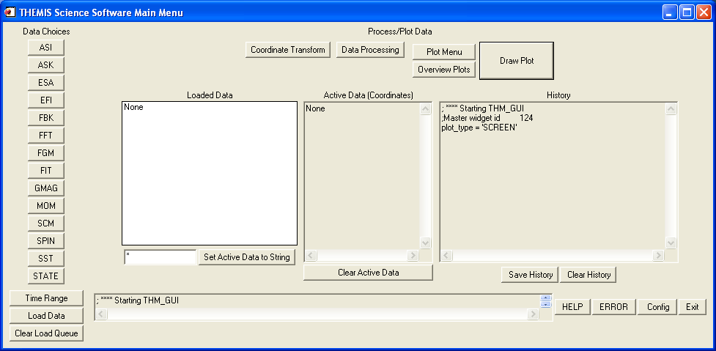

Starting from the left, the buttons in the first column (under "Data Choices") on the left side are used to choose different kinds of data to load, to choose the time range for the data, and to load the data. There is a button for each instrument, a button for time range selection, a button which initiates the loading process and a button which clears the queue for loading data. Each of these buttons (except for the load/clear load buttons) pops up a selection widget.

The buttons across the top in the middle are for coordinate transforms, data processing, plotting and overview plots. When clicked, each of these buttons pops up a widget for different data manipulation tasks. If the "Draw Plot" button is clicked, a plot of the data is created.

In the middle of the window there are windows which show the data sets that have been loaded, data that has been selected, and the history of IDL commands.

On the bottom of the main window there is a one-line progress widget that informs the user about the status of the current data loading or processing. There are also buttons: "Help", "Error", "Config" and "Exit". The Help button pops up a text widget that shows a text only version of this user’s guide. The Error button pops up a widget with the THEMIS help request form, which can be edited, saved and emailed. The “Config” button pops up a widget that allows the user to set different parameters in the system variable that controls automatic downloading. The Exit button ends the program.

6.1.1 Loaded Data Window

When data is loaded, information appears in the window. For each data set loaded, the appropriate variable name and time range are listed. To choose a particular data set for plotting or other processing, left-click on it. Multiple data sets can be selected by holding the "control" key, and clicking more than one. Also, you can click on an option, then hold "shift" and the left mouse button, and drag the cursor over the other data sets. Each of the data sets includes one "tplot variable", which can be processed and plotted using the IDL program TPLOT. The data sets that you click on in the Loaded Data window are called the "active" data sets.

6.1.2 Choosing Data Using Strings

Just below the Loaded Data window is a window in which the user can type in a string (or a set of strings separated by spaces) and set the active data sets to the variables including those strings. For example, typing in "tha_spin* tha_fg*" (don't include the quotes in the actual window) will set the active data sets to all variables that start with the string "tha_spin" and also all variables with names starting with the string "tha_fg". The question mark can be included as a wild card for single characters: e.g., "th?_spin*", will return all variables with "th" then one letter, then "_spin*. Once the string is typed, click on the "Set Active Data to String" button, and the appropriate data sets will become active. If you type "*" in the window, and click the "Set Active Data to String" button, all of the data available will be set to active

6.1.3 Active Data Window

In this window, the "active" data sets are shown. The data sets that you click on in the Loaded Data window are called the "active" data sets. Any coordinate transform, data processing or plotting task will refer to these data only.

Right after you load data, then the "active" data sets are those which have just been loaded. Usually a data processing task will change the active data set to be the data that has been just been created. When you are in doubt which is the active data set, click on it and it will be set.

The coordinate systems of the active data sets are shown in parentheses after the variable name for informational purposes. "(Unknown)" means that there is no coordinate system associated with that data. This is shown in the screenshot below, which shows the state of the widget after loading data. If you click the "Clear Active Data" button below the window, the active data is cleared. The window is also cleared and the active data sets become inactive. No data is deleted. Just click on data in the loaded data window to activate it.

6.1.4 History Window

The history window is a list of the IDL commands which have been used, and error messages. Just below the history window are buttons that allow the user to save the history in a file, and clear the history. The "Save History" button will save the history in an IDL source file. When you click here, a file selection widget pops up, allowing you to choose the filename and path for the file. The default file is "thm_gui_history_yyyymmddss.pro" in your local working directory. The time stamp on the default file name is the local system time. The "Clear History" button deletes the history. Since this history includes error message, it will be used as a debugging tool.

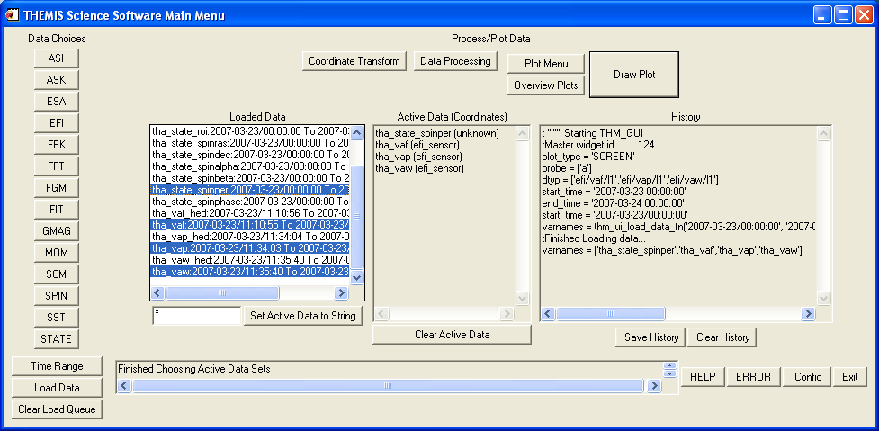

It is hoped that users will save and email this file when errors occur. If an error occurs or you have found a bug in the software, please remember to save the history file and email it to us.

6.1.5 Progress Window

In this window, at the bottom of the main widget, there is a line of text that tells the user what is happening, with respect to data loading and processing tasks. It will also display warnings; in particular, when an invalid input value for some data processing task is input, there will be a warning in the progress widget. If there is an error that causes the code to crash, then this window will display the string "Error - See History:" to alert the user to an error.

6.1.6 Data Choices Selection Buttons

Each data choice selection button pops up a widget that shows the different types of data that can be loaded for that instrument. For ground-based data the list on the left gives the different ground stations that are available. For spacecraft data, the choice is of the different probes. To choose data from that station/probe, click on it. Multiple stations/probes can be selected by holding the "control" key, and clicking more than one. Also, you can click on an option, then hold "shift", and the left mouse button, and drag the cursor over the others. Clicking "*" will select all available ground stations or probes. The example in the screenshot below is for EFI data.

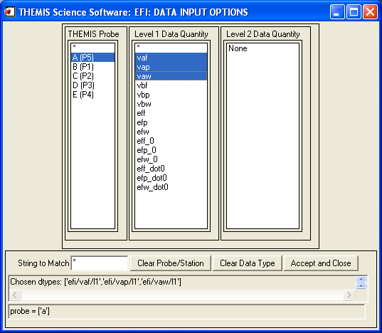

The types of data that are available are listed in the middle, for level 1 data, and on the right for level 2 data. Click on the type of data to select it, multiple selections and "*" are handled in the same manner as the choice of ground station or probe.

Below these windows, there is a place to type in a string for the data selection. If you type in here, the data types that match this string are then displayed in the list windows. Wild card characters are necessary. If for example, you are selecting state data, and you wanted all data types that include "spin", then you type "*spin*". If there are no matches, “None” is displayed. Note that you still need to click on something in the list window to choose the data, even if there is only one variable available. Below this window, there are windows that show what the current data that is being selected and the probe or ground station selected. If no data types are selected, then no data for that instrument will be loaded.

There are 3 buttons, one that allows the user to clear the choice of probe/station, one that allows the user to clear the chosen data types, and one that exits the widget. When you are done, click the "Accept and Close" button to exit the popup. The chosen data types will show up in the history window. Occasionally, the highlighted data types/probes/stations may not match what is displayed in the bottom windows – if you clear the data types or probes, then the values are cleared, even if the highlights remain on the upper windows.

The GUI is set up to allow data from multiple instruments to be input together. For example, the user can choose some EFI data types, and some FGM data types, and some other types, and load it all with one click on the "Load Data" button. Note that the selection of "probe" is global. All of the selected data will be loaded for the probe(s) chosen most recently. If, for example, you want to load EFI data from probe "A" and FGM data from probe "B", you will need to load these separately.

You will notice that all of the other buttons on the widget are inactive while this popup is active. You must click on "Accept and Close" for anything to happen after you choose data types.

The data names can be cryptic, and are not necessarily clear to the casual user. Please see Section 4.2 for a list of data types, with some description.

It should be noted that the choice of “probe” in the data loading widgets is global, that is, all of the selected data will be loaded for the probe(s) chosen most recently. For example, if you want to load EFI data from probe “A” and FGM data from probe “B” you will need to load these separately.

6.1.7 Time Range Selection Button

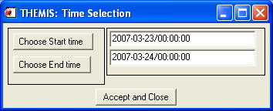

Choose Start Time: Pops up a widget that allows you to choose a start time for data to be loaded. You may also type a string value of the form yyyy-mm-dd/hh:mm:ss in the window next to the button. The selected time is displayed in the history window. This allows the user to check that the time is correct, before loading data.

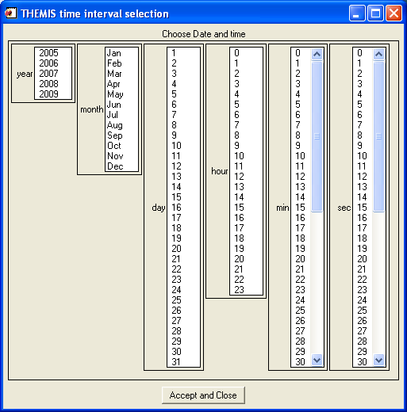

Choose End Time: Pops up a widget that allows you to choose an end time for data to be loaded. You may also type in a date string of the form yyyy-mm-dd/hh:mm:ss in the window next to the button.

When you are done, click the "Accept and Close" button to exit the popup.

Note that the initial times are 1970-01-01/00:00:00. You are required to choose a time range before you can load any data. Once an initial time range is set, it is saved, and when the widget is popped up later in the session, the most recent inputs are displayed. You need not type or select a full time; all you have to do is edit.

6.1.8 Load Data Button

Click on this button to load the selected data. All selected data types will be loaded. The list of loaded data types, or "Load Queue" are saved. If you want to reload the same data for a different time range, you can simply change the time range and hit the load button. This only works if you haven't chosen any other data types, though. The list of data types is re-initialized when you click a data selection button after loading. As discussed above in section 6.1.3, the data sets loaded in the most recent button click are the "active" data sets and will appear in the Active Data window. If you do not want all of the data to be active, you can click on what you want after the data is loaded.

Some of the data types have large files, it is best not to load more than a couple of day at a time, or a couple of hours if you are loading full resolution all-sky imager (asf) data. And, remember to always choose a time frame before selecting the load button.

6.1.9 Clear Load Queue Button

Click this button to clear out the load queue. This is useful if a load request failed. If the load routine crashes (heaven forbid), then it is a good idea to clear out the queue before trying to load other data.

Once you’ve chosen new data, use the “Clear Load Queue” button to clear it out if you do not want to load it.

6.1.10 Help Button

Clicking on the "HELP" button displays the text from this document related to the GUI. Clicking “Close” closes the widget.

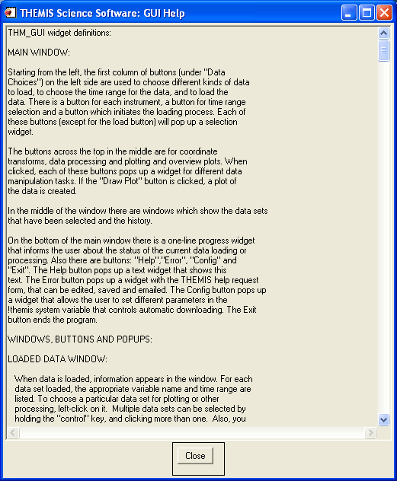

6.1.11 Error Button

When this button is clicked, an editable text widget pops up displaying the THEMIS Science Help Request Form. This allows the user to input information about the error which has occurred. There is a save button, which saves the request in a file, which can be emailed to THEMIS_Science_Support@ssl.berkeley.edu. Click “Close” to dismiss this widget.

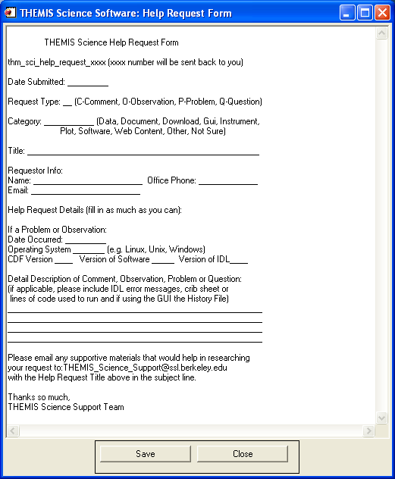

IMPORTANT NOTE: This error widget also pops up automatically when processing errors occur. The Error button should only be needed if everything else fails.

6.1.12 Config Button

This button pops up a widget that allows access to the system variable that controls the automatic downloading process. You can type in values for the different options in the windows. Note that you should not need to do this very often.

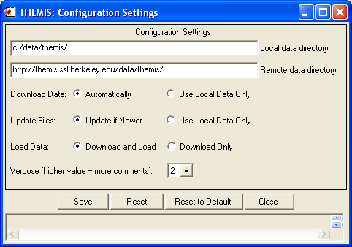

The top window gives the local data directory. Any THEMIS data downloaded is expected to be downloaded into this directory. The default value for users who are logged on to an ssl.berkeley.edu machine is "/disks/data/themis/". For windows users, the default value is "C:\data\themis\". It can be set to any directory for which the user has write permission.

The second window shows the remote data directory. The default is "http://themis.ssl.berkeley.edu/data/themis/"

Next is the flag for automatic downloads; set this to 0 for automatic downloads, 1 for no automatic downloads. (This should be set to 1 for local SSL users, or anybody who has the entire database stored locally).
Next is the flag for file updates, if set to zero this will update files in local data directories if there is a file in the remote data directory which has the same name, but is new. If set to 1, then this is not done.
Next is the download only flag; Set this to 0 to download and load data, set to 1 to only download data, and not load.
Last is the verbose flag, set this to a number from 0 to 10. The higher the number, the more messages you get during processing.

It should be noted that changes to the appearance of this widget were made with Version 4.0. The functionality remains the same.

6.1.12.1 Reset

If you press this button, the configuration is returned to the state which existed before you popped up the widget.

6.1.12.2 Reset to Default

If you press this button, the configuration is returned to the default state in THM_CONFIG.pro, and any saved configuration file is deleted. This means that if you want to go back to a configuration that you have saved previously, you need to reset the values and then save the configuration. Alternatively, you can locate the previously saved file and copy it to the appropriate location in the APP_USER_DIR shown below.

6.1.12.3 Save

If this button is pressed, then the current configuration is saved in a file. This file ends up in a directory created by the IDL APP_USER_DIR routine, on a windows system the path looks like this: "C:\usernme\.idl\themis\thm_config-4-win32\thm_config.txt". On a linux machine, it looks like: "$HOME/.idl/themis/thm_config-4-linux/thm_config.txt"

Important: Once you have saved this file, it will always be read when you run any THEMIS routines -- you should only need to do this once for each operating system that you are using.

Whenever you save a new file, the old file is copied to a file tagged with the current date and time, for retrieval in case of disaster.

6.1.12.4 Message Window

This message window will alert the user when an invalid input parameter is set. The text is the same as in the progress window of the main GUI.

6.1.12.5 Close Button

Closes the configuration widget

6.1.13 Exit Button

Exits the program, and closes all of the popups, except for the Help, Error and Configuration widgets, which are designed as stand-alone widgets.

6.2 Coordinate Transform Widget

When the "Coordinate Transform" button is clicked, a popup appears with different choices for coordinate transforms. Each possible output coordinate system has a button. The possibilities are: "SPG" (Spacecraft Probe Coordinates), "SSL" (Spinning Spacecraft Coordinates), "DSL" (Despun Spacecraft Coordinates), "GSE" (Geocentric Solar Ecliptic), "GSM" (Geocentric Solar Magnetospheric), and "GEI" (Geocentric Earth Inertial). On the right hand side of the window a text box displays the current output coordinate system.

Only the active data sets are transformed. The input coordinate systems for the active data sets are automatically obtained. Data with "Unknown" coordinates will not be transformed.

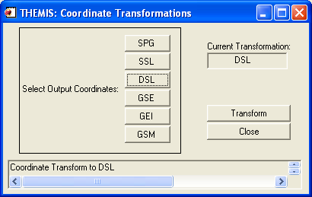

Click on the "Transform" button to perform the transformation. Warnings and error messages will appear in the text window at the bottom, and also in the progress window on the main widget. Click on the "Close" button to dismiss the popup.

Please note that changes to the appearance of this widget were made with Version 4.0. The functionality remains the same.

6.3 Data Processing Widget

When the "Data Processing" button is clicked, a popup appears with various options for data processing. Only one data processing popup will appear; if you click the button multiple times, the same popup will show up. The popup contains multiple buttons and a text widget which displays messages. When one button is clicked, the other buttons are disabled.

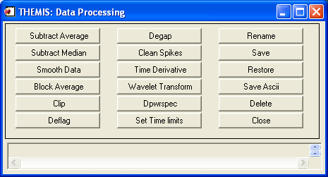

Only the variables shown in the Active Data window will be operated on by these processes. Also, these processes change the active data sets to the output variables of the processes. If you want to do multiple processes on the same data sets, you need to reset the active data sets each time. Data processing tasks are only possible when there is “active” data.

Changes to the appearance of this widget were made with version 4.0. No modifications were made to the functionality.

6.3.1 Message Window

In addition to alerting the user when a process crashes, the message window will alert the user when an invalid input parameter is set for the processes. The text is the same as in the progress window of the main GUI. For user input errors, the THEMIS Error widget does not pop up. It is important to note, however, that the user input error checking in IDL does not catch everything with respect to values typed into a widget. If the necessary input is a numerical value, then most strings that are not true numbers will not be rejected. For example, if a user inputs "XDFB%%%", this is interpreted as a value of zero; IDL does not stop processing when there is a type conversion error, it simply returns zero. Unusual things can happen. If the user inputs "1apppk", then this is interpreted by IDL as one, but if the user inputs "a1pppk", then this is interpreted as zero. If there seems to be a problem, and no error message pops up, look at the history window in the main GUI. The input values will be recorded there.

6.3.2 Subtract Average

For each active data set, the average value is subtracted. new variables are created, the new names have the syntax: new_var = old_var+"-d", and the new variables become the active data sets`.

6.3.3 Subtract Median

For each active data set, the median value is subtracted. new variables are created, the new names have the syntax: new_var = old_var+"-m", and the new variables become the active data sets.

6.3.4 Smooth Data

This process performs boxcar smoothing of the data. A widget will pop up, asking how many data points to smooth over. Choose a value, and click on "Accept and Close". The default is 11 points. New variables will be created, with "_sm_npts" appended to the old variable names, where npts is the smoothing resolution. Click “Cancel” to cancel the operation.

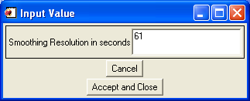

6.3.5 Block Average

Click this button to average that data over time; a window will pop up, asking for the time resolution. The default time resolution is 60 seconds. New variables will be created, with "_av_tres" appended to the old variable names, where "tres" is the time resolution. Click “Cancel” to cancel the operation.

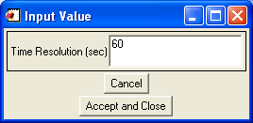

6.3.6 Clip

Clips data above and below a set maximum and minimum, a widget pops up which allows these values to be set. Then data outside the range is set to NaN. New variables will be created, with "_clip" appended to the old variable names. Click “Cancel” to cancel the operation.

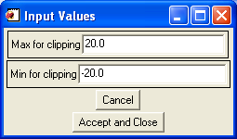

6.3.7 Deflag

Interpolates or repeats the most recent valid data value over gaps in the data (gaps are denoted by NaNs, and can be created by the clipping process). A window pops up which is used to set the method, there are two choices: "repeat" will repeat the last good value over the gap; "linear" will interpolate over gaps. New variables will be created, with "_deflag" appended to the old variable names. Click “Cancel” to cancel the operation.

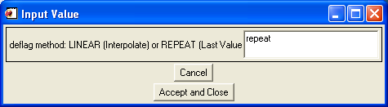

6.3.8 Degap

The degap procedure locates gaps in data, and fills them in with 'NaN' values, so that the plotting process displays the data gaps correctly (Otherwise it simply draws a line across the gap). It figures out where to add data points by checking which time differences are greater than or equal to an input time interval, plus a margin, and inserts equally spaced 'NaN' data points at time intervals with spacing determined by the size of the data gap divided by the number of points that fit with minimum cumulative error. Click “Cancel” to cancel the operation.

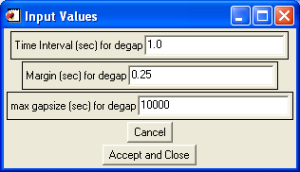

6.3.9 Clean Spikes

This process removes large spikes from messy data. New variables will be created, with "_dspk" appended to the old variables.

6.3.10 Time Derivative

This process takes the time derivative of the active data sets. New variables will be created, with "d_" prepended to the old variable names.

6.3.11 Wavelet Transform

The data is split into components, and a basic wavelet transform is performed on each component, with "_wv" appended to the old variable names. Note that this is designed for data which are either electric or magnetic field data type. Applying this to other data (e.g., spectrograms) will cause non-intuitive results.

6.3.12 Dpwrspec

The data is split into components, and a dynamic power spectrum is obtained from each component, with "_dpwrspc" appended to the old variable names. Note that this is designed for data which are either electric or magnetic field data type. Applying this to other data (e.g., spectrograms) will cause non-intuitive results. For some time ranges and data types, the "dpwrspec" button crashes in the IDL POLY_FIT routine. We have no clue why this happens. Try changing the input time range.

6.3.13 Set Time Limits

When the time limits button is selected, a popup appears allowing the user to set time limits for the processing application, either by using the cursor on the existing plot window, or by using a time selection widget. The “Choose Start time” and “Choose End time” buttons work as in the loading time selection widget, as to the windows for typing in values. The additional buttons work as follows:

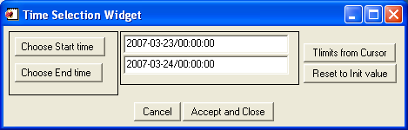

Tlimits from Cursor: Click here move the cursor over the plot window, and click twice on the plot to choose a new time range. You must select a time range by clicking twice on the plot; all other operations on this widget are disabled while you do this.

Reset to Init value: Click here and the time limits will be reset to the initial values in the active data variables.

When you are done, click the "Accept and Close" button to exit the popup. The plot will be reset to the new time limits. If you click the "Cancel" button, the popup will close, with nothing happening.

6.3.14 Rename

By selecting the “Rename” button, a popup is displayed which prompts the user for the new variable name for each of the "active" data sets, and each variable is renamed to the new name. Click the “Cancel” button to cancel the operation. Since this window is displayed for each “active” data set, all operations must be performed on each individual data set, including the “Cancel” button.

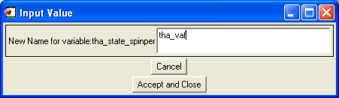

Save

An IDL save file is created with all of the active data sets. A filename selection window is popped up, and the user can change the default filename; “.tplot” is always appended to the selected file. This can be changed, but it is not advised, since the restore routine will look only for those files that end in “.tplot”. Click “Ok” to save. Click the “Cancel” button to cancel the operation.
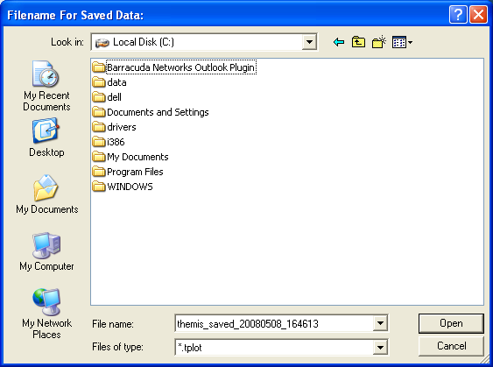

6.3.16 Restore

Saved files can be restored using this button. A file name selection window, similar to the one above, will pop up and the user can use this to select a saved file. Click or type the file name, select “Ok” to restore the variables. Click “Cancel” to cancel the operation. The data sets restored from the chosen file are set to be the “Active” data sets.

6.3.17 Save Ascii

The active data sets are saved in ascii files in the current working directory. These cannot be restored, but can be read. A file name selection window, similar to the one above, will pop up and the user can use this to select a file name. Click or type the filename, select “Ok” to save the data in ascii format. Click “Cancel” to cancel the operation.

6.3.18 Delete

The active data sets are deleted. To delete all loaded data, type “*” in the window below the Loaded Data window on the main GUI widget, click the “Set Active Data to String” button on the main widget, and then click the delete button on this widget.

6.3.19 Close

Click here to close the widget.

6.4 Plot Menu Widget

When the “Plot Menu” button is first clicked a plot of the active data sets pops up, if there are active data. This is because certain plot parameters have to be initialized for some of the buttons to work properly. If there is no active data, then no plot appears, and nothing will happen if the buttons on this widget are clicked.

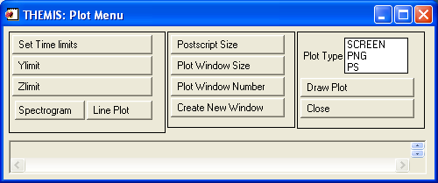

Several modifications to this panel were made for version 4.0. They include the addition of the Postscript size button, change to the Spectrogram button, addition of the Line Plot button, and the general appearance of the widget. Other than the additional feature of postscript sizing, the functionality of this panel remains the same.

6.4.1 Set Time Limits

A popup will appear, allowing the user to set time limits for the processing application, either by using the cursor on the existing plot window, or by typing the limits directly, or using a time selection widget. This is essentially the same as described in section 6.3.13.

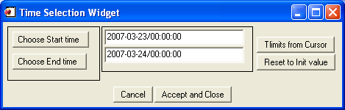

.
6.4.2 Ylimit

This panel sets the Y limits for the active data sets. For each active data set, a text widget pops up, allowing the limits to be set. The user can choose between linear or log plots by selecting one of the two radio buttons located directly below the two text boxes. If both the maximum and minimum are zero, the plotting process chooses the default limits. Click “Cancel” to cancel the operation.

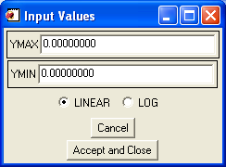

6.4.3 Zlimit

Same as Ylimit, for the Zlimits for spectrogram data.

6.4.4 Spectrogram / Line Plot

The ‘Spectrogram’ and ‘Line Plot’ buttons set each of the active data sets to be plotted either as a spectrogram or as a line plot. Note that not all data can be characterized as a spectrogram. An informational message for each variable that is not set to be plotted as a spectrogram
is printed in the message window, and the history.

6.4.5 Postscript Size

The ‘Postscript Size’ button pops up a window which allows users to enter x and y sizes for the postscript file. The user may also select which units the values use by selecting one of two radio buttons below the two text boxes. The options are inches or centimeters. Note that you must set xsize and ysize greater than zero, or an error message appears and the postscript size is not set. In general it is a good idea not to make windows larger than your screen size. Click “Accept and Close” to close the window and set the postscript size. Click “Cancel” to cancel the operation. This button just sets the size, the postscript file is not created until the user selects the ‘PS’ options for plot device and clicks the ‘Draw Plot’ button. See section 6.4.9 and 6.4.10 for more details on creating the file. This button and window are new features released with version 4.0.

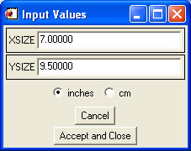

6.4.6 Plot Window Size

Pops up a widget for the window size. For screen plots you can just drag the window for resizing. The set plot window size window can also be used to set the size for png plots. Note that you must set xsize and ysize greater than zero for this to work. Otherwise an error message appears and the window size is not set. It is a good idea not to make windows larger than your screen size. Click “Accept and Close” to close the window and set the window size. Click “Cancel” to cancel the operation.

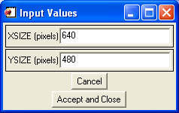

6.4.7 Plot Window Number

Sets the window number for the screen plots. Only window numbers between 0 and 32 are accepted. The current window number is displayed when the window pops up. Click “Accept and Close” to close the window and set the window size. Click “Cancel” to cancel the operation.

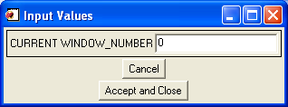

6.4.8 Create New Window

Pops up a plot window with whatever values are currently saved in the widget. The default initial values are 0 for the window number and [xsize,ysize] = [640,480]. This option is not enabled if the plot type is set to 'PNG'.

6.4.9 Plot Type

Click on "SCREEN" for screen plots. Click on "PNG" for png plots and “PS” for postscript. If you choose “PNG” or “PS” it is important to remember to set your plot type back to screen.

6.4.10 Draw Plot

Click here to draw the plot. If "SCREEN" is set, then the plot will show up on the screen. If "PNG" or “PS” is set either a png plot or a postscript file will be created in your local working directory. When you click the "Draw Plot" button a file selection window appears. A default filename of "thm_gui_plot_yyyymmddss.xxx" where the extension xxx is either ‘.png’ or ‘.ps’. The time stamp on the file is the local system time. It is recommended you don’t plot more than 10 quantities when plotting spectrogram data.

6.4.11 Close

Click here to dismiss the widget.

6.4.12 Message Window

In addition to alerting the user when a process crashes, this message window will alert the user when an invalid input parameter is set for the processes. The text is the same as in the progress window of the main GUI. For user input errors, the THEMIS Error widget does not pop up.

6.5 Plot Data (Main GUI widget)

There is also a “Draw Plot” button on the main GUI widget. This has exactly the same effect as the “Draw Plot” button on the Plot Menu widget: If "SCREEN" is set, then the plot will show up on the screen. If "PNG" is set a png plot will be created when you click the "Draw Plot" button, with a default filename of "thm_gui_plot_yyyymmddss.png" in your local working directory. The time stamp on the file is the local system time. A file selection window pops up to allow you to change the filename.

6.6 Overview Plot

By clicking this button, a pop up window is displayed. The user is allowed to select between the five THEMIS probes, various instruments, or ground-based data. Only one probe is allowed at a time.

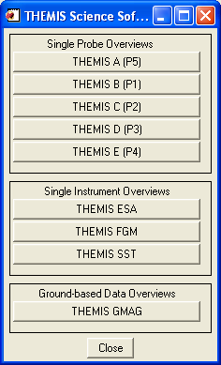

The "Draw Overview plot" button pops up a plot that shows a broad view of THEMIS data. The data sets that are plotted are set to be the active data sets. Here is a sample plot:

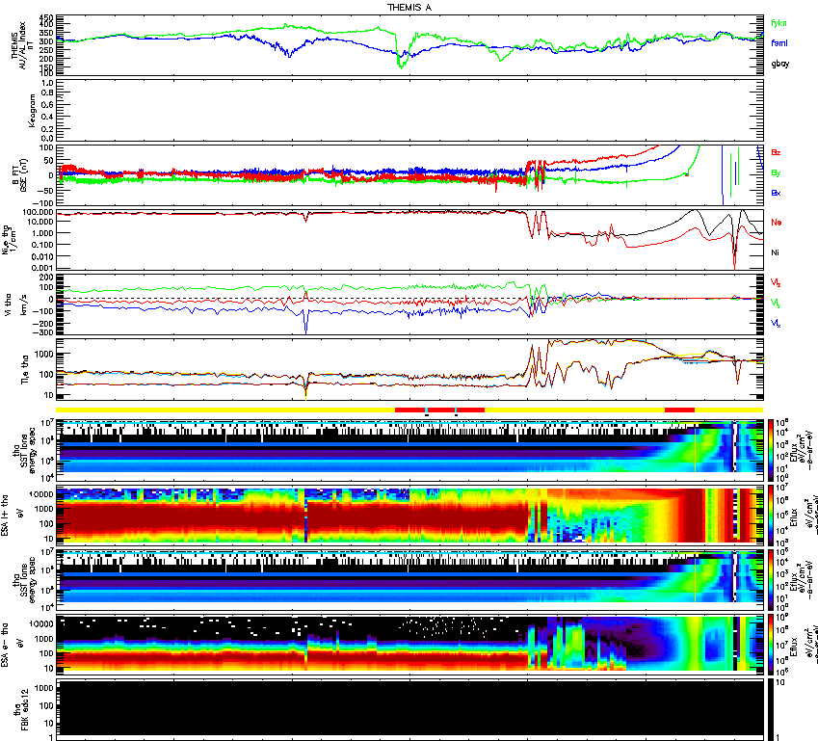

6.7 GUI Tips
- Remember to save and email your history file if you have a bug. Also feel free to include any other output messages that show up in the IDL command line.
- Always choose a time range before loading data.
- Don't load more than a couple of days at a time, or a couple of hours if you are loading full resolution all-sky imager (asf) data.
- d. The choice of "probe" in the data loading widgets is global, that is, all of the selected data will be loaded for the probe(s) chosen most recently. If, for example, you want to load EFI data from probe "A" and FGM data from probe "B", you will need to load these separately. When choosing multiple probes, data types, or whatever, hold the "control" key, and click more than one. Also, you can click on an option, then hold "shift" and the left mouse button, and drag the cursor over the others.
- In some cases, the data names are cryptic. There is a table in the User's Guide and also at the end of the text in the help widget for guidance.
- Once you've chosen data, hit the "Clear Load Queue" to clear it out if you don't want to load it. If a load fails (for a reason other than "the data isn't there"), then the data are still waiting to be loaded. Clear the load queue.
- Remember that all loaded data are set to "active" immediately upon loading. If you don't want all of that data to be active, then click on what you want in the Loaded Data window.
- If you want to delete all data, type "*" window below the Loaded Data window, click "Set Active Data to String", call up the Data Processing widget, and click "Delete".
- For coordinate transforms, data that have "Unknown" for a coordinate system will not be transformed.
- Multiple data sets with different input coordinates *can* be transformed.
- Data Processing and Plotting tasks are only possible when there is "active" data.
- When typing in strings for numerical input -- be careful. Strings that aren't numbers are interpreted as 0 by IDL, but strings that aren't numbers, but start with a number are set to the number, e.g., 'a14' is set to 0, but '1a4' is set to 1. When in doubt, look in the History.
- Sometimes data is inappropriate for a given operation (especially wavelet transforms, and power spectra). We have tried to catch as many of these situations as we can, but there probably will be more as more types of data are imported. If something looks weird, save your history, and email us.
- For some time ranges and data types, the "dpwrspec" button crashes in the IDL POLY_FIT routine.
- We have no idea why this happens, but are working on a fix. Try changing the input time range to a longer range, and see if that helps.
- n. Some processes can take a while (e.g., calibrating SCM data, wavelet transforms of whole days). Currently there is no good way to stop a process except for the standard IDL "control-C" on the IDL window. This doesn't always work.
- o. The Plot Data button first issues a "tplot" call when the widget pops up.
- p. If you create a "PNG" plot, remember to reset to "SCREEN" for screen plotting.
- q. Don't try to plot more than about 10 quantities at a time, if there is spectrogram data, there will be a crash.

