THEMIS User’s Guide:
Software Web Interface
THM-SOC-120
March 2012

Jim McTiernan, THEMIS Science Software Engineer

Pat Cruce, THEMIS Science Software Engineer

Aaron Flores, THEMIS Science Software Engineer

Cindy Russell, THEMIS Science Software Engineer

Lydia Philpott, THEMIS Science Software Engineer

Ben Sadeghi, THEMIS Science Software Engineer

Jim Lewis, THEMIS Science Software Engineer

David A. King, THEMIS Science Software Manager

Vassilis Angelopoulos, THEMIS Principal Investigator

Document Revision Record

Rev. | Date | Description of Change | Revised By
01 | 08/06/2007 | v2.01 Incremental Changes | D. King
02 | 11/06/2007 | v3.00 Release Changes | D. King / J. McTiernan / Andreas Keiling
03 | 11/19/2007 | Replace Data Variable Description Tables | D. King / Andreas Keiling
04 | 05/2008 | v4.00 Release Changes | Software Team
05 | 04/2009 | V5.00 Release Changes | Software Team
06 | 06/2009 | V5.1 Release Changes | Software Team
07 | 02/2010 | V5.20 Release Changes | Software Team
08 | 03/2011 | V6.00 Release Changes | Software Team
09 | 03/2012 | V7.00 Release Changes | Software Team

Distribution List
See: http://themis.ssl.berkeley.edu/team.shtml
Table of Contents
Document Revision Record 2
Distribution List 2
1. Introduction 7
1.1 Purpose and Scope. 7
1.2 Supplementary Documents. 7
2. THEMIS Web Page Interface 8
2.1 THEMIS Web Site - Home Page 8
2.2 THEMIS Data Web Pages 9
2.3 THEMIS Science Software Web Page 30
2.4 THEMIS Science Software - For Developers Web Page 36
2.5 THEMIS Contact Us Web Page 38
3. THEMIS Science Support Help System 39
3.1 THEMIS Science Support Help Process 39
3.2 THEMIS Science Support Help Form - Web Form 40
3.3 THEMIS Science Support Help Form – GUI Interface 41

Introduction

Purpose and Scope.

The purpose of this document is to present to the worldwide scientific community the available tools for viewing, downloading, processing, calibrating and plotting THEMIS data and how to use these tools.

Supplementary Documents.

Various supplementary documents can be found on the THEMIS website. These include but are not limited to documentation for:

- Coordinate Systems
- Time Conventions
- Instrument Calibration
- Data Calibration and Processing
- Variable Naming (for data products)
- Software Documentation (including this user’s guide)

These documents may be accessed from the THEMIS home page by selecting Documentation under the Software menu.

http://themis.ssl.berkeley.edu/index.shtml

They may also be accessed directly via the link below:
ftp://apollo.ssl.berkeley.edu/pub/THEMIS/3%20Ground%20Systems/3.2%20Science%20Operations/Science%20Operations%20Documents/

THEMIS Web Page Interface

THEMIS Web Site - Home Page

The THEMIS Home Web Page can be displayed by using the following URL: http://themis.ssl.berkeley.edu/.
Across the top portion of this web page are a series of drop down menus (Home, The Mission, Data, Software, Publications, News & Events, Contact Us and For the Public). In this document we will be discussing the Data, Software and Contact Us Web Pages.

The THEMIS Data Drop Down Menu allows you to select the following options: Overview, Data Policy/Credits, Summary Plots, Data Retrieval, Data Descriptions, Data Products, Event List, Data Processing and Collaboration Tools. These options will be discussed in more detail in Section 2.2.

The THEMIS Software Drop Down Menu allows you to Select the following options: Software, Documentation, Developers and Enhancements. These options will be discussed in more detail in Section 2.3.

The THEMIS Contact Us automatically links you to a web page that allows you to send email to the THEMIS PI or THEMIS Instrument Scientists or send a Help Request to the THEMIS Science Support Team with Comments, Observations, Problems or Questions concerning data, a document, download, GUI, Plot, Software, Web Interface or any other issue not listed.
This Help Request option will be discussed in more detail in Section 2.4.
Please note: Differences between the screen displays presented in this document and what you may see online are due to Web Page Upgrades not yet reflected in this document. The screen displays incorporated into this document are to give the reader a sense of the functionality of the Web Interface to THEMIS Science Software.
Please see copy of the THEMIS Home Web Page on the Next Page.
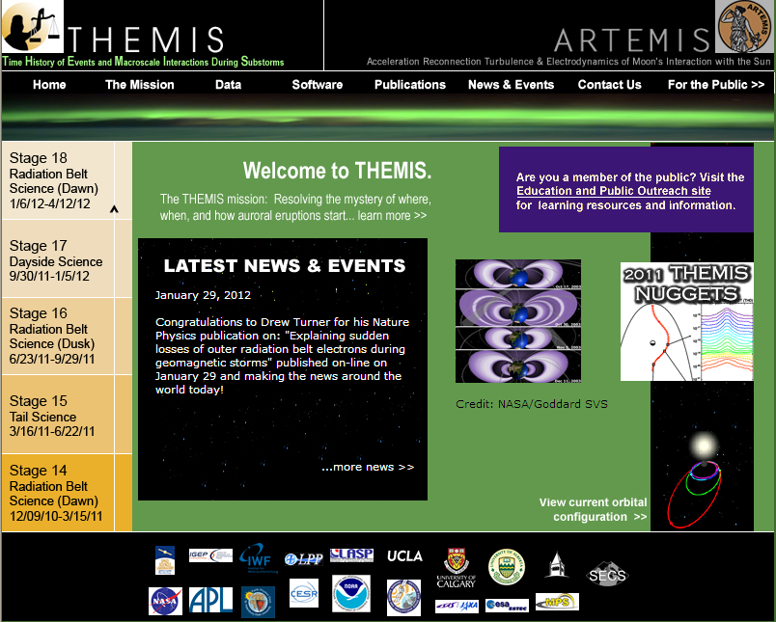
Figure 2.1a THEMIS Web Site - Home Page

THEMIS Data Web Pages

The THEMIS Data Drop Down Menu has the following options.
- Overview - A Data Overview and convenient location to Instruments, Orbits, Data Descriptions and more.
- Data Policy/Credits - displays the Rules for using the THEMIS Data website (Rules of the Road).
- Summary Plots which will allow you to look at Summary Plots of one Probe, Multiple Probes, Ground Magnetometer, All Sky Imager or Orbits Data. Download Data to Download THEMIS Data.
- Data Retrieval - Menu of the following options:
Data Files All -ftp site of all THEMIS data directories and data files
Data Files By Platform - allows selection to either a probe, gmag or flatsat data files
Data Files By Group - allows selection by Probe and Instrument
- Data Descriptions - which will lead you to the documentation ftp site where the 'Science Data Variable Descriptions' document can be found.
- Data Products – which has descriptions of Level 2 data products, and status of the data products.
- Event List which will display the Events ftp site.
- Data Processing – containing descriptions of the data processing and status of the data processing.
- Collaboration Tools – Menu of the following options:
SSCWeb 3-D Orbit Viewer – NASA GSFC Plots of orbital position in 3-D.
CDAWeb – NASA SPDF Data Access page.
THEMIS Wiki Pages – Useful THEMIS information in Wiki format.
Magnetopause Crossing Database – CDAWeb plots of data for Magnetopause crossings.

Please note: If using THEMIS Science Software Data Analysis Tools there is no need to use the
Data Retrieval - Data Files By Group Option. Please see screen displays below for all options.

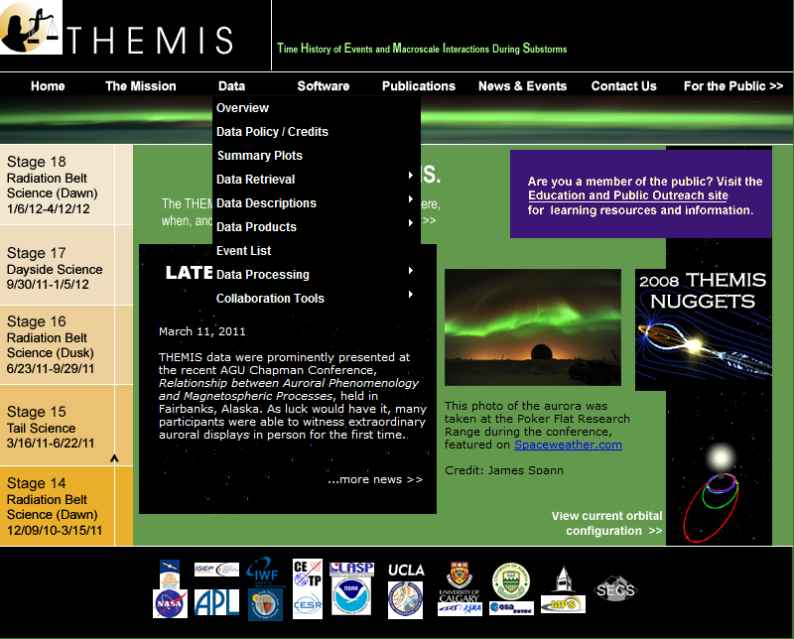
Figure 2.2a THEMIS Data Dropdown Menu
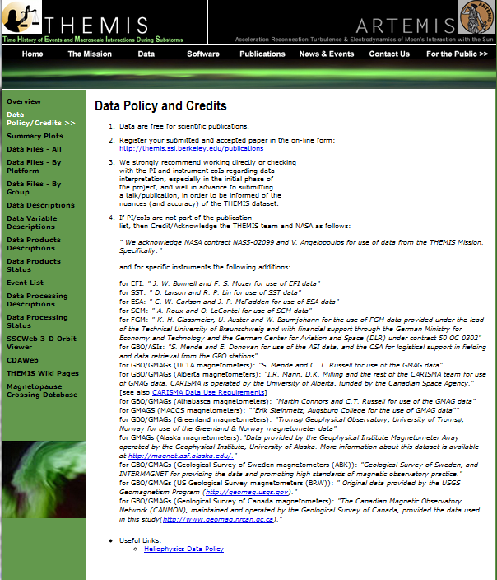
Figure 2.2b THEMIS Data Usage Rules Web Page

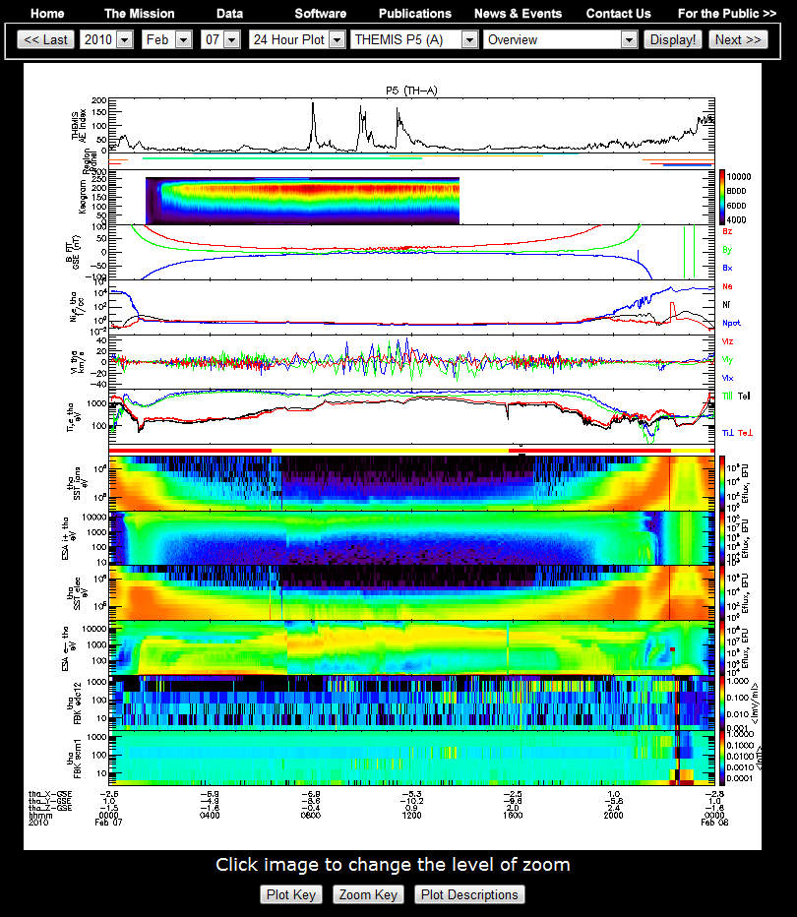
Figure 2.2c THEMIS Data Summary Plot Web Page

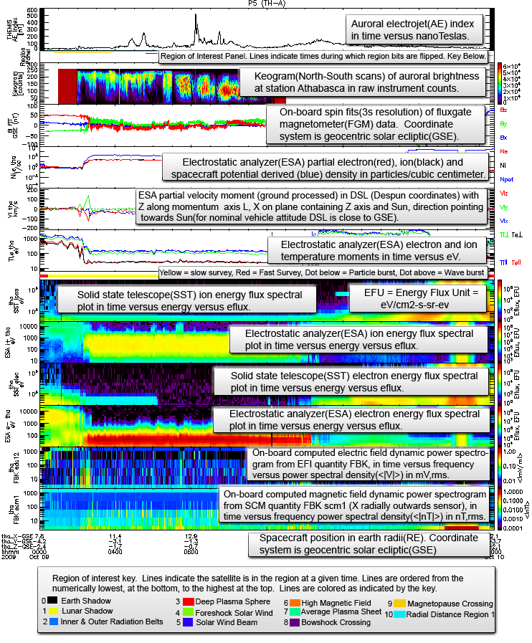
Figure 2.2d THEMIS Summary Web Page - View Plot Key Button

THEMIS Online Summary Plot Descriptions.
Found at: http://themis.ssl.berkeley.edu/summary.shtml?autoload=1
Plot Type/Name | Description | Observatories | Time Intervals
Overview | General snapshot of THEMIS spacecraft instruments and ground data. | Single Spacecraft  Selected ASI site.  Aggregated GMAGs | 24hr,6 hr,2 hr
Space ESA moments. | Electron/Ion velocity, pressure, field aligned temperature vector, and energy eflux. Values derived from high resolution ESA data on spacecraft before down sampling for transmission | Single Spacecraft. | 24hr,6 hr,2 hr
Ground ESA moments. | Electron/Ion velocity, pressure, field aligned temperature vector, and energy eflux. Values derived from ESA reduced distribution during ground processing. | Single Spacecraft | 24 hr,6 hr,2 hr
ESA burst | Electron/Ion energy eflux spectrograms derived from ESA burst distribution during ground processing and spacecraft mode indicator plots. | All Spacecraft | 24 hr,6 hr,2 hr
ESA Full | Electron/Ion energy eflux spectrograms derived from ESA full distribution during ground processing and spacecraft mode indicator plots. | All Spacecraft | 24 hr,6 hr, 2 hr
ESA Reduced | Electron/Ion energy eflux spectrograms derived from ESA reduced distribution during ground processing and spacecraft mode indicator plots. | All Spacecraft | 24 hr, 6 hr, 2 hr
SST Full | Electron/Ion energy eflux spectrograms derived from SST full distribution during ground processing and spacecraft mode indicator plots. | All Spacecraft | 24 hr, 6 hr, 2 hr
SST Reduced | Electron/Ion energy eflux spectrograms derived from SST reduced distribution during ground processing and spacecraft mode indicator plots. | All Spacecraft | 24 hr, 6 hr, 2 hr
FGM | Fluxgate Magnetometer FGS and FGL data. Spacecraft mode indicator plots. | All Spacecraft | 24 hr,6 hr, 2 hr
FGM Wave Survey | Fluxgate Magnetometer FGL12 and FGE data. | All Spacecraft | 24 hr,6 hr, 2 hr
FFF, FBK | Fast-Survey FFT14 data, and FBK15 data. | All Spacecraft | 24 hr,6 hr, 2 hr
Burst Memory | Burst memory segment fill level. | All Spacecraft | 24 hr, 6 hr, 2 hr
Survey Memory | Survey memory segment fill level. | All Spacecraft | 24 hr, 6 hr, 2 hr
GMAG High-H | Stacked plot of H component of HDZ ground magnetometer readings. | High Latitude THEMIS-GBO sites. | 24 hr
GMAG High-D | Stacked plot of D component of HDZ ground magnetometer readings. | High Latitude THEMIS-GBO sites. | 24 hr
GMAG High-Z | Stacked plot of Z component of HDZ ground magnetometer readings. | High Latitude GBO sites. | 24 hr
GMAG Low-H | Stacked plot of H component of HDZ ground magnetometer readings. | Low Latitude GBO sites. | 24 hr
GMAG Low-D | Stacked plot of D component of HDZ ground magnetometer readings. | Low Latitude GBO sites. | 24 hr
GMAG Low-Z | Stacked plot of Z component of HDZ ground magnetometer readings. | Low Latitude GBO sites. | 24 hr
ASI-Summary16 | Interactive grid of station versus hour/minute/second ASI thumbnails. | 20 THEMIS ASI sites. | 1 hr/1 minute/3 second.
ASI-Keograms | Interactive grid of station versus hour ASI Keograms. | 20 THEMIS ASI sites. | 1 hr
ASI-Averages | Interactive grid of station versus hour ASI averages. | 20 THEMIS ASI sites. | 1 hr
ASI-Mosaic | Map showing ASI station mosaic overlayed on map. | 20 THEMIS ASI sites. | 3 second.
Orbits-GSM | 3 plots of THEMIS orbits over X/Y/Z axis of GSM coordinates, in an earth centered frame and 40 Re range in each dimension. | All Spacecraft | 24 hr/6 hr
Orbits-GSE | 3 plots of THEMIS orbits over X/Y/Z axis of GSE coordinates, in a moon centered frame and 120 Re range in each dimension. | All Spacecraft | 24 hr/6 hr
Ground Tracks North | Plot of THEMIS footprints on map of northern polar region. Generated by tracing field lines from spacecraft position to the north using the T89 model. | All Spacecraft | 24 hr/6 hr
Ground Tracks South | Plot of THEMIS footprints on map of southern polar region. Generated by tracing field lines from spacecraft position to the south using the T89 model. | All Spacecraft | 24 hr/6 hr
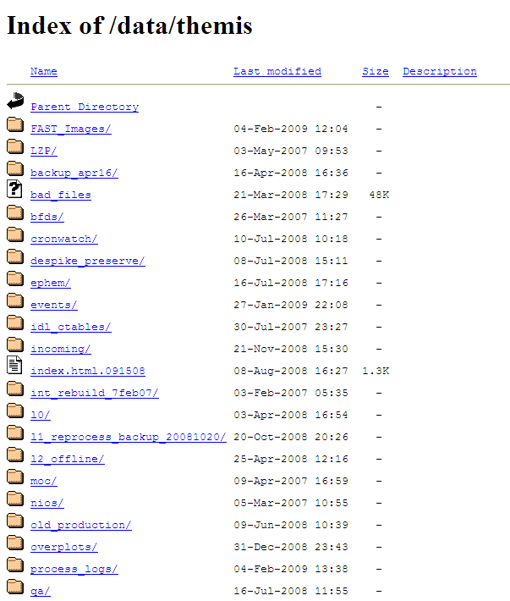
Figure 2.2e THEMIS Data Retrieval - ALL

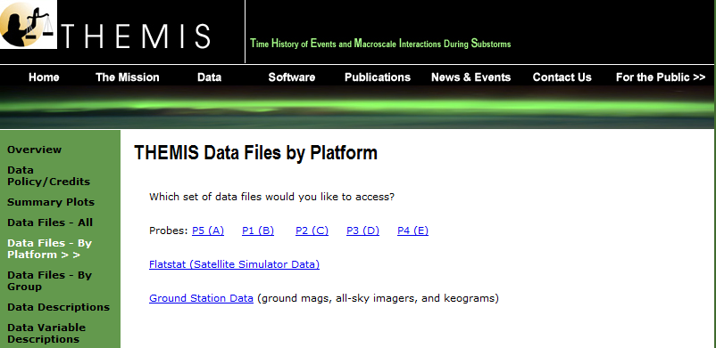
Figure 2.2f THEMIS Data Retrieval - By Platform
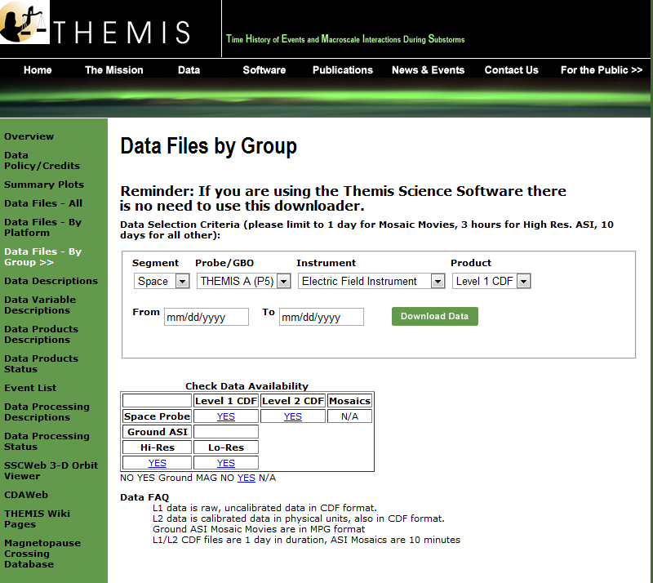
Figure 2.2g THEMIS Data Retrieval - By Group

Selecting Data Descriptions will display this web page. Click on the instrument or data type you wish to see. Note links at the bottom of the web page.
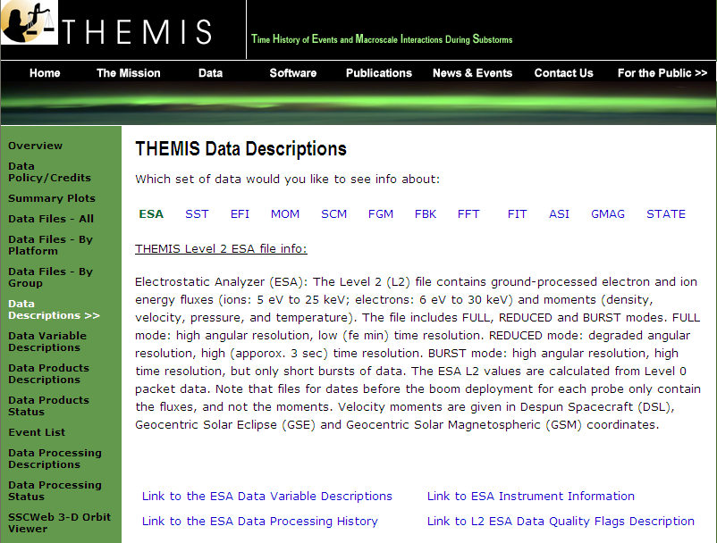
Figure 2.2h
Selecting GMAG on the Data Descriptions page will display information about the GMAG data, together with a list of available GMAG sites (partial list only shown below).
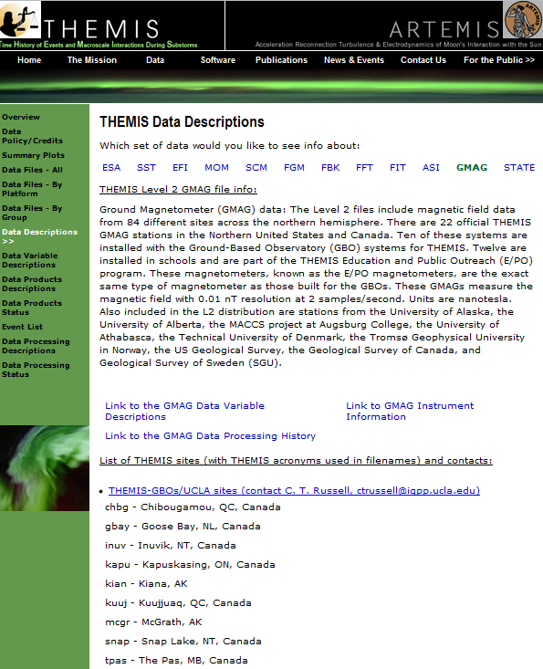
Figure 2.2i
Clicking on Data Variable Descriptions will display the current Data Variables Description Documents on the ftp site

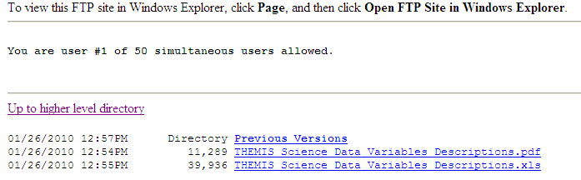
Figure 2.2j

Selecting Data Products Descriptions will display this web page and then click on data product you wish to see. Note links at the bottom of the web page.

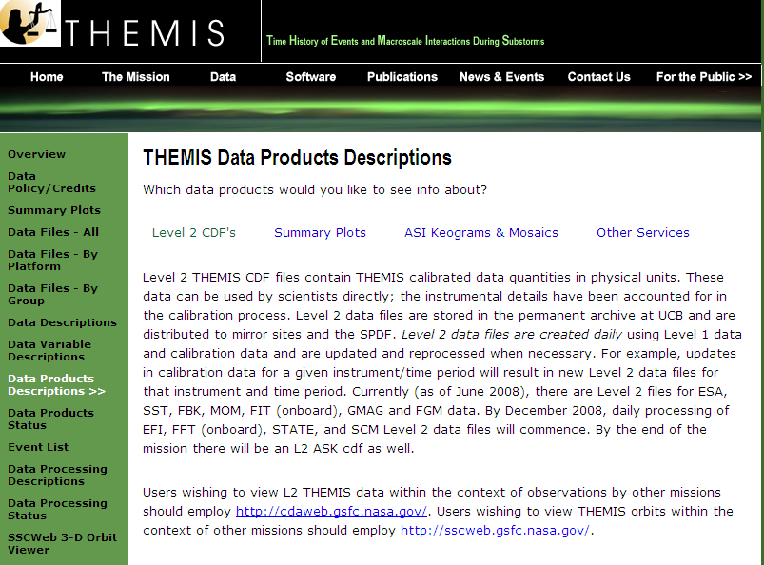

Figure 2.2k
Selecting Data Products Status will display this web page

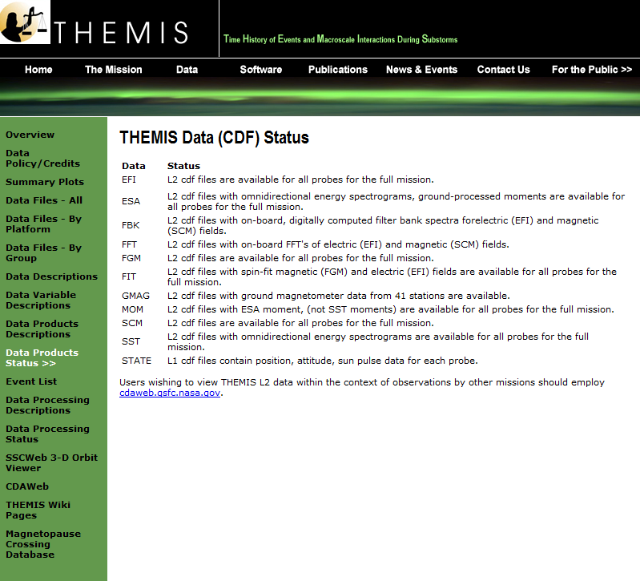
Figure 2.2l
Selecting Event List will display this web page
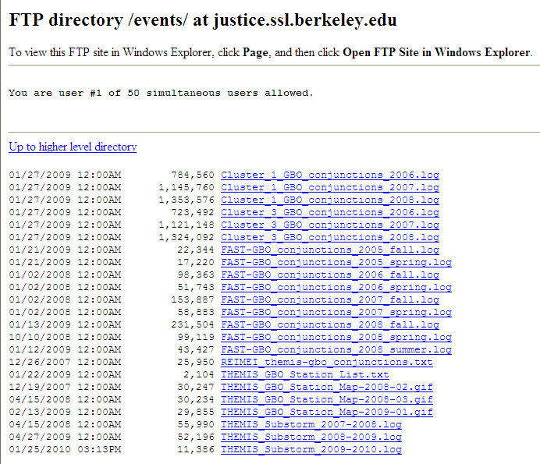
Figure 2.2m THEMIS Event List - ftp site

Selecting Data Processing Descriptions will display this web page and then click on data processing description you wish to see.

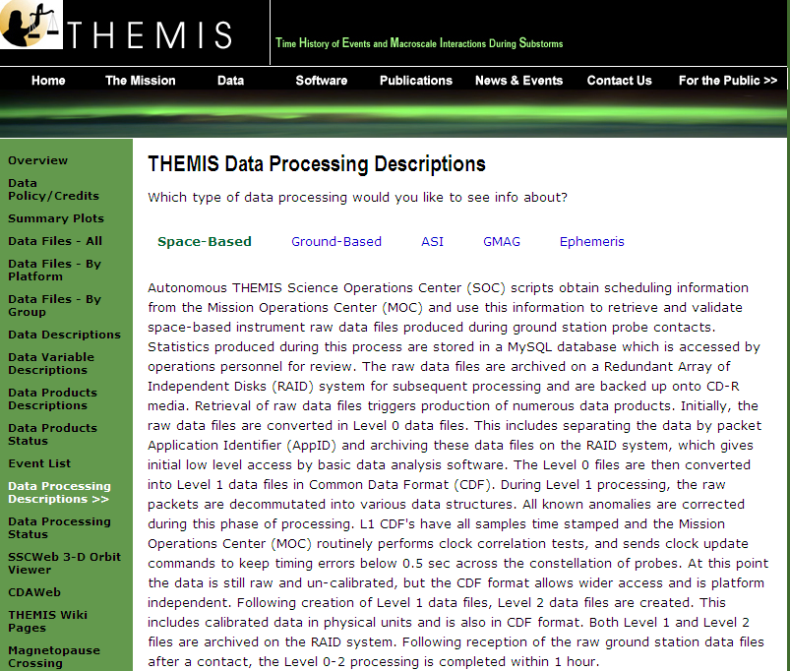
Figure 2.2n
Selecting Data Processing Status will display this web page

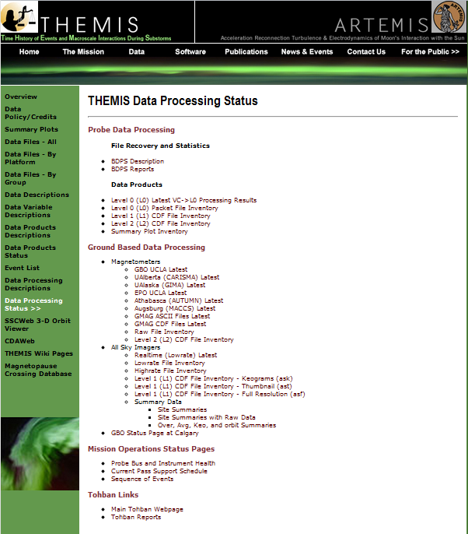
Figure 2.2o

Selecting Collaboration tools will display this list of links

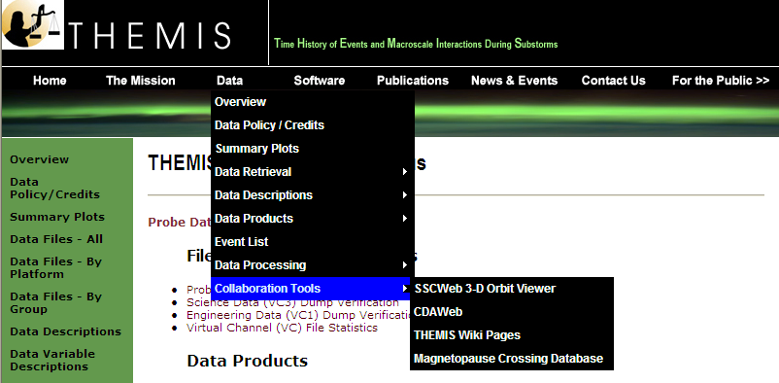
Figure 2.2p

THEMIS Science Software Web Page

The THEMIS Science Software Drop Down Menu has the following options. Software displays a web page for downloading the latest release of the THEMIS Science Software Data Analysis Tools, Documentation, Registering to be notified of Future Releases of the Software, Download not yet released Software and Contacting the THEMIS Science Support Team with Help Requests. Developers, options to read about how to develop and contribute Software to THEMIS Science Software. Documentation which provides a link to the THEMIS Science Software Documentation ftp site. Enhancements, which will display the latest Accomplishments and Enhancements (A&E). The previous month's A&E is available as well.
Please note: If you download the not yet released Software, this Software may not have been tested (you are on your own). Please see screen displays below.
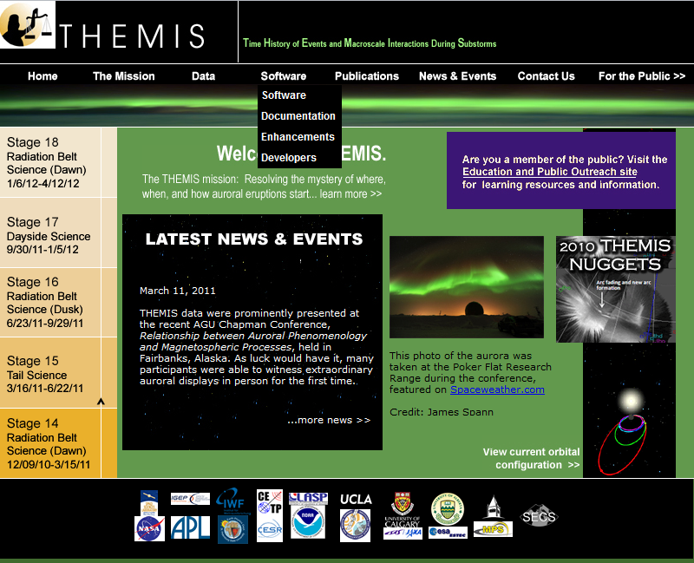
Figure 2.3a THEMIS Science Software Drop Down Menu
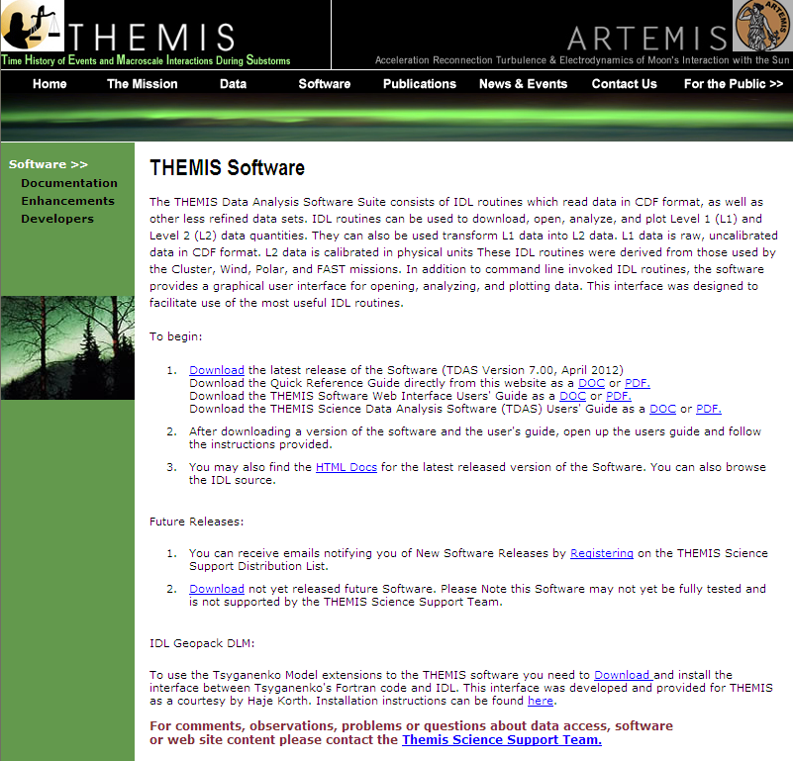Figure 2.3b THEMIS Science Software Web Page
When you click on Download the latest release on a Windows machine A File Download dialogue box will be displayed. Click on 'Open' and the WinZip box will appear. Select the Extract icon to download the unzipped versions of the THEMIS Science Software to your computer. Notice the Extract display will ask you where to put the downloaded files. Please see Screen displays on this and the next page.
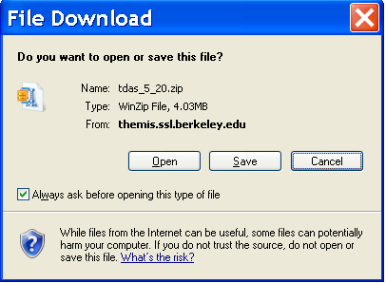
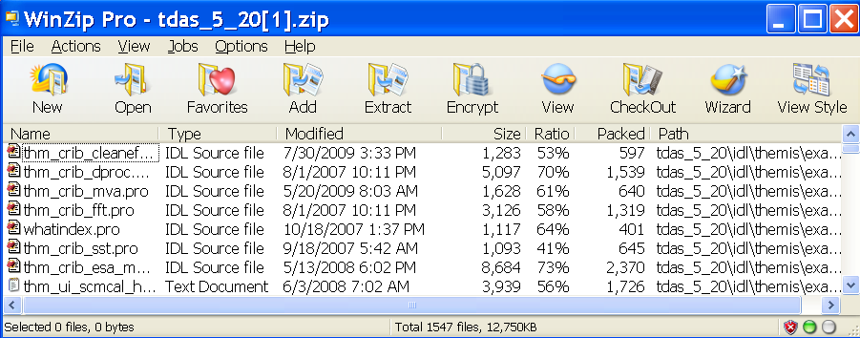
Figure 2.3c THEMIS Science Software - Download Software

Recommendation: put the Software where you can easily find it as you will need to set the IDL path.

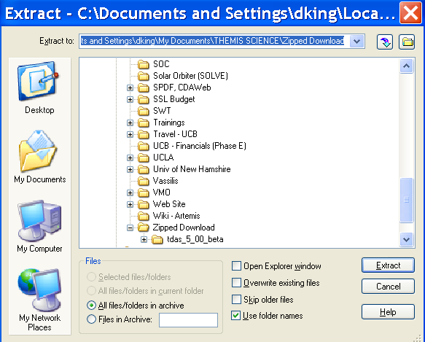
Figure 2.3d THEMIS Science Software - Download Software

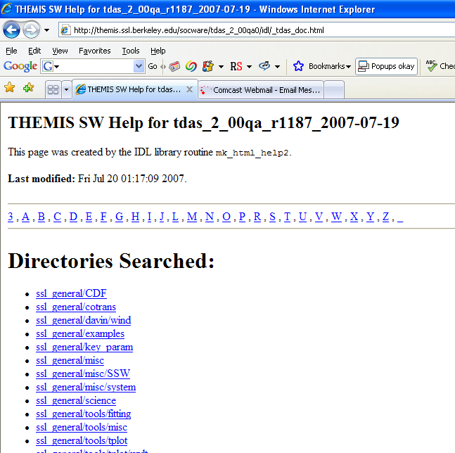
Figure 2.3e THEMIS Science Software - HTML Docs
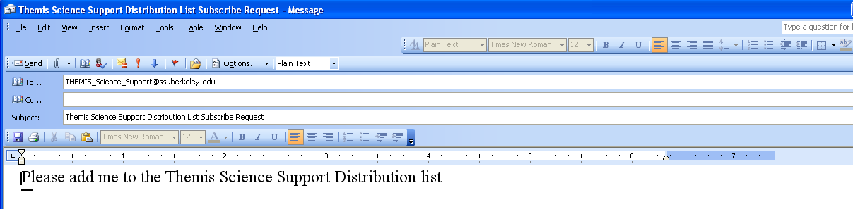
Figure 2.3f THEMIS Science Software - Registration for Notification

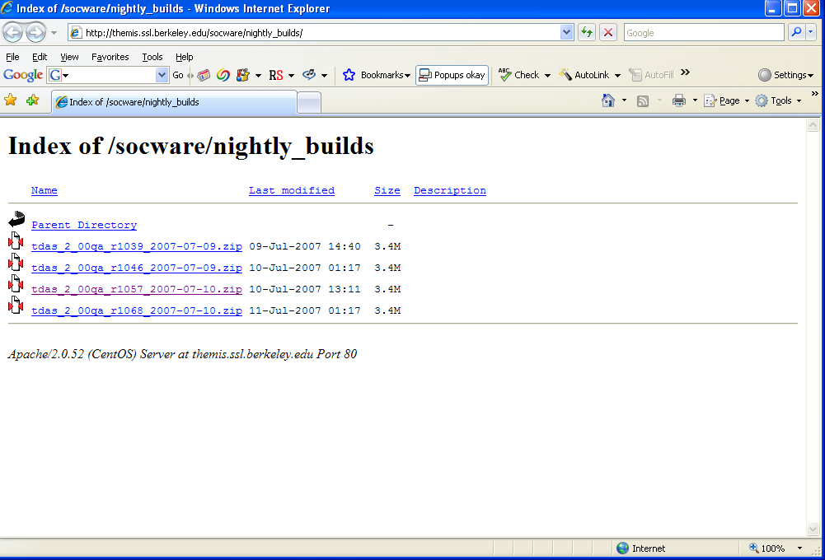

Figure 2.3g THEMIS Science Software - Download Not Yet Released Software

THEMIS Science Software - For Developers Web Page

The THEMIS Science Software for Developers Web Page has links to aide software developers in developing and contributing software to the THEMIS Science Software library. The 'Additional Documentation' option will link you to the ftp site where current THEMIS Science Software documentation can be found.
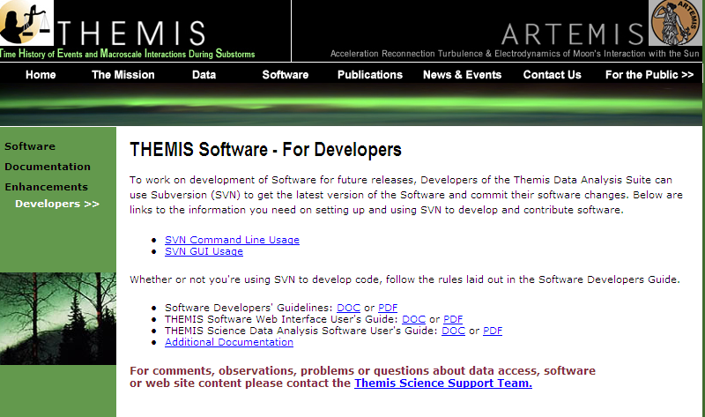Figure 2.4a THEMIS Software - For Developers Web Page
When you click on the Documentation Option on the THEMIS Software Dropdown menu you will be transferred to the THEMIS Document ftp site.
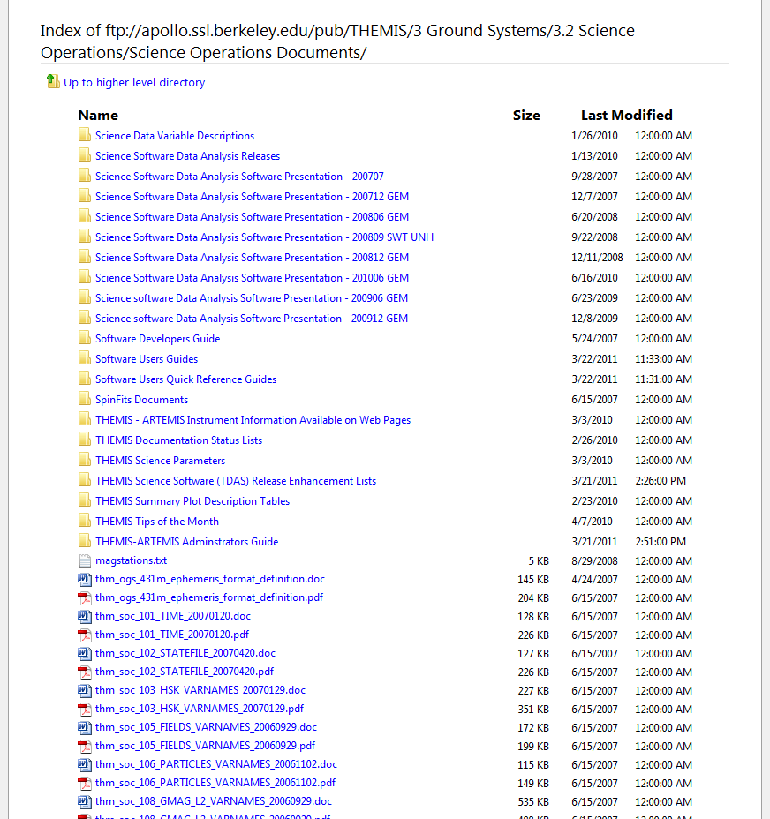

Figure 2.4b THEMIS Documentation ftp site

THEMIS Contact Us Web Page

The THEMIS Contact Us Web Page lists the contact information for the THEMIS Principal Investigator as well
as the Co-Investigators for each THEMIS Instrument. In addition there is an option to send a Help Request to the THEMIS Science Support Coordinator with comments, observations, problems or questions. The Help Request form and process will be explained in more detail in Section 3. Please see the screen display below.

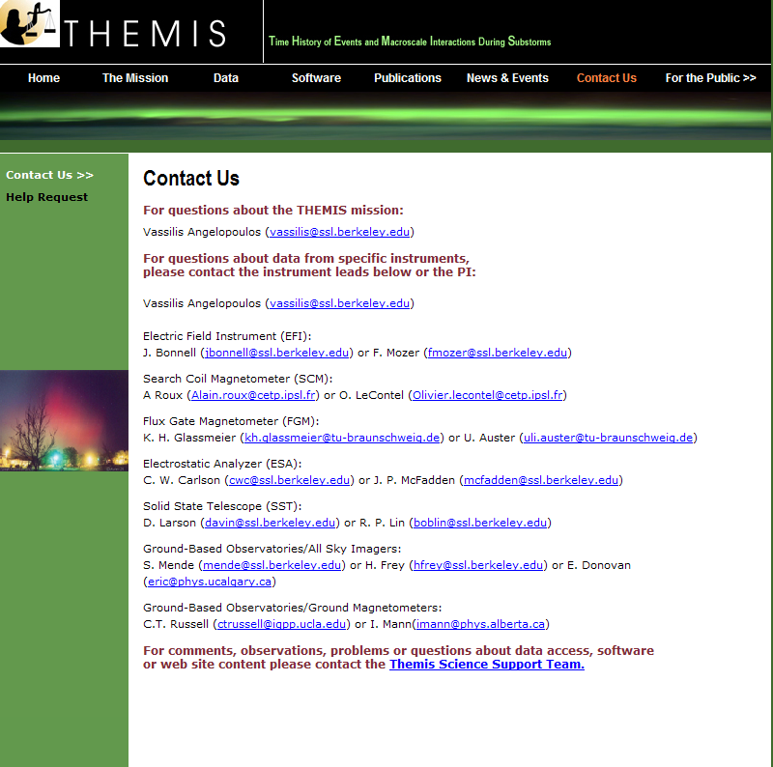

Figure 2.5 THEMIS Software Contact Us Web Page

THEMIS Science Support Help System

THEMIS Science Support Help Process

The THEMIS Science Support Help Process exists for users who have Comments, Observations, Problems or Questions concerning data, a document, download, GUI, Plot, Software, Web Interface or any other issue not listed. The Help Process is a bit different for Step 1 if you are using the Web or the GUI Interface.

For the Web to Help Request Form Interface:
From either the Software or Contact Us Web Pages (example on previous page) the user will see the following:
For comments, observations, problems or questions about data access, software or web site content
please contact the THEMIS Science Support Team.

If you click on THEMIS Science Support Team a THEMIS Science Support Help Request Form (example in Section 3.2) will be displayed. The user fills out the form and hits 'Submit'. Depending on your computer and email application the processing will be different for the email to be sent. For some computers the form is sent automatically. If you have a PC running Windows a box asks you which email Application you use. If you use a desktop email application like Outlook, Outlook Express, select that button, hit OK and the Form will be automatically sent to the Support Coordinator. If you choose either of the two other options (Internet Email or Other) Windows will guide you through a three step process to send your email. Again, if not using windows (e.g. Mac, Linux or Unix) the process maybe different. Yet the main goal is for the Help Request Form to be sent to THEMIS_Science_Support@ssl.berkeley.edu.

For the GUI to the Help Request Form Interface:
If you select the “HELP" drop down menu on the THEMIS Science Software GUI Main window or if the GUI detects an error, a Help Request Form is displayed (see example in Section 3.3). Fill out the form and then click on 'Save'. (Be sure to save it somewhere you can find it.) If reporting a bug please save and send your history file. Do this by first selecting “History Window” on the “View” drop down menu and then clicking on “Save” at the bottom of the History window. We suggest that you put your Help Request Form and Saved History file in the same location. At this point you can address your email to THEMIS Science Support Team, attach your Help Request Form and your History file and send.

The remaining steps are the same for either the Web or GUI Interface.
Step 2: User sends any additional information (logs, error messages, etc) to THEMIS_Science_Support@ssl.berkeley.edu.

Step 3: The Support Coordinator logs in your help request, and sends back an email confirming receipt of your help request with your Help Request Number. The Support Coordinator will also forward your Help Request and any attachments to the person (Actionee) who will investigate and answer your Help Request.

Step 4: The Actionee will contact the User to respond to the comment, observation, problem or question.

Step 5: Feel free at any time to send an email to the Support Coordinator requesting status of your request.

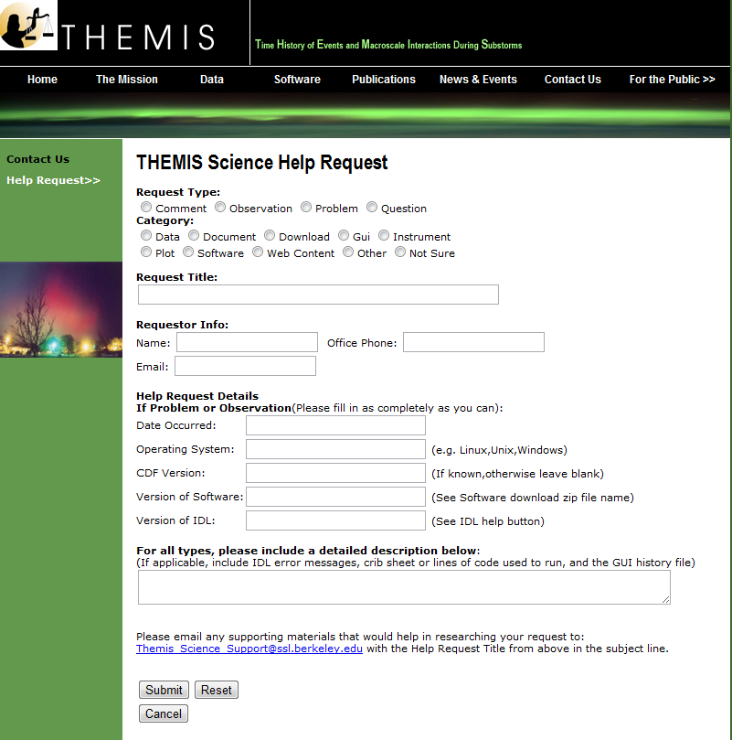
THEMIS Science Support Help Form - Web Form
Figure 3.2

THEMIS Science Support Help Form – GUI Interface
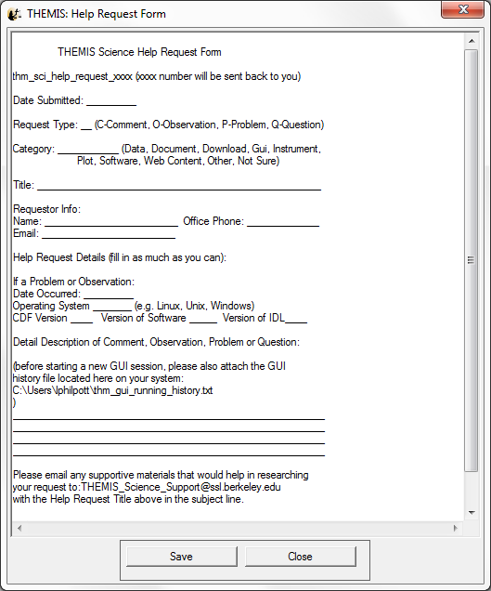
Figure 3.3

. Detailed description at http://themis.ssl.berkeley.edu/key.png
. All single spacecraft plots are available for all THEMIS spacecraft when data is available, but displayed on separate plots.
. Aggregated using an algorithm like AE-index, but using THEMIS gmags rather than standard AE ground stations.
. Also for reference E= -VxB, spacecraft measured spin resolution magnetic field, and t89 model predicted magnetic field.
. Also for reference E= -VxB, spacecraft measured spin resolution magnetic field, and t89 model predicted magnetic field.
. ESA Reduced distribution has high temporal (~3 second) resolution but low angle (1-6 bins) resolution.
. ESA Burst distribution has high temporal (~3 second) and high angle (88 bins) resolution but limited availability.
. ESA Full distribution has low temporal (~395/~98 seconds) and high angle (88 bins) resolution.
. SST Full distribution has low temporal and high angle(128 bins) resolution.
. SST Reduced distribution has high temporal (~3 second) and low angle (1-6 bins) resolution.
. FGS data is at spin resolution (~3 second) and is continuously available for most of the mission.
. FGL data is at 1/4 second resolution and is available during configured regions.
. FGE data is engineering data, occasionally available. 14. FFT data is On Board Fast Fourier Transform (FFT) power spectra of Electric (EFI) and Magnetic (SCM) field. 15. FBK data is on-board, digitally computed filter bank spectra for EFI and SCM. 16. Map indicating ASI site locations and field of view provided for reference

